
Pacific Regional Cell Broadcast Strategy Version: 0.1
Document History
Versions
Version | Revision Date | Summary | Reviewed by
0.1 |  | Initial document created
0.2
0.3

Distribution
Version | Date | Distribution
1.0
Document ID: Document1
Document Owner:
Last updated: 31 May 26
Review frequency:
Version: 0.1

Executive Summary
Pacific Island Countries and Territories (PICTs) face some of the world’s highest exposure to severe weather, geological hazards, and climate-driven emergencies. Mobile Cell Broadcast Service (CBS) systems offer a transformative capability for real-time, geo-targeted public alerting — but they are expensive to procure, complex to operationalise, and require sustained technical and institutional capacity.
With more than ten CBS systems already installed or planned as of May 2026, the region is entering a rapid expansion phase without the support systems yet in place to ensure sustainability. This strategy provides the regional framework needed to coordinate investments, strengthen national and regional capability, harmonise operating practices, and ensure CBS systems deliver long-term value to Pacific communities.
Facilitated by the Weather Ready Pacific (WRP) Programme, the strategy strengthens key elements of the programme — in particular KRA 5 Communication and Delivery of Forecast and Warnings to End-Users (also aligned to EW4All Pillar 3) — by establishing a coherent, regionally coordinated approach to CBS deployment, operations, and sustainability. It also supports the Framework for Resilient Development in the Pacific (FRDP) through enhanced risk-informed decision-making, improved warning dissemination, and Pacific-led resilience.
The strategy further aligns with the Pacific Islands Meteorological Strategy (PIMS), the WMO Unified Data Policy, and the United Nations’ Early Warnings for All (EW4All) initiative. Together, these frameworks provide the strategic foundation for a regionally harmonised, sustainable, and Pacific-owned approach to mobile CBS implementation and operations.
Achieving these goals requires a coordinated regional approach. While CBS systems are deployed nationally, their sustainability depends on shared technical expertise, harmonised operating procedures, regional device testing, and collective negotiations with mobile network operators (MNOs) and vendors. Smaller Pacific Island countries, in particular, face significant challenges in maintaining the specialised skills, funding, and institutional arrangements required to operate CBS systems independently. A regional framework enables economies of scale, reduces duplication, and ensures that all countries — regardless of size or capacity — can access the support needed to operationalise and sustain their systems.
The strategy outlines five medium-term outcomes essential for a resilient and Pacific-owned CBS ecosystem:
(1) full regional coverage by 2027;
(2) long-term sustainability of systems and operations;
(3) strengthened national and regional capability;
(4) integration of CBS into forecasting, warning, and emergency management workflows; and
(5) predictable and coordinated funding arrangements.
To achieve these outcomes, the strategy recommends a tiered technology approach suited to the diverse contexts of Pacific Island countries, the adoption of standardised message identifiers and alert templates, and the establishment of a regional Community of Practice supported by a CBS Knowledge Hub. These mechanisms will enable consistent training, shared learning, and continuous improvement across the region.
Finally, the strategy proposes a long-term sustainability model that maximises upfront investment, reduces ongoing operational burdens, and establishes the regional pooled maintenance fund to support essential services such as training, testing, and vendor-level support. This approach ensures that CBS systems remain reliable, functional, and ready to support life-saving early warnings long after initial project funding ends.
Together, these measures position the Pacific as a global leader in coordinated early warning dissemination and support the region’s commitment to ensuring that every person is protected by timely, accurate, and actionable alerts.
The Case for a Regional Strategy
Mobile CBS systems improve the ability of alerting agencies to warn for meteorological, geological and other emergency events across the Pacific region. Recognising that the protection of life is paramount, the additional social and economic benefits are substantial. These include safeguarding infrastructure, personal assets, livelihoods and contributing to impact-based warnings.
In isolation, smaller Pacific Island nations may experience difficulties in sustainably implementing and operating CBS systems. A regional approach is therefore essential: harmonised technologies and operating procedures, shared expertise, coordinated end-user device testing, and a regional approach to negotiations with mobile network vendors for CBS licensing will provide resilience and economies of scale that no country can achieve alone.
Key Challenges
Consultations across the Pacific highlight recurrent barriers:
- Limited technical capability: many countries have a limited number of technicians and specialists who can run mobile CBS alerting systems; turnover is high, and training pathways are limited.
- Meteorological and NDMO capability and workflows: few organisations across the region have experience using CBS systems and sending alert messages; existing SOPs and warning systems are not designed for national mobile alerts. In addition, Common Alerting Protocol (CAP) is the standardised messaging format advocated by UN agencies globally and yet many stakeholders at the national level are not trained on the use of CAP.
- Lifecycle and funding risks: initial capex and annual ongoing CBS system opex costs as well as other support/operational costs are unavailable in many countries across the region.
- Rapid rollout: Only one country in the region has so far operationalised its CBS system and completed a national end-user test – Tonga in April 2026. At least nine other countries across the Pacific are at various stages of system implementation but they will benefit from coordinated regional support to modify SOPs, undertake testing and implement best practice. In addition, another seven Pacific Island nations will need to implement a national solution in the next eighteen months if the Early Warnings for All target is to be met.
Strategic Outcomes
The strategy defines five medium-term outcomes:
- Coverage: mobile CBS system in every Pacific Islands country by the end of 2027 to meet the region’s commitment to the UNs Early Warnings for All global initiative; this region may be the only one that achieves the target.
- Sustainability: long-term technical, financial and operational viability.
- National & Regional Capability: balanced support model combining country-level capacity with regional coordination and support.
- Service Delivery: CBS integrated into forecasting platforms, SOPs and early warning dissemination channels.
- Funding: secure, predictable support for operations and development.
Recommended Network and Technology Approach
Given the very small size of many Pacific Island countries, and the resulting limited budgets and human resources available locally, simpler entry-level CBS systems are recommended for these markets. Only the larger countries in the region who are most prone to sudden-onset natural disaster events, primarily Fiji, Papua New Guinea and Vanuatu, would opt for the more expensive Tier 1 solutions offered by the global vendors and which would require donor funding.
Additional technical recommendations include using standardised Message Identifiers (MI) for the different types of CBS message alerts, coordinated approach to standardising alert message templates and collaboration on end-user device testing and sharing device test results.
Building Regional Capability
A sustainable CBS Pacific ecosystem requires a multi-layered support model:
- Level 1: in-country users trained to manage routine system tasks and send alerts.
- Level 2: regional practitioner experts providing support, advice and recommending changes to best-practice.
- Level 3: vendor-level or specialist support for complex issues.
To further support local stakeholder capability, an online “CBS Knowledge Hub” will be developed; this will be a centralised depository for documents, templates, news articles, test results, project planning documents etc. A regional “Community of Practitioners” will further strengthen peer support and knowledge exchange and be a foundational component towards successful sustainability.
Funding and Long-Term Sustainability
Given that ongoing costs (power, communications, maintenance, training, spares, site operations) will exceed the operating budgets of most NMHSs, the strategy recommends:
- maximising upfront investments (solar power, long-term licences, pre-purchased spares, resilient communications links) to reduce future burden
- creation of a regional pooled maintenance fund, supported by countries and donors, to finance technician deployments, training, spares, and essential recurring costs
This funding model would enable continuity of service, reduce system downtime, and support a Pacific-led approach to radar operations.
Table of Contents
Executive Summary 2
1. Introduction 8
1.1. Background: Weather Ready Pacific 8
1.2. Purpose and Scope of the Strategy 8
1.3. Strategic Context 9
1.4. Current Status Across the Pacific 10
1.5. Guiding Principles 11
1.6. Methodology and Stakeholder Engagement 12
2. The Case for a Pacific Cell Broadcast Strategy 13
2.1. National and Regional Requirements 13
2.1.1. Global Context 13
2.1.2. National Requirements 14
2.2. Use Cases 14
2.2.1. Representative Use Cases 15
2.3. Social and Economic Benefits 15
2.4. Benefits of Regional Coordination 15
3. Challenges and Risks 17
3.1. Security 17
3.2. Technical Capability 17
3.3. Integration with Other Systems 17
3.4. System Management Capability 18
3.5. Lifecycle Management & Funding 18
4. Strategic Outcomes 19
4.1. Strategic Outcomes 19
4.1.1. Coverage 19
4.1.2. Sustainability 20
4.1.3. National and Regional Capability 20
4.1.4. Security Considerations 20
4.1.5. Funding 21
5. Technology 22
5.1. CBS System Components 22
5.2. Key Benefits of Cell Broadcast 23
5.3. End User Devices 23
5.4. Message Identifiers 23
5.5. PICI Panel 24
6. People 25
6.1. Regional and National Capability 25
6.2. CBE Users 25
Capacity Development & Training 26
6.3. 26
6.4. CAP Training 26
6.5. Community of Practitioners 26
6.6. Gender Equality, Disability and Social Inclusion (GEDSI) 27
7. Operating Processes 28
7.1. Integrations 28
7.2. Service / Support Agreements 28
7.3. Workflows and Standard Operating Procedures 28
7.4. Regulatory Considerations 29
8. Safeguarding 30
9. Funding and Lifecycle Management 31
9.1. Total Cost of Ownership 31
9.2. Minimising Ongoing Costs 32
9.3. Potential Funding Arrangements 33
Appendix 1 34
Abbreviations 34
Appendix 2 36
Recommendations and Strategic Goals 36

Introduction

Background: Weather Ready Pacific
In 2021, Pacific Leaders endorsed the Weather Ready Pacific (WRP) Decadal Programme of Investment, a transformative initiative aimed at reducing the human and economic costs of severe weather, water, and ocean-related events across Pacific Island communities. The programme seeks to strengthen the capabilities of National Meteorological and Hydrological Services (NMHSs) and enhance their collaboration with national disaster management agencies.
WRP is structured around six Key Result Areas (KRAs), each addressing a critical component of regional meteorological resilience. KRA 5 Communication and Delivery of Forecasts and Warnings to End-Users, specifically Outputs 5.1.3 and 5.1.5, focuses on supporting weather and hazard information to be accessible and actionable to all Pacific peoples, regardless of language, literacy, digital access or disability; and supporting the development and use of a diversified and inclusive set of communication tools, from high to low technology, to ensure that warnings reach every household, including those in remote, offline, or underserved areas.
Within KRA 5, under Output 5.1.5, the need for a coordinated regional CBS strategy has emerged as a priority. This reflects both the growing deployment of CBS EWS systems under the UNs Early Warnings for All global initiative and other development initiatives, and the recognition that long-term sustainability, interoperability, and strategic planning are essential to maximise the value of these investments.
The strategy has been informed by stakeholder consultations, international best practices, and technical guidance from the WMO, ITU, IFRC, and partner agencies. It is intended to support high-level decision-making by NMHS & NDMO directors and planners, while also providing a technical foundation for implementation teams and development partners.
This Pacific regional CBS Strategy will serve as a foundational framework to guide the identification, design, procurement, installation, operation, and maintenance of CBS systems across the region.

Purpose and Scope of the Strategy
The purpose of the Pacific Regional Cell Broadcast Strategy is to provide a coherent, regionally coordinated framework for the sustainable development, deployment, and operation of mobile Cell Broadcast Service (CBS) systems across the Pacific. It is designed to support informed decision-making at both national and regional levels, ensuring that investments and initiatives are strategically aligned with the needs of Pacific Island Countries and Territories (PICTs), and that they contribute meaningfully to the broader goals of the Weather Ready Pacific (WRP) programme.
This strategy responds to the growing demand for improved early warning capabilities in the face of increasing climate variability and extreme weather events. It aims to ensure that CBS systems are not only successfully deployed and tested, but also financially and operationally sustainable over the long term.
The strategy seeks to:
- Guide the planning, procurement, and deployment of CBS systems in a coordinated and cost-effective manner;
- Support the development of technical capacity and institutional readiness to operate and develop the national systems;
- Provide a framework to inform sustainable budgeting and investment planning and financing; and
- Promote regional collaboration, including supporting capability, operating best practices and funding arrangements.
The audience for the strategy includes operators and other stakeholders:
- Regional NMHSs and NDMOs
- Regional Institutions
- Development Partners
- Donors
The strategy is not intended to provide all the information needed when planning, procuring, installing or operationalising a CBS system. There are other documents available that fulfil this purpose. It is intended to make recommendations that are relevant at the regional level, helping to ensure that activities in this space are strategic, sustainable, and regionally harmonised.

Strategic Context
The strategy is delivered as a contribution to Weather Ready Pacific but exists within a broader strategic context. The intent is for the strategy to be approved and owned by the Pacific Meteorological Council.
This strategy aligns with:
- WRP KRA 5 Communication and Delivery of Forecasts and Warnings to End-Users;
- the Framework for Resilient Development in the Pacific (FRDP);
- the Pacific Islands Meteorological Strategy (PIMS);
- the WMO Unified Data Policy;
- the UN Early Warnings for All (EW4All) initiative.
Together, these frameworks provide the foundation for a Pacific-owned, sustainable, and interoperable CBS ecosystem.
The strategy also aligns with work that started in early 2025 by the Pacific Islands Telecommunications Association (PITA), a Fiji based non-profit industry association for the telecommunications and ICT sector across the Pacific Islands region. PITA, working with partners from the telecom sector, is promoting the adoption of CBS systems in the region to support delivery of the EW4All initiative. Once this strategy is approved, PITA should be engaged to see how their plans and ongoing activities might be leveraged to achieve the strategy targets more effectively.
Recommendation 1
After the strategy is approved, engage with PITA to discuss how the strategy targets might be achieved more effectively.

Current Status Across the Pacific
CBS technology has been available for many years, but it has only more recently been actively promoted as a key EWS tool to protect vulnerable countries. Table 1 shows the status of CBS system implementations as at May 2026 across the Pacific Islands region; only 0.1 million of the region’s 14.5 million population are fully protected by a mobile CBS alerting system.
Table 1 – CBS systems in the Pacific Islands
Country | Population | Status | Notes
American Samoa | 46,770
Cook Islands | 24,500 | Implementing | Omnitouch solution
Fiji | 928,780 | Initial Planning | Part of EW4All
French Polynesia | 281,810 | Implementing | Intersec solution
FSM | 113,160
Kiribati | 134,520 | Implementing | Omnitouch solution
Marshall Islands | 37,550
Nauru | 11,950
New Caledonia | 292,640 | Implementing | Enghouse solution
Niue | 1,817 | Initial planning | Omnitouch solution
Palau | 17,700 | Implementing | Nokia solution
Papua New Guinea | 10,576,502
Samoa | 218,020 | Implementing | Omnitouch solution
Solomon Islands | 819,200 | Implementing | Omnitouch solution
Tokelau | 2,700
Tonga | 104,170 | Operational | Everbridge solution
Tuvalu | 9,650
Vanuatu | 327,780
Wallis & Futuna | 11,110 | Implementing | Intersec solution

Guiding Principles
The strategy is aligned with the principles outlined in the Investment Framework of the Weather Ready Pacific:
- Pacific Led; solutions are locally relevant, reflect Pacific priorities and respect national sovereignty
- Coordination and collaboration: designed to bring fragmented projects together into a single coherent programme, reducing duplication and administrative burden
- Transformational: aims for system-wide change, not incremental improvements
- Sustainable: includes development of regional financing mechanisms and asset management approaches to ensure systems remain operational over time.
- For all nations, assured access to localised, accurate and timely forecast and warning products.
- Strengthened preparedness and response to severe weather events that provides improved safety for all communities in the region and travellers.
- Reduced economic impacts of extreme events on key industries (agriculture, fisheries, aviation, shipping, tourism) and livelihoods of small businesses, farmers etc.
The strategy aligns with the relevant principles of the Pacific Islands Meteorological Strategy 2017-2026, in particular:
- Pacific focus within a global context: aligning the work of the NMHSs with global frameworks.
- Value for money: support from better-resourced NMHSs to those with less, and regional delivery of certain services and support at a regional level.
- Sharing information: sharing data in line with international and regional obligations and national policies.
- Partnerships: among NMHSs, public and private sectors, non-government organisations, UN agencies, regional agencies, donors and technical partners.
- Stakeholder Engagement: to ensure weather, climate, water and ocean products and services meet decision-making needs and are tailored and accessible.
Please note that the PIMS is currently under review as of May 2026, and more detail can be added/amended to this section once complete.
The Sustainability Framework of Weather Ready Pacific defines sustainability as:
Enabling both the existing and future Pacific hydrometeorological and multi-hazard early warning services to last, and to be Pacific owned and led in the long term.

Methodology and Stakeholder Engagement
The development of the Pacific Regional Cell Broadcast Strategy has been guided by a structured, consultative, and evidence-based approach. Recognising the diversity of early warning alerting capacities, infrastructure, and priorities across the Pacific region, the methodology has been designed to ensure inclusivity, technical rigour, and alignment with both regional and international best practices.
The strategy has been developed through a combination of:
- Desk-based research: Review of publicly available documents and reports, including GSMA country reports analysing CBS systems in action in other parts of the world and highlighting best practice.
- Informal Stakeholder Interviews: gathered during ongoing activity from Pacific Meteorological Service Directors, Pacific NDMO Directors, regional institutions, donors, implementing entities and technical experts.
- Situational analysis: Mapping of current and planned CBS systems, identification of gaps, and assessment of regional needs.
Stakeholder engagement has been structured to ensure that the strategy, while originating from internationally recognised frameworks, reflects both national priorities and regional aspirations. Moreover, the intention is for the outputs to be grounded in the operational realities of Pacific Island countries and territories. Each country has its own operational context, including varying levels of technical capacity, infrastructure maturity, and budgetary constraints. These differences influence national priorities for system deployment, operationalisation, and sustainability.
Particular attention has been given to ensure that the voices of smaller and more remote countries are represented, and that the strategy supports equitable access to technical capabilities across the region. This collaborative approach ensures that the strategy is not only technically sound, but also regionally owned, contextually relevant, and operationally feasible.

The Case for a Pacific Cell Broadcast Strategy

National and Regional Requirements
Over recent years mobile network operators have invested significant sums of money to expand their network coverage across all the Pacific Islands. It is estimated that as of 2024, 87% of Pacific Islanders had mobile network coverage and the mobile phone has become not just a communications device but the primary means to access digital content and services. Mobile networks are, therefore, the prime candidate for delivering life-saving alert messages during times of national disaster and CBS systems are the preferred global technology to achieve this.
In the Pacific region, where countries are highly exposed to weather and climate-related hazards, the benefits of timely and geo-targeted alert messages are significant. Many countries are subject to hydrometeorological and geological hazards, making CBS a necessary component of a resilient and comprehensive multi-hazard early warning system (MHEWS). Figure 1, below, shows 120 years of hazard event data for Pacific Island countries and highlights that PNG, Fiji and Vanuatu are the most at risk countries from the quantity of events (not necessarily the severity of those events).
Figure 1 – Quantity of key Meteorological and Geological events in the Pacific
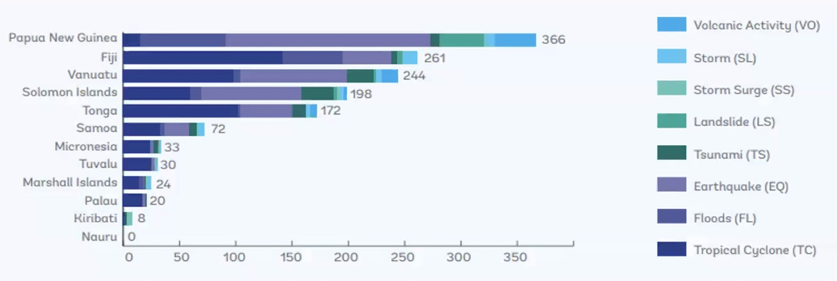
Source: Pacific Regional Infrastructure Facility (PRIF)

Global Context
The United Nations’ Early Warnings for All (EW4All) initiative aims to ensure that every person on Earth is protected by early warning systems by the end of 2027 and are supported by other development programmes across the region, including Weather Ready Pacific. The Pacific Regional Cell Broadcast Strategy directly supports this goal and hence has tacit support from the International Telecommunication Union (ITU) as EW4All Pillar 3 (warning dissemination and communication) global lead.

National Requirements
Many Pacific Island Countries and Territories (PICTs) share common vulnerabilities: exposure to tropical cyclones, earthquakes, tsunamis, severe thunderstorms, flash floods and rising sea levels; limited observational infrastructure; and logistical challenges in accessing remote communities. Mobile CBS systems address these challenges by providing almost instantaneous geo-targeted alert messages to end-user mobile devices, wherever there is mobile network coverage.
National requirements can be considered across several categories:
- Enhanced Early Warning Capabilities: timely and accurate warnings for tropical cyclones, severe thunderstorms, landslides, and flash floods are critical for saving lives and protecting assets and infrastructure. CBS systems improve the ability to quickly disseminate geo-targeted alert messages to the specific area(s) impacted. CBS systems are not constrained by mobile network congestion, and messages should be delivered to all devices in under ten (10) seconds.
- Support for Disaster Risk Reduction and Climate Resilience: a CBS system provides a powerful additional dissemination alerting channel for all Government agencies with a mandate to protect the public against specific hazards and risks. After implementation, any new investment by an alerting agency in new technology, such as NMHS investing in new radar systems, will be able to use CBS to maximise the impact of their investment in protecting citizens lives and assets in the future.
- No data privacy or data protection concerns: Cell Broadcast is a one-way ‘broadcast’ technology, similar to the way that FM radio is broadcast from an antenna to any receiving device within range and, therefore, the system does not require or capture any lists of user data, SIM or mobile telephone numbers, to name a few. Because of this, there are no data privacy or data protection issues using the system unlike, for example, mass SMS message campaigns which are used in some countries which do require lists of the mobile numbers to contact.
- Capacity Building and Regional Integration: a coordinated CBS strategy strengthens technical and operational capacity within local stakeholder organisations and promotes regional data sharing of device testing, SOP best practices and joint training initiatives.

Use Cases
Whilst CBS is a powerful tool to disseminate hazard alerts quickly to those at risk in a specific geographic area, it needs to be used in conjunction with other alerting channels as part of an integrated multi-hazard early warning system (MHEWS). When developing the SOP for using the CBS system, it will become clear that some hazard events, such as slow onset events, and at some points during a prolonged hazard event, such as an early warning of a tropical cyclone in the region, should not use Cell Broadcast messages.

Representative Use Cases
- Impending meteorological event: warn citizens in the path of a tropical storm or cyclone about to make landfall to vacate to a safer location or a river / flood plain forecast to be consumed by heavy rain which will impact citizens living nearby.
- Geological event: inform citizens what has happened immediately after an earthquake or volcanic eruption and what action to take and/or provide tsunami warning for those along coastal areas advising to move to higher ground.
- Wild fire: Fire or Police message to inform citizens to evacuate their homes if an active fire is predicted to move towards them.
- Key facilities – ports and airports: Police message advising citizens to avoid the area if there is an incident at a key facility, because it is dangerous and/or to keep the area clear so emergency service personnel can quickly gain access.
- Maritime: Coastguard message to small boats offshore warning of a hazard which might require them to return to shore.
- Civil unrest: Police message to instruct citizens involved in an area of civil unrest to leave peacefully and/or citizens in surrounding areas to avoid the affected area.

Social and Economic Benefits
The services underpinned by CBS systems strengthen community resilience and save lives through more accurate and timely warnings of severe meteorological, geological and man-made hazard events. CBS systems allow alerting agencies, such as NMHSs and NDMOs, to issue targeted alerts or update and improve existing warnings that allow potentially affected people to take protective action. Improved situational awareness also supports emergency responders, local community leaders, and disaster risk reduction planning - building public trust in national Government agencies and enhancing the effectiveness of Early Warning Systems across the region.
Economically, CBS systems generate substantial value by reducing the costs associated with hazard related damage and disruption (as well as saving lives by providing time sensitive warnings). They can help protect critical sectors of the local economy such as tourism, transportation, and fishing.

Benefits of Regional Coordination
The small size of many Pacific countries makes it difficult to develop and retain the skill sets necessary to support complex multi-agency systems and the operational skills and experience to manage them on an ongoing basis.
However, through working together, and with pooled resources, the region can provide more resilient capabilities with deeper knowledge and expertise. There are already good examples of regional technical cooperation, through CROP agencies and/or development partners, and these can be built upon to support future CBS systems in the region.

Challenges and Risks

Security
CBS systems are very powerful message dissemination tools but in the wrong hands they could cause major disruption and therefore security has to be maintained at all times – both internally and externally. Systems and procedures must be set up so that a senior person has to approve an alert message before it can be sent out and they must be different to the user who creates the message in the system, i.e. no one person can create and approve a message. In addition, there should be two factor authentication in place for each user to create and approve each message. Each CBS system should have a nominated system manager who manages users on the system; when a user leaves their job or changes job so they no longer need access to the system, they should be removed from the CBS system.
External IT security measures should also be put in place so that third parties are unable to hack into the system. The Government’s standards and protocols relating to the protection and use of other national IT systems should be applied to the CBS system, including the interface between the CBE and the CBC(s) which may be physically hosted in another location.

Technical Capability
Whilst use of the CBE to generate and send hazard alerts is not too complex, it is important that system users are confident in their ability and mistakes are not made; the repercussions from sending an incorrect message to the public could be significant. Experience learned on the job is therefore likely to be important for the future regional success of the technology. Unfortunately, many NMHS, NDMO and other alerting agencies in Pacific Islands countries have small headcounts, staff are often travelling overseas to attend work events and staff retention is a challenge. As a result, maintaining a level of knowledge and experience in each country operating a CBS system will be a challenge.

Integration with Other Systems
Ideally CBS systems need to be integrated into the country’s existing early warning systems and more broadly into the forecasting systems for meteorological and geological hazard events. The extent to which this can be achieved will vary across the region but during the planning stage consideration should be given to machine-machine-interfaces (MMIs), human-machine-interfaces (HMIs) and the Geographic Information System (GIS) environment. In addition, some countries might already have or plan to have a CAP message aggregator unit (sometimes called a hub) which acts as the centralised unit to collect, filter and redistribute CAP alert messages as part of a MHEWS.

System Management Capability
As already highlighted, CBS is a relatively new technology for the region and, as a result, there are few staff with direct experience of sending CBS message alerts to the public. Not all emergency events and not all messages during an extended event will require use of the CBS system; knowing when to activate will be a critical success factor. In addition, if a country configures its CBS system so many agencies have the ability to send out alerts, it is important that a central coordinator has overall oversight to ensure that citizens are not being overloaded with different agency messages. Overuse of the system runs the risk that the community starts to ignore CBS alert messages and complacency must be avoided (in some countries SMS has reached that inflexion point and mobile users do not read many of their incoming SMS messages).
In addition, current operating procedures will need to be significantly modified, or new procedures and workflows developed to extract maximum benefit out of mobile CBS as part of an enhanced MHEWS capability. This may also require specialised/contextualised trainings for staff using the CBE with a phased approach and mentoring to allow for proper operational embedding. UN agencies managing the four pillars of the global EW4All initiative also advocate use of CAP for message generation and in many Pacific Island countries there is currently limited training and use; this will need to be addressed as part of this strategy.

Lifecycle Management & Funding
A key concern for CBS system projects is the high total cost of ownership (TCO) over multiple years. Beyond the initial capital investment, which may be donor-funded, the ongoing expenses for software support contracts, other licensing, IT support costs and ongoing user training and capacity building can exceed local operational budgets.
If these long-term financial commitments are not properly considered at the design and procurement stage, there will be sustainability issues once any initial donor support ends. As has been seen with other infrastructure investments, this can lead to under-maintained or inoperative systems, reducing the return on investment and eroding confidence in the NMHS, NDMO and other public sector alerting agencies.

Strategic Outcomes

Strategic Outcomes
The strategic outcomes are the long-term objectives, or the desired state, of the CBS systems across the Pacific Islands region. Taking into consideration the requirements outlined in Section 2 and the challenges and risks outlined in Section 3, these objectives can be framed. The objectives will inform the strategic actions outlined in the following sections.

Coverage
The UNs EW4All initiative provides a window of opportunity for those countries in the Pacific who do not yet have a fully funded plan for implementing a CBS system to take action and do so before the end of 2027 deadline. It is feasible for this region to be the only one globally that will actually achieve the UN Secretary General’s goal – what an achievement that would be. It would result in maximum coverage and protection for Pacific Islanders against hazard risks.
Concentrated short-term focus on this goal may create the necessary funding opportunities from donors to not only cover the initial system costs but also fund the community of practitioners, the online Knowledge Hub and ongoing training and capacity building. Figure 2, below, shows the current status (as at May 2026) of national CBS system implementations across the Pacific Islands region; whilst there is activity, much more needs to be started and sustainability needs to be fully addressed.
Figure 2 – Current status of CBS system implementations across the region
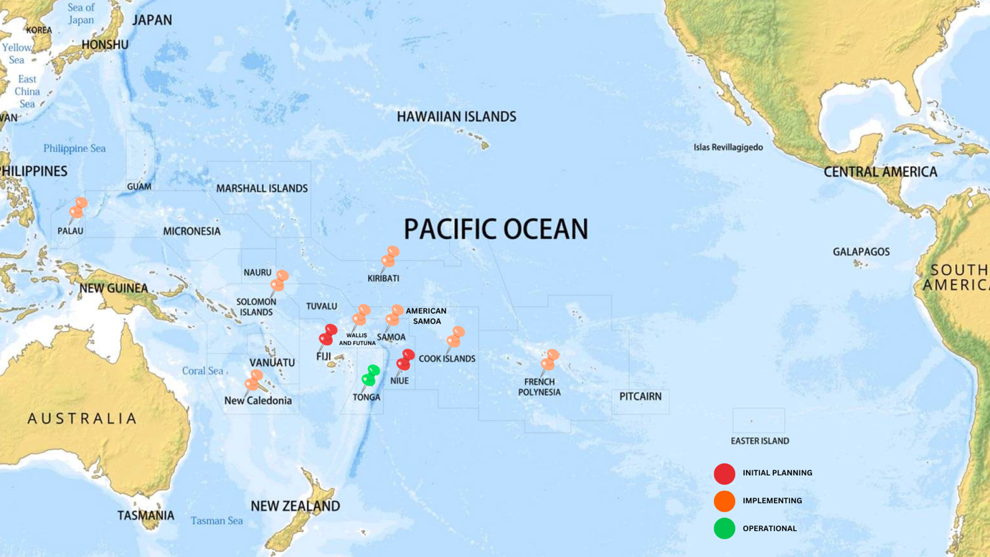

Sustainability
CBS systems can be expensive to install and come with ongoing operational costs. Investments in CBS systems need to be sustainable over the lifetime of the investment so nations need to consider at least the next five to seven years operations when scoping the system specification and planning the funding sources. However, sustainability is not just about funding, staff resources and maintaining a sustainable workforce with the requisite skills, experience and training is also paramount. Ideally, executing capacity building needs should come from within the region and, over time, developing a community of CBS practitioners across the Pacific Islands will help enhance the sustainability. In addition, regular ongoing reporting and regional convenings that track use of CBS systems and promote innovation and adoption of best practice will help keep CBS top-of-mind.
To summarise, key parts of the sustainability strategy for CBS in the region will include:
- securing capex funding sources for national CBS system projects needing it;
- identifying annual opex funding sources in each country;
- undertaking capacity development and training needs;
- maintaining a sustainable workforce over time to manage operations;
- developing a Pacific region community of CBS practitioners;
- implementing a centralised Pacific CBS Knowledge Hub;
- undertaking regular reporting and regional convenings that track use of the CBS systems and promote adoption of best practice.
Done together, these activities will ensure that CBS delivers the societal benefits that are envisaged and protect vulnerable Pacific Islands communities for many years to come.

National and Regional Capability
To effectively support CBS system operations in the region, and make maximum use of the functionality, there needs to be an effective and sustainable capability both nationally and across the region. The right mix of national and regional support capability needs to be found and maintained. Successfully developing and maintaining a community of practitioners across the Pacific, led from within the region, will be a critical success factor in this regard.

Security Considerations
Security considerations, both internal to users and external from third party threats, need to be formally addressed at all stages of each national CBS system implementation and ongoing operational use across the Pacific. National Government and public sector security protocols and requirements must be met and where they might be lacking, it is advised that country agencies request external help and adopt regional best practice.

Funding
Recognising that, even if all efforts are made to reduce ongoing costs to a minimum, funding for ongoing operations and development needs to be provided as this will not be affordable within most national budgets.

Technology

CBS System Components
A CBS system comprises just two major components, the CBE and the CBC, and connects into the mobile network infrastructure across the country, known as the Radio Access Network (RAN), to deliver geo-targeted alert messages to mobile devices, as shown in Figure 3.
Figure 3 – CBS System Overview
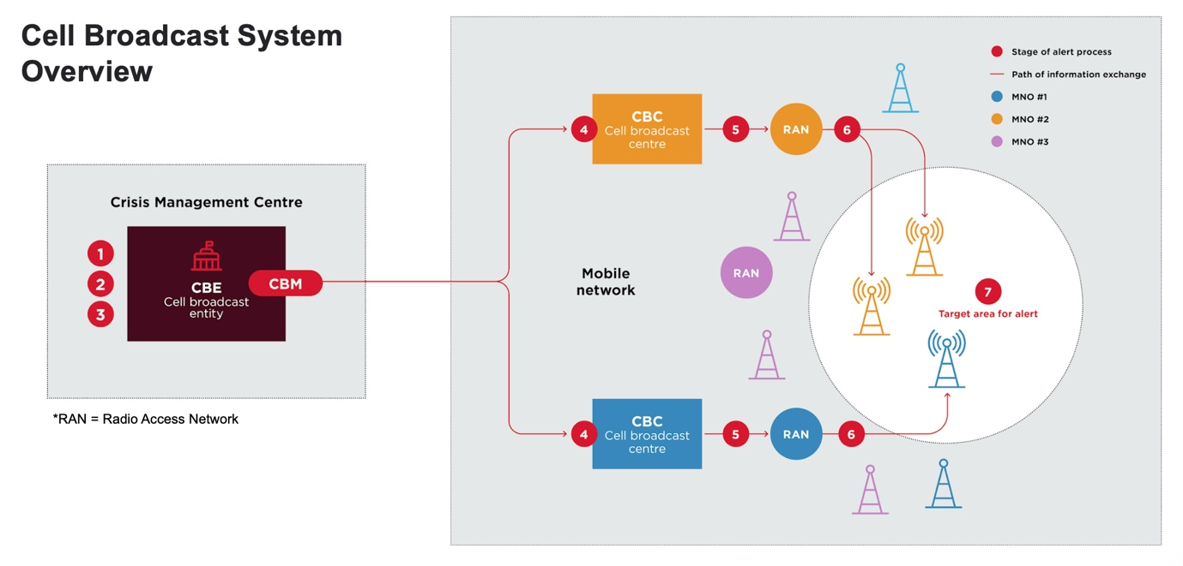
Cell Broadcast Entity (CBE)
The CBE is the central unit that is used by a national alerting agency(s) to create, approve and send the CBS alert message. The message is then passed electronically to the CBC. The CBE will control system user access and hold message templates for different alerts as well as standard polygon area templates.
Cell Broadcast Centre (CBC)
The CBC electronically receives the alert message from the CBE and converts the polygon area for the message delivery into a list of mobile base stations which will be the ones that broadcast the alert message. The CBC interfaces with the mobile operator’s network to then send the message to those tower locations around the country.
There are two CBC configuration options – either a single centralised unit which then interfaces to and works with all the country’s mobile operators or a decentralised configuration whereby there is a separate CBC for each mobile operator. As one would expect, a decentralised configuration adds to the system’s cost.

Key Benefits of Cell Broadcast
Whilst not perfect, CBS systems offer a number of unique benefits over traditional alert message dissemination channels that Pacific Island countries may already be using, including: bulk SMS messaging, social media such as facebook, specialist mobile app, FM radio, terrestrial TV, sirens etc.
The key CBS benefits are:
- An alert message should be rapidly delivered in under ten seconds, even if the mobile network is congested;
- Alert messages are geo-targeted so only those people in an at-risk area should receive the alert message;
- The user experience is unique (high pitch beep tone, vibration) so the user knows it is not a normal message delivery;
- The message will be delivered even if the mobile user has no credit on their account;
- The message will be delivered to international visitors even if they do not have roaming enabled;
- There are no data privacy concerns because the system does not hold any mobile customer information or mobile numbers;
- The message should be received in the mobile device owner’s own language and messages can be sent in multiple languages;
- The message length can be longer than an SMS;
- Messages are secure and, unlike SMS, cannot be spoofed.

End User Devices
The end user devices, mobile feature phones and smartphones, are crucial to the success of a CBS system because they need to deliver the alert message to the population at risk. In theory every mobile device manufactured since 2012 should be CBS compatible. However, that should always be checked and some device models may need a manual settings change or a firmware update before they will deliver a CBS alert.
The important point about end user devices is that every country should be doing as much physical testing of devices, focusing on the models that are most common in the country, as possible and sharing the test result data across the region. Device testing is likely to be a joint exercise involving the disaster management agency(s) and the mobile network operators.

Message Identifiers
The international standards supporting CBS systems include Message Identifiers (Mis) which facilitate different types of alert messages to be broadcast and for them to have different characteristics. It is helpful if the Pacific Islands region adopts a common approach to the Mis used. Many countries around the world have adopted the format developed by the EU which is shown in Figure 4, below and which also aligns with CAP.
Figure 4 – CBS Alert Message Identifiers
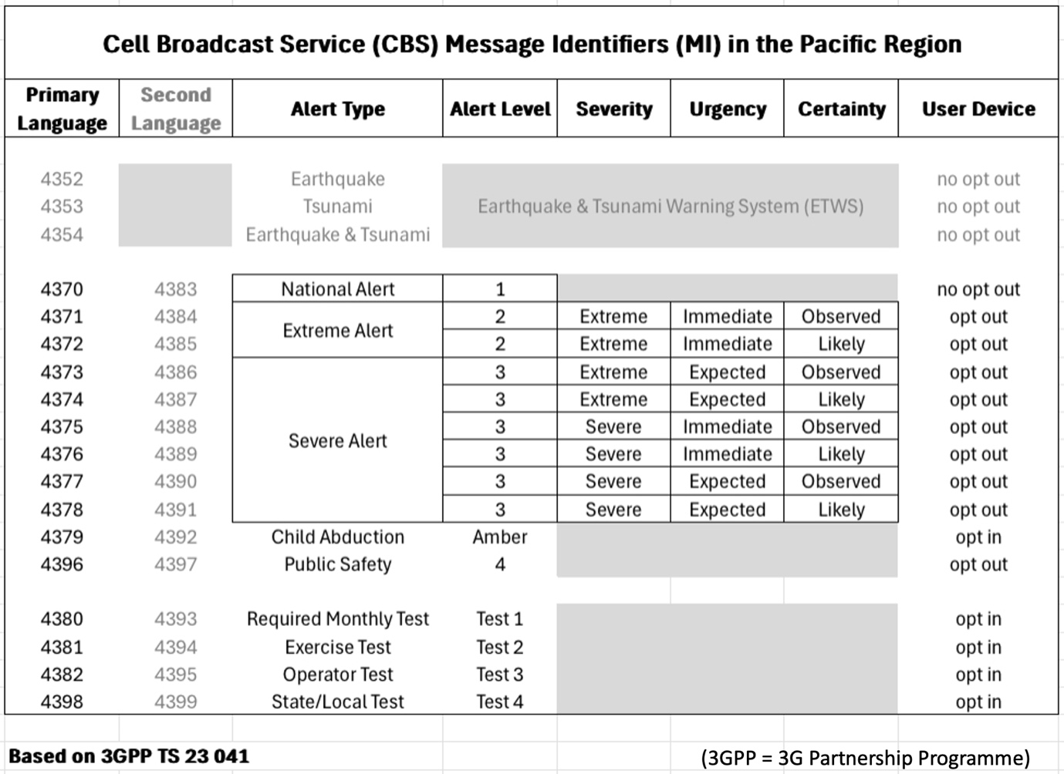
It is recommended that the Pacific Islands region adopt MIs as per Figure 2.
Recommendation 2
All countries across the Pacific to adopt the same MI structure as the EU so there is consistency across the region.

PICI Panel
Ongoing technical support is expected to be managed through the Pacific Island Communications & Infrastructure (PICI) panel to support this strategy execution and ongoing direction from the PMC.
xxx

People

Regional and National Capability
CBS systems are not inherently complex (see Section 5) but their operation requires coordination across the public and private sectors and across multiple Ministries within Government. Stakeholders therefore have to have an appreciation of the role played by others and be willing to support each other to ensure the mobile enabled EWS is fully functional at all times.
We can consider three levels of support for CBS systems:
- Level 1: in-country users trained to manage routine system tasks and send alerts.
- Level 2: regional practitioner experts providing support, advice and recommending changes to align with best-practice.
- Level 3: vendor-level or specialist support for complex issues or system enhancements.
Since a significant proportion of Pacific Island nations have small populations, and therefore a small talent pool, the benefits from having Level 2 resources across the region is expected to provide a vital safety net.

CBE Users
Registered users of the CBS system will use the CBE module (see Section 5) to create draft alert messages, approve them and send them. Due to security concerns, a senior ‘approver’ user should approve a drafted message so there should be a minimum of two system users involved in a CBS alert being sent to the public.
Officers on duty at the time of an emergency event must have user access to the CBE and be familiar with the system’s menu options so the draft alert message can be created promptly; having standard message templates and polygon areas already pre-configured in the system will help here. Since emergencies can start at any time, Pacific countries need to consider how they will manage the system on a 24x7 basis, especially smaller nations with limited staff working in the alerting agencies.
The senior ‘approver’ user might be able to remotely sign-in to the CBE to review a draft alert message and approve it (ideally using a two factor authentication process) because time will be of the essence. IT and security protocols will dictate the level of flexibility given to the approver and their ability to remotely access the CBE from outside the office and potentially outside the country. From a practical perspective, many senior staff at Pacific Island alerting agencies often travel overseas for work and this needs to be factored into the approvals process.
Recommendation 3
CBE user resourcing needs to be planned and recorded in revised Standard Operating Procedures during the implementation of a CBS system to ensure the investment is used effectively.

Capacity Development & Training
To support successful execution and future sustainability, it will be important that each country identifies the capacity development and training needs of stakeholders early in the system implementation phase so these can be addressed prior to system launch. As discussed earlier in this section, many Pacific Island countries have very small populations so some individuals may need to be trained to do multiple tasks. Developing this national capability is important and will support institutional strengthening across the region.
In future, periodically each country should undertake a review of resources and re-evaluate needs for further capacity development and training because over time staff change jobs and roles. By doing this each country will develop a sustainable workforce that is fully equipped to operate this vitally important national alerting channel.

CAP Training
UN agencies advocate Common Alerting Protocol (CAP) as the preferred format to create and send alerting messages across MHEWS configurations. Using this XML format, alerts can be created by one agency, passed to another for verification and then seamlessly distributed to the public using multiple dissemination channels. A CBS system will fit within this operating framework and, once implemented, will increase the justification for all alerting agencies to adopt CAP.
In many markets across the Pacific, only NMHSs are currently trained and use CAP. This strategy recommends that the implementation of CBS systems be used as a trigger to encourage the rest of the national disaster management ecosystem to be trained and then adopt CAP as standard. There are multiple agencies willing to support this training initiative, including WMO and ITU.
Recommendation 4
CBS system implementations should include CAP training for all alerting agencies needing it and CAP should be formally adopted as the default message format as soon as practicable.

Community of Practitioners
Many Pacific alerting agencies face isolation, limited access to specialist training, and challenges in retaining skilled staff. An important way to share knowledge and expertise, build sustainable capacity and provide peer-to-peer support is through a structured Community of Practitioners. This also strongly aligns with the Pacific led approach.
A community of practitioners allows discussion of case studies, lessons learned and, for smaller services, provides a source of peer support and advice. Such a group will be enabled by the regional exchange of device testing and national alert test data and would strongly benefit from an online platform (the Knowledge Hub), shared archive and periodic regional workshops.
Recommendation 5
Establish a peer-to-peer Community of Practitioners in the region, connecting alerting agency staff, mobile operator staff and other stakeholders in the region.

Gender Equality, Disability and Social Inclusion (GEDSI)
Gender Equality, Disability and Social Inclusion (GEDSI) is central to achieving equitable and effective outcomes in weather and climate infrastructure and Early Warning Systems. GEDSI considerations must be embedded across all stages of CBS infrastructure planning, implementation, and management.
To guide this, implementation will reference and follow the WRP GEDSI Strategy once released, ensuring alignment with regional priorities and good practice.
The approach emphasises inclusive participation, equitable access to benefits, and infrastructure that responds to the diverse needs and capabilities of Pacific communities.
Recommendation 6
CBS system projects should follow the WRP GEDSI Strategy.

Operating Processes

Integrations
As discussed in Section 3.3, the successful implementation of a new CBS system will require integration with existing systems across the alerting agency ecosystem as part of an enhanced MHEWS. On the telecommunications side, there also needs to be ongoing engagement with each mobile network operator to make sure that the connection to the CBC(s) and from there to each mobile network is always maintained and monitored to ensure that CBS message alerts are guaranteed to be delivered by all the country’s mobile networks.

Service / Support Agreements
Each national CBS system implementation will be expected to include one or more of the following service and support agreements to ensure that stakeholders, and their vendor partners, involved in running the system know what is expected of them on an ongoing basis:
- CBS system vendor and Government procuring agency for overall system services;
- CBE primary user and Government IT agency for hosting CBE, if applicable;
- Each mobile operator and their RAN vendor(s) for CBS licensing and support, if needed;
- With each mobile operator to ensure CBS system availability via their mobile network.
Successfully putting these documents in place will be a key foundational part of each national project’s long-term sustainability.

Workflows and Standard Operating Procedures
There should be workflows and standard operating procedures (SOP) in place that document how a country’s alerting agencies operate the existing early warning systems and disseminate alert messages to the general public. The implementation of a CBS system, as part of an enhanced MHEWS, will necessitate a process to either update the existing SOP(s) or draft a new one to reflect the changes.
As part of the regional approach, smaller countries who may need help with this process should be able to either request a standard SOP template to use as a starting point which they can then customise and/or request help from a Pacific neighbour who has already been through the process and who is willing to provide resources to help.
Developing the online Knowledge Hub and building out the Community of Practitioners will support the development of SOP templates and ideas for best practice improvements which are tailored to Pacific Island countries.
Recommendation 7
Develop the online Knowledge Hub to help support CBS workflow and SOP development and encourage best practice enhancements.

Regulatory Considerations
CBS systems straddle both the disaster management and the telecommunications / ICT sectors and therefore they need to operate within both sectors’ regulatory framework in each country. When each country in the region is planning for a CBS system, it is important that the key regulatory framework documents are reviewed to make sure there are no impediments to its use; this might include the following: Act, Regulation, Policy, Rules or similar document.
In addition, the Ministry in charge of disaster management or telecommunications may decide that a new Regulation is needed to document how the CBS system should be used, for example it must not be used for political, religious or commercial messages, and requirements on stakeholders to ensure the system is always available, for example specific requirements on the mobile network operators concerning minimum system uptime.
As with SOPs, discussed in Section 7.2, countries should really benefit from shared knowledge and the ability to ask experts who have experienced similar scenarios through the development of the online Knowledge Hub and the Community of Practitioners.
Recommendation 8
Review of Regulatory Framework to ensure it aligns with and supports the introduction of the new CBS system, or identifies the need to introduce a new national Regulatory instrument.

Safeguarding
Environmental and Social Safeguards (ESS) are an essential consideration for the planning, design and management of Early Warning Systems in the Pacific. This strategy recognises that safeguarding processes will follow the Weather Resilience Programme Operations Manual, ensuring consistency with regional standards and good practice.
The intent is to promote infrastructure that not only strengthens climate and disaster resilience, but also protects communities, cultural heritage and ecosystems.
Implementing partners are encouraged to:
- Integrate ESS considerations early in project design and planning;
- Ensure meaningful community engagement and respect for traditional governance and land systems;
- Apply the principle of “do no harm” to both people and the environment;
- Promote inclusive participation, equitable access to benefits, and transparent decision-making.
Once released, the WRP Operations Manual, specifically the WRP ESS chapter, will contain a screening checklist(s) to ensure that potential risks are identified from the very beginning. This checklist(s) is to be used for the initial screening of all WRP activities to determine potential environmental and social risks.
Recommendation 9
All CBS projects, from inception, should be screened against the ESS checklist within the WRP Operations Manual.

Funding and Lifecycle Management
Ensuring the long-term sustainability of CBS systems in the Pacific is a key objective of this Strategy. While CBS technology leveraging the ever-growing national mobile networks offers significant capabilities, its benefits can only be fully realized when systems are properly maintained, staffed and supported over their entire lifecycle. UN agencies and donors emphasize that sustainability must be considered from the outset in the planning of operations, maintenance, upgrades, and eventual replacement of CBS systems.

Total Cost of Ownership
Assessing the Total Cost of Ownership (TCO) provides a structured approach to long-term financial and operational requirements. This can be broken down into constituent parts, as follows:
CBS System Capex
Globally the market for CBS systems is limited and therefore there has historically been a small pool of specialist global vendors to choose from. As a result, the cost to buy a CBS system has been expensive – often USD multi million. That being said, vendors are now offering virtual or cloud-based solutions which are more cost effective and if countries opt for a single centralised CBC that will reduce the cost as well.
It is worth noting that a joint GSMA and PITA regional initiative is already deploying a CBS-lite software solution being offered free of charge as a CSR initiative by its owner, Omnitouch Network Services from Australia, in some of the smaller countries in the region. However, it is understood that this will not be offered in the larger and more hazard impacted countries across the Pacific, including Fiji, PNG and Vanuatu, due to the complexities around hazards and capabilities required by the Governance systems.
Pacific countries needing to go to tender for a CBS system are likely to need external donor support to pay for the system; as Tonga has already done through the World Bank.
CBS System Opex
Typically, when a CBS system is procured there will be an ongoing maintenance and support agreement with the vendor that will cost between 10% and 15% of the initial capex cost each year. This will either have to be added to annual budgets, if funding allows, or external funding support would be sought.
CBE Support Costs
There will be direct support costs related to housing the physical or virtual server where the CBE software resides in a secure environment together with indirect IT systems costs. In addition, there may be training and capacity building costs to get the system users familiar with using the system and integrating it with the existing alerting and dissemination systems.
CBC Support Costs
There will be direct support costs related to housing the physical or virtual server where the CBC software resides in a secure environment together with indirect IT systems costs; if a decentralised CBC configuration is deployed then each mobile operator will bear these costs.
There may also be indirect support costs related to the mobile operator’s network vendor(s) because they will need to activate the CBS functionality within the mobile network architecture; this may incur a one-off licensing fee and/or a professional services fee to implement the network change by the network vendor. Ideally, as this is a humanitarian initiative and the mobile network operator(s) is not generating any incremental revenue, the network vendor would contribute this free of charge but that cannot be guaranteed.
Other Costs
A key part of the operationalisation of a new CBS system is the public awareness campaign and subsequent national test. When a CBS alert is received by a mobile device the user experience is unique (the device produces a high pitched beeping sound, it vibrates and the message is displayed on the screen until the user clears it). Because of this, countries that have deployed CBS systems undertake a media campaign to educate the general public so they know what to expect and know that it is an official message from a Government agency and therefore must be taken seriously. The extent of the campaign, the media channels used and the cost to deliver the public awareness with differ by country but funds should be made available to do it. Funds might also be needed to undertake a subsequent national alert test and to gather feedback on the results.
Finally, funding will be needed to support ongoing events and workshops to build the regional community of practitioners.
Summary
For the Pacific, where Government agencies in general have very limited operating budgets, assessing and minimising the total cost of ownership is critical for sustainability. In particular, the annual cost or operations beyond the end of the original funding project need to be understood and then provided for.

Minimising Ongoing Costs
There are multiple examples around the Pacific of projects that implemented new technology but which after an initial implementation phase where significant funds were spent, gradually fell into disrepair and obsolescence. The CBS Strategy aims to avoid doing this at all costs.
Therefore, where possible, initial project funding sources should be used to not just complete the CBS system implementation but help minimise ongoing running costs in future years when funding may become more problematic. For example, during system contract negotiations, it may be possible to prepay some of the annual support costs.
Recommendation 10
Where possible, CBS projects should maximise upfront investments where these have the potential to mitigate ongoing running costs once the project is completed.

Potential Funding Arrangements
As previously noted, CBS systems can be costly. Although some costs can be front loaded in the system procurement, there will always remain an ongoing cost which has to be considered, and funding source(s) identified to ensure there is sustainability.
Larger countries, outside the Pacific, may have the internal capacity to self-fund Cell Broadcast, but this is unlikely across the PICTs. Therefore, external funding sources likely need to be identified in order to implement this strategy in a sustainable manner. There are options to leverage donors associated with the UNs Early Warning for All initiative, such as Global Climate Fund (GCF), CREWS and World Bank, though they can be slow to process funding requests. Other regional donors, including JICA, DFAT, MFAT, ADB and EU should also be considered.
If donors are to be approached, it is recommended that an initial Cell Broadcast Readiness Assessment be undertaken beforehand. This is a methodology developed by the GSMA in Africa which involves engaging all local stakeholders to map out the current EWS ecosystem, mobile sector and then draft a blueprint for the proposed CBS system architecture, operating model and indicative budget. Preparing this should make the process of fundraising easier and faster. Fiji, PNG and Vanuatu would definitely benefit from this.
Recommendation 11
Undertake Cell Broadcast Readiness Assessments in Fiji, PNG and Vanuatu, to support informed donor funding activities.
It is also worth highlighting that in some countries outside the Pacific, the ICT sector Universal Service Fund (USF) has been used to help pay for parts of CBS system costs – initial capex or ongoing annual opex.

Appendix 1

Abbreviations
ADB = Asian Development Bank
CAP = Common Alerting Protocol
CBC = Cell Broadcast Centre
CBE = Cell Broadcast Entity
CBS = Cell Broadcast Service
CROP = xxx
CSR = Corporate Social Responsibility
DFAT = Department of Foreign Affairs & Trade
ESS = Environmental & Social Safeguards
EU = European Union
EW4All = Early Warnings for All
EWS = Early Warning System
FRDP = Framework for Resilient Development in the Pacific
GCF = Global Climate Fund
GEDSI = Gender Equality, Disability & Social Inclusion
GIS = Geographic Information System
GSMA = GSM Association
HMI = Human Machine Interface
IFRC = International Federation of Red Cross & Red Crescent Societies
ICT = Information Communications & Technology
ITU = International Telecommunication Union
JICA = Japan International Cooperation Agency
KRA = Key Results Area
MFAT = Ministry of Foreign Affairs & Trade
MHEWS = Multi Hazard Early Warning System
MI = Message Identifier
MMI = Machine Machine Interface
NDMO = National Disaster Management Office
NMHS = National Meteorological & Hydrological Services
PICI = Pacific Island Communications Infrastructure
PICT = Pacific Island Countries & Territories
PIMS = Pacific Islands Meteorological Strategy
PITA = Pacific Islands Telecommunications Association
PNG = Papua New Guinea
PRIF = Pacific Regional Infrastructure Facility
RAN = Radio Access Network
SMS = Short Message Service
SOP = Standard Operating Procedure
TCO = Total Cost of Ownership
UN = United Nations
USD = United States Dollar
USF = Universal Service Fund
WMO = World Meteorological Organisation
WRP = Weather Ready Pacific
XML = Extensible Markup Language

Appendix 2

Recommendations and Strategic Goals
No. | Recommendation | Coverage | Sustainability | National and Regional Capability | Service Delivery | Funding
1 | After the strategy is approved, engage with PITA to discuss how the strategy targets might be achieved more effectively. | X | X |  |  | X
2 | All countries across the Pacific to adopt the same MI structure as the EU so there is consistency across the region. | X |  | X | X
3 | CBE user resourcing needs to be planned and recorded in revised Standard Operating Procedures during the implementation of a CBS system to ensure the investment is used effectively. |  | X | X | X
4 | CBS system implementations should include CAP training for all alerting agencies needing it and CAP should be formally adopted as the default message format as soon as practicable. | X | X | X
5 | Establish a peer-to-peer Community of Practitioners in the region, connecting alerting agency staff, mobile operator staff and other stakeholders in the region. |  | X | X
6 | CBS system projects should follow the WRP GEDSI Strategy. |  | X
7 | Develop the online Knowledge Hub to help support CBS workflow and SOP development and encourage best practice enhancements. |  | X | X
8 | Review of Regulatory Framework to ensure it aligns with and supports the introduction of the new CBS system, or identifies the need to introduce a new national Regulatory instrument. |  | X |  | X
9 | All CBS projects, from inception, should be screened against the ESS checklist within the WRP Operations Manual. |  | X
10 | Where possible, CBS projects should maximise upfront investments where these have the potential to mitigate ongoing running costs once the project is completed. |  | X |  |  | X
11 | Undertake Cell Broadcast Readiness Assessments in Fiji, PNG and Vanuatu, to support informed donor funding activities. | X | X |  |  | X

https://www.gsma.com/about-us/regions/asia-pacific/wp-content/uploads/2025/07/280425-Investment-gaps-Pacific-Islands_rev2.pdf

