Fourth Weather Ready Pacific Steering Committee Meeting
Honiara, Solomon Islands
02 June 2026
___________

Agenda Item 9.5 – Pacific Integrated Forecasting Platform Phases 2

Purpose
For decision:
- WRP SC4 – Decision 9.5.1 Approve the Pacific Integrated Forecasting Platform Phase 2 to adopt the Fiji Meteorological Services IBL software system and high-level Architecture Design.
- WRP SC4 – 9.5.2 - Approve WRP to biennially scan the environment and assess ongoing risks and opportunities for the Pacific IFP, given the rapid changing technology landscape and capacity development in the Pacific.
- WRP SC4 – 9.5.3 – Approve to prioritise communication project activities in WRP for countries that will promote and raise the profile of the value of the IFP to the leaders through local forums (i.e. TV weather, cell broadcasting, etc)
Background
The IFP Peer review considered various approaches to developing an IFP which enables full core high-level capabilities required:
- Data ingestion
- Visualisation
- Forecast production/generation
- Dissemination
The IFP must be able to meet these core requirements across the full suite of services including Public Weather, Aviation, Marine, Severe Weather and Geo Hazards.

Investigated Options
- Do Nothing.
- Use and expand the NZ Severe Weather Forecasting Pilot tool to become full IFP.
- Existing Fiji Software Expansion
- Procurement: Utilise a procurement process to go to market for a commercial off the shelf (COTS) software that suits the requirements of the IFP.
- Develop bespoke software from the ground up.

IFP Review Recommended option
From the Weather Ready Pacific Integrated Forecasting Platform peer review, Option 3 was recommended: Use existing Fiji IBL Visual Weather licenced software and TC Module in Phase 1 to enable enhanced product generation and dissemination for the Group A countries (within Year 1), and then Phase 2 (2a-visualisation and 2b-product generation), expand IBL licence to implement Online Weather (web based portable solution) across all WRP countries for full visualisation, production and dissemination capability (Year 2-3).
Review Decision Rationale:
The IFP needing to enable data ingestion, visualisation, forecast production/generation and product dissemination across a breadth of services makes this undertaking a complex task and experience in this type of application delivery significantly reduces risk.
Option 1 to "Do Nothing" does not have any associated cost but also does not meet the needs of the Pacific for an IFP.
Cost Rating: 1 - Low
Description​ | Pros ​ | Cons​
Do Nothing. ​ | No cost ​ | Does not meet the needs of Pacific NMHSs
Option 2 The NZ SWFP option was a possibility and was well received as a limited visualisation tool, but the amount of build required was prohibitive and the costs were very high. It was essentially another bespoke system development and therefore it was not recommended.
Cost Rating: 4 – High capital, Medium –High operating
Summary Table:
Description​ | Pros ​ | Cons​
Use and expand the NZ SWFP tool to become full IFP. ​ | Piloted in several countries  Positive feedback.​ | Primarily visualisation, no production and dissemination  Substantial additional development needed at high costs and time.​  A bespoke solution unlikely to scale from a visualisation-focused pilot to a full IFP.

Option 5 to develop bespoke software or to use open-source software and develop this into a full IFP was considered.
This option is potentially able to save some capital costs upfront (though unlikely) but would present considerable risk to meet compliance requirements for continuous major upgrades. It addresses part of the solution, but our research has shown there is not a full IFP solution possible without paid versions of software. It also requires very high skilled software engineering to maintain the system and adds considerable operational risk. Comparing to a dedicated software company (e.g. IBL), which employs several software engineers to maintain the system and upgrade the software regularly for compliance, this bespoke option would require employing these staff directly. Due to this ongoing high-end skill requirement, the costs ongoing would be considerably higher than using an established vendor. It is likely that due to the complexity of the task (including the enhanced production and dissemination approaches tailored for operational forecasting), that the software build and full deployment into operations would be in the order of five to ten years. This would then make this a costly exercise, and this is considered a risky and not favourable option.
Cost Rating: 5 Medium - High capital, High operating
Summary Table:
Description​ | Pros ​ | Cons​
Develop bespoke software from the ground up (e.g. Hire developers/contractors, utilise available open-source software). ​ | Could potentially reduce some upfront capital costs.​ | Significant compliance, sustainability, and delivery risks  Longer implementation timeline: To achieve this level of software build may take much longer and increase implementation risks and costs.​  Cannot realistically deliver a complete IFP without some paid software components. ​  Require ongoing access to highly specialised software engineering skills, regular upgrades, testing and bug fix, operational deployment (~5+ extra staff)​  - Higher whole-of-life costs than an established commercial off-solution (known costs).​

Option 4 New Procurement
To approach the market is also a viable option (though there exist limited vendors with this type of experience and expertise required). However, with procurement it will extend the time for implementation of an IFP in the Pacific for another 12-18 months. Whilst there are pros and cons of the other software it is acknowledged that a software system that does not leverage knowledge and experience in the application of Meteorological forecasting at a level required for a larger NMHS is a higher risk, as they can lack the specialised data integration and learned approach to forecast generation required. Other systems on the market which offer a visualisation capability that is good but lack the customisable product generation capabilities across all the services required, or in some cases offer only limited visualisation capability. This narrows the field significantly for options that address the full IFP requirements of integration with required data, visualisation through to full production and dissemination capabilities for meteorology and hydrology in line with the requirements of international standards such as stipulated via ICAO/WMO.
Other known systems that have high-level capability include Info-Electronics Systems and the Meteo France software suite (e.g. Meteofactory, Synergie-Web). Though this software is potentially a strong alternative, the IBL software is known to excel in data integration and efficient forecast generation across the key services for the Pacific. Moving from phase 1 in Visual Weather to a new system would require re-working the phase 1 upgrades for Fiji to align with the new system configurations, rather than utilising these to expand to phase 2 with IBL software compatible modules and configurations. Effectively the result of a new system obtained via procurement is extending the timeframe considerably for delivering a full IFP, adding to that is also the considerable cost and timeframe of a complex procurement that may or may not yield the same result.
Cost rating: 3 – Medium-High capital, Medium operating
Description​ | Pros ​ | Cons​
Procurement: Go to market for a commercial off the shelf (COTS) software that suits the requirements of the IFP. ​ | Open procurement is a viable option​ | Currently small number of vendors globally with the necessary meteorological and hydrological expertise and experience. (e.g. Info-Electronics Systems and MeteoFrance software - Meteofactory/Synergie-Web, IBL). ​  Longer implementation timeline - delay 12-18 months  Project leveraged regional expertise of Aus/NZ/UK is not strong with other possible procured software, but is with IBL software.

Option 3 Existing Fiji Software Expansion (IBL)​
The recommended Option 3 leverages off known excellent options for the Pacific that utilises existing software and hardware already implemented at Fiji Meteorological Services, a designated Regional Specialised Meteorological Centre (RSMC) and build upon that to deliver an IFP solution that best fully meets the high function requirements of operational forecasting NMHS's of different sizes and levels of complexity.
Cost Rating : 2 Medium Capital, Medium Operating
Summary Table:
Description​ | Pros ​ | Cons​
Existing Fiji Software Expansion ​  (IBL)​ | Proven software already in Pacific (Fiji, Samoa)​  Faster delivery – avoids 12–18 months procurement​  Proven vendor – trusted, responsive​  Ready-to-use capability and standard compliance (i.e. aviation, impact-based forecasts, ICAO IWXXM and WIS 2.0)​  Configurable to country-specific needs​  Low-bandwidth solution – full functionality across constrained environments​  Pacific led and Regional hub at Fiji​  Regional support available - Aus/NZ/UK​ | Incur ongoing costs

Phase 1 Status and Phase 2 Analysis
The project was endorsed at WRP SC3 to proceed with phase 1 implementation of the uplift of software and hardware systems in Fiji, including IBL Visual Weather and BOM TC Module. This project is progressing well with an expert team assembled with staff across the BOM, Met Service NZ, Synoptic Data and WRP. Architecture oversight has been provided by UKMet and the PICI Panel Task Team for the IFP was assembled at the PICI Panel meeting on 1 May 26 in Fiji to provide project oversight. The project has gathered requirements through surveys and workshop analysis, as well as directly from FMS. This exploration stage has led to the development of draft architecture that would enable a world class IFP to be accessed for the whole Pacific. Further analysis work with FMS continues for the project before development and implementation during the year. Work has begun on the Visual Weather Uplift, initially starting with aviation services. Further assessment of product outputs and forecast process analysis is planned for Fiji "in-person" in July, where build specifications can be broadened to include all services for the Visual Weather uplift.
Considerable efficiencies in the project will be made by replicating the Fiji development approach across the Pacific, country by country in a repeatable and scalable approach. This leverages off the work from phase 1 directly to expand to the full IFP for the Pacific for Phase 2.
The approach and architectural design of the IFP Project, which includes a hybrid approach of IBL software and open-source software for data integration (e.g. WIS2.0, Data Tailoring Service/data lake, API's), were reviewed and confirmed during the IFP development workshop held in Fiji from April 29 to May 1, 2026. The approach utilizes IBL software for core IFP forecasting functionality to ensure the highest compliance for ICAO/WMO products and services. The workshop included forecasting and IT Subject Matter Experts from across the Pacific (WRP Region). The workshop involved robust and interactive discussion about the IFP approach. IFP Development Workshop country participants unanimously voted in support of proceeding with IFP Phase 2 and adoption of IBL Online Weather software. PICI panel subsequently also endorsed this recommendation and the preliminary ICT architecture design out of session on 19/05/2026.
There are additional benefits of the architecture design for participating countries beyond forecasting capabilities. During the workshop there was agreement for a Regional WIS2 node, acting as back-up to any country nodes. The centralisation and integration of data into Fiji, will simplify future supply of data (NWP, satellite, observations) into a central data tailoring service, which can enable the same data for the IFP to be accessible to other IFPs in the region (for example Vanuatu and Tonga). Therefore countries such as Tonga and Vanuatu using other platforms can also benefit from this architecture design.
The workshop and project activities, including surveys, revealed that some countries lack essential IT equipment and connectivity needed for an IFP. Addressing these gaps should be a top priority before developing and implementing the IFP across the Pacific. Although the IFP IBL software can function during connection dropouts and periods of low bandwidth, technical experts believe that upgrading certain computing infrastructure is necessary to fully leverage the new IFP and generate high-quality forecasts.
In order to leverage the benefits of existing software and licences in the Pacific (IBL software) and the expertise and assistance of key larger NMHS's in the region such as Bureau of Meteorology, Met Service NZ and UKMO it is strongly advised that the WRP SC4 agree to the approach of the Pacific Integrated Forecasting Platform Phase 2 to adopt the Fiji Meteorological Services IBL software system and high-level Architecture Design from the IFP Project.

Associated Costs (Indicative only as requires design to be finalised and ICT infrastructure gaps analysis to be completed)
Capital: Phase 1 and 2 USD$3-4 Million, funded by WRP and other complementary projects in the region
Operating costs: TBC following full design, where a cost-sharing arrangement, operating and support model will be established and agreed upon by all countries utilizing the IFP and data infrastructure.
Critical Parallel Projects/aligned activities
- ICT and Data Infrastructure upgrade to implement the target state architecture solution design. Address the gaps in availability of NWP, satellite, observations, quality control, data exchange with WIS2, upgrade to NMHSs communication links and computing infrastructure. This will be part of Phase 2 but activities may be funded by complementary projects in the region.
- Implement a strategy to support ICT capability retention in Fiji Meteorological Service. Pre-condition for greater pacific owned and managed systems.
- Uplift forecasting capabilities through twinning, training and standard operating procedures is important and part of KRA2 associated activities when funded.
- Impact-based forecasting - define the criteria for impacts, working with NDMOs, local authorities, communities (under KRA 5 activities). Once defined add to Visual weather/online weather product outputs as part of Phase 2.
- Alignment with SPC Pacific Oceans Portal, SOFF/ECMWF data provision, CliDE upgrades, and WIS 2.0 regional rollout are either already part of the core Phase 1 architecture design or will be integrated through Pacific meteorological data framework.
- Additional database development in the Pacific for access to regional specialised and quality-controlled observation datasets. This may be part of Phase 2 or funded by other projects in the region

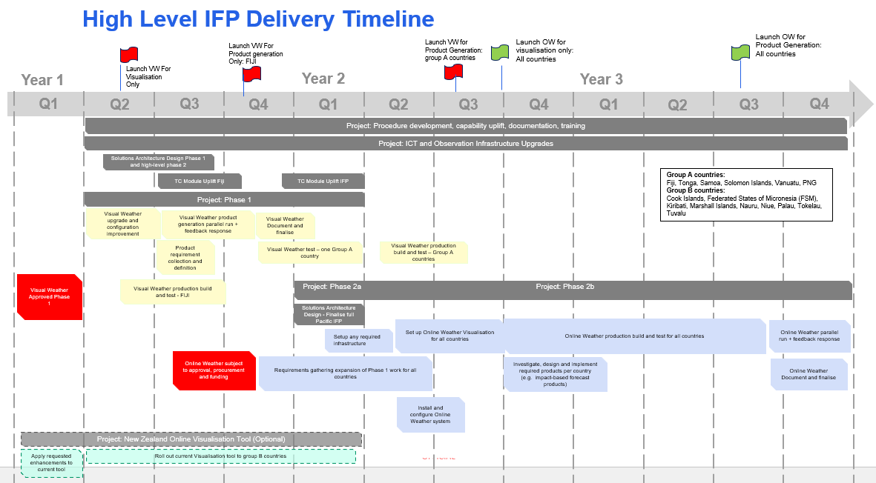

WRP_SC4 Decisions required

The following decisions are requested of the WRP Steering Committee (WRP_SC4)
- WRP Dec. 9.5.1 – WRP SC4 Approves the Pacific Integrated Forecasting Platform Phase 2 to adopt the Fiji Meteorological Services IBL software system and high-level Architecture Design
- WRP SC4 – 9.5.2 - Approve WRP to biennially scan the environment and assess ongoing risks and opportunities for the Pacific IFP, given the rapid changing technology landscape and capacity development in the Pacific.
- WRP SC4 – 9.5.3 – Approve to prioritise communication project activities in WRP for countries that will promote and raise the profile of the value of the IFP to the leaders through local forums (i.e. TV weather, cell broadcasting, etc)

