4th Weather Ready Pacific Steering Committee Meeting
Honiara
2 June 2026
___________
Agenda Item 9.6 Sustainability Framework Roadmaps Progress
Purpose:
For WRP_SC4 to discuss and approval the progress on implementing the Sustainability Framework Roadmap as part of WRP’s objective to enable sustainability of Pacific NMHSs.
Background:
Two key roadmaps were proposed as part of the SC approved WRP Sustainability Framework of Pacific Hydrometeorological Services and incorporated in the WRP Implementation Plan and Funded Work Plan.
- Training and Capacity Development Roadmap
- Sustainable Financing and Asset Management Roadmap - approved at SC2 May 2025 (summary figure below)
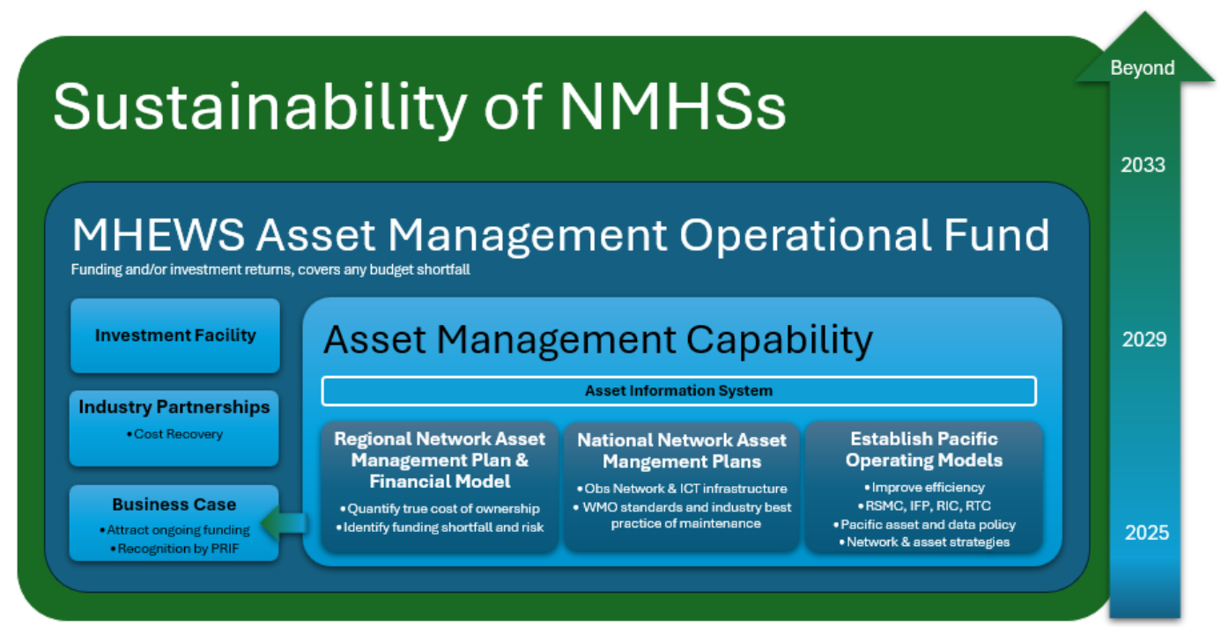

Progress Update - Training and Capacity Development Roadmap
Procurement has commenced to engage a consultant to develop the roadmap. Terms of Reference is found in Annex 1.

Progress Update - Sustainable Financing and Asset Management Roadmap
1. Establish Pacific Operating Models (In Progress)
- Pacific Meteorological Asset Policy (drafted)
  - This has been drafted for SC discussion and feedback (Annex 2).
  - A policy is important for Pacific countries to agree to a harmonised approached to managing assets going forward in order to gain the benefit of regional approaches.
  - This is proposed to be tabled to PICI and PMC approval.
- Pacific Meteorological Data Framework (drafted)
  - Key pillars of the data framework has been drafted for SC discussion and feedback (Annex 3)
  - The framework supports a common approach to data management to support cost recovery and revenue generation for sustainability.
  - The regional framework works in tandem with National Data Policies and Data Sharing agreements to enable systemic regional linkage and coherence, ensuring that they work in unison.
- Pacific Asset Strategies (in progress)
  - The Asset Policy identifies the strategies required at a regional level, to guide improvement in the Pacific context. As there are unique challenges to each asset type, different strategies are required.
  - Several strategies are tabled to this SC for Approval, having already been endorsed by PICI Panel (Annex 4-5)
  - These will be also tabled to PMC for approval.
Asset classes | Improvement Strategy | Status
AWS network (incl AWOS) | Pacific Regional Observation Network Strategy (Annex 4) | Endorsed by PICI Panel
Manual observation network | Pacific Regional Observation Network Strategy (Annex 4) | Endorsed by PICI Panel
Upper air network | Pacific Regional Observation Network Strategy (Annex 4) | Endorsed by PICI Panel
Wave buoy and Ocean network | Pacific Regional Observation Network Strategy (Annex 4) | NYC
Tide gauge network | Pacific Regional Observation Network Strategy (Annex 4) | NYC
Radar Network data | Pacific Regional Radar Strategy (Annex 5) | Endorsed by PICI Panel
Hydrology and Flood network | Pacific Regional Hydrological Services Strategy | In development (SPC)
Seismic Network |  | TBC
ICT Infrastructure | Pacific ICT Architecture and Strategy | In development.  Prelim ICT Architecture endorsed by PICI Panel
Buildings |  | NYC

- Task Team for Asset Management, Radar and IFP has been established under PMC PICI panel
  - This Task Team will provide governance and technical input to WRP projects delivering outcomes for this the Roadmap.
  - This Task Team is represented by eight countries (Vanuatu, Fiji, Nauru, Solomon Islands, PNG, Niue, Tonga, Samoa) and technical partners (SPC, ESNZ, BoM)
 | IFP | Radar | Asset Management
1 | Fiji - (Chair) | Tonga (Chair) | Vanuatu (Chair)
2 | Vanuatu | Fiji | Fiji
3 | Samoa | Vanuatu | Nauru
4 | Tonga | PNG | Solomons
5 | PNG | Solomons | PNG
6 | Solomon Is. | Niue | Niue
7 |  |  | Tonga
8 |  |  | Samoa
 | Technical Partners
1 | SPC | NZ Met | SPC
2 | UK Met | ESNZ | ESNZ
3 | BOM - CliDE | BOM | BOM
4 | ESNZ
- Improving Efficiency (In Progress)
  - The Pacific Regional Observation Network Strategy (Annex 4) KRA 3, Activity 3.1.1, has been shared to the PICI Panel for review and was endorsed 19/05/2026, for recommendation to the PMC.
  - A Guidance Document for Standardisation, Optimisation and Maintenance of Earth Observation Equipment in the Pacific Islands with supporting Procurement Toolkits was also endorsed by the PICI Panel as a working document for NMHSs (Annex 6) KRA 3, Activity 3.1.1. This package is to support regional guidance on standards and principles for observation network and infrastructure planning, procurement and maintenance.
  - Pacific Radar Preferred Supplier Panel and standard Radar procurement, KRA 3, Activity 3.1.1– procurement completed and agreements being established through SPREP. This panel can be used by any future radar project and ensures consistent design and shared operational support arrangements for sustainability.
  - Regional Training Centre (RTC) and Regional Instrument Centre (RIC) (in progress) KRA2, Activity 2.1.1 and KRA3 Activity 3.2.1 – [awaiting update]
  - Regional Specialised Meteorological Centre (RSMC Nadi, Fiji) - WRP Pacific Integrated Forecasting Platform (IFP) Project Phase 1, KRA 4 Activity 4.1.1, is uplifting Fiji Meteorological Services ICT forecasting system capability in 2026 and Phase 2 if approved, will extend this capability to the whole of the Pacific. Refer to SC Agenda 9.5.
  - Integrated Forecasting Platform ICT architecture development, including Data systems and WIS2.0 has been progressed. A high level ICT architecture has been endorsed by PICI Panel (Annex 9.0). Preliminary indication from countries on their preferred WIS2.0 architecture option is show in table below.
Country/Organisation | WIS2.0 Architecture Option
SPC | Set up and run your own WIS2.0 node
Vanuatu | Set up and run your own WIS2.0 node
Tonga | Set up and run your own WIS2.0 node
PNG | Set up and run your own WIS2.0 node
Nauru | Use a shared WIS2.0 node (supported by the region)
Cook Islands | Use a shared WIS2.0 node (supported by the region)
Federated States of Micronesia | Run a national WIS2.0 node within the Pacific WIS2.0 hub (supported by the region)
Fiji | Run a national WIS2.0 node within the Pacific WIS2.0 hub (supported by the region)
Samoa | Set up and run your own WIS2.0 node or Run a national WIS2.0 node within the Pacific WIS2.0 hub (supported by the region)
Solomon Islands | Set up and run your own WIS2.0 node or Run a national WIS2.0 node within the Pacific WIS2.0 hub (supported by the region)
Tokelau | TBC
Tuvalu | TBC
Palau | TBC
Marshall Islands | TBC
Niue | TBC
Kiribati | TBC

2. National Network Asset Management Plans (In Progress)
- The National Asset Plans outline how assets will be managed at country level, all assets identified, improvement/upgrades and maintenance activities and costs, in alignment with and reference to the regional Asset Strategies.
- National Asset Plan preliminary template has been developed (Annex 7) KRA 3, Activity 3.1.1. These have been developed in alignment with WMO operations and maintenance manual.
- The template will be improved further when a consultant is engaged as part of developing the regional network asset management plan and lifecycle cost.
- These are being developed with support from WRP on a country by country basis over 2026 and 2027.
- PNG is the first country that have developed their draft National Asset Management Plan and working with WRPP partner (ESNZ) to review them.
3. Regional Network Asset Management Plan & Financial Model (In Progress)
- Pacific Regional Observation (PRO) Network (In Progress) KRA 3, Activity 3.1.1
  - This network is the critical stations that will be financially supported by the MHEWS Asset Management Operational Fund, supplementing national and international (i.e SOFF) funding to ensure sustainable maintenance and operations of these assets.
  - A stocktake of existing observation assets across the Pacific has been developed.
  - Determining which assets will be part of the PRO network will carried out as part the National Asset Plans development
- Regional Asset Management Plan (Not commenced) KRA 3, Activity 3.1.1
  - Once the PRO network is identified with each country, this will be captured in the Regional Asset Plan and lifecycle cost model.
  - A specialist consultant will be engaged to ensure the plan is robust and can support the business case and spending allocations of the MHEWS Asset Management Operational Fund.
4. Asset Information System (In Progress)
- This system will be the source of truth for all assets under the Pacific Meteorological Asset Policy and be kept in line with national Asset registers. KRA 3, Activity 3.1.1
- This system will be used by all Pacific NMHSs, SPC and Technical Partners supporting the operations and maintenance of hydrometeorological assets.
- Procurement Technical Requirements have been developed and procurement process to commence mid 2026.
- Task Team for Asset Management will govern and support the selection of the system and project team roll out of system across the pacific.
5. Investment Facility & MHEWS Asset Management Operations Fund (In Progress)
- WRP Pooled Fund is being operationalised subject to SC approval (Agenda 9.1) KRA1 Activity 1.1.1. The funding framework enables ringfenced funding to be managed by WRP for the purpose of maintenance and operations, as an interim solution to the need for an Operations Fund.
- A high level concept of the Operations Fund and Investment Facility has been prepared by WRP (Annex 8) KRA 1, Activity 1.2.1.
- ToR has been drafted for consultant to undertake options assessment for the Investment Facility and longer term Operations Fund. This is expected to occur in 2026.
- Discussions with SOFF on potential collaboration or partnership on the Operations Fund and the SOFF Compliance Phase bond.
6. Industry Partnership (In Progress)
There are several priority areas for industry partnership for cost recovery and revenue generation for NMHSs, as highlighted in the WRP Investment Plan.
Cost recovery from aviation sector modelled on Australia's approach is being actively explored with PASO and Pacific CAA. Joint Workshop occurred on 28 May 2026 in Solomon Islands to progress this initiative. KRA4, Activity 4.2.1.
Cost recovery and revenue generation through Observation Data is another opportunity. The Pacific Meteorological Data Framework (Annex 3) and the Pacific ICT architecture design (including WIS2.0) (Annex 9) is setting up the groundwork to enable efficient data management and data sharing in the Pacific. KRA 3, Activity 3.1.1
7. Business Case (Not commenced)
No progress yet.
Recommendations
- To note and discuss progress on implementation of roadmaps

WRP_SC4 Decisions required
WRP Dec. 9.6.1 – Endorse the continued development of a Pacific Meteorological Asset Policy and Meteorological Data Framework and MHEWS Asset Operations and Investment Facility Concept, for PMC approval.
WRP Dec. 9.6.2 – Approve the Pacific Regional Observation Strategy, Radar Strategy, Standards and Procurement Guidelines and preliminary Pacific ICT Architecture Design.
WRP Dec. 9.6.3 – Endorse the development of National Asset Management Plans for each country in 2026 and 2027, which will define the Pacific Regional Observation (PRO) Network of critical infrastructure that will be financially supported by the MHEWS Asset Management Operational Fund, supplementing national funding.

-------
Annex 1 – ToR Training and Capacity Development Roadmap Consultancy Services
Annex 2 – Pacific Meteorological Asset Policy
Annex 3 – Pacific Meteorological Data Framework
Annex 4 – Pacific Regional Observation Network Strategy
Annex 5 – Pacific Radar Strategy
Annex 6 – Guidance Document for Standardisation, Optimisation and Maintenance of Earth Observation Equipment in the Pacific Islands with supporting Procurement Toolkits
Annex 7 – National Asset Management Plan template
Annex 8 – MHEWS Asset Management Operations Fund and Investment Facility Concept
Annex 9 – High level ICT Architecture Design

