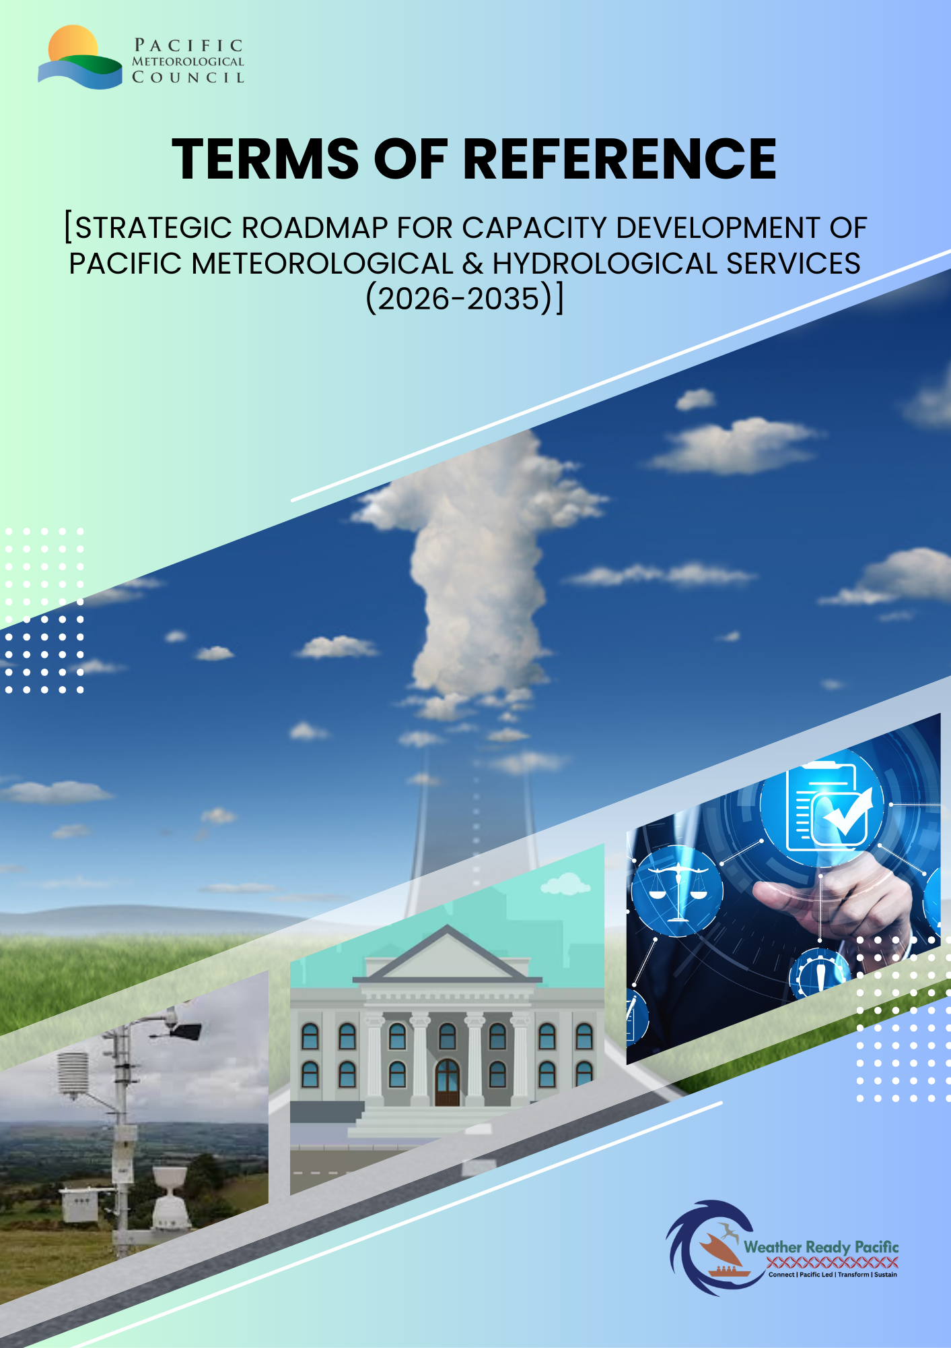

Background
Pacific Island Countries and Territories (PICTs) are highly exposed to tropical cyclones, floods, droughts, sea-level rise and coastal inundation, with small, dispersed populations and limited domestic resources to sustain observing, forecasting and communication systems. Since 1950, extreme hydrometeorological events in the Pacific have affected millions of people and caused substantial economic losses, threatening human security and critical infrastructure and underscoring the need for stronger early warning and climate services.
Pacific NMHSs have progressively organized under regional governance mechanisms such as the Pacific Meteorological Council (PMC), which provides political and technical leadership for weather, climate, ocean and hydrological services. PMC expert panels on climate services, education and training, aviation, marine, infrastructure and hydrology coordinate technical work and identify shared capacity gaps across the region.
The Pacific Islands Meteorological Strategy (PIMS) set an overarching vision for NMHS development and is widely regarded as the “navigational chart” for future service strengthening. To operationalise the Global Framework for Climate Services in a Pacific context, countries adopted the Pacific Roadmap for Strengthened Climate Services (PRSCS), which prioritises actions for climate information systems, user interface, observations, research and capacity development from national to regional levels.
Despite progress, many NMHSs still face critical shortfalls in basic observing networks, forecasting infrastructure, impact-based warning capability, skilled personnel, legislation and sustainable financing. Reviews commissioned through initiatives like Weather Ready Pacific have shown that while multiple projects operate in the region, support is often fragmented and short term, highlighting the need for a coordinated, long-term capacity development approach for meteorology and hydrology together.
Programs such as the Climate and Oceans Support Program in the Pacific (COSPPac), WISER, CREWS Pacific SIDS and Weather Ready Pacific have strengthened forecasting systems, IT capacity, impact-based forecasting and end-to-end multi-hazard early warning systems. A parallel push on hydrology, including the Pacific Early Warning Systems for Flood and Flash Flood Guidance and the Pacific Hydrological Services (PHS) Panel, is building institutional and technical capacity for flood forecasting and water resources management.
Experience from these initiatives shows that targeted, sustained capacity development covering human resources, institutional frameworks, infrastructure and user engagement is essential to maintain and expand services once project funding ends. Building on this, the Secretariat of the Pacific Regional Environment Programme (SPREP), through the Weather Ready Pacific Programme (WRP), seeks to engage a qualified consultant to develop a comprehensive Capacity Development and Training Roadmap for meteorological and hydrological services across Pacific Island Countries and Territories (PICTs). This Strategic Roadmap is explicitly repositioned as a core delivery mechanism under Weather Ready Pacific (WRP) Key Result Area 5 (KRA5), serving as an operational regional implementation framework governed through PMC processes and directly supporting the Early Warnings for All (EW4ALL) pillar, rather than as a standalone study that risks sitting on the shelf. It is intended to be an everyday working tool in use across the region and will also function as the implementation document of the PIETR Panel, aligning national and regional priorities, sequencing investments over the next 5–10 years, and providing a strategic framework to strengthen technical competencies, enhance institutional capacity, improve service delivery, and directly support disaster risk reduction, climate adaptation, regional security, and the long-term resilience of essential weather, climate, ocean and hydrological services in the Pacific.

Objective

The primary objective of this consultancy is to develop a comprehensive, evidence-based Capacity Development and Training Roadmap that will:
- Assess current capacity levels across Pacific meteorological and hydrological services, identifying critical gaps in technical skills, institutional capabilities, and human resources;
- Define priority training needs aligned with operational requirements for weather forecasting, hydrological monitoring, climate services, data management, and early warning systems;
- Establish a strategic framework for capacity development that addresses technical, institutional, and governance dimensions;
- Propose competency-based training pathways and modalities suitable for Pacific contexts, including short courses, certification programmes, on-the-job training, regional exchanges, and online learning;
- Identify resource requirements and design sustainable financing models to support roadmap implementation, including options for predictable, recurring funding for training and capacity development at national and regional levels;
- Enhance coordination between national, regional, and international training providers; and
- Promote gender equality and social inclusion in capacity development initiatives.
- Develop workforce sustainability models for Pacific NMHSs, including retention strategies, succession planning frameworks, and minimum sustainable staffing levels tailored to operational requirements and country contexts.
- Link training outcomes to measurable operational service delivery improvements, including forecast accuracy, warning lead times, service availability, and user satisfaction metrics.
- Position capacity development as a core enabler of regional security and service resilience, ensuring that strengthened NMHS capabilities contribute to the continuity of critical services, protection of lives and livelihoods, and stability of Pacific Island communities.

Scope of Work

The consultant will undertake the following tasks:

Inception and Planning (Phase 1)

- Conduct an inception meeting with SPREP, PIETR panel, Project Task Team, and key stakeholders to finalize methodology, work plan, timeline and risks;
- Review relevant documentation, Pacific Island Meteorological Strategy, PIETR panel reports and decisions, WRP decadal investment plan, RTC feasibility study, including recent assessments of climate services, national meteorological and hydrological service strategies, WMO competency frameworks, and existing training programmes;
- Develop detailed data collection tools (surveys, interview protocols, focus group guides); and
- Prepare and submit an Inception Report outlining the approach, methodology, stakeholder engagement plan, and detailed timeline.

Capacity Assessment (Phase 2)

- Conduct comprehensive capacity assessments across selected Pacific Island Countries (minimum 8-10 countries representing diverse contexts and capacities).
- Assess technical competencies in:
  - Weather forecasting (nowcasting, short-range, medium-range, seasonal);
  - Hydrological monitoring and forecasting (rainfall, streamflow, reservoir management, flood forecasting);
  - Climate services development and delivery;
  - Early warning systems and disaster risk reduction;
  - Data management, quality control, and analysis;
  - Oceanographic and marine services;
  - Use of numerical weather prediction models and climate models; and
  - Communication and user engagement.
- Evaluate institutional capacity, including:
  - Organizational structures and governance;
  - Staff numbers, qualifications, retention rates, and succession planning;
  - Operational procedures and standard operating procedures (SOPs);
  - Inter-agency coordination mechanisms; and
  - Financial sustainability and resource mobilization.
- Identify gender and social inclusion dimensions in current capacity levels.
- Document best practices and lessons learned from successful capacity development initiatives within the region.

Training Needs Analysis (Phase 3)

- Synthesize findings from capacity assessments to identify priority training needs at individual, institutional, and systemic levels;
- Align training needs with WMO competency frameworks for meteorological and hydrological personnel;
- Prioritize needs based on:
  - Criticality to core service delivery
  - Number of staff requiring training
  - Urgency (immediate vs. medium-term vs. long-term)
  - Feasibility and resource requirements
  - Gender and inclusion considerations
- Categorize training needs by:
  - Technical domains (forecasting, hydrology, climate services, data management, etc.)
  - Career levels (entry-level, mid-career, senior/management)
  - Training modalities (formal education, short courses, on-the-job training, mentoring, e-learning)

Roadmap Development (Phase 4)

- Develop a 5–10-year Capacity Development and Training Roadmap with a clear vision, goals, objectives, and strategic pillars
- Develop plan to operationalize the Regional Training Centre Nadi (RTC-Nadi) and sustainability plan, working with Fiji Meteorological Service as host of RTC-Nadi, and in close collaboration with other regional training institutions and WMO Regional Training Centres, to ensure full alignment with the emerging Pacific regional training architecture.
- Define training pathways, competency framework and accreditations, for different career levels and technical domains, tailored and fit for purpose for Pacific NMHSs including linkages to regional and international certification pathways (e.g. WMO competency-based qualifications and relevant tertiary credentials);
- Identify suitable training providers (regional institutions, universities, international training centers, WMO Regional Training Centres)
- Propose training and capacity development delivery modalities appropriate for Pacific contexts:
  - Regional training workshops and courses
  - In-country training and mentoring/twinning programmes
  - Attachments and study tours to leading meteorological/hydrological services
  - Online and blended learning approaches
  - Train-the-trainer initiatives
  - South-South knowledge exchange
  - Community of practices
- Develop an implementation plan with:
  - Phased approach (short-term: 1-2 years; medium-term: 3-5 years; long-term: 6-10 years);
  - Responsible institutions and coordination mechanisms;
  - Clear implementation ownership and long-term governance arrangements, including the roles of PMC, the PIETR Panel, SPREP, WMO and national NMHSs in overseeing, resourcing, and updating the Roadmap;
  - Resource requirements (budget estimates, staffing, infrastructure);
  - A sustainable training financing model, outlining options for recurrent funding (e.g. national budget allocations, cost-sharing arrangements, programme earmarking, and partner support) to maintain core training functions and the regional training architecture over time; and
  - Review and update (if needed) the PIMS and WRP monitoring and evaluation framework with indicators related to capacity development, explicitly linking training outputs to operational outcomes.
- Address cross-cutting themes:
  - Gender equality and women's empowerment
  - Youth engagement and career pathways
  - Integration of traditional knowledge
  - Public-private partnerships
  - Regional cooperation and resource sharing

Stakeholder Consultation and Validation (Phase 5)

- Facilitate regional validation workshop with representatives from National Meteorological Services, National Hydrological Services, Disaster Management Offices, WMO, training institutions, and development partners;
- Present draft roadmap and gather feedback;
- Conduct targeted consultations with key stakeholders as needed; and
- Incorporate feedback into final roadmap.

Finalization and Reporting (Phase 6)

- Finalize the Capacity Development and Training Roadmap incorporating all stakeholder feedback;
- Prepare executive summary and policy brief for decision-makers;
- Deliver final report with annexes (assessment data, stakeholder consultation records, resource materials); and
- Present final roadmap to SPREP management and partners.

Methodology
The consultant is expected to employ a participatory, evidence-based methodology that includes:

- Desk review of relevant literature, policy documents, service assessments, WMO frameworks, and existing training programmes;
- Stakeholder consultations through surveys, key informant interviews, focus group discussions, and workshops with National Meteorological Services, National Hydrological Services, Disaster Management Offices, training institutions, and development partners;
- Capacity assessments using structured tools aligned with WMO competency frameworks and regional service priorities;
- Participatory analysis to identify training needs and prioritize interventions;
- Design of a digital learning transformation approach, including use of Regional Learning Management System (LMS) platforms, remote forecasting mentorship, and blended learning modalities;
- Regional validation workshop to review draft roadmap and ensure ownership by Pacific Island Countries; and
- Gender-responsive approach ensuring women's voices are heard and gender considerations integrated throughout.
The methodology should be refined and detailed in the Inception Report following consultations with SPREP and other relevant stakeholders.

Deliverables
All written deliverables shall: (i) be concise and analytical, (ii) clearly distinguish main text from annexes, and (iii) provide sufficient implementation detail (roles, timelines, resourcing, and monitoring arrangements) to enable adoption and operationalization by PMC/PIETR and SPREP. The consultant is expected to produce the following deliverables:

No. | Deliverable | Timeline (days)
1 | Inception Report including detailed methodology, work plan, stakeholder engagement strategy, data collection tools, timeline and risks. | 5 days
2 | Capacity Assessment Report documenting current capacity levels, gaps, and training needs across selected Pacific Island Countries | 22 days
3 | Draft Capacity Development and Training Roadmap (5-10 years) including clearly defined implementation and governance framework that assigns ownership, roles and decision-making arrangements at national and regional levels, implementation plan, resource requirements, and monitoring framework with indicators that track both training outputs and their linkages to service delivery improvements. | 5 days
4 | Regional Validation Workshop Report summarizing stakeholder feedback and recommendations | 3 days
5 | Final Capacity Development & Training Roadmap incorporating all feedback, with Executive Summary and Policy Brief | 5 days
6 | Final Consultancy Report documenting all activities, outputs, lessons learned, and recommendations | 5 days
All deliverables must be submitted in English in editable format (Microsoft Word for documents; PowerPoint for presentations) and as PDF. The consultant will present the Inception Report, Draft Roadmap, and Final Roadmap to SPREP and stakeholders through virtual meetings and one regional validation workshop.

Qualifications and Experience

The consultant or consulting team must demonstrate the following qualifications and experience:
Essential Requirements
- Advanced degree (Master's or PhD) in meteorology, hydrology, atmospheric sciences, climate science, water resources management, or related field;
- Minimum 10 years of professional experience in training, workforce planning and operating meteorological and/or hydrological training services and institutes, with at least 5 years working in Pacific Island contexts;
- Proven expertise in capacity development, training needs assessment, and design of training programmes for technical services;
- Strong knowledge of WMO competency frameworks, standards, and best practices for meteorological and hydrological personnel;
- Experience conducting organizational assessments and developing strategic plans;
- Familiarity with Pacific Island meteorological and hydrological services, operational challenges, and institutional contexts;
- Excellent analytical, writing, and presentation skills with ability to produce high-quality reports and facilitate stakeholder workshops; and
- Demonstrated ability to work effectively with diverse stakeholders, including government agencies, regional organizations, and international partners.
Desirable Requirements
- Experience with climate services, early warning systems, and disaster risk reduction;
- Knowledge of hydrological monitoring networks, flood forecasting, and water resources management;
- Familiarity with regional training institutions (e.g., Regional Specialized Meteorological Centre Nadi, WMO Regional Training Centres);
- Understanding of gender and social inclusion in technical capacity development;
- Experience working with SPREP, Pacific Meteorological Council, WMO, or other regional/international organizations; and
- Previous consultancy experience with multilateral organizations or development partners.

Work Arrangements

- Duty Station: Home-based with travel to Pacific Island Countries for consultations and validation workshop.
- Supervision: The consultant will report to Weather Ready Pacific Programme Manager and the Capacity Development and Training Adviser and work closely with the Climate Science and Information programme at SPREP, and Fiji Meteorological Services (host of RTC).
- Support: SPREP will facilitate introductions to National Meteorological Services, National Hydrological Services, and key stakeholders; provide relevant documentation; and support logistics for the regional validation workshop.
- PIETR Panel Task Team Group: A Task Team will be established comprising representatives from SPREP, WMO, Pacific Meteorological Council, selected National Meteorological Services, and training institutions to provide technical guidance and review deliverables.

Duration and Schedule

- Total consultancy duration: 45 working days over 3 months
- Start date: 1st May 2026
- End date: 31st August 2026
- Travel: The consultant is expected to undertake travel to facilitate one regional validation workshop (location TBD).

Payment Schedule
Payment will be made upon submission and approval of deliverables according to the following schedule:

Milestone | Deliverable | Payment (%)
1 | Inception Report approved | 20%
2 | Capacity Assessment Report approved | 25%
3 | Draft Roadmap approved and Validation Workshop completed | 25%
4 | Final Roadmap and all deliverables approved | 30%

Travel costs (flights, accommodation, per-diem) for field consultations and the regional validation workshop will be covered separately according to SPREP travel policies.

Annex 1: Technical Assessment Criteria & Weighting.

Technical criterion | Description | Suggested weight (technical component)
1. Understanding of TOR, context and risks | Demonstrated understanding of Pacific NMHS/Capacity Development and Training context, TOR objectives, PIC diversity, risks/assumptions, and gender & inclusion issues. | 20%
2. Methodology and work plan | Appropriateness, clarity and feasibility of proposed approach for capacity assessment, roadmap design, validation and reporting, including stakeholder engagement strategy and data collection tools. | 35%
3. Relevant experience and track record | Proven experience with capacity development, training roadmaps, and NMHS/DRR/climate services in PICs or comparable SIDS/regions; evidence from similar assignments and references. | 25%
4. Key expert(s) and team composition | Qualifications, skills mix and availability of proposed consultant or team (team leader, capacity dev/training expert, institutional/governance expert, GEDSI specialist, etc.), and balance of regional/local expertise. | 20%

End…

