Pacific Meteorological Asset Policy (EARLY DRAFT FOR DISCUSSION ONLY)

1. Purpose
This Policy sets a shared Pacific approach to meteorological assets. The purpose of this Policy is to make Pacific meteorological assets sustainable and producing quality multi-hazard early warning services through uplifting asset management capability in the region.

2. Scope
This policy applies to Assets owned or leased by Pacific NMHSs as listed in Appendix A.

3. Policy position
1. A Sustainable Financing and Asset Management Roadmap (Appendix B) and Improvement Strategies for each asset class are developed and updated at least every 5 years, to guide capability uplift and asset performance in the region.
2. Standardised regional technology for inter-operability and establish preferred supplier panel contracts for the Pacific, to streamline sharing of spares and maintenance resources, reduce cost and technical burden for countries through pooled regional solutions.
3. Establish the Pacific MHEWS Asset Management Operational Fund and Investment Facility, to provide sustainable long-term pooled financing to operate and maintain critical regional assets, supplementing national budgets.
4. Critical regional assets for MHEWS are agreed and identified as the Pacific Regional Observing Network (Appendix C) and is reviewed at least biennially. This includes enabling assets such as regional training centre, regional instrument centre, pacific WIS2 node and pacific integrated forecasting platform. GBON SOFF stations are a subset.
5. A Regional Asset Management Plan will be developed and updated every year by SPREP to govern all critical assets of the Pacific Observing Network that will be financed by the MHEWS Operational Fund. Asset Plans adopt a risk-based approach to meet the desired service level and lifecycle costs.
6. National Asset Plans will be developed and updated every year by NMHSs supported by SPREP to govern all asset activities. These cover all asset that are identified as a national priority to the NMHS. This enables NMHS long term planning and decision making aligned with the regional asset plan and improvement strategies, and assists securing of national, regional and partner financing.
7. Maintenance Agreements will be established (Appendix D template) to define the contributions to the Operational Funds by countries, regional agencies, projects, investors and Partners. All project budgets to provision contribution of at least the first 5 years of asset lifecycle cost.
8. A common asset information and maintenance system (AIMS) will be used by NMHSs, administered by SPREP, which will be the source of truth of meteorological assets that underpin the national and regional asset plans. The information will be proactively kept up to date to enable evidence-based decision making, strengthen countries maintenance and quality management systems, to allow changes to be understood and managed to maintain the quality and integrity of the observation record.
9. The PMC will review this policy at least every four years to reflect technological, institutional, and regional changes. SPREP will update the Appendices as needed, in consultation with the PMC Panel.

4. Signatories
Signatories to this policy include:
Country xxxx, Representative xxx

Appendix A – Asset Classes

Asset classes | Improvement Strategy | Status
AWS network | Pacific Regional Observation Strategy | Endorsed by PICI Panel
Manual observation network | Pacific Regional Observation Strategy | Endorsed by PICI Panel
Upper air network | Pacific Regional Observation Strategy | Endorsed by PICI Panel
Wave buoy and Ocean network | Pacific Regional Observation Strategy | NYC
Tide gauge network | Pacific Regional Observation Strategy | NYC
Radar Network data | Pacific Radar Strategy | Endorsed by PICI Panel
Hydrology and Flood network | Pacific Hydrology Strategy | In development (SPC)
Seismic Network |  | TBC
ICT Infrastructure | Pacific ICT Architecture and Strategy | In Development  Prelim ICT Architecture endorsed by PICI Panel
Buildings |  | NYC

Appendix B – Sustainable Financing and Asset Management Roadmap
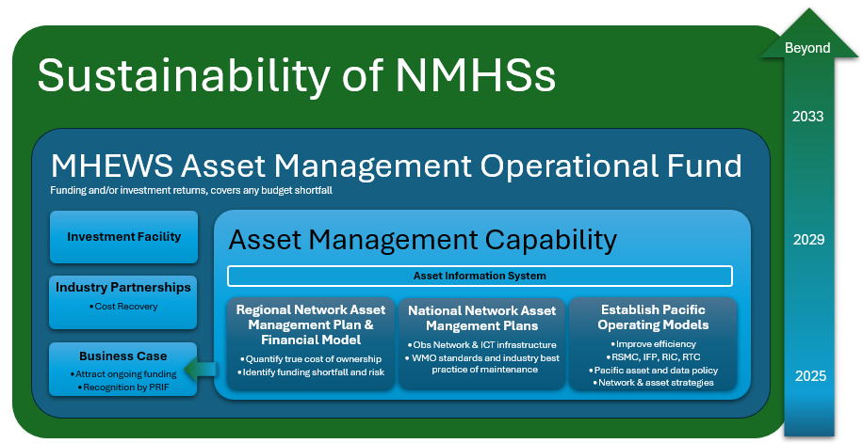

Appendix C – Pacific Regional Observing (PRO) Network

To be defined through the development of National Asset Plans

Appendix D – Maintenance Agreement Template

To be developed

