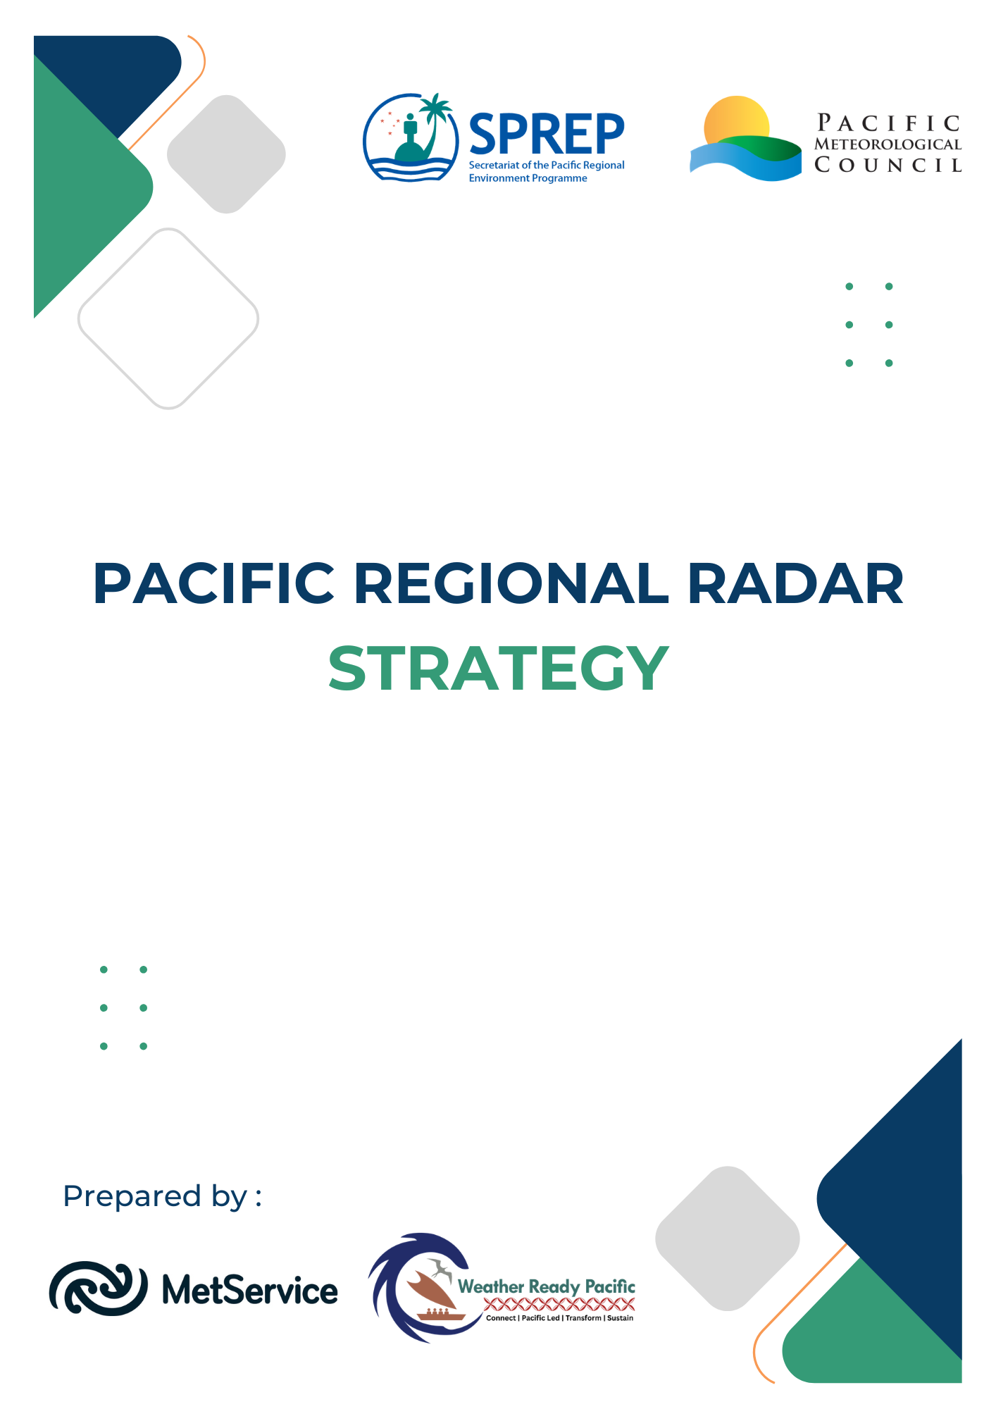

Document History
Versions
Version | Revision Date | Summary | Reviewed by
0.1 | 15 Jun 2025 | Initial document created | Collin Quarrie
0.2 | 22 Nov 2025 | First draft for comment | Emma Coombe, Anthony Rea, Neal Osborne
0.3 | 29 Jan 2026 | Second draft for WRP | Marica Ratuki
0.4 | 01 Apr 2026 | 3rd Draft for TEC review | Ofa Fa’anunu

Distribution
Version | Date | Distribution
1.0 | 01/04/2026 | WRP TEC members – for review and comments
2.0 | 01/05/2026 | PICI Panel
Document ID: Document 1
Document Owner:
Last updated: 21 Apr 26
Review frequency:
Version: 2.0

Executive Summary
Pacific Island Countries face some of the world’s highest exposure to severe weather and climate hazards, yet their National Meteorological and Hydrological Services (NMHSs) have limited observational networks, constrained budgets, and small technical workforces. Weather radar, whilst transformative for early warning and real-time hazard monitoring, is amongst the most expensive and technically demanding infrastructure a small NMHS can operate. With more than a dozen radars already installed or funded for installation and a further ten proposed, the region is entering a phase of rapid expansion without the support systems yet in place to ensure sustainability.
This Pacific Regional Radar Strategy provides the framework needed to coordinate investment, build technical capability, standardise technology, and ensure that radar systems contribute meaningful and lasting value to national and regional early warning efforts.
Weather Ready Pacific (WRP) offers the overarching strategic context: a decade-long, region-wide effort to strengthen multi-hazard early warning systems. Within WRP, the radar strategy supports KRA 3: Observation network infrastructure, and aligns with the Pacific Islands Meteorological Strategy (PIMS), the World Meteorological Organization (WMO) Unified Data Policy, and the Early Warnings for All initiative.
The Case for a Regional Strategy
Weather radar improves the ability of NMHS to warn for tropical cyclones, severe thunderstorms, flash flooding and high-impact convective storms. Recognising that the protection of life is paramount, the additional social and economic benefits are substantial. These include safeguarding infrastructure, supporting aviation and maritime safety, enabling localised nowcasting and contributing to impact-based warnings.
In isolation, smaller NMHSs may experience difficulties in sustainably operating radar systems in isolation. The region lacks sufficient trained technicians, meteorologists skilled in radar interpretation, integrated forecast systems, and the ongoing funding needed to support maintenance, communications links, spares, and eventual replacement.
A regional approach is therefore essential: harmonised technologies, shared expertise, coordinated maintenance, and real-time data exchange will provide resilience and economies of scale that no country can achieve alone.
Key Challenges
Consultations across the Pacific highlight recurrent barriers:
- Supporting infrastructure gaps: unreliable power, fragile communications, high transport costs and inaccessible sites reduce reliability and increase downtime.
- Limited technical capability: many countries have a limited number of technicians, mostly with no radar experience; turnover is high, and training pathways are limited.
- Meteorological capability and workflows: few forecasters have experience using radar data; existing SOPs and warning systems are not designed for radar-enabled services.
- Lifecycle and funding risks: long-term costs far exceed normal NMHS budgets, risking system failure once donor funding ends.
- Rapid rollout: with 13 radars installed or committed, sustainability systems must mature before further expansion.
Strategic Outcomes
The strategy defines five long-term outcomes:
- Coverage: radars located to maximise benefit to vulnerable populations and key infrastructure.
- Sustainability: long-term technical, financial and operational viability.
- National & Regional Capability: balanced support model combining country-level capacity with regional hubs.
- Service Delivery: radar integrated into forecasting platforms, SOPs and warning services; data used to its full value.
- Funding: secure, predictable support for maintenance and operations.
Recommended Network and Technology Approach
Given the Pacific’s high rainfall rates and logistical constraints, the strategy recommends standardising on C-band, solid-state, dual-polarisation radars. C-band provides the best balance of range, resolution, cost and resilience to attenuation, while solid-state transmitters enable higher reliability, safer operation, and lower maintenance.
Additional technical recommendations include incorporation of renewable energy power supply, synchronised scan strategies, coordinated frequency management, standardised data formats and siting radars at or near NMHS headquarters where infrastructure is strongest.
Building Regional Capability
A sustainable radar network requires a multi-layered support model:
- Level 1: basic in-country technicians trained to manage routine checks.
- Level 2: regional technical hubs providing maintenance, spares, and fault rectification.
- Level 3: vendor-level or specialist support for complex issues.
To support meteorological capability, procurement packages must include sustained, phased training in radar meteorology, integration with forecast platforms, and updated SOPs for severe weather and impact-based forecasting. A regional Community of Practice and a Radar Technical Working Group will strengthen peer support and knowledge exchange.
Data, Integration and Downstream Value
Radar data only generates impact if fully integrated into forecasting workflows. This requires:
- modern display and visualisation systems
- real-time regional radar data exchange
- a consistent archive and metadata policy
- development of new radar-enabled warning products and communication channels
Funding and Long-Term Sustainability
Given that ongoing costs (power, communications, maintenance, training, spares, site operations) will exceed the operating budgets of most NMHSs, the strategy recommends:
- maximising upfront investments (solar power, long-term licences, pre-purchased spares, resilient communications links) to reduce future burden
- creation of a regional pooled maintenance fund, supported by countries and donors, to finance technician deployments, training, spares, and essential recurring costs
This funding model would enable continuity of service, reduce system downtime, and support a Pacific-led approach to radar operations.
Table of Contents
1. Introduction 6
1.1. Background: Weather Ready Pacific 6
1.2. Purpose and Scope of the Strategy 6
1.3. Strategic Context 7
1.4. Guiding Principles 8
1.5. Methodology and Stakeholder Engagement 8
2. The Case for a Pacific Weather Radar Strategy 10
2.1. National and Regional Requirements 10
2.1.1. Global Context 10
2.1.2. National Requirements 10
2.2. Use Cases 11
2.2.1. Representative Use Cases 11
2.3. Social and Economic Benefits 12
2.4. Benefits of Regional Coordination 12
3. Challenges and Risks 13
3.1. Supporting Infrastructure 13
3.2. Technical Capability 13
3.3. Integration with Downstream Systems 13
3.4. Meteorological Capability 13
3.5. Lifecycle Management 14
3.6. Ongoing Funding 14
4. Strategic Outcomes 15
4.1. Strategic Outcomes 15
4.1.1. Coverage 15
4.1.2. Sustainability 15
4.1.3. National and Regional Capability 15
4.1.4. Service Delivery 15
4.1.5. Funding 15
5. Network 16
5.1. Current and Planned Radars 16
5.2. Siting and Network Spacing 22
5.3. Scanning Strategies 23
5.4. Frequency Management 23
5.5. Interoperability 24
6. Technology 25
6.1. Radar Frequency Bands 25
6.2. Transmitter Technology 25
6.3. Rain Attenuation 26
6.4. Calibration 27
6.5. Standardisation 27
7. People 29
7.1. Regional and National Capability 29
7.2. Radar Technicians 29
7.3. Meteorologists 30
7.4. Safety 31
7.5. Community of Practice 31
7.6. Radar Technical Working Group 32
7.7. Gender Equality, Disability and Social Inclusion (GEDSI) 32
8. Data and Downstream value 34
8.1. Integration with Forecast and Display Systems 34
8.2. Workflows and Operating Procedures 34
8.3. Regional Data Exchange 35
8.4. Data Management, Archive and Access 35
9. Safeguarding 36
10. Funding and Lifecycle Management 37
10.1. Total Cost of Ownership 37
10.2. Minimising Ongoing Costs 38
10.3. Potential Funding Arrangements 38

Introduction

Background: Weather Ready Pacific
In 2021, Pacific Leaders endorsed the Weather Ready Pacific (WRP) Decadal Programme of Investment, a transformative initiative aimed at reducing the human and economic costs of severe weather, water, and ocean-related events across Pacific Island communities. The programme seeks to strengthen the capabilities of National Meteorological and Hydrological Services (NMHSs) and enhance their collaboration with national disaster management agencies.
WRP is structured around six Key Result Areas (KRAs), each addressing a critical component of regional meteorological resilience. KRA 3: Observation network focuses on the enhancement of hydro-meteorological observation networks and associated information technology systems.
Within KRA 3, the need for a coordinated regional radar strategy has emerged as a priority. This reflects both the growing deployment of radar systems under WRP and other development initiatives, and the recognition that long-term sustainability, interoperability, and strategic planning are essential to maximise the value of these investments.
This Pacific Regional Radar Strategy will serve as a foundational framework to guide the identification, design, procurement, installation, operation, and maintenance of weather radar systems across the region. It will also support regional alignment with the World Meteorological Organization’s Unified Data Policy, the Pacific Regional Observation Network Strategy (currently under review) and the Guidance Document for Standardisation, Optimisation and Maintenance of Earth Observation Equipment in the Pacific (currently under review), promoting open and standardised data exchange to enhance forecasting capabilities and regional cooperation.
The strategy will be informed by stakeholder consultations, international best practices, and technical guidance from the WMO and partner agencies. It is intended to support high-level decision-making by NMHS directors and planners, while also providing a technical foundation for implementation teams and development partners.
Ultimately, the strategy aims to ensure that radar infrastructure investments are regionally coordinated, sustainable and aligned with Pacific priorities, contributing to the broader WRP goal of building a resilient, weather-ready Pacific.

Purpose and Scope of the Strategy
The purpose of the Pacific Regional Radar Strategy is to provide a coherent, regionally coordinated framework for the sustainable development, deployment, and operation of weather radar systems across the Pacific. It is designed to support informed decision-making at both national and regional levels, ensuring that radar investments are strategically aligned with the needs of Pacific Island Countries and Territories (PICTs), and that they contribute meaningfully to the broader goals of the Weather Ready Pacific (WRP) programme.
This strategy responds to the growing demand for improved weather monitoring and early warning capabilities in the face of increasing climate variability and extreme weather events. It aims to ensure that radar systems are not only technically appropriate and geographically well-sited, but also financially and operationally sustainable over the long term.
The strategy seeks to:
- Guide the planning, procurement, and deployment of radar systems in a coordinated and cost-effective manner;
- Promote regional interoperability and data sharing, in line with the WMO Unified Data Policy;
- Support the development of technical capacity and institutional readiness to operate and maintain radar infrastructure;
- Ensure that the necessary meteorological capacity and systems are in place to maximise downstream benefits from radar systems
- Provide a framework to inform sustainable budgeting and investment planning around maintenance (including insurance); and
- Promote regional collaboration, including supporting capability, network design and funding arrangements.
The audience for the strategy includes operators and other stakeholders:
- Regional NMHSs
- Regional Institutions
- Development Partners
- Donors
The strategy is not intended to provide all the information needed when planning, procuring and installing a radar. There are other documents available that fulfil this purpose. It is intended to make recommendations that are relevant at the regional level, helping to ensure that radar investments are strategic, sustainable, and regionally harmonised.

Strategic Context
The strategy is delivered as a contribution to Weather Ready Pacific but exists within a broader strategic context. The intent is for the strategy to be approved and owned by the Pacific Meteorological Council.
The strategy also aligns with the Pacific Islands Meteorological Strategy, currently under review, and the United Nations’ Early Warnings for All Initiative.

Guiding Principles
The strategy is aligned with the principles outlined in the Investment Framework of the Weather Ready Pacific:
- Pacific Led; solutions are locally relevant, reflect Pacific priorities and respect national sovereignty
- Coordination and collaboration: designed to bring fragmented projects together into a single coherent programme, reducing duplication and administrative burden
- Transformational: aims for system-wide change, not incremental improvements
- Sustainable: includes development of regional financing mechanisms and asset management approaches to ensure systems remain operational over time
- For all nations, assured access to localised, accurate and timely forecast and warning products: derived utilising world-leading forecasting capability.
- Strengthened preparedness and response to severe weather events that provides improved safety for all communities in the region and travellers.
- Reduced economic impacts of extreme events on key industries (agriculture, fisheries, aviation, shipping, tourism) and livelihoods of small businesses, farmers etc.
The strategy aligns with the relevant principles of the Pacific Islands Meteorological Strategy 2017-2026, in particular:
- Pacific focus within a global context: aligning the work of the NMHSs with global frameworks.
- Value for money: support from better-resourced NMHSs to those with less, and regional delivery of certain services and support at a regional level.
- Sharing information: sharing data in line with regional obligations and national policies.
- Partnerships: among NMHSs, public and private sectors, non-government organisations, UN agencies, regional agencies, donors and technical partners.
- Stakeholder Engagement: to ensure weather, climate, water and ocean products and services meet decision-making needs and are tailored and accessible.
The Sustainability Framework of Weather Ready Pacific defines sustainability as:
Enabling both the existing and future Pacific hydrometeorological and multi-hazard early warning services to last, and to be Pacific owned and led in the long term.

Methodology and Stakeholder Engagement
The development of the Pacific Regional Radar Strategy has been guided by a structured, consultative, and evidence-based approach. Recognising the diversity of meteorological capacities, infrastructure, and priorities across the Pacific region, the methodology has been designed to ensure inclusivity, technical rigour, and alignment with both regional and international best practices.
The strategy has been developed through a combination of:
- Desk-based research: Review of existing radar infrastructure, national meteorological strategies, regional investment plans, and relevant technical literature, including the WMO’s Guide to Operational Weather Radar Best Practices and ISO 19926 standards.
- Structured Interviews: a series of structured interviews with Pacific Met Service Directors, regional institutions, donors, implementing entities and technical experts.
- Situational analysis: Mapping of current and planned radar systems, identification of gaps, and assessment of regional needs using a structured SWOT framework.
Stakeholder engagement has been structured to ensure that the strategy, while originating from internationally recognised frameworks, reflects both national priorities and regional aspirations. Moreover, the intention is for the outputs to be grounded in the operational realities of Pacific Island countries and territories. Each country has its own operational context, including varying levels of technical capacity, infrastructure maturity, and budgetary constraints. These differences influence national priorities for radar deployment, maintenance, and data utilisation.
Particular attention has been given to ensure that the voices of smaller and more remote NMHS’s are represented, and that the strategy supports equitable access to radar capabilities across the region. This collaborative approach ensures that the strategy is not only technically sound, but also regionally owned, contextually relevant, and operationally feasible.

The Case for a Pacific Weather Radar Strategy

National and Regional Requirements
Over recent decades, the use of weather radar has expanded significantly and National Meteorological and Hydrological Services (NMHSs) around the world have increasingly relied on radar systems to enhance their short-term forecasting and early warning capabilities. Over this time, the capability of radar systems has also improved with the introduction of doppler and dual-polarization capabilities, and more recently with digital signal processing.
In the Pacific region, where countries are highly exposed to climate and weather-related hazards, the benefits of weather radar are significant. The region presents unique challenges for weather monitoring. Many countries are subject to tropical cyclones, severe thunderstorms and heavy precipitation, making radar a necessary component of a resilient and responsive meteorological infrastructure.

Global Context
The United Nations’ Early Warnings for All (EW4ALL) initiative aims to ensure that every person on Earth is protected by early warning systems by 2027 and are supported by other development programmes across the region, including Weather Ready Pacific. The Pacific Regional Radar Strategy directly supports this goal by enhancing the region’s capacity to detect, monitor, and respond to hazardous weather in real time.

National Requirements
Many Pacific Island Countries and Territories (PICTs) share common vulnerabilities: exposure to tropical cyclones, severe thunderstorms, flash floods, droughts, and rising sea levels; limited observational infrastructure; and logistical challenges in accessing remote communities. Radar systems address these challenges by providing real-time, high-resolution data that can support early warning systems, localised forecasting, and disaster risk reduction.
National requirements can be considered across several categories:
- Enhanced Early Warning Capabilities: timely and accurate warnings for tropical cyclones, severe thunderstorms, and flash floods are critical for saving lives and protecting infrastructure. Radar systems improve the ability to detect and warn for severe events such as thunderstorms, providing spatial and structural information not available from existing ground-based observations.
- Localised Monitoring and Nowcasting for Diverse Microclimates: many islands have complex terrain and localised weather systems. Radar enables high-resolution monitoring that supports tailored warnings for communities, critical infrastructure, and vulnerable zones.
- Support for Disaster Risk Reduction and Climate Resilience: radar data contribute to preparedness planning, impact-based forecasting, and long-term climate adaptation strategies, particularly for agriculture, fisheries, and water resource management.
- Operational Continuity for Transport and Logistics: reliable weather information is essential for aviation and maritime operations, which are lifelines for many PICs. Radar supports safe flight planning, port operations, and emergency logistics during severe weather events.
- Capacity Building and Regional Integration: a coordinated radar strategy strengthens technical and meteorological capacity within NMHSs and promotes regional data sharing, interoperability, and joint training initiatives.

Use Cases

Representative Use Cases
- Cyclone Tracking and Impact Forecasting: radar systems positioned along cyclone-prone corridors enhance tracking accuracy and support impact-based forecasting. This enables NMHSs to issue more precise warnings and coordinate evacuation and response efforts.
- Flood-Prone Urban and Rural Catchments: radar coverage over vulnerable river basins and urban centres enables real-time monitoring of heavy rainfall intensity and accumulation. This supports early flood alerts and coordination with disaster management agencies, particularly during tropical depressions and monsoon events.
- Airport and Airspace Monitoring: radar installations near airports can provide wind shear alerts, storm tracking, turbulence detection and precipitation intensity data to support aviation safety and air traffic management. These systems are especially valuable during for storm tracking, during cyclone season and for managing inter-island flights.
- Public access: freely-available radar products to enhance community understanding of rainfall and severe weather events, to facilitate response and build public awareness of the NMHS and its services.
- Sub-Regional Observation Hubs: strategically located radars can potentially serve multiple countries through overlapping coverage and shared data processing. During cyclone season, systems may be tracked from the coverage of one country’s radar to another’s.
- Remote Island Monitoring and Maritime Safety: radar systems can be used to monitor weather conditions around isolated islands and key shipping routes, supporting maritime safety, border security and search-and-rescue operations. This is particularly important for Pacific nations with large areas of ocean within their territories.
- Volcano monitoring and Fire management: radar systems can be used to detect and monitor volcanic eruptions as well as fire management in remote areas.

Social and Economic Benefits
The services underpinned by weather radars strengthen community resilience and save lives through more accurate and timely warnings of severe weather events such as tropical cyclones, flash floods, and intense rainfall. Radar data enables forecasters to monitor storms in real time and issue targeted alerts or update and improve existing warnings that allow potentially affected people to take protective action. Improved situational awareness also supports emergency responders, aviation and maritime safety, and disaster risk reduction planning - building public trust in national meteorological and hydrological services and enhancing the effectiveness of Early Warning Systems across the region.
Economically, radar networks generate substantial value by reducing the costs associated with weather-related damage and disruption. They can help protect critical sectors such as agriculture, transport, tourism, and energy by enabling more precise decision-making. For example, aiding decisions by farmers, guiding aircraft and shipping operations, and managing water resources more efficiently.

Benefits of Regional Coordination
Weather radars are complex infrastructure that require significant capabilities to operate, maintain and make full use of. The small size of many Pacific countries makes it difficult to develop and retain the skill sets necessary to support weather radars, and other complex meteorological and related infrastructure.
However, through working together, and with pooled resources, the region can provide more resilient capabilities with deeper knowledge and expertise. There are already good examples of regional technical cooperation, through SPREP and SPC, and these can be built upon to support future weather radars in the region.

Challenges and Risks

Supporting Infrastructure
NMHSs across the Pacific face persistent challenges related to supporting infrastructure that undermine the reliability and sustainability of their operations. Many observing sites are located in remote or outer island areas where power supply is unstable or entirely absent, forcing reliance on generators or solar systems that are often under-maintained. Limited and costly internet connectivity hampers real-time data transmission, while frequent communication outages isolate stations during severe weather events - the times when data are most critical.
Poor transport infrastructure further complicates installation, maintenance and calibration of equipment, with technicians often unable to reach sites for extended periods due to damaged roads, limited shipping schedules or high travel costs. Together, these constraints increase system downtime, reduce data quality, and heighten the operational vulnerability of Pacific NMHSs.

Technical Capability
Interviews highlighted that the limited pool of potential radar technicians in the Pacific is one of the most critical and persistent challenges to sustaining radar operations. Most NMHSs rely on one or two individuals with the requisite technical knowledge, often gained informally or through short-term overseas training. The small size of this talent pool means there is little redundancy, and the loss of even a single technician can severely disrupt operations. Retention is also difficult, as skilled staff are frequently attracted to better-paid positions in telecommunications, aviation, or the private sector. The combination of low national salary scales, limited career progression, and isolation from peer networks contributes to high turnover and discourages younger recruits from entering or remaining in the field.

Integration with Downstream Systems
Weather radar systems need to be integrated into broader forecasting and early warning frameworks. In the Pacific, many of the NMHSs do not have an integrated data viewer or forecast platform, instead relying on a mixture of different websites and portals to provide the information they need to deliver their services.
Radar implementations will need to consider links to the proposed development of an Integrated Forecast System under Weather Ready Pacific and will need to incorporate display systems for accessing and interacting with the radar data.

Meteorological Capability
Apart from the Fiji Meteorological Service, radar is a relatively new technology for NMHSs in the region and, as a result, there are few staff with direct experience in using radar data. Current data management and forecasting systems in most countries lack the ability to incorporate radar data and will require additional investment and training in their use.
In addition, current operating procedures will need to be significantly modified, or new procedures and workflows developed to extract maximum benefit out of radar data in enhancing EWS. This will also require specialised/contextualised trainings for forecasters with a phased approach and mentoring to allow for proper operational embedding. The proper use of radar in provision of forecasts and warnings may also require additional resources, particularly if operational staff are also covering other functions such as generating aviation products or taking manual observations.

Lifecycle Management
A key challenge identified across Pacific NMHSs is the high total cost of ownership (TCO) associated with weather radar systems. Beyond the initial capital investment, which is often donor-funded, the ongoing expenses for lifetime maintenance, spare parts, software licensing, calibration, and power supply can exceed local operational budgets. The costs of technician training, periodic site access for maintenance in remote locations, and the need for reliable communications links add further burden.
If these long-term financial commitments are not properly considered at the design and procurement stage, there will be sustainability issues once donor support ends. As has been seen with other infrastructure investments, this can lead to under-maintained or inoperative systems, reducing the return on investment and eroding confidence in the NMHS.

Ongoing Funding
Linked to the total cost of ownership is the need for ongoing funding to sustain meteorological infrastructure, including radars, beyond the end of the initial project funding. Operational budgets of regional NMHS are, for the most part, inadequate to support operations of existing equipment. Adding significant infrastructure such as radars increases the financial burden significantly. If not addressed, this issue will result in radars rapidly becoming non-functional once project funding terminates.

Strategic Outcomes

Strategic Outcomes
The strategic outcomes are the long-term objectives, or the desired state, of a regional radar network. Taking into consideration the requirements outlined in Section 2 and the challenges and risks outlined in Section 3, these objectives can be framed. The objectives will inform the strategic actions outlined in the following sections.

Coverage
The regional network should be developed in such a way that it maximises coverage for vulnerable populations. Radars should be sited in locations that are readily accessible, and have access to underpinning services including power, communications and transport.
The large expanses of ocean between countries mean that full coverage over the region is not achievable.

Sustainability
Radars are expensive to install compared to other meteorological systems and come with significant ongoing costs. Investments in radars need to be sustainable over the lifetime of the investment, which is at least 15 years for radar systems.

National and Regional Capability
To effectively support radars installed in the region, and make maximum use of the outputs, there needs to be an effective and sustainable capability both nationally and across the region. The right mix of national and regional technical capability needs to be found.

Service Delivery
Radar data needs to be used to its full extent. Meteorologists and observers need to be fully trained in the use of radar data to improve local forecast and warning services. Radar data needs to be integrated into visualisation and forecasting platforms, built into operations, and shared regionally. The sharing of data across the region, and the associated exchange of expertise and knowledge will be essential for sustainability and enabling a Pacific-led approach.

Funding
Recognising that, even if all efforts are made to reduce ongoing costs to a minimum, funding for ongoing operations and maintenance needs to be provided as this will not be affordable within most NMHS budgets.

Network

Current and Planned Radars
Table 1 lists the meteorological radars either already installed in the region, or with definite plans for installation under existing projects. As can be seen, there are significant plans to install radars across the region under multiple projects.
Table 1 - List of Radars Installed or Planned for Installation
Location | Radar | Planned Installation
Tonga Fua'amotu | C-band solid state | Installed 2024
Fiji Nadi | C-band magnetron | Installed 1990s, upgraded 2020s
Fiji Nausori | C-band magnetron | Installed 1990s, upgraded 2024
Fiji Labasa | S-band magnetron | Installed 2010s, currently obsolete
Vanuatu | C-band magnetron | Installed 2025
Solomons Islands Honiara | C-band solid state | 2026 (WRP)
Samoa Faleolo | C-band solid state | 2026 (WRP)
Cook Islands | C-band solid state | 2027 (CIS-Pac5)
Niue | C-band solid state | 2027 (CIS-Pac5)
Palau | C-band solid state | 2027 (CIS-Pac5)
Republic of the Marshall Islands | C-band solid state | 2027 (CIS-Pac5)
Tuvalu | C-band solid state | 2027 (CIS-Pac5)
PNG Port Moresby | C-band solid state | 2027
The coverage of these radars is shown in Figure 1 with the addition of neighbouring radars operated by Australia, France and US territories. As can be seen, most investment to date has been in the Southern Pacific, with the majority of radars in the corridor between New Caledonian and Vanuatu in the west, and Tonga in the east. The installation of the planned radars under CIS-Pac5 will extend this corridor eastward across Niue and the Cook Islands.

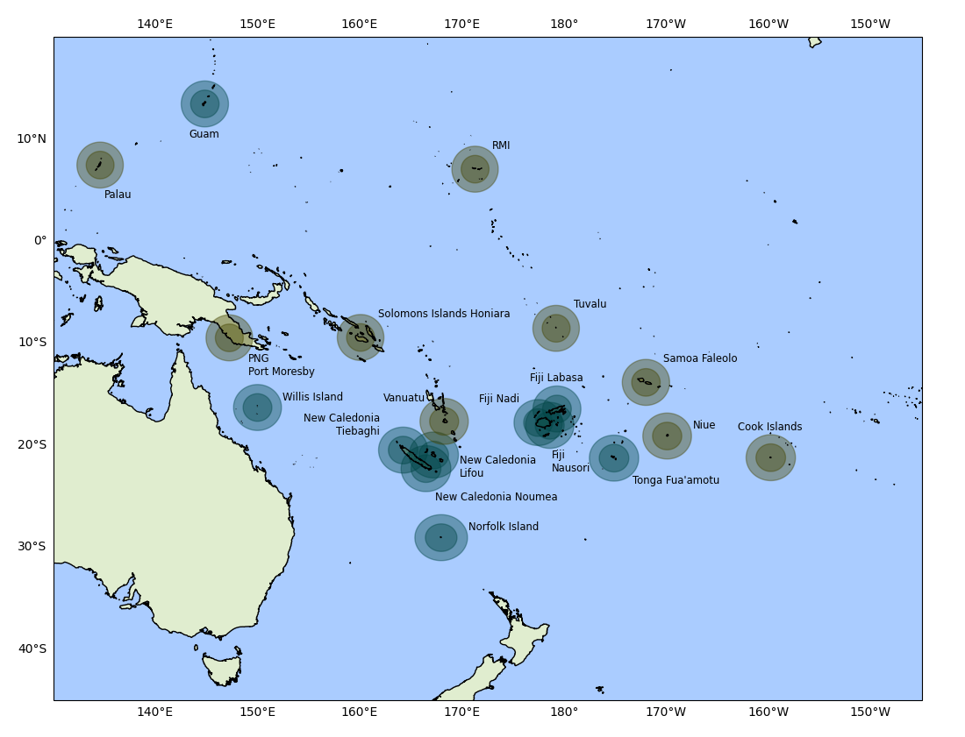
Figure 1 - Existing and Planned Radars in the Pacific
The Weather Ready Pacific Decadal Plan also lists possible future radars across the Pacific. Figure 1 shows the range coverage of all listed existing and planned weather radar stations.
Legend – Radar Coverage
Green circles: Existing radar sites
Yellow circles: Planned radar sites
Coverage zones: 150 km (inner circle) and 250 km (outer circle)
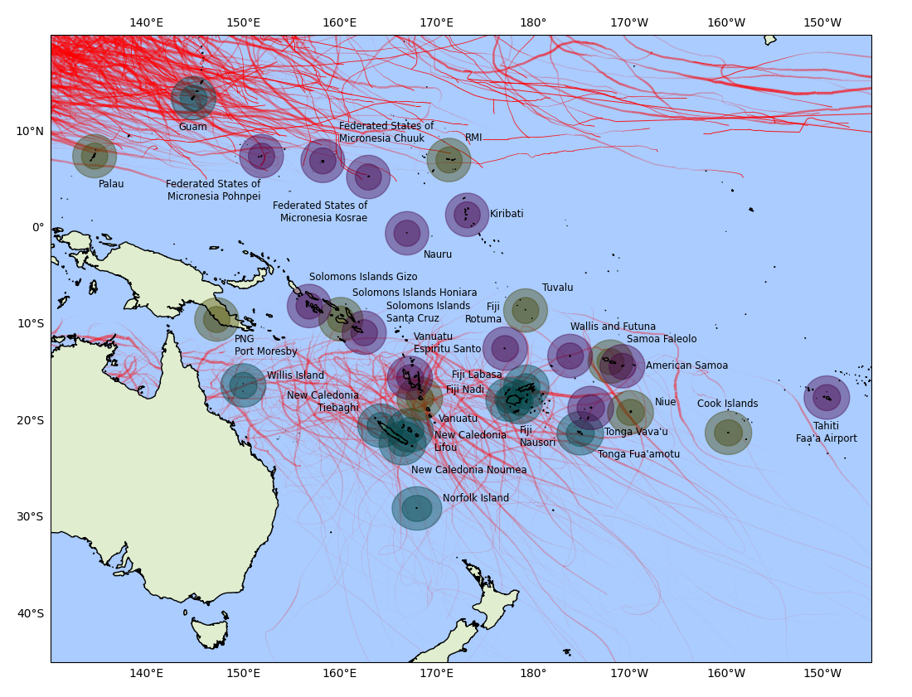
Figure 2 - Existing, planned and potential radars overlaid with tropical cyclone tracks (1975-2025)
Figure 2 presents the same radar coverage information shown in Figure 1, with the addition of newly identified potential radar locations, which are labelled for clarity. This figure also overlays historical tropical cyclone tracks recorded between 1975 and 2025. Figures 3 and 4 provide closer‑scale views of these radar sites and cyclone tracks, separated into North Pacific and South Pacific regions.
Legend – Radar Coverage
Green circles: Existing radar sites
Yellow circles: Planned radar sites
Purple circles: Potential radar sites
Coverage zones: 150 km (inner circle) and 250 km (outer circle)
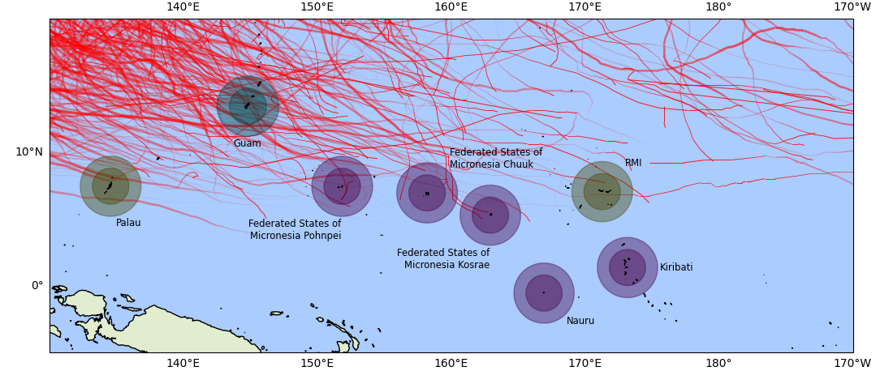
Figure 3 – Close up of the Northern Pacific islands - existing, planned and potential radars overlaid with tropical cyclone tracks (1975-2025)
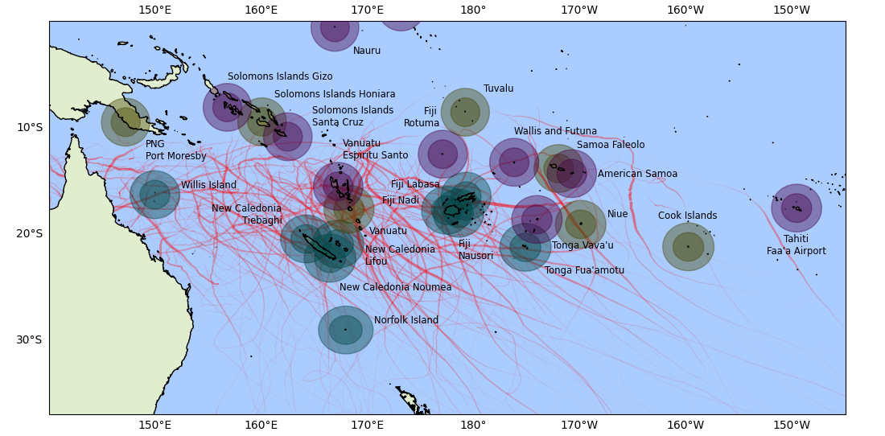
Figure 4 - Close up of the Southern Pacific islands - existing, planned and potential radars overlaid with tropical cyclone tracks (1975-2025)
These potential radars and their coverage are overlaid with a heat map of historical tropical cyclone tracks. Considering tropical cyclones only, the radar locations with the most potential to add to the regional coverage are Vanuatu Espiritu Santo, Tonga Vava’u and Solomon Islands Santa Cruz. However, final site selection must also take into account a range of local considerations before any radar installations are confirmed at the country level.
Site selection will therefore follow a two‑step process: first, the Radar Technical Working Group will assess locations against agreed criteria at the country level; second, once a location has met these criteria, additional NHMS‑specific considerations will be applied prior to final confirmation. The methodology to be used in the two-step process is outlined in Appendix 4.

Table two below outlines the potential radar sites, along with the population numbers of each region, and the country as a whole.
Table 2 - List of Potential Sites and their populations
Country / region | # Radars | Pop. size (region/island) | Pop. size (Country total)
Federated States of Micronesia Pohnpei | 1 | 36,896  (as of 2021) | 113,160 (as of 2024)
Federated States of Micronesia Chuuk | 1 | 49,595  (as of 2021) | 113,160 (as of 2024)
Federated States of Micronesia Kosrae | 1 | 6,744  (as of 2021) | 113,160 (as of 2024)
Nauru | 1 | 11,947  (as of 2024)
Kiribati | 1 | 134,518  (as of 2024)
Solomons Islands Santa Cruz (Temotu Province) | 1 | 22,319  (as of 2019) | 819,198 (as of 2024)
Solomons Islands Gizo (Western Province) | 1 | 94,106  (as of 2019) | 819,198 (as of 2024)
Vanuatu (Espiritu Santo) | 1 | 40,000+ (as of 2020 census) | 340,815 (as of 2026)
Fiji (Rotuma) | 1 | 1,583  (as of 2017) | 884,887  (as of 2017)
Tonga Vava'u | 1 | 13,988 (as of 2021) | 100,179
Wallis and Futuna | 1 | 11,151  (as of 2023)
American Samoa | 1 | 49,710  (as of 2020)
Tahiti | 1 | 209,980  (as of 2022) | 278,786
Further validation would be required by the radar technical working group under the PICI Panel (included in recommendation 13), including detailed technical assessments and engagement with the Meteorological Offices of the respective countries for details regarding the radar sites.
The installed and planned radars are a significant program of investment for the region and, as support arrangements have not yet been finalised or decided, it makes sense to stagger new radar installations to allow support arrangements to be developed and so that they are not all due for replacement at the same time.
Recommendation 1
Further investments in new weather radars in the Pacific region should be phased where possible so that effective support and funding mechanisms can be established. Replacement of existing, ageing radars in Fiji should also be prioritised, and decisions on any new radar installations should be guided by the map in Figure 2 and the accompanying country level recommendations. A practical methodology for assessing the priority order and readiness is suggested in Appendix 4 - Criteria for Installing New Radars.
Radar are complex items of infrastructure with very significant ongoing costs. Weather radar represents arguably the most complex instrument that a meteorological service or service provider must service and maintain.
Before installing a radar or accepting a radar from a donor, countries and implementing entities need to assess the readiness of the national meteorological service to own and operate a weather radar. A proposed framework is given in 3.
Table 3 - Criteria for installing new weather radars
Criterion | Measure
Assess the social and economic benefits of the radar and ensure that the benefits outweigh the costs. Regional benefit can be included in this calculation. | Benefits outweigh lifetime cost
Calculate the total cost of ownership over the life of the radar (assume 15 years) and, in particular, the annual running costs per annum, including staff. If funds cannot be sourced internally (from government) or externally (through a regional mechanism), the radar should not be installed. | Future expenses are covered by funding commitments
Assess the service capability of the national meteorological service, in particular the ability to utilise radar data in forecasting operations and run a 24/7 warning service. If there is no 24/7 warning service, the utility of the radar will be severely limited. | NMS has 24/7 warning capability and preferably a website or app
Examine the national meteorological service’s maintenance capability and whether it is able to maintain its existing observational infrastructure before accepting a weather radar. | NMS is maintaining its existing infrastructure to a high standard
Assess join ventures and partnerships, with partners especially in socio-economic developments happening in and around the radar site e.g. solar farm | Cost sharing
Radars on their own do not generate downstream benefits. Donors, implementing entities and governments need to assess the service capability of the national meteorological service, in particular the ability to utilise radar data in operations and run a 24/7 warning service. If there is no 24/7 warning service, the utility of the radar will be severely limited.
Recommendation 2
Before installing new radars, the criterion listed in Table 2 should be applied to ensure that the radar installation is sustainable and that there are systems in place to derive downstream value.

Siting and Network Spacing
As can be seen from Figure 1, the potential locations for radars in the Pacific are limited. Full regional coverage is not possible and, instead, radars will be located to maximise coverage of exposed and vulnerable populations and to support infrastructure such as airfields and ports.
Ideally, radars should be located around 20-30 km from the area of interest to minimise any short-range effects. However, this may not be feasible or practical in many smaller countries and a possible solution is to locate the radar at the NMS or at the nearest airport. Radars also need to avoid sources of interference, in particular wind turbines which can cause significant clutter in the returning signal.
For regional coverage, a separation of 250-400 km is acceptable in terms of achieving maximum coverage. Given that a significant portion of the rainfall and storm systems are convective, placing radars closer than 150 km may be of limited benefit in the context of usage in the Pacific.
Recommendation 3
Radars should be located to maximise local benefits and maximise regional coverage. For reasons of infrastructure and technical support it is recommended to locate radars at or in close proximity to NMS headquarters in each country.

Scanning Strategies
To the extent possible, scan strategies should also be harmonised to support regional data integration. This includes volume coverage patterns (VCPs), update cycles, and elevation angles. Consistent scan protocols enable better alignment of radar outputs for composite imagery, regional nowcasting, and assimilation into numerical weather prediction models. For forecasters working in regional centres, consistent scan strategies will reduce the discrepancies between different radars and streamline processing into downstream products and services.
To achieve this, the radar controllers will need to be synchronised regularly to minimise drift and reduce co-interference. All radars should nominally commence their scans pointing due north and scan cycles should be harmonised, preferably at 5 or 6 minutes. Exact harmonisation is not critical, but synchronisation will be required perhaps once or twice per day.
Recommendation 4
To achieve the full benefits of regional coverage, it is advisable that the scan strategies be synchronised across the region.

Frequency Management
Frequency management involves assigning radar operating frequencies in a way that minimises overlap and interference and ensuring that radars are properly licensed to provide protections for the frequencies on which they operate and to ensure their emissions are properly managed.
Radio spectrum licensing remains the responsibility of individual national authorities. Each radar installation will require a radio licence issued in accordance with the procedures of the relevant country or jurisdiction, typically based on an application specifying the operating frequency, transmission power, and modulation characteristics.
As the Pacific region moves toward a coordinated, multi-national radar network, effective frequency management will be essential to its operation. Radar systems operating in overlapping coverage zones must be carefully coordinated to avoid co-interference, which can degrade data quality and reduce system reliability.
The WMO Guide to Operational Weather Radar Best Practices (WMO-No. 1257) highlights the importance of frequency planning in regional radar networks. Volume IV of the guide, focused on radar siting, configuration, and scan strategies, provides technical recommendations for harmonising radar operations across national boundaries.
From a regional coordination perspective, this does not require changes to national licensing arrangements. Rather, it requires coordination on the selection of radar operating frequencies, for example by agreeing a small set of standard C‑band frequencies and allocating individual radars a frequency that differs as much as practicable from neighbouring systems.
Recommendation 5
Radar frequency allocation will need to be coordinated across the region to minimise any risk of interference.

Interoperability
In the Pacific, where meteorological services must often collaborate across borders and share data in real time, ensuring that radar systems can operate seamlessly together is essential for coordinated hazard monitoring, early warning, and other use cases. Data interoperability is an important consideration. This ensures that outputs from different radars can be integrated into regional systems and be used in regional centres that are providing forecast and warning coverage for their neighbours.
Radar data should be shared using common data standards and in a standard format. The WMO-endorsed format is netCDF FM 301 CfRadial2.
Recommendation 6
Radar data should be exchanged regionally in WMO standard format, specifically FM 301–CfRadial2, and using WIS2.0 protocols.

Technology

Radar Frequency Bands
Weather radar systems operate across different frequency bands, each with distinct characteristics that influence their suitability for various operational environments. The three primary bands used in meteorological applications are X-band, C-band, and S-band. This section outlines the advantages and disadvantages of each, with a strategic recommendation for the Pacific region.
X-band Radar (8–12 GHz)
X-band radars offer high spatial resolution and are compact and relatively inexpensive to deploy. They are well-suited for short-range, high-resolution applications such as urban hydrology, operational flight control at airports, or research. However, their limited range and high susceptibility to signal attenuation in heavy rainfall make them unsuitable for tropical environments and regional-scale monitoring. X-band radars are available with solid state or magnetron-based transmitters.
C-band Radar (4–8 GHz)
C-band radars provide a good balance between range, resolution, and cost. With a range of up to 400 km, depending on antenna size, they are widely used by national meteorological services and offer moderate resilience to attenuation by tropical rainfall. While attenuation can still be an issue during intense events, dual-polarization and signal processing techniques can partially mitigate these effects. C-band radars are available with solid state or magnetron-based transmitters.
S-band Radar (2–4 GHz)
S-band radars are the largest and most expensive radars available. They are highly effective in tropical environments due to the minimal signal attenuation, even in severe weather. They offer long range of up to 400 km. However, these benefits come with significant trade-offs. S-band systems require substantial upfront investment, including larger antennas, more complex siting requirements, and higher power and infrastructure demands. S-band radars are currently mainly available with klystron-based transmitters although there a number of solid state options entering the market, but not many in operational use.

Transmitter Technology
The choice of transmitter technology is an important one, with impacts on ongoing maintenance and costs, as well as on downstream products.

Magnetrons
Magnetrons have been the primary technology used in weather radars over the past few decades. When operated at a conservative duty cycle, magnetrons are cost-effective, efficient, and robust radar transmitters that deliver high peak power, making them suitable for many weather radar systems. However, the industry trend is clearly away from magnetrons, and they are expected to become harder to obtain and even more expensive over the operational lifespan of a radar. Magnetrons also have a limited lifespan, requiring periodic replacement (every 4 to 5 years at a significant cost).
Magnetrons are less stable in phase, leading to lower data quality and less effective clutter rejection. They also generate spurious RF that can cause interference to other spectrum users, which tends to increase with ageing. Expensive waveguide filters must be installed to mitigate this.
Solid State Power Amplifiers
Solid-state power amplifiers (SSPAs) offer excellent frequency stability, reliability, and longevity, making them ideal for modern Doppler and polarimetric weather radars. They enable coherent transmission, modular redundancy, and easier maintenance since failed modules can be replaced without major downtime. However, SSPAs typically provide lower peak power than magnetrons, using pulse compression or multiple combined modules to achieve comparable performance.

Rain Attenuation
Rain attenuation of radar signals increases with rain intensity, and this effect is particularly pronounced for X-band frequencies. This severe attenuation results in a substantial reduction in the radar’s effective range and accuracy. C-Band or S-Band radars suffer much less from this effect which is shown in Figure 1.

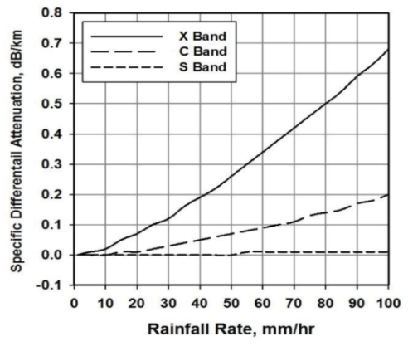
Figure 3 - Attenuation of the weather radar frequencies based on rainfall rate

The Rain Zone Map (below) based on an ITU technical report, categorizes the world into 15 zones based on rain rate, from lowest to highest. The Pacific Islands fall within the highest rain rate zones, where rain rates can reach up to 145 mm/hr.

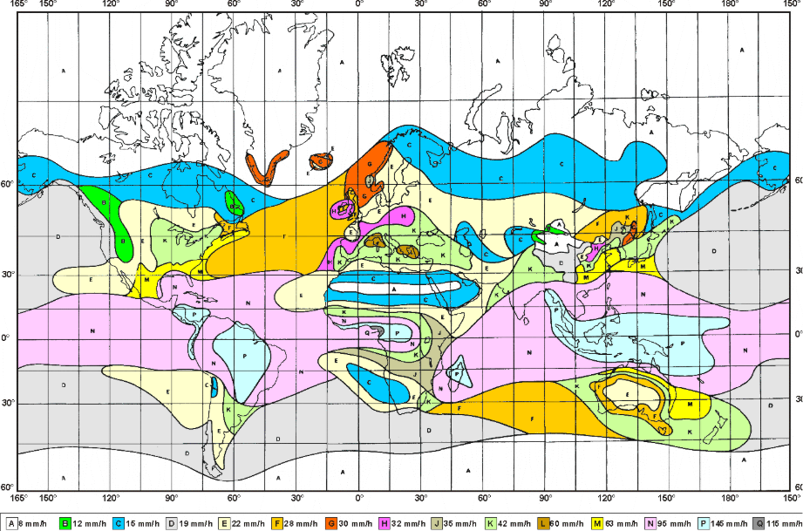
Figure 4 - ITU-R PN.837 Rain Zone Map categorizes the world into 15 zones based on rain rate.
At these intensities, the calculated attenuation for an X-band radar in horizontal polarization is over 7 dB per km. This level of attenuation drastically reduces the maximum range to as little as 3 km, which severely limits its usefulness in operational meteorology. In contrast, C-band radars, experience significantly less attenuation under the same conditions.

Calibration
Solid-state radar transmitters generate stable, repeatable output power and frequency over time, unlike magnetron-based systems whose characteristics drift with age and temperature. The solid-state modules operate at lower power but in highly consistent phase and amplitude. As a result, system calibration can be maintained, eliminating the need for frequent manual calibration and reducing downtime and maintenance costs.

Standardisation
The analysis in the previous sections provides a clear way forward. In summary, the high rainfall intensity in the Pacific Islands will significantly attenuate X-band radar signals, limiting their range and accuracy. C-band or S-band radars, with their lower attenuation rates, offer a more reliable solution for weather forecasting and coordination between agencies in the Pacific which we will look at in more detail in the next section.
C-band radar provides a more balanced solution, offering sufficient range and resilience for regional monitoring, with lower costs and more manageable infrastructure needs. For a regional strategy that prioritises scalability, sustainability, and cost-effectiveness, C-band radar is recommended as the preferred technology.
Radars based on solid state technology are also preferable for a number of reasons: reduced maintenance requirements and no requirement to replace magnetrons multiple times throughout the lifetime of the radar. Solid state radars also maintain steady calibration over their lifetimes which further reduces maintenance and the need for highly specialised staff. From a safety perspective, solid state radars have much lower internal operating voltages and are less of a hazard to maintenance personnel.
It is recommended to standardise on C-band, solid state radars across the region.
After considering a range of options reviewed by the PMC, the region, through SPREP, established a preferred supplier panel for radar systems through an Expression of Interest (EOI), which should be used by members and implementing entities when purchasing radars.
Recommendation 7
To the extent possible, weather radars should be standardised across the region to simplify maintenance and support, and to reduce ongoing operating costs. To achieve this, the preferred supplier panel for radar systems being established by WRP should be used to ensure standardisation. The proposed standards are provided in Appendix 1.

People

Regional and National Capability
Meteorological radars require specialised technicians to conduct maintenance and rectify faults. Currently, within the region, technical expertise relating to radar is limited to Fiji, Tonga and Vanuatu. Effectively supporting a regional radar network will require significant capacity development and training at the regional and national levels.
We can consider three levels of support for radars:
- Level 1: basic maintenance and fault finding conducted by technicians with limited training in radar, as part of their normal duties.
- Level 2: more complex maintenance, fault finding and basic repair – such as swapping out components – conducted by specialised radar technicians
- Level 3: complex fault finding and repair above and beyond that able to be undertaken by radar technicians – may be referred to a vendor or centre of high-level technical expertise
In the context of the Pacific, it is envisaged that Level 1 support will be carried out by field technicians based in country, generally within the NMHS. For the larger regional NMHS, with greater technical capability, Level 2 maintenance may also be carried out internally. However, for those countries with small populations and limited technical capability, a regional technical team will be required to support radar maintenance and fault rectification.

Radar Technicians
To effectively operate and maintain their weather radar systems requires qualified and trained field technicians. Training as a radar technician is somewhat specialised and normally requires a prerequisite qualification of a degree or diploma in electronics or electrical engineering.
Based on guidance from the World Bank, based on a survey of countries operating weather radars, for one radar, three field technicians are recommended to allow reliable operation in the case of the absence of one employee. The nature of weather radars, and some of the safety considerations, mean that a minimum of two staff is required for a site visit. Both of the staff visiting should be trained in radar maintenance and safety.
As the number of radars in the network grows, the number of field technicians per station may be reduced below this 3:1 ratio, but this will be dependent on two factors. Firstly, the availability and capability of technicians in the NMHS (or drawn from across other areas of government or private industry, such as telecommunications), and secondly the reliability of the installed radar systems. To achieve the desired ratio of staff to radars will require a combination of national, regional and supplemental capabilities.
At the national level, to provide Level 1 support, technicians will need to receive radar training from the manufacturer, specific to the radars installed. For those smaller NMHS where staff with the necessary prerequisite qualifications may not exist, it may be necessary to locate appropriate staff from technical roles elsewhere in government.
For Level 2 support, larger countries such as Vanuatu and Fiji may be self-sufficient. Smaller countries will require the establishment of a regional support model. The enormous expanse of the Pacific means that it is not feasible to support all radars with a single technical hub. A model utilising a number of regional hubs, in Fiji (Nadi) and Vanuatu (Port Vila), with additional support from New Zealand (Auckland), the Philippines (Manila), Australia (Darwin) and the United States (Honolulu) could be a solution.
A support mechanism will be dependent on securing sufficient funding to cover staff time, travel, logistics, and any additional training that is required. Funding arrangements are discussed in Section 10.
Recommendation 8
Radar procurements should include training in maintenance, fault diagnosis and repair for radar technicians and other operational staff. Training should be extended to operational staff from neighbouring countries and regional hubs, once established.
Recommendation 9
Establish regional technical arrangements to provide maintenance and fault rectification support to countries that lack the capacity or capability to fully support themselves.

Meteorologists
To obtain any benefit from weather radar, meteorologists and other operational staff such as observers (meteorological technicians) will need to undertake specialised training. Currently there is limited experience in the region in the use of radar data. Initial training, as well as refresher courses need to be included in the initial radar procurement. Training should include use of proprietary software as well as use of any visualisation or forecast platforms.
Given that radar will be new to the Pacific NMHSs, training needs to be considered carefully and delivered in phases so that there is proper upkeep and updating of skills over time. Ongoing mentoring and case study writing will be extremely important to embed radar meteorology in forecasting thinking and processes.

Recommendation 10
Radar procurements should include training in the use of the data for any operational staff including meteorologists and observers or meteorological technicians. Training should be extended to other users such as air traffic controllers, and operational staff from neighbouring countries.

Safety
Radar systems pose several safety risks that must be carefully managed. The most widely recognized concern is electromagnetic radiation, particularly from high-power transmitters operating in the microwave spectrum. While weather radars are generally designed to minimize human exposure, prolonged or close proximity to an active antenna can exceed safe limits and cause tissue heating or burns. To mitigate this, radars must be equipped with clearly marked exclusion zones, interlocks, and warning systems to prevent personnel from entering hazardous areas when the transmitter is active. Proper grounding and shielding also reduce the risk of electromagnetic interference with nearby electronic equipment and communication systems.
Beyond radiation, radar installations present multiple physical and electrical hazards. Towers and antenna mounts can reach tens of metres in height, exposing workers to fall risks during installation or maintenance—especially in high winds or wet conditions. Electrical hazards arise from high-voltage power supplies and lightning protection systems, requiring strict adherence to lock-out/tag-out procedures and proper insulation. Mechanical hazards also exist from rotating antennas and drive mechanisms, which can cause crush or entanglement injuries if safety guards are bypassed. Effective radar safety management therefore combines engineering controls, training, and operational procedures to ensure safe maintenance and operation in often remote or harsh environments.
Recommendation 11
Safety should be considered at all stages of any radar project, from installation to maintenance to end of life and safety training should be provided as part of the radar deployment and repeated at regular intervals.

Community of Practice
Many NMHSs face isolation, limited access to specialist training, and challenges in retaining skilled staff. An important way to share knowledge and expertise, build sustainable capacity and provide peer-to-peer support is through a structured Community of Practice. This also strongly aligns with the Pacific led approach.
A community of practice allows discussion of case studies, lessons learned and, for smaller services, provides a source of peer support and advice. Such a group will be enabled by the regional exchange of radar data and would strongly benefit from an online platform, shared archive and common visualisation system.
Recommendation 12
Establish a peer-to-peer Community of Practice in the region, connecting meteorologists, meteorological technicians and other users of radar data in the region.

Radar Technical Working Group
Establishing a radar technical working group under the PICI Panel is recommended to drive coordinated, region-wide integration of weather radar systems. A Radar Technical Working Group would provide a structured mechanism to develop a shared coordination framework and guide regional integration efforts. It could harmonise frequency allocations, scan strategies, and synchronisation approaches, and support consistent data archiving and regional/global data sharing. It would also ensure alignment with agreed regional standards and good practice, ultimately improving radar reliability, data quality, and system sustainability across the Pacific.
Recommendation 13
Establish a radar technical working group under the PICI Panel to ensure alignment with agreed regional standards and good practice.

Gender Equality, Disability and Social Inclusion (GEDSI)
Gender Equality, Disability and Social Inclusion (GEDSI) is central to achieving equitable and effective outcomes in weather and climate infrastructure. In alignment with the WRP GEDSI Strategy 2025–2033, radar infrastructure projects will adopt a transformative twin-track approach—simultaneously mainstreaming inclusion across all technical operations while delivering targeted interventions that responds to the diverse needs and capabilities of Pacific communities.
GEDSI considerations must be embedded across all stages of radar infrastructure planning, implementation, and management. To ensure alignment with regional priorities and good practice, radar projects will consider the following Key Priority Areas as in the WRP GEDSI Strategy:
- Inclusive Risk Understanding and Early Warning Systems for All: Radar implementation means ensuring investing in the "last mile" to reach the hardest-to-reach communities where the gap between a warning issued and a warning received is most critical.
- Gender-Transformative Approaches: Prioritising inclusive participation and equitable access to benefits. It emphasises empowering Pacific peoples in all their diversity to anticipate, prepare for, and respond to disasters.
- Holistic Disability Inclusion: Infrastructure and technical design must respond to the diverse capabilities and needs of Pacific communities. Communication protocols will ensure that radar-derived alerts are both accessible and actionable for persons with disabilities.
- Institutional Strengthening and Capacity Building: All radar project staff and partners are encouraged to engage with ongoing GEDSI training to ensure technical investments are managed through an inclusive lens.
- Deepening Social Inclusion and Community Engagement: Infrastructure planning will leverage community-led networks to ensure that radar data serves everyone, regardless of age, gender, or disability.

Recommendation 14
Radar projects should follow the WRP GEDSI Strategy 2025-2033 Implementation teams are to integrate GEDSI-disaggregated indicators into monitoring, evaluation, and learning (MEL) frameworks to address systemic barriers and ensure that all related activities are inclusive, accessible, and equitable for all individuals, particularly those in underserved groups.

Data and Downstream value

Integration with Forecast and Display Systems
Integrating radar data with display and forecast systems enhances real-time monitoring and short-term prediction. Modern workstations merge radar imagery with satellite and surface observations, providing a clear, composite picture of evolving weather. Quality-controlled radar mosaics give seamless national or regional coverage, supporting both public forecasts and aviation operations.
Effective display tools allow meteorologists to overlay radar products with model output or other observations such as lightning data, improving interpretation and situational awareness. Integrated forecast systems use radar-derived products such as rainfall rate, storm motion, velocity products including vertical wind profiles and echo tops to drive automated alerts and short-term predictions. Interactive radar display functions allow meteorologists to investigate convective cell cross sections and storm cell tracking which significantly enhances severe thunderstorm forecasting and monitoring.
These systems can combine radar observations with extrapolation and tracking algorithms to produce near real-time forecasts of storm movement and intensity. Rapidly advancing AI technology is significantly contributing to this process. This integration allows meteorologists to issue more targeted warnings and updates, improving the timeliness and accuracy of hazard information for users and emergency services.
Recommendation 15
Radar projects need to include provision of data to local display and forecasting platforms, where they exist, and training in the use of radar in these systems.

Workflows and Operating Procedures
The integration of radar data into the regional NMHSs will be a significant change to be managed. The real-time intelligence delivered by radar will open up new possibilities in terms of service provision to the country’s population.
In addition to integration of radar data into visualisation systems and training of staff in the use of the data, the delivery of value from radar systems will require updates to standard operating procedures and development of new products and delivery mechanisms. This could include updates to the NMHS website or application as well as new classes of warnings and advisories.
Existing severe weather warning products and SOPs will require updating/enhancing or new ones designed to benefit from radar capabilities. Integration of IBFWS will also need to be considered. For sustainability, a Pacific network of radar meteorology experts will need to be addressed. Impact of this will also need to be measured/recorded to demonstrate Return on Investment (ROI). The meteorologist training will require a holistic approach.
Recommendation 16
Radar projects will need to consider the full value chain including development of new products, new delivery channels, changes to standard operating procedures and sustainability.

Regional Data Exchange
An important consideration for a regional radar network is data exchange between countries. Regional radar data exchange is vital for effective weather monitoring and early warning across national boundaries. Severe weather systems such as tropical cyclones operate at regional scale, so sharing radar data ensures continuous coverage and earlier warnings as well as more accurate tracking. Collaborative data exchange also supports capacity building and facilitates forecast and synoptic discussions between regional NMHSs.
For those centres operating in a supporting role, access to radar data from the supported countries will be critical to the ability to provide timely and effective warnings. In future, as numerical weather prediction and AI-based systems increase their ability to assimilate radar data in real time, the regional and global exchange of radar data will become even more important.
Recommendation 17
Radar projects should facilitate the real-time regional exchange of radar data in standard formats.

Data Management, Archive and Access
Modern weather radars generate high volumes of data which need to be managed. Whilst radar data primarily have immediate, real-time value, the data also have significant value in post-analysis of events, for research and climate analysis, for training purposes and, in future, for reanalysis.
It is, therefore, critically important to archive radar data, with its associated metadata, for future use. From a regional perspective, it would also make sense to archive data in a standard way, with standard retention policies, formats and metadata standards across the region. This will facilitate future value extraction from the data. To the extent possible, WMO frameworks such as the weather radar database should be used.
Recommendation 18
A consistent data archive and access policy should be developed and followed by all NMHSs and donors deploying radars in the region.

Safeguarding
Environmental and Social Safeguards (ESS) are an essential consideration for the planning, design and management of weather infrastructure in the Pacific. This strategy recognises that safeguarding processes will follow the Weather Resilience Programme Operations Manual, ensuring consistency with regional standards and good practice.
The intent is to promote infrastructure that not only strengthens climate and disaster resilience, but also protects communities, cultural heritage and ecosystems.
Implementing partners are encouraged to:
- Integrate ESS considerations early in project design and planning.
- Ensure meaningful community engagement and respect for traditional governance and land systems.
- Apply the principle of “do no harm” to both people and the environment.
- Promote inclusive participation, equitable access to benefits, and transparent decision-making.
Once released, the WRP Operations Manual, specifically the WRP ESS chapter, will contain a screening checklist(s) to ensure that potential risks are identified from the very beginning. This checklist(s) is to be used for the initial screening of all WRP activities to determine potential environmental and social risks.
Recommendation 19
All radar projects, from inception, should be screened against the ESS checklist within the WRP Operations Manual.

Funding and Lifecycle Management
Ensuring the long-term sustainability of weather radar systems is one of the most critical challenges facing National Meteorological and Hydrological Services (NMHSs) in the Pacific. While radar technology offers significant capabilities, its benefits can only be fully realized when systems are properly maintained, staffed, and supported over their entire lifecycle. The World Meteorological Organization (WMO) emphasizes that sustainability must be considered from the outset in the planning of operations, maintenance, upgrades, and eventual replacement.

Total Cost of Ownership
Assessing the Total Cost of Ownership (TCO) provides a structured approach to long-term financial and operational requirements. It enables NMHSs and regional stakeholders to make informed decisions about radar acquisition and network design, ensuring that systems are not only technically appropriate but also affordable and maintainable. As highlighted in the WMO Guide to Operational Weather Radar Best Practices, a failure to plan for sustainability can lead to underutilised or non-functional systems, undermining the very purpose of the investment.
For the Pacific, where NMHSs in general have very limited operating budgets, assessing and minimising the total cost of ownership is critical for sustainability. In particular, the annual cost or operations beyond the end of the original funding project need to be understood. Wherever possible, up front investments should be used to reduce these ongoing costs for the lifetime of the radar.
Ongoing costs include:
- Site lease or rental costs
- Electrical supply to the radar station, including:
  - Radar system
  - Auxiliary systems (security, telecommunications)
  - Ventilation, heating or cooling
- Radio frequency licenses
- Cost of telecommunication link to the data centre
- Cost of maintenance of radar station infrastructure, equipment room, tower, radome, fence, etc.
- Security
- Upgrades and software licence fees
- Spares (if not included in a service-level agreement).
- Refresher training for meteorologists and technicians

Minimising Ongoing Costs
For each of the line items listed above, it may be possible to reduce ongoing costs to the NMHS by strategically investing during the project phase. For example, investing in solar panels and batteries, whilst increasing the cost of the initial build, will significantly reduce the ongoing costs of electricity supply in the long run. It should be noted that electricity supply costs in the Pacific are amongst the most expensive in the world. Investing in batteries also provides a buffer against power outages or irregular supply voltages.
Table 4 provides some further examples of ongoing costs and outlines potential actions that can be taken at the investment stage to reduce the long-term financial burden on NMHSs.
Table 4 - Minimising ongoing costs
Cost Item | Cost Mitigating Measure (where feasible)
Site lease or rental costs | Locate radar on government land where possible  Secure long-term lease arrangements with fixed costs
Electrical supply | Install solar panels and battery to minimise draw on grid power and contributing to the grid where feasible.
Radio frequency licences | Obtain long-term licences during project phase
Telecommunications | Invest in microwave or fibre links where feasible
Maintenance | Pre-purchase spares to cover 10 years of operation
Upgrades and software licences | Pre-purchase perpetual licences and upgrades
Refresher training | Repeat training to be included in purchase, train the trainer
Recommendation 20
Where possible, radar projects should maximise upfront investments where these have the potential to mitigate ongoing running costs once the project is completed.

Potential Funding Arrangements
As previously noted, radars are amongst the most expensive and complex items operated by NMHS globally. Although some costs can be front loaded in radar procurements, there will always remain a significant ongoing cost. And given the limited operational budgets available to Pacific NMHSs, consideration needs to be given to additional funding to support longer-term operations and maintenance over the life of the radar.
A pooled maintenance fund would provide a sustainable mechanism for ensuring the ongoing operation of Pacific weather radars through shared regional resources. Rather than each National Meteorological Service struggling to budget for repairs or spare parts, countries and donors would contribute annually to a collective fund that supports preventive maintenance, regional technician deployments, natural disasters and urgent interventions.
The fund could be managed through an existing regional institution, with oversight by the WRP Steering Committee or Pacific Meteorological Council. By aggregating resources and coordinating maintenance activities, the pooled fund would enable economies of scale, ensure continuity of service, and strengthen regional self-reliance in radar operations.
The fund could be used to support a range of support activities:
- Supporting a regional maintenance hub as outlined in Section 7.2
- Providing funds to pay for maintenance and fault-rectification visits from neighbouring NMHSs
- Ongoing training for regional radar technicians
- Additional spares
- Ongoing training for meteorologists and meteorological technicians
- Support to NMHS for paying ongoing costs
- Responding to radar damage caused by a natural disaster
Recommendation 21
Establish a pooled radar support fund, contributed to by countries and donors, to support regional radar maintenance and ongoing support.

Appendix 1
Technical Recommendations for Weather Radars
Recommendation | Justification
Radars should be C-band | S-band is expensive, complex  Good range for convective precipitation  Regional consistency  X-band lacks range and is attenuated by heavy rain
Radars should be dual polarisation | Required for addressing rain attenuation  Assists in detecting squalls and other wind events  Allows phase detection  Improved decluttering
Radars should be solid state | Lower failure rates  Reduced infrastructure (with transmitter/receiver in radome)  Reduced length of waveguides and less moving parts  Reduced maintenance and tuning  Safer operation (lower voltages and peak power)  Eliminates expensive consumables (magnetron)  Better management of out of band emissions, occupied bandwidth, and frequency stability  Failed components can be replaced off the shelf  Potentially lower power consumption  Magnetrons are likely to be phased out by manufacturers over the next decade, becoming progressively harder to source
Products should be produced in standard formats | Required for regional data exchange  Required for integration into existing or future forecast and visualisation platforms
Radar installations should include solar generation and battery backup | Reduces or eliminates ongoing power costs for the radar and supporting systems  Provides consistent power in areas where grid power is unreliable  Provides grid-independent continuity in the event of local blackouts, especially during weather events
Radar purchases should include standard spares | Holding spares in-country reduces return to service times  Pre-purchase of spares reduces ongoing operating costs

Appendix 2
Recommendations and Strategic Goals
No. | Recommendation | Coverage | Sustainability | National and Regional Capability | Service Delivery | Funding | Equity
1 | Further investment in Pacific weather radars should be phased to allow strong support and funding mechanisms, while prioritising the replacement of ageing Fijian radars and using Figure 2 and its country-level recommendations to guide decisions on any new installations. |  | x | x |  | x
2 | Ensure that the radar installation is sustainable and that there are systems in place to derive downstream value. |  | x | x | x |  | x
3 | Radars should be located to maximise local benefits and maximise regional coverage | x |  |  | x |  | x
4 | Scan strategies be synchronised across the region. | x |  |  | x
5 | Radar frequency allocation will need to be coordinated | x | x
6 | Radar data should be exchanged regionally in WMO standard format | x |  |  | x |  | x
7 | Weather radars should be standardised and procured via the WRP preferred supplier panel for radar systems. |  | x | x | x
8 | Training in maintenance, fault diagnosis and repair |  | x | x | x
9 | Establish regional technical arrangements |  | x | x |  |  | x
10 | Radar procurements should include training in the use of the data |  |  | x | x |  | x
11 | Safety should be considered at all stages of any radar project |  |  | x |  |  | x
12 | Establish a peer-to-peer Community of Practice |  | x | x | x |  | x
13 | Establish regular meetings of a peer-to-peer radar working group |  | x | x | x
14 | Radar projects should follow the WRP GEDSI Strategy |  | x |  |  |  | x
15 | Radar projects need to include provision of data to local display and forecasting platforms |  |  | x | x |  | x
16 | Radar projects will need to consider the full value chain |  | x | x | x |  | x
17 | Radar projects should facilitate the real-time regional exchange of radar data | x |  | x | x |  | x
18 | A consistent data archive and access policy should be developed |  | x | x | x
19 | All radar projects, from inception, should be screened against the ESS checklist |  | x |  |  |  | x
20 | Where possible, radar projects should maximise upfront investments |  | x |  |  | x
21 | Establish a pooled radar support fund, contributed to by countries and donors |  | x | x | x | x
22 | Radar projects should consider and facilitate and use of solar power to offset operational spending on fossil fuel. | X | X | X | X | X | X

Appendix 3
Economic Assessment Method for Evaluating New Weather Radars
1. Overview of the Assessment Method
A Cost–Benefit Analysis (CBA) is undertaken for each proposed radar investment. The analysis compares lifetime costs—capital, installation, operation and maintenance (O&M), any mid-life servicing, and decommissioning—against lifetime benefits including avoided disaster losses, aviation and marine safety improvements, reduced economic disruption, and (where relevant) regional spillover benefits. The Benefit–Cost Ratio (BCR) is calculated as PV(Benefits)/PV(Costs); a radar is economically justified where BCR > 1 or Net Present Value (NPV) > 0. In simple terms, the radar is justified when the benefits exceed the costs. Technically, this means a benefit–cost ratio above 1

2. Cost Components
- Capital costs: radar purchase, shipping, site works, power and communications, commissioning.
- Annual O&M: preventative and corrective maintenance, spares, calibration, staff, power, telecommunications.
- Mid-life servicing: major component replacements where expected.
- End-of-life decommissioning (where applicable).

3. Benefit Components
- Avoided disaster losses through improved cyclone/heavy-rain warnings and impact-based forecasts.
- Aviation safety and efficiency: fewer weather-related diversions, turn-backs, cancellations and delays.
- Marine safety and shipping reliability: fewer incidents and search-and-rescue deployments.
- Reduced economic disruption: avoided closures and service interruptions for communities and essential services.
- Regional spillovers: where coverage benefits neighbouring countries or shared airspace/sea lanes, these benefits are included either as a percentage uplift or a direct annual value.

4. Time Horizon and Discounting
Costs and benefits are projected over 15–20 years (typical radar life) and discounted to present value using a real discount rate of 3–7% (default 5%).

5. Decision Rule
The radar meets the economic criterion when BCR > 1 and/or NPV > 0. Sensitivity analysis will test key assumptions (discount rate, O&M costs, benefit percentages, and mid-life servicing).

6. Flowchart of the Economic Assessment Method

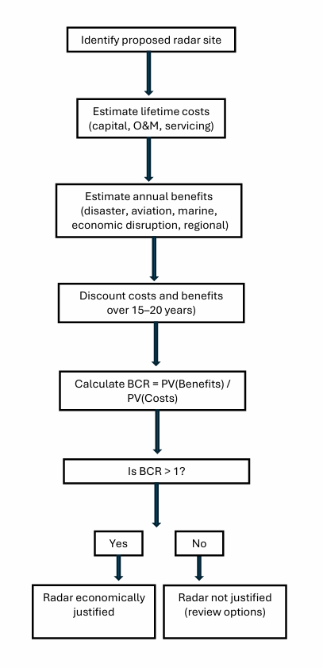

Appendix 4
Two step criteria for prioritisation
Step one:
Criteria to consider for prioritisation | Weighting (1-10)
Population size within radar's coverage radius (1000's of people) | 9
Proximity to historic tropical cyclone paths ( 1 - 10) | 9
Precipitation - from ITU-R PN.837 Rain Zone Map (Zone A=1, ZoneB =2, … ZoneQ=15 etc) | 9
Fills a hole in existing regional network spacing (1 - 5) | 5
International aviation requirements e.g. number of international airports within the radar coverage | 3
International aviation movements - total number of international flights per year (100's) | 3
Domestic aviation requirements e.g. number of domestic airports and landing strips | 3
Domestic aviation movements - total number of domestic flights per year (100's) | 3
Maritime requirements % of GDP derived from sales of fish caught from boats... number of registered local vessels?? | 3
Maritime requirements % of GDP derived from tourism involving cruise ships and yachts. Presence of international shipping lanes | 3
Step two:
Criteria to consider for capability and readiness | Weighting (1-10)
Availability of a site with suitable access, power, and comms (1 - 5) | 10
Maintenance capability of the national meteorological service (1, 2, or 3) refer to document criteria | 9
Meteorologist capability of the national meteorological service (1, 2 ,or 3) | 9
The country's ability to self-fund the ongoing operational costs (1 - 5) | 7
Country's ability to co-fund capital cost for radar installation | 7

Tracks from https://www.ncei.noaa.gov/products/international-best-track-archive - track positions with central wind speeds of 34 kts (gale) or more.
Tracks from https://www.ncei.noaa.gov/products/international-best-track-archive - track positions with central wind speeds of 34 kts (gale) or more.
Tracks from https://www.ncei.noaa.gov/products/international-best-track-archive - track positions with central wind speeds of 34 kts (gale) or more.
Data sourced from Government of the Federated States of Micronesia Department of Resources & Development website
Data sourced from The World Bank
Data sourced from Government of the Federated States of Micronesia Department of Resources & Development website
Data sourced from Government of the Federated States of Micronesia Department of Resources & Development website
Data sourced from The World Bank
Data sourced from The World Bank
Data sourced from the Solomon Islands Government Report on 2019 Population & Housing Census
Data sourced from The World Bank
Data sourced from the Solomon Islands Government Report on 2019 Population & Housing Census
Fiji: Divisions and Provinces, Major Urban Areas & Urban Areas - Population Statistics, Maps, Charts, Weather and Web Information
Data sourced from the Tonga Population and Housing Census 2021
Data sourced from the Tonga Population and Housing Census 2021
Wallis and Futuna: Islands, Districts & Major Villages - Population Statistics, Maps, Charts, Weather and Web Information
American Samoa: Division (Districts and Counties) - Population Statistics, Charts and Map
French Polynesia: Circumscriptions & Places - Population Statistics, Maps, Charts, Weather and Web Information
World Bank, 2022. Charting a Course for Sustainable Hydrological and Meteorological Networks in Developing Countries. Washington, DC: World Bank.
A simple cost–benefit calculation is used to determine whether the social and economic benefits of a new radar exceed its lifetime costs. Lifetime costs (capital, operations and maintenance, and mid-life servicing) are compared with estimated annual benefits, including avoided disaster losses, improved aviation and marine safety, reduced economic disruption, and any regional benefits. A radar meets the criterion when the Benefit–Cost Ratio (BCR) is greater than 1. See Appendix 3.
Guide to Operational Weather Radar Best Practices, Volume VII: Weather Radar Data Representation and Exchange
ITU-R PN.837 - Characteristics of precipitation for propagation modelling
World Bank, 2022. Charting a Course for Sustainable Hydrological and Meteorological Networks in Developing Countries. Washington, DC: World Bank.
‘Meteorological Technician’ here is intended to mean those who have undertaken BIP-MT qualifications as per Guide to the Implementation of Education and Training Standards in Meteorology and Hydrology, Volume I – Meteorology, WMO-No. 1083
World Bank, 2022. Charting a Course for Sustainable Hydrological and Meteorological Networks in Developing Countries. Washington, DC: World Bank.
Solid-state Meteorological Radars in the C and X Bands. Dr. Masakazu Wada, Toshiba Infrastructure Systems & Solution Corporation, Japan. © 2017 (Slide 9)
http://www.pulsesystem.com/images/TR-3600_Product_Release_Brochure.pdf

