A TEMPLATE FOR
DEVELOPING A NATIONAL ASSET MANAGEMENT PLAN
(Draft)

Who is this document for? | Staff including Network Managers, Engineers, Technicians and Observers engaged in the day-to-day operation, technical support, and maintenance of observing stations
Purpose of the document | To describe the contents of a plan for the successful operation and maintenance of  Weather Observing Systems.

Contents
Glossary 5
PURPOSE 9
1. Introduction 11
1.1 Organizational Structure 11
1.2 Operation and Maintenance Strategies 11
2. Scope of National Asset Management Plan 12
2.1 Observing stations 12
2.2 Support systems and infrastructure 12
3. Objectives of National Asset Management Plan 13
3.1 Primary objectives 13
3.2 Targets of the NAMP 14
3.3 Key Performance Indicators (KPIs) 15
4. Potential Risks and Challenges for the Implementation of the National Asset Management Plan 16
4.1 Organizational Structure 16
4.2 NAMP Strategy 16
4.3 Resources 16
4.4 Quantity and Qualification of the Staff 17
4.5 Environmental and Local Conditions 17
4.6 Site Security 17
4.7 Others 17
5. Resources for the National Asset Management Plan 19
5.1 Financial Resources 19
5.2 Human Resources 20
5.3 Technological Resources (Tools and Equipment) 21
5.3.1 Operations – network management and network maintenance 21
5.3.2 Maintenance – observing stations 21
5.4 Management of Spare Parts inventory 22
5.5 Logistic Resources 22
6. Managing the Operation of Observing Systems 23
6.1 Manual weather observing stations 23
6.2 Automatic weather stations 24
6.3 Upper air land stations 24
6.4 Metadata Management 25
6.5 Quality monitoring 25
6.6 ICT Equipment 25
6.7 Health and Safety 26
6.8 Environmental Sustainability Considerations 26
7. Maintenance of Observing Systems 27
7.1 Surface land stations 27
7.1.1 Preventive maintenance 27
7.1.2 Corrective maintenance 28
7.1.3 Field verification 28
7.1.4 Calibration 28
7.2 Upper air land stations 29
7.2.1 Preventive Maintenance 29
7.2.2 Corrective maintenance 29
7.2.3 Testing 29
7.3 ICT equipment 30
7.3.1 Preventive maintenance 30
7.3.2 Corrective maintenance 30
8. Reference Documents 31
9. Monitoring, Assessment and Update of the NAMP 33
10. Annexes 34
Annex I: Structure and Strategies 34
Annex II: Scope 36
Annex III: Example Key Performance Indicators 39
Annex IV(a): Risk register example template #1 41
Annex IV(b): Risk register example #2 42
Annex V(a): Initial investment 45
Annex V(b): Annual operation costs 47
Annex V(c): Annual maintenance costs 48
Annex V(d): Total lifecycle costs 49
Annex V(e): Total cost of ownership summary form 50
Annex V(f): Cost summary form 52
Annex VI: List of Operation and Maintenance Staff template 56
Annex VII: Maintenance of Observing Sysytems 57
Annex VII(a): Recommended exchange intervals for servicing and/or calibration. 57
Annex VII(b): Brief inspection planning checklist 58
Annex VII(c) Inspection/field verification task list 59
Annex VII(d): AWS Inspection/Field verification form 62
Annex VII(e): Station record sheets / site description form 79
Annex VII(f): Siting classification form 90
Annex VII(g): Example of installation and maintenance equipment list 101

Glossary
The following terms, when used in the present Manual, have the meanings given below.
These have been sourced from the Technical Regulations (WMO-No. 49), Volume I, the Manual on WIGOS (WMO-No. 1160), and the Guide to Instruments and Methods of Observation (WMO-No. 8), Volume III.

Accuracy: The extent to which the results of the readings of an instrument approach the true value of the calculated or measured quantities, supposing that all possible corrections are applied.
Adaptive maintenance: Modification of an instrument, software or other product, performed after installation to keep it usable in a changed or changing environment.
Automatic weather station (AWS): A meteorological station at which observations are made and transmitted automatically.
Calibration: Operation that, under specified conditions, in a first step, establishes a relation between the quantity values with measurement uncertainties provided by measurement standards and corresponding indications with associated measurement uncertainties and, in a second step, uses this information to establish a relation for obtaining a measurement result from an indication.
Certification: The provision by an independent body of written assurance (a certificate) that the product, service or system in question meets specific requirements.
Competency: The knowledge, skills and behaviours required to perform specific tasks in the fulfilment of a job responsibility.
Compliance: Adherence to an internal code of conduct where employees follow the principles of one of the quality management standards series (such as the ISO standards) or other internationally recognized practices and procedures. It could also be an external stamp of approval by an accreditation firm when customers or partners request documented proof of compliance.
Core data: Minimum set of core data that Members shall exchange on a free and unrestricted basis to underpin the services they provide for the protection of life and property and for the well-being of all nations. (see also Recommended data)
Corrective maintenance: Maintenance actions performed to repair instruments or any component of an observing station in order to restore it to operational condition after a fault, malfunction, or failure has occurred. Corrective maintenance may include repair, replacement, adjustment, or recalibration carried out in accordance with established procedures and priorities.
Co‑sponsored observing system: An observing system in which some but not all observations are WMO observations.
Data quality objectives: Definition of the type, quality and quantity of primary data and derived parameters required to yield information that can be used to support decisions.
Environmental sustainability: The practice of conserving, maintaining and protecting global ecosystems while planning observing systems across all domains without adding unnecessary strain on ecosystems.
Field verification: Process of evaluating and confirming the accuracy, reliability and operational performance of measuring instruments at their operational site against pre-defined requirements by comparing their measurements to reference or travelling standards. This verification is carried out under actual environmental conditions to ensure that instruments continue to provide reliable, consistent, and accurate data after installation.
Inspection (also site inspection and field inspection): Periodic inspection actions undertaken on site or remotely, as necessary, to monitor the correct functioning of observing stations/platforms and instruments to ensure that a standard of observations that meets its defined uncertainties is maintained, that instruments and all their indicators are functioning correctly, and that the exposure relevant to the instrument measurements are known, recorded and acceptable.
Global Basic Observing Network (GBON): A subset of the surface based subsystem of WIGOS, used in combination with the space based subsystem and other surface based observing systems of WIGOS, to contribute to meeting the requirements of Global NWP, including reanalysis in support of climate monitoring. (See also RBON)
Meteorological observation: The evaluation or measurement of one or more meteorological elements.
Meteorological observing station (Meteorological station): A place where meteorological observations are made with the approval of the WMO Member or Members concerned.
Meteorological instrument technician: A specialist technician responsible for installing, operating, maintaining, troubleshooting, and verifying meteorological instruments and observing system components.
Meteorological technician: A person who has successfully completed the requirements of the Basic Instruction Package for Meteorological Technicians.
Observation: The evaluation of one or more elements of the physical environment.
Observational metadata: Descriptive data about observational data and/or observing stations/ platforms: information that is needed to assess and interpret observations or to support the design and management of observing systems and networks.
Observing network : More than one observing station/platform, acting together to provide a coordinated set of observations.
Observing station/platform: A place where observations are made; this refers to all types of observing stations and platforms, whether surface‑based or space‑based, on land, sea, lakes or rivers, or in the air, fixed or mobile, and making in situ or remote observations, using one or more sensors, instruments or types of observations.
Observing system: One or more stations/platforms, acting together to provide a coordinated set of observations.
Operational personnel: Personnel involved in the production and provision of services (for example, meteorological, hydrological, climatological and related services) and decision support information intended for users including the general public.
Preventive maintenance: Scheduled maintenance activities carried out at predetermined intervals to prevent faults, deterioration, or failures of instruments, systems, or components. Preventive maintenance includes inspections, cleaning, lubrication, adjustments, replacement of parts, functional checks, and recalibration to ensure instruments continue to meet operational and performance requirements.
Qualification: The minimum core knowledge, usually acquired through education, required to enter a profession.
Quality: Quality is defined by ISO as “the degree to which a set of inherent characteristics fulfils requirements”.
Note: It should be noted that “quality” has no explicit meaning unless it is related to a specific set of requirements.
Quality assurance: Activities undertaken to instil confidence that quality requirements have been met. It involves the systematic monitoring and evaluation of the processes associated with the generation of a product or service.
Quality control: Activities undertaken to ensure that quality requirements have been fulfilled prior to the dissemination of a product or the delivery of a service.
Quality management: A process that focuses not only on the quality of the product but also on the means to achieve it and is centred on the following four activities: quality planning, quality control, quality assurance and quality improvement.
Quality management system (QMS): The organizational structure, procedures, processes and resources needed to ensure the delivery of an organization’s products and services.
Recommended data: Certain recommended data that should also be exchanged by Members to support Earth system monitoring and prediction efforts. (see also Core data)
Reference climatological station: A climatological station gathering data intended for the purpose of determining climatic trends.
Note: This requires long periods (not less than 30 years) of homogeneous records, where human‑induced environmental changes have been and/or are expected to remain at a minimum. Ideally, the records should be of sufficient length to enable the identification of secular changes of climate.
Regional Basic Observing Network (RBON): A network of surface-based meteorological, hydrological and related observing stations/platforms defined and adopted by the responsible WMO regional association or by the Executive Council/World Meteorological Congress. (See also GBON)
Regional Training Centre (RTC): A national education and training institution, or group of institutions, recognized by Congress or the Executive Council (following the recommendation of the relevant WMO regional association) as (a) providing education and training opportunities for WMO Members in the region, particularly staff of National Meteorological and Hydrological Services (NMHSs); (b) providing advice and assistance on education and training to other WMO Members; and (c) promoting education and training opportunities in weather, water and climate for WMO Members.
Surface observation: An observation, other than an upper‑air observation, made on the Earth’s surface.
Surface land observation: An observation, other than an upper-air observation, made at an observing station situated on land.
Surface land station: A station at which surface land observations are made.
Upper-air observation: An observation made in the free atmosphere either directly or indirectly.
Upper-air station: A surface location from which upper-air observations are made.
User requirements for observations: Requirements for geophysical variables expressed in terms of up to eight criteria: uncertainty, horizontal resolution, vertical resolution, observing cycle, timeliness, stability, layer/s quality and coverage quality, including relative priority for each of them. For each of these criteria, three values are determined:
(a) The goal is an ideal requirement above which further improvements are not necessary.
(b) The threshold is the minimum requirement to be met to ensure that data are useful,
(c) The breakthrough is an intermediate level between threshold and goal which, if achieved, would result in a significant improvement for the targeted application.
Verification: ￼The process of establishing the truth, accuracy or validity of something.
WMO Integrated Global Observing System (WIGOS): A framework for all WMO observing systems including WMO contributions to co-sponsored observing systems in support of all WMO Programmes and activities.

PURPOSE
This document describes the contents of a National Asset Management Plan (NAMP). It describes the information needed to successfully operate and maintain meteorological observing networks, including land-based AWSs.
Examples of what this may look like for different National Meteorological Hydrological Services (NMHSs), and relevant agencies are provided in the annexes.
These guidelines will enable NMHSs and relevant agencies to:
- Plan, implement and monitor the activities for operation and maintenance of the observing stations operated by the NMHS as well as those that may be operated by a third party
- Support and deliver sustainable, high-quality observations
- Contribute to traceability of measurements by implementing appropriate traceability assurance approach calibration and traceability levels as specified by WMO and adapted by Systematic Observations Financing Facility (SOFF) for Global Basic Observing Network (GBON) stations
- Identify the observing systems to be considered when planning activities under the NAMP.
- Identify existing and required resources for operation and maintenance of observing stations
- Identify gaps in resources to support the allocation of necessary resources
- Make efficient use of the resources
- Improve the capacity (skills and numbers) of staff required to carry out operation and maintenance
- Prepare system documentation
- Prepare full and complete metadata with updates, as needed
- Keep records and emergency response procedures

In accordance with the purpose of this guidance document, the following sections describe the main structure and contents of the NAMP, serving as a flexible template that Members can adapt by adding, removing, or modifying sections as needed.
Examples are included in the annexes.
Organizational structures within NMHSs will differ depending on their size, capacities, observing networks and operation and maintenance strategy.
In some instances, operations (including network management) and maintenance will be done within the same team. In others there will be separate teams responsible for operations and for maintenance. Others may have combinations of team compositions.

Introduction
This section describes the Organizational structure and operation and maintenance strategies of the (your?) agency (e.g. NMHS).
This section may cover the following:

Organizational Structure
Describe the type of organisational structure of the agency for operation and maintenance.
Examples include:
- All operation and maintenance activities are performed by the central departments (centralization approach)
- There are regional/local offices performing regular operation and maintenance activities under coordination of central departments (decentralization approach)
- The use of Co-sponsored observing systems - An observing system in which some but not all observations are WMO observations.

Operation and Maintenance Strategies
Describe the method of operation and maintenance of stations and systems in the observing network.
Examples include:
- NAMP activities are performed by staff of NMHS or agency operating observing systems, OR
- NAMP activities are performed by a third-party contractor under a maintenance contract, OR
- Operation activities performed by staff of NMHS, and maintenance activities performed by a third-party contractor under a maintenance contract, OR
- A different structure that best describes the teams, contractors, agencies responsibilities for operation and maintenance

Scope of National Asset Management Plan
This section describes the scope of the weather observing stations, systems and sub-systems that are included and excluded as responsibilities of the network management, operation, and maintenance teams.

Observing stations
Make a list of the types of stations to be operated and maintained within the scope of NAMP.
Examples include:
- Manual observing stations
- Automatic weather stations
- Climate reference stations
- Upper air observing stations
The same principles for developing NAMP can be applied to other observing stations.

Support systems and infrastructure
Describe the areas of support systems and infrastructure that are within scope of the NAMP.
These types/systems should also be described in sufficient detail to make the NAMP as clear as possible.
- Data transmission infrastructure
- Power supply infrastructure
- Describe any Service Level Agreements (SLAs)
- Physical security infrastructure
- Logistical access. E.g. road, river, sea routes
- Information and Communications Technology (ICT) systems
- Spare parts and consumables
- Maintenance, test and field verification equipment (reference or travelling standards also need to be maintained and calibrated).
If any of the above support systems or infrastructure are out of scope, then it should be described how these systems (or services) are managed. Include links and / or contact details of the teams responsible the out-of-scope dependencies.

Objectives of National Asset Management Plan
This section describes the primary objectives, related targets and key performance indicators of the NAMP.
This section will normally form part of operations plans.

Primary objectives
These are the overarching objectives of the plan.
Use this section to define and list the primary objectives of the NAMP.
Some examples of objectives include:
- Data quality objectives: Definition of the type, quality and quantity of primary data and derived parameters required to yield information that can be used to support decisions.
- The NAMP is used to make sure observation data complies with the applicable quality standards of the NMHS observing station.
- The NAMP contributes to ensuring observation data complies with World Meteorological Organization (WMO) regulations, manuals and guidelines, for example the Manual on the WMO Integrated Global Observing System, WMO-No. 1160.
- The NAMP is used to support observation data compliance with the national requirements.
- The NAMP will explain how measurement data is collected, recorded and transmitted.
- To improve and sustain the international data exchange and support compliance with WMO unified data policy.
- To improve the skills of the staff for operating weather stations.
- To ensure the safety and security of staff while performing NAMP activities.
- The NAMP is used to assist in planning the allocation and use of financial resources, human resources, and technological resources.

Targets of the NAMP
Targets are the quantifiable benchmarks needed to meet the primary objectives.
Use this section to define and list the quantifiable benchmarks.
The targets are dependent on local conditions and existing capabilities of the NMHS and AWS.
Some examples of targets include:
- Define the number of observing stations that are necessary in the observing network.
- Define the number (or percentage) of operational stations that are necessary in the observing network. As produced from a network design exercise.
- Define the required availability of each measurement (air temperature, relative humidity, precipitation measurement, etc.) that are necessary in the network.
- Define the applicable calibration standard for each measurement and the number of sensors that comply with the standard. Specify these details for each parameter to be measured.
- Define the maintenance periods and maintenance procedures for each sensor and device in an AWS.
- Define the number of spare sensors and observation devices that should be available.
- Define the time it should take to get a spare sensor or observation device.
- Define the amount of time it should take to repair an observation sensor / component.
- Define the AWS metadata and the methods for updating the metadata.
- Define timeliness requirements to update metadata. Define the mandatory training courses for the NMHS staff to operate and maintain the observing stations.
- Define the review periods of the risk assessments to operate and maintain the AWSs

Additional examples of targets are given in Annex III.

Key Performance Indicators (KPIs)
KPIs differ from targets. A target is the requirement, the KPI is the level achieved.
This section describes the measured values used to track progress towards the objectives and targets, in other words, the key performance indicators (KPIs).
This is how you can measure performance. A large difference between the target and the KPI is an indication of unrealistic performance. For example, the percentage/ratio between targets and KPIs.
Define, monitor and record the KPIs.
Examples of KPIs include:
- The number/percentage of operational observing stations.
- The number of available air temperature measurements.
- The number of available wind speed measurements.
- The number of calibrated air temperature sensors.
- The number of calibrated wind speed sensors.
- The number of maintenance visits for each observing station.
- The number (from time and date metrics) of maintenance actions for each sensor. E.g. field verification checks.
- The amount of time taken to acquire a replacement sensor / component.
- The amount of time it takes to resolve a fault.
- The number of (from time and date metrics) of metadata updates.
- The number, status and validity dates of mandatory courses that staff have completed.
- The number of risk assessments that are in (or out of) date.
- The number and type of occupational health and safety incidents that have occurred.
ETR-24: A Compendium of Topics to Support Management Development in National Meteorological and Hydrological Services, p. 239.
An example table of KPIs is given in Annex III.

Potential Risks and Challenges for the
Implementation of the National Asset Management Plan
This section describes the potential risks and challenges for the implementation of a NAMP. It describes the proposed control actions for risk management. The following headings and examples are a guide for content.

Organizational Structure
Describe or list any risks and challenges related to the organizational structure in this section.
Examples include:
- Lack of clear roles and conflicting responsibilities/priorities.
- Lack of efficient cooperation and communication between regional and central departments.
- Inefficient communication channels between departments.
- Overlapping or conflicting authority.
- Structure that is not compatible with the size and distribution of observing network.

NAMP Strategy
Describe or list any risks and challenges related to the NAMP strategy.
Examples include:
- Inadequate alignment of NAMP strategy with operational goals.
- Over-reliance on reactive maintenance instead of preventive.
- Lack of adaptability to changing conditions or technologies.

Resources
Describe or list any risks and challenges related to the allocation and usage of resources (financial, human, technical and logistics) which will affect the implementation of the NAMP.
Examples include:
- Insufficient budget allocation.
- Lack of suitably skilled human resources.
- Lack of appropriate technical tools and spare parts.
- Delays in procurement and logistics.
- Lack of calibration equipment.
- Diversity of observing systems.

Quantity and Qualification of the Staff
Describe or list any risks and challenges related the quantity and qualification of the staff assigned for operations and maintenance of observing stations.
Examples include:
- Inadequate number of skilled personnel.
- High staff turnover or lack of motivation.
- Limited training and development opportunities.

Environmental and Local Conditions
Describe or list any risks and challenges may be caused by environmental and local conditions.
Examples include:
- Harsh weather conditions affecting site access (e.g., snow, floods).
- Remote locations with limited infrastructure.
- Natural disasters or seasonal disruptions.

Site Security
Describe or list any safety and security risks for implementing NAMP.
Implement safety and security measures and instructions defined in the user manuals/guides of the observing stations and ICT systems provided by the manufacturers or suppliers.
Examples include:
- Exposure to hazardous conditions or equipment.
- Vandalism or theft at remote sites.
- Lack of emergency response protocols.

Others
Example Risks and Challenges:
- Regulatory or compliance issues.
- Community resistance or lack of local engagement.
- Outdated technology.

Two risk register examples are given in Annex IV(a) and IV(b).

Resources for the National Asset Management Plan
This section describes the resources required to carry out the National Asset Management Plan.
The capabilities, personnel and equipment of the organization or unit responsible for maintenance must be adequate for the instruments and networks.
A useful guide to defining an assessment of the necessary resources is, Charting a Course for Sustainable Hydrological and Meteorological Observation Networks in Developing Countries, developed by the World Bank/GFDR.

Financial Resources
This section provides the assessment of financial resources and funds needed for operation and maintenance. Include the following, where relevant:
- An estimated cost (e.g. 10% of the supply cost of the stations and relevant infrastructure) for annual operation and maintenance of observing systems including hardware and software components, spare parts and consumable items.
- The cost of radiosondes, balloons, parachutes and gas generation for at least 2 launches per day.
- Data transmission costs for both internal at national level and international data exchange. Examples include cellular phones, hard-wired phones, and satellite communications.
- The salaries of the staff performing the operation and maintenance tasks, expenditure of travel, accommodation, and daily subsistence for site visits.
- Supply and operation cost of test, control, measuring and calibration equipment for preparation and implementation of the NAMP.
- Cost of the observers at manual stations.
- Cost for capacity development activities including training of the staff.
The cost estimation for the implementation of the NAMP should be prepared and updated every year. (See Annex V(a-e) and/or Annex V(f)). This cost estimation should cover all spare parts and consumable items, maintenance tools and test equipment, calibration cost, data transmission cost, expenditure for staff, training of the staff, and travel expenses.

Human Resources
The NAMP needs well-trained staff in sufficient quantity to implement the plan and perform defined tasks.
The following aspects should be assessed and reflected in the plan:
Engineers/Technicians:
- Identify the number and types of engineers and technicians that are necessary to effectively implement the NAMP.
- Specify the skills and qualifications required for these roles.
- Highlight any gaps between current staff and required staff.
Current Engineers/Technicians:
- Compile a comprehensive list of current engineers and technicians involved in the implementation of the NAMP.
- Include details such as their roles, responsibilities, and areas of expertise.
- See section 8 for more references.
Staff Structure:
- Outline the organizational structure of staff in central departments and regional/local offices.
- Include an organizational chart if available.
- Describe the reporting lines and communication channels.
Staff Qualifications:
- Assess the qualifications of existing staff to ensure they have the necessary skills and knowledge to perform their tasks.
- Identify any training needs or professional development opportunities to address skill gaps.
Certification Status (e.g., electrical):
- Identify and use relevant national and international qualification standards.
- Verify the certification status of all staff members.
- Ensure that certifications are up-to-date and relevant to their roles.
- Plan for any necessary re-certifications or additional certifications.
Observers at Manual Stations:
- Evaluate the availability and qualifications of observers at manual stations.
- Ensure that observers are adequately trained and capable of performing their duties.

Requirements for Meteorological Technicians (Observers):
- Specify the skills, experience, and training that is necessary for observers.
- Outline the process for recruiting, training, and certifying observers.

An example of a register of staff and their qualifications is shown in Annex VI.

Technological Resources (Tools and Equipment)
Operations and maintenance functions will have specialized needs.

Operations – network management and network maintenance
Describe any IT network analysis tools used to analyse the operation and the health of the Observing Network. The organization can use a remote monitoring system to monitor key performance indicators.
For the observing system, several factors need to be considered, these include:
- An asset management system
- A maintenance plan (which includes corrective, preventive and adaptive maintenance)
- Logistic management will be discussed in detail later in this document.

Maintenance – observing stations
People are needed to maintain observing stations.
If the organization decides to use its own staff to do the maintenance, then the maintenance team must have the necessary tools and equipment. This will include:
- Laptops, with necessary application software and suitable for using on site
- Maintenance tool set
- Field test and verification equipment
A more complete list is given at Annex VII(g)

If the organization decides to outsource all the maintenance to a service provider, then a suitable Service Level Agreement (SLA) must be developed and used.

Management of Spare Parts inventory
Spare parts and consumable items must be available for sustainable and efficient operation of observing stations. Management of the spare parts inventory will be an important component of the NAMP. The activities must be identified in the NAMP and implemented accordingly.

Logistic Resources
Identify the logistic resources available and needed for the implementation of the NAMP, such as:
Suitable Work Areas:
- Dedicated maintenance workshops equipped with the necessary tools and diagnostic equipment.
- Storage areas for spare parts and consumable items.
Specially Designed and Equipped ICT Room:
- An ICT room with climate control, secure server racks, and high-speed internet connectivity.
- Backup power supplies and fire suppression systems to protect critical IT infrastructure.
Suitable Transportation for Personnel and Equipment:
- A fleet of vehicles for transporting maintenance staff and equipment to various sites.
- Boats and aircraft for accessing remote or hard-to-reach locations.
Personal Protective Equipment (PPE):
- PPE such as helmets, safety glasses, gloves, high-visibility vests, and safety boots for all maintenance staff.
- Regular inspection and replacement of PPE to maintain safety standards.

Managing the Operation of Observing Systems
This section describes the operational status and principles for each type of observing system.
The processes and procedures for daily / weekly activities for data collection from the observing stations are listed here. These processes reference the data availability targets and KPIs given in section 3.
Processes for quality control checks must be written.

Manual weather observing stations
Identify the operational status and principles of stations to meet observational data requirements (e.g., GBON).
Specify:
- Operation time e.g., 24/7, daytime
- Observed variables
- Observation interval
- Technical regulations, manuals and guidance materials of the WMO
- Observations made in the stations (synoptic, climate, etc.)
- Availability of the observers
- Availability of the instruments
- Documented traceability
- Data transmission infrastructure
- Message reporting interval
- International data exchange
- Office power supply including backup systems (e.g., Uninterruptible power supply)
- User manuals
- Local conditions and access to the site

Automatic weather stations
Identify the operational status and principles of Automatic Weather Stations (AWSs) to meet observational data requirements (e.g., GBON).
Specify:
- Instrument configuration
- Documented traceability
- Data sampling interval
- Data output interval
- Message reporting interval
- Data transmission infrastructure
- International data exchange
- Availability and capacity of the central data collection and data management system
- Power supply (e.g., solar panels, mains)
- User manuals
- Local conditions and access to the site

Upper air land stations
Identify the operational status and principles of upper air land stations to meet observational data requirements (e.g., GBON).
Specify:
- Daily schedule for sonde launches (expected 2 launches are made per day at 00.00 and 12.00 UTC)
- Data transmission infrastructure
- Capability for reporting messages in BUFR format
- Safety and security
- User manuals
- Documented traceability
- Office power supply including backup systems (e.g., Uninterruptible power supply)
- Local conditions and access to the site
- Hydrogen generation or procurement

Metadata Management
Metadata can be broadly characterized as station metadata and observational (measurement) metadata.
NMHS must have systems in place to manage data and metadata for observing systems.
Observing systems that are shared internationally shall be registered and metadata kept up to date in OSCAR/Surface.

This section describes how metadata are exchanged and archived in accordance with WMO and local practices.

Quality monitoring
Quality of the observational data is highly important. A national quality monitoring system should be in place.
For data that are shared internationally, the WIGOS Data Quality Monitoring System (WDQMS)⁷ and Regional WIGOS Centres (RWCs)⁸ should be utilized for quality monitoring and improving the data quality of the observing stations.
Data that are not shared internationally should also be monitored.
This section describes the quality monitoring processes that are used.

ICT Equipment
Identify the status of the Information and Communications Technology (ICT) systems.
Specify:
- Operation time e.g. 24/7, daytime
- Hardware and software component of the ICT systems
- Main functions of the ICT systems
- Data transmission infrastructure
- Availability of optional methods for data transmission
- International data exchange infrastructure
- Implementation status of WIS 2.0
- Capability for reporting messages in BUFR format
- Power options
- Local conditions

Health and Safety
Provide links to national regulations for occupational health and safety.
Describe the processes to comply with these regulations.
Examples include:
- Task based risk assessments
- Method statements for safe systems of work
- Working at height.
- Permit to work processes.
- Chemical Storage and use
- Working with Laser equipment.
- Working with / on / around electrical equipment.
- Working with gas systems.
- Working with lifting operations and equipment.

Environmental Sustainability Considerations
With reference to the WMO definition of Environmental sustainability: The practice of conserving, maintaining and protecting global ecosystems while planning observing systems across all domains without adding unnecessary strain on ecosystems.
This section describes the organisation’s actions to promote environmentally friendly weather and climate observing systems, technologies, and practices. It describes the implementation within the NAMP to achieve the necessary long-term environmental sustainability objectives.
It describes the development and use of specifications that support environmental sustainability for procurement of instruments and tools necessary for the NAMP.
Examples include:
- Clauses in tender specifications
- Use of biodegradable materials
- Demonstration of low-carbon manufacturing and lifecycle
This section describes the integration of sustainability initiatives for the management of operation of GBON stations, including installation, calibration, and maintenance.
Examples include:
- Logistic decisions that limit CO₂ carbon usage.
- Use of trains instead of flights.
- Processes that reduce the number of site visits by combining tasks.

Maintenance of Observing Systems
This section describes and outlines the processes, procedures, and responsibilities necessary to maintain all observing stations and associated equipment. Regular inspection, preventive maintenance, corrective maintenance, field verification, and calibration are essential to ensure stations remain operational, produce high-quality data, and meet national and WMO requirements.
Maintenance activities should comply with guidance in the Guide to Instruments and Methods of Observation (WMO-No.8)^{[1]}.
Standard operating procedures (SOPs) must define specific actions, responsible personnel, documentation requirements, and safety protocols.
Annex II-E of the SOFF Operational Guidance Handbook provides further guidance on approaches for traceability assurance in GBON stations. The approaches described in that guidance document can be applied not only to GBON stations but also any type of surface observing stations operated by Members.
Some examples of field verification and/or maintenance forms are given in Annex VII. These may be adapted to suit the needs of the NMHS.

Surface land stations

Preventive maintenance
Preventive (scheduled) maintenance is undertaken to avoid unplanned failures and is based on manufacturers’ recommendations and local environmental conditions. Activities must follow written procedures for each instrument and system component.
Preventive maintenance shall include:
- Defined maintenance intervals (e.g., daily, weekly, 3-monthly, 6-monthly, annual).
- Both local (on-site) and remote tasks, ensuring testing activities do not disrupt operational data streams.
- Inclusion of planned corrective actions where issues are identified through remote monitoring.

Corrective maintenance
Corrective maintenance restores equipment to operational condition after faults or failures occur. This includes repair, replacement, adjustments, and recalibration as needed.
Procedures should:
- Provide troubleshooting flowcharts and/or diagnostic guidance.
- Specify tasks requiring local intervention versus tasks that may be resolved remotely.
- Reference manufacturer documentation and safety instructions.

Field verification
Field verification ensures that instruments continue to meet performance requirements under actual site conditions.
Procedures should:
- Define and describe verification methods for pressure, temperature, humidity, precipitation, and other sensors.
- Define, and describe, the use of calibrated travelling standards, with serial numbers recorded for traceability.
- Specify pre- and post-verification test procedures.
- Ensure travelling standards are periodically calibrated in accredited laboratories.

Calibration
Calibration ensures traceability to SI units and compliance with WMO guidance.
Calibration activities should:
- Comply with the Guide to Instruments and Methods of Observation (WMO-No. 8).
- Define calibration intervals for each sensor based on environmental conditions and manufacturer guidance.
- Be performed only by laboratories operating according to ISO/IEC 17025 “General Requirements for the Competence of Testing and Calibration Laboratories”.
- Utilize national/Regional Instrument Centres (RICs) when available.

Upper air land stations
Upper air land stations (radiosonde stations) require rigorous maintenance because of the safety and operational risks related to hydrogen systems and balloon-launch infrastructure.

Preventive Maintenance
Preventive (scheduled) maintenance is undertaken to avoid unplanned failures and is based on manufacturers’ recommendations and local environmental conditions. Activities must follow written procedures for each system component.
Preventive maintenance shall include:
- Scheduled inspections (daily, weekly, 3-monthly, 6-monthly, annual) following written procedures.
- Both local and remote tasks, ensuring testing does not interrupt operational soundings.
- Inclusion of planned for corrective actions identified through monitoring.

Corrective maintenance
Corrective maintenance restores equipment to operational condition after faults or failures occur. This includes repair, replacement, adjustments as needed.
Procedures should:
- Provide troubleshooting flowcharts and/or diagnostic guidance.
- Specify tasks requiring local intervention versus tasks that may be resolved remotely.
- Reference manufacturer documentation and safety instructions.

Testing
Before each radiosonde launch, pre-launch testing must be performed, typically by verifying the instrument against local surface observations.
Procedures include:
- Following manufacturer recommendations for instrument warm-up, synchronization, and functional checks.
- Verifying performance of ground system, sensors, and communication links.

ICT equipment
ICT systems underpin both network-wide operations and local station functionality. Equipment includes dataloggers, communication devices, servers, routers, interfaces, laptops, and embedded firmware systems.

Preventive maintenance
Preventive (scheduled) maintenance is undertaken to avoid unplanned failures and is based on manufacturers’ recommendations and local environmental conditions. Activities must follow written procedures for each system component.
Preventive ICT maintenance should:
- Follow written procedures for each hardware and software component.
- Assess, plan, and implement updates (e.g., firmware, OS patches, API changes).
- Consider security risks, interoperability issues, and testing requirements.
- Include scheduled local and remote maintenance actions.
- Incorporate corrective maintenance tasks identified through monitoring.

Corrective maintenance
Describe the procedures and processes to do corrective maintenance activities to fix failures and repair faulty units.
Corrective ICT maintenance should:
- Use documented troubleshooting workflows.
- Clearly define tasks requiring site visits vs. remote action.
- Reference manufacturer documentation for repair procedures.

Reference Documents
The following documents are important reference documents for the NAMP. This is not an exhaustive list and other documents will also be useful:
- National Legislation defining the mandates of the NMHS or relevant agency
- National Regulation on Occupational Health and Safety
- National WIGOS Implementation Plan
- Strategic Plan of NMHS or relevant agency
- Financial Plan of NMHS or relevant agency)
- Charting a course for Sustainable Meteorological Observing Networks in Developing Countries (World Bank/GFDRR)
- Technical Regulations, Volume I – General Meteorological Standards and Recommended Practices (WMO-No. 49)
- Manual on WMO Integrated Global Observing System (WIGOS) (WMO-No.1160)
- Manual on WMO Information System (WMO-No.1060)
- Manual on Codes (WMO-No. 306)
- Guide to the WMO Integrated Global Observing System (WIGOS) (WMO-No.1165)
- Global Basic Observing Network (WMO-No.1165, Ch. 11)
- Guide to Instruments and Methods of Observation (WMO-No.8)
- Guide to WMO Information System (WIS) (WMO-No.1061)
- WIGOS Metadata Standard (WMO-No.1192)
- Vol V, Ch 1.10.1 (Inspections)

The following documents should be considered as the implementation documents for the NAMP.
- User manual/guide for Automatic Weather Stations
- User manual/guide for the Upper Air (Radiosonde) Stations
- User manual/guide for the Hydrogen Generator
- User manual/guide for the field verification equipment
- User manual/guide for the maintenance and test equipment
- User manual/guide for the ICT systems
- Operation procedures, process, instructions and forms
- Maintenance procedures, process, instructions and forms
- Documents for any other observing systems
- Block schematics to describe the configuration of the instruments, logging, power, and communications devices
- Wiring schematics to describe details of the connections between the instruments, logging, power, and communications devices

Monitoring, Assessment and Update of the
NAMP
Implementation of the NAMP should be regularly monitored. The implementation results should be assessed, and the NAMP should be updated, as required.

Annexes
The annexes provided here give examples to support the main chapters. The annex number is aligned with the chapter number
– Annex I provides examples for chapter 1, Annex II for chapter 2, and so on.

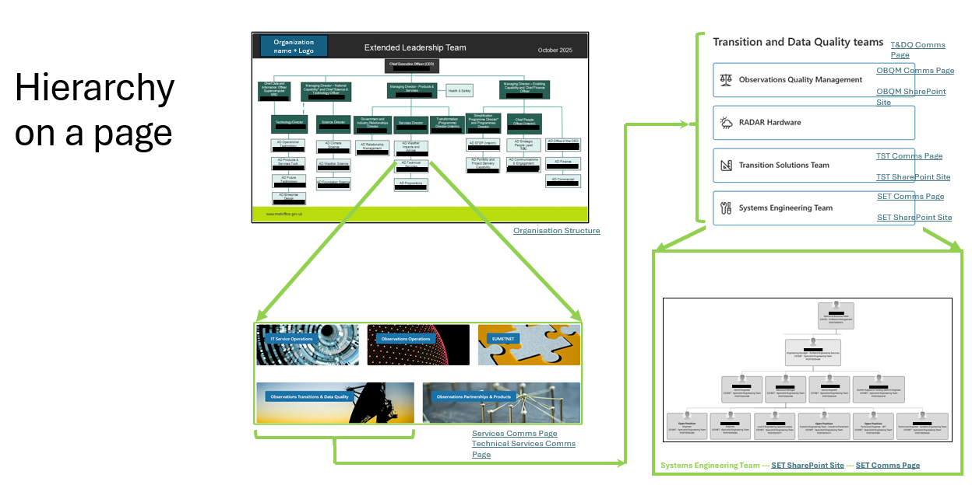
Annex I: Structure and Strategies
Figure 2: Local Team Structure
Figure 1: Organizational Structure
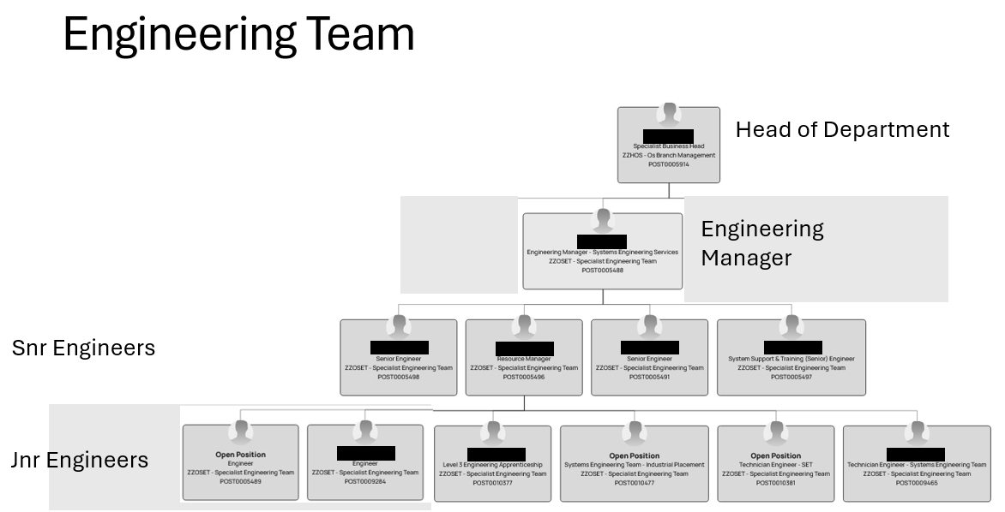

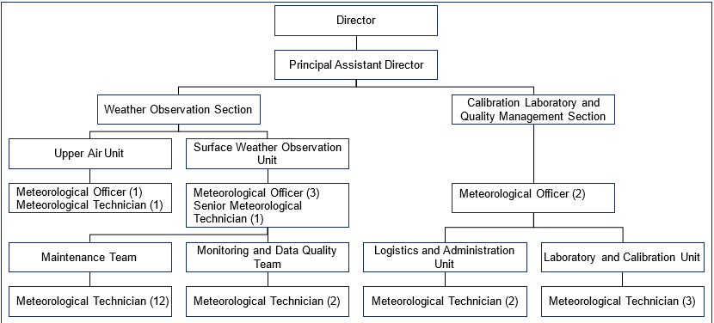
Figure 3: Example of an organizational structure

Annex II: Scope
For a high-level system schematic, include details of:
- Observing station type. E.g. manual, automatic, hydrometric, upper air
- Servers
- Data storage devices
- Cloud computing elements
- Visualisation platforms. e.g., visual display units, mobile applications
- Wireless links. e.g., satellite, mobile, WiFi, LoRaWAN
- Hardwired links. e.g., CAT5, Landline telecommunications

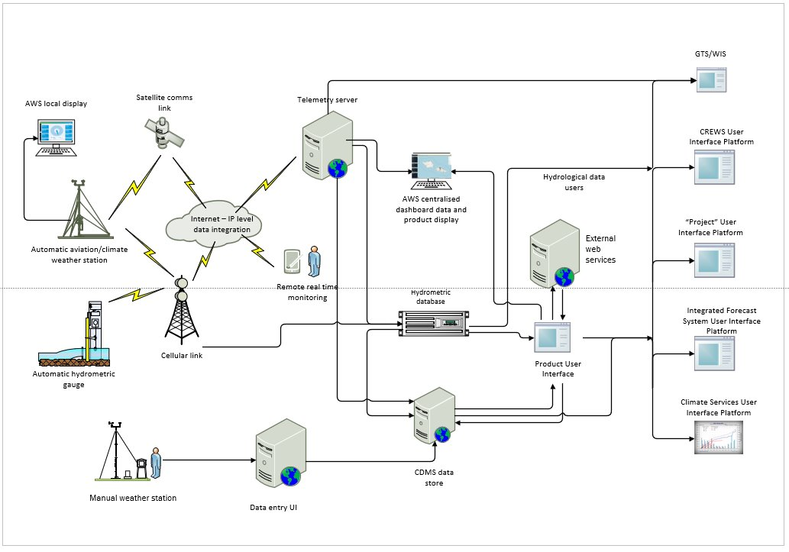
Figure 4: Example of an observing system schematic

For a local level schematic of an observing station, it can be useful to include details of:
- Power supply infrastructure
- Describe points of demarcation – mains distribution junction boxes
- High voltage systems e.g. >120 V AC – mains supplies
- Low voltage systems e.g. <50 V DC – batteries, solar panels
- Telecommunication infrastructure – routers, modems, antennas
- Data cable infrastructure
- Sensors and junction boxes
- Loggers, serial data converters, bus devices
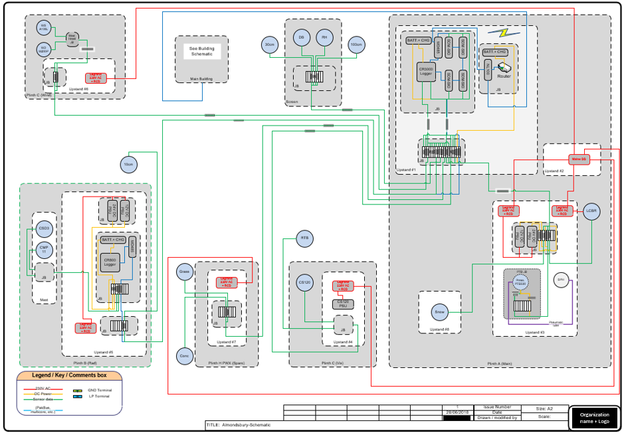
Figure 5: Example of Observing Station Schematic

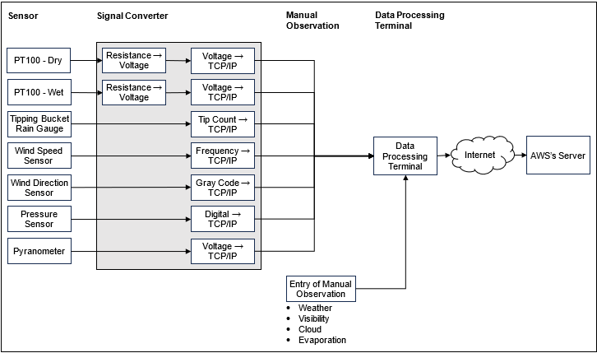
Figure 6: Example of Observing Station Schematic

Annex III: Example Key Performance Indicators
KPIs and targeted achievements can be defined considering the observing systems operated, resources, local conditions as well as operation and maintenance strategy of the NMHS or relevant agency of the Member.
The following example KPIs have been derived from GBON requirements and compliance criteria (WMO-No. 1165)
These are not exhaustive and are intended as an example.

Nr | Key Performance Indicator (KPI) | Target | Remarks
1 | Number of GBON stations registered in OSCAR/Surface | All designated stations | Ensures visibility and traceability
2 | Annual operational availability of surface stations | ≥ 80% | Measures uptime and reliability
3 | Annual operational availability of upper-air stations | ≥ 80% | Supports consistent radiosonde launches
4 | Hourly reporting of surface variables | ≥ 95% of scheduled reports | Pressure, temperature, humidity, wind, etc.
5 | Twice-daily upper-air observations (00 & 12 UTC) | ≥ 95% of scheduled launches | Required for global NWP and climate monitoring
6 | Compliance with BUFR format for international exchange | 100% of GBON stations | Ensures standardized data format
7 | Monthly data availability in WDQMS | ≥ 80% | Tracks data flow and identifies outages
8 | Monthly data quality issues in WDQMS | < 10% | Indicates effectiveness of quality control
9 | Calibration compliance of sensors | ≥ 80% calibrated per schedule | Ensures measurement traceability
10 | Number of RBON stations reporting to RWCs | 100% of designated RBON stations | Ensures regional data coverage
11 | Timeliness of data reporting to RWCs | ≥ 95% within expected timeframes | Supports regional forecasting
12 | Metadata completeness in OSCAR/Surface | 100% of RBON stations | Enables proper data interpretation
13 | Incident resolution time for data issues | < 7 days | Measures responsiveness
14 | Training activities for operations and maintenance staff | ≥ 1 per year | Supports capacity building
15 | Number of trained staff | Defined by NMHS needs | Based on network size and complexity

Annex IV(a): Risk register example template #1

1. Risk Identification |  |  |  | 2. Risk Assessment |  |  |  |  |  |  |  |  |  |  |  |  |  |  |  |  | 3. Risk Response / Treatment Plan
Risk number | Risk title | Risk description | Risk owner | Category & Risk appetite | Risk status | Risk approach | Probability | Probability as a numerical % | Impact | Current Risk Score | Target probability | Target impact | Target score | Score difference | Scoring justification | Target resolution date | Next review date | Start date | End date | Escalated to | Risk mitigation action  (Title & Description) | Assigned to | Status | Priority | Due date | Work notes

Annex IV(b): Risk register example #2

Risk | Description | Owner | Probability (%) | Impact | Score | Mitigation Action | Status
Organizational Structure | Lack of clear roles, poor communication, incompatible structure | Network Manager | 70 | High | 21 | Define roles, improve communication, restructure if needed | In Progress
NAMP Strategy | Misalignment with goals, reactive maintenance, poor adaptability | NAMP Lead | 60 | High | 18 | Review strategy, shift to preventive maintenance | Planned
Resources | Budget shortfalls, skill gaps, tool shortages, procurement delays | Finance & Ops Lead | 80 | High | 24 | Resource planning, training, procurement streamlining | In Progress
Staff Quantity & Qualification | Insufficient skilled staff, high turnover, limited training | HR Manager | 75 | High | 22.5 | Recruitment, retention strategy, training programs | Planned
Environmental & Local Conditions | Harsh weather, remote access, seasonal disruptions | Field Ops Manager | 65 | Medium | 13 | Seasonal access planning, remote monitoring | In Progress
Site Security | Hazards, vandalism, lack of emergency protocols | Safety Officer | 50 | High | 15 | Security audits, emergency response plans | Planned
Regulatory & Community Issues | Compliance gaps, community resistance, outdated tech | Compliance Officer | 55 | Medium | 11 | Stakeholder engagement, tech upgrades, compliance reviews | Planned

Risk Score Calculation
The risk score is derived using a simple matrix approach:
Risk Score=Probability (scaled)×Impact (scaled)

- Probability: Expressed as a percentage (e.g., 70% → scaled as 7).
- Impact: Assigned a numeric scale (Low = 1, Medium = 2, High = 3).
- Score: Combines these two to give a relative severity measure.
Example:
- Inadequate Staffing: Probability = 70% (scaled as 7), Impact = High (3)
Score=7×3=21
Higher score = higher priority for mitigation.
- Typical ranges:
  - 1–10: Low risk (monitor)
  - 11–20: Medium risk (plan mitigation)
  - 21+: High risk (urgent action)

Annex V(a): Initial investment
The following five tables (Annex V(a) to V(e)) have been adapted from Charting a Course for Sustainable Hydrological and Meteorological Observation Networks in Developing Countries, developed by the World Bank/GFDR.
These are intended to be used as a set, but can be adapted for use as appropriate for specific needs.
Cost of Capital Equipment
Total Cost of All Field Equipment
Total Cost of Spare Parts, Sensors, or Equipment
Cost of Mobile Field Equipment
Total Cost of Information Processing System Hardware
Total Cost of Capital Equipment | $
Cost of Civil Works
Total cost to procure land and buildings
Total cost of site preparation
Installation of utilities
Construction of major supporting structures
Cost of security
Construction of offices and server room
Total Cost of Civil Works | $
Cost of Supplier Services
Installation of equipment
Factory Acceptance Testing
Site Acceptance Testing
Training of staff on new systems
Prepaid calibration of sensors
Total cost of supplier services | $
NMS Cost to Install Operational Systems
Project management
Cost of logistics (Staff travel expenses)
Installation Time
Cost of Staff Training
Total NMS cost for installation | $

Annex V(b): Annual operation costs
Business Costs
Business operating costs | $ -
Administrative Costs
Adminstrative costs | $ -
Other Operating Costs
Calibrations
Consumables
Software licenses
Service-level agreements
Land-lease costs
Utilities
Total of other operating costs | $ -

Annex V(c): Annual maintenance costs
Preventive Maintenance
Field tech staff salaries
Site maintenance personnel
Logistics costs
Mobile field equipment
Replacement parts
IPS computer equipment
Total cost of preventive maintenance | $ -
Corrective Maintenance
Cost of corrective maintenance | $ -
Adaptive Maintenance
Cost of adaptive maintenance | $ -

Annex V(d): Total lifecycle costs
Field equipment
Cost of replacement/removal | $ 1.00
Lifetime of system (years) | 1
Component useful life (years) | 1
Number of components | 1
Total cost of field equipment | $ 1.00
Other field equipment (Vehicles etc)
Total cost of other field equipment | $ -
IPS computer and software
Cost of replacement/sustainable removal | $ 1.00
Lifetime of system (years) | 1
Component useful life (years) | 1
Number of components | 1
Total cost of IPS computer and software | $ 1.00
Total Lifecycle costs | $ 2.00

Annex V(e): Total cost of ownership summary form
Total Cost of Ownership Summary Form
 | Project:
 | Capital Budget:
 | Operation Budget:
 | Date:
Initial investment (Capital Costs)
Line | Description |  | A
1 | Cost of Capital Equipment |  | $0.00
2 | Cost of Civil Works |  | $0.00
3 | Total cost of supplier services |  | $0.00
4 | NMS cost to install operational system |  | $0.00
5 | Total Initial Investment (Capital Costs) |  | $0.00
Cost of Annual Operations
6 | Business Costs |  | $0.00
7 | Administrative Costs |  | $0.00
8 | Other Operating Costs |  | $0.00
9 | Total Cost of Annual operations |  | $0.00
Cost of Annual Maintenance
10 | Preventative Maintenance |  | $0.00
11 | Corrective Maintenance |  | $0.00
12 | Adaptive Maintenance |  | $0.00
13 | Total Cost of Annual Maintenance |  | $0.00
14 | Total cost of Annual operations and Maintenance |  | $0.00
15 | Lifetime of System (Years) |  | 10
16 | Total Cost of Annual Operations and Maintenance Over Lifetime |  | $0.00
Life-Cycle Costs over Lifetime
17 | Total Life Cycle Costs |  | $2.00
18 | Total Cost of Ownership over Lifetime |  | $2.00

Annex V(f): Cost summary form
This table is a further example that may be adapted for making a cost estimation.
The equipment and activities should be defined based on the stations operated, and the maintenance strategy of the NMHS.
 | Item | Unit Price | Quantity | Total
1. | Automatic Weather Stations (Spare parts)
1.1 | Data logger (Data Collection Unit)
1.2 | Air temperature and humidity sensor
1.3 | Radiation Shield
1.4 | Precipitation sensor
1.5 | Wind Speed Sensor
1.6 | Wind Direction Sensor
1.7 | Pressure Sensor
1.8 | Snow Depth Sensor
1.9 | Wind Mast
1.10 | Stands ( temperature/humidity, precipitation, radiation)
1.11 | Power units
1.12 | Communication Units
1.13 | Lightning protection units
1.14 | Grounding systems
1.15 | AWS cabinet
1.16 | Junction and terminal boxes
1.17 | Cables, wires, connectors
1.18 | Others
 | Sub Total

2. | Upper Air Observing System (Spare parts and consumables)
2.1 | Radiosonde
2.2 | Balloon
2.3 | Parachute
2.4 | Spare parts for hydrogen generator
2.5 | Spare parts for fire extinguishing system
2.6 | Spare parts for ground receiving system (antennas, computers, etc.)
2.7 | Operational Cost (electricity, water, chemicals, data transmission, maintenance of the equipment)
2.8 | Water purification system
2.9 | Hydrogen detection tool
2.10 | Balloon fill nozzle (piping and connectors)
2.11 | Helium (if used)
2.12 | Others
 | Sub Total

3. | Maintenance Tools and Test Equipment
3.1 | Field test and verification equipment (for sensors)
3.2 | Tool set for maintenance (Cutter, allen set, screwdriver, crescent wrench, open ended wrench, wrench set, cable stripper, etc.)
3.3 | Multimeter
3.4 | Ground Resistance Meter
3.5 | Oscilloscope
3.6 | Calibrators for sensors
3.7 | Others
 | Sub Total

4. | Operation and Maintenance of Activities
4.1 | Installation, Operation and Maintenance staff
4.2 | Calibration staff
4.3 | Observers in the WIGOS stations operated manually
4.4 | IT experts
4.5 | Site visits for preventive maintenance (including travel and accommodation expenses)  2 visits per station per year by 2 staff for 2 days
4.6 | Site visits for corrective maintenance  (XX stations, 1 visit to 20% of the stations per year)
4.7 | Calibration of the sensors (including any maintenance and freight costs)
4.8 | ICT Equipment for observing network management  (preventive maintenance once per year, 5% of supply cost)
4.9 | Training of the staff for operations and maintenance
4.10 | Transport costs
4.11 | Data transmission cost
4.12 | Others
 | Sub Total
 | Grand Total

Annex VI: List of Operation and Maintenance Staff template
This table can be adapted for use as a register of staff and their credentials involved in operations and maintenance of observing stations.

Name | Education | Expertise | Trainings Attended | Responsibility | Certificates | Remarks

Annex VII: Maintenance of Observing Sysytems
The following are examples for AWS maintenance and field verification activities.
Equipment, activities and time intervals should be defined based on the manufacturer recommendations and maintenance strategy of the NMHS or relevant agency of the Member.
The maintenance team can check if the station is registered in CliDE and OSCAR/Surface correctly and communicate with CliDE and OSCAR/Surface National Focal Point (NFP) for further actions.
The maintenance team can check if there are any availability or quality issues in CliDE and the WDQMS web tool and communicate with OSCAR/Surface NFP and/or WDQMS NFP for further actions.

Annex VII(a): Recommended exchange intervals for servicing and/or calibration.
Figure 7: Recommended routine exchange interval for servicing and/or recalibration.
1 Year | 2 Year | 3 Year
Relative humidity (HMP155x) | Wind speed (A101M) | Air temperature (InTech)
Air temperature (HMP155x) | Wind direction (W200P) | Air temperature (CSI107)
 | Pressure (PTB100/PTB330) | Grass/soil temperature (LM34)
 | Solar radiation (LI200) | All-in-one (WXT53x)
4 Year | 5 Year | On fault
Rainfall (TB3) | Battery | Soil moisture
Rainfall (OTA) |  | Wind (Ultrasonic)

Annex VII(b): Brief inspection planning checklist
The following is an example of a checklist that can be adapted for use when planning an inspection, maintenance or field verification visit.

📄 Documentation
☐ Inspection forms gathered
☐ Record sheets current and available
☐ Wiring diagrams current and included
☐ Additional paperwork (specify): _______________________

🧰 Verification Kit
☐ Toolkit packed
☐ Temperature/RH meter included
☐ FCD (Field Calibration Device) included
☐ Other instruments (specify): _______________________

🔧 Sensors
☐ Sensors to be exchanged are packed and labelled
☐ Spare sensors available if needed

📋 Additional Work Items
☐ Thermometer Screen replacement required?
☐ Mast painting required?
☐ Record sheets need updating?
☐ Wiring diagram needs updating?
☐ Other tasks (specify): _______________________

🧪 Bench Testing
☐ Loggers tested and functioning
☐ Instruments tested and familiarized

⚠️ Final Checks
☐ Double-checked all items
☐ Confirmed all tasks are listed
☐ No assumptions made—everything verified

Annex VII(c) Inspection/field verification task list
This list contains examples of maintenance and field verification tasks that can be adapted as required to suit the needs of the NMHS.

Sensors/Instruments
- Wind Sensor
- Check / replace wind sensor
- Check the north (N) orientation and the pole standing upright with a compass
- Checking Direction - Swept by rotating the wind vane in clockwise and counterclockwise direction 360º, 90º, 180º, 270º, 360º, 270º, 180º, 90º
- Inspect the physical condition of the wind mast
- Inspect the terminal connection box
- Inspect the stay wire and hook

- Temperature Sensor - Dry & Wet Bulb
- Physical inspection
- Do on-site verification
- Inspect the distilled water container and the sock for wet bulb
- Inspect the terminal connection box and wiring

- Precipitation - TBRG
- Physical inspection
- Clean up the filter at the bottom of funnel
- Verify the number of tipping using the Portable TB Calibrator
- Inspect the terminal connection box and wiring

- Atmospheric Pressure Sensor
- Do on-site verification

- Global Radiation - Pyranometer
- Physical inspection
- Inspect the condition of desiccant
- Inspect the terminal connection box and wiring
Main Terminal Box
- Physical inspection
- Inspect to wiring
- Inspect the rubber seal

Power Supply for the Acquisition Electronics
- Incoming 240VAC
- Outgoing 24VDC
- Outgoing 12VDC
- Test the functionality of circuit breaker (4 units)
Acquisition Electronics
- Check all the indicator lights on the Sensor Interface
- Dry Bulb Temperature Converter
- Wet Bulb Temperature Converter
- Temperature Interface
- Rainfall Interface
- Pressure Interface
- Wind Interface
- Solarimeter Interface (if any)
- Communications Switch
- Inspect the wiring from the Main Terminal Box to the Acquisition Electronics Box
- Test the TCP/IP between the switch and PC (ping test)
Data Processing Unit (DPU)
- Hardware
- Ensure the DPU is functioning well
- Ensure the communication system to Server is working [PC (ping test)]
- Software for the AWS
- Ensure AWS software is from the latest version
- Ensure Synchronize Clock (the AWS computer time is the same as the server time)
- Power Supply for the DPU
- Ensure the UPS is working well
Earthing / Grounding
- Check the earth resistance value on the wind mast
- Check the earth resistance value on the building
- Check the earth resistance value on the AE Box
Back-up Equipment
- Barometer
- Ensure the back-up barometer works
- Do on-site verification
- Liquid in glass thermometer
- Physical inspection of the dry / wet bulb thermometer (if any)
- Do on-site verification
- Physical inspection of the maximum / minimum bulb thermometer (if any)
- Raingauge
- Physical inspection
- Physical inspection on the measuring cylinder of the raingauge
- Evaporation Pan
- Physical inspection
  - Hook Gauge
  - Stilling Well
  - Odometer
- Cleanliness of the pan
Stevenson Screen
- Physical inspection
- Doors, hinges and latches

Annex VII(d): AWS Inspection/Field verification form
The following is an example of a checklist that can be adapted for use when doing an inspection, maintenance or field verification.
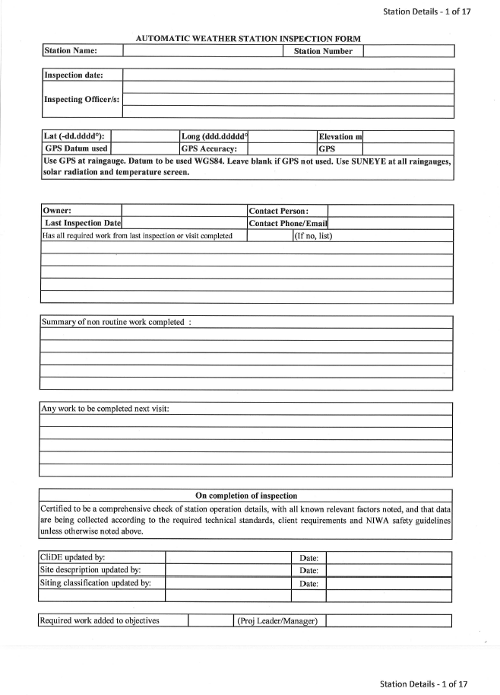
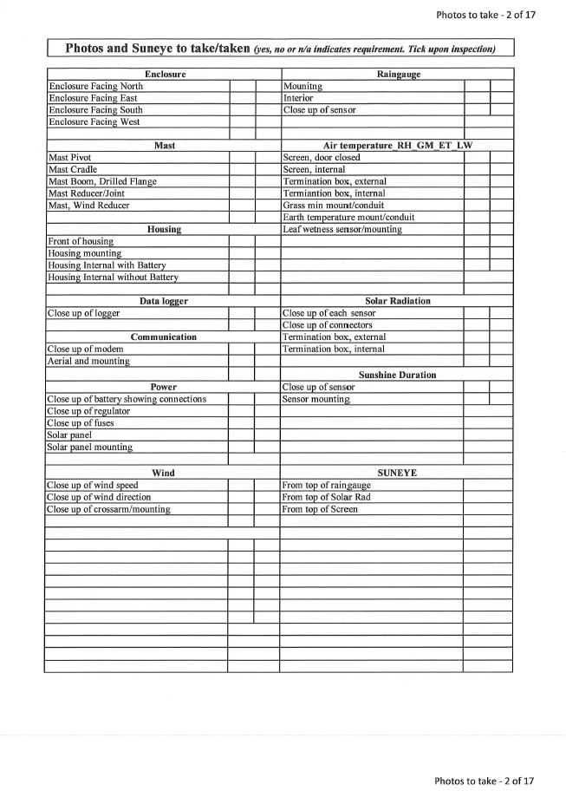
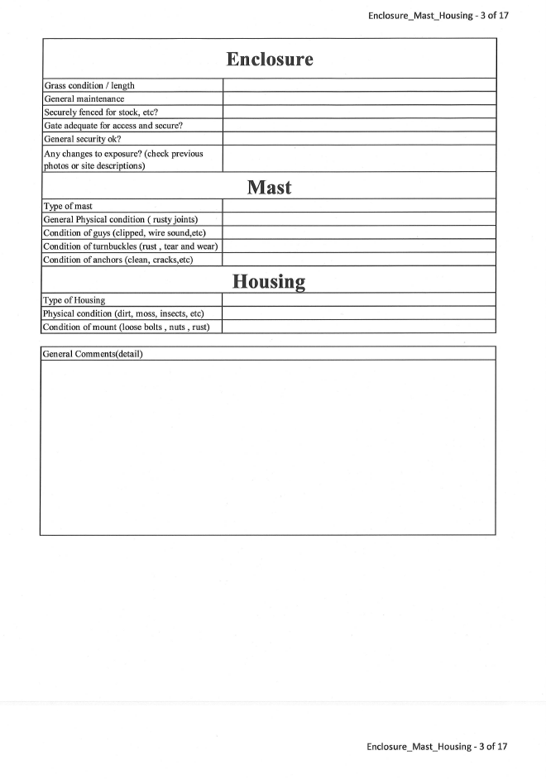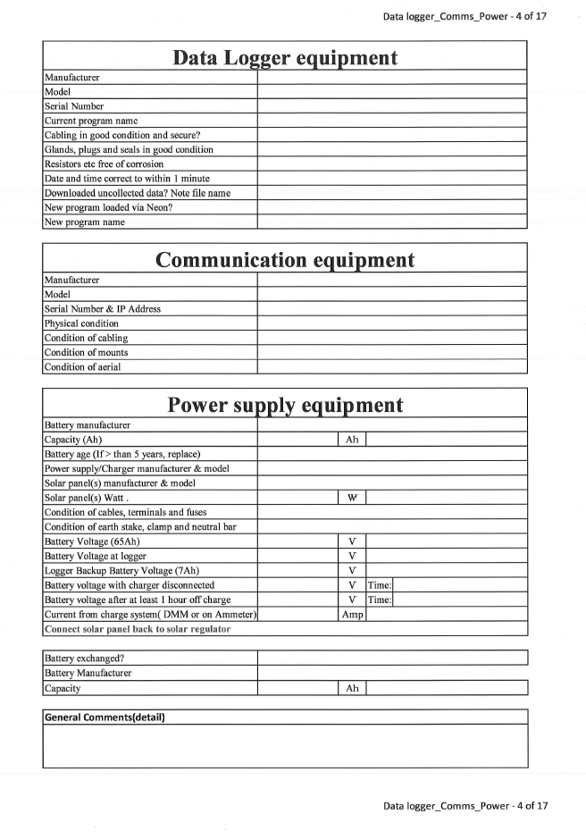
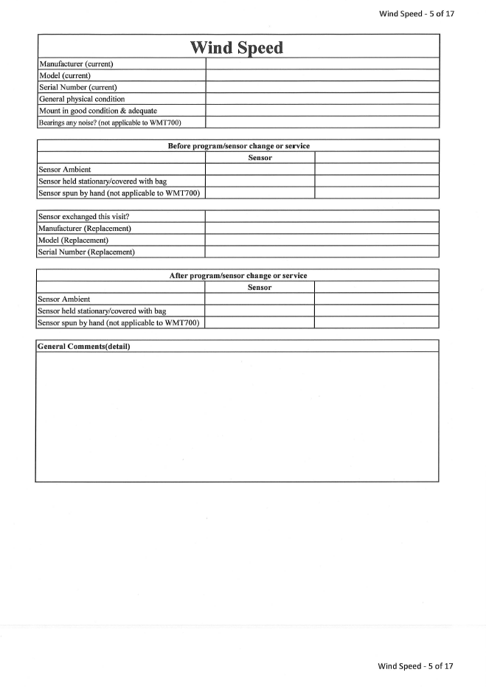
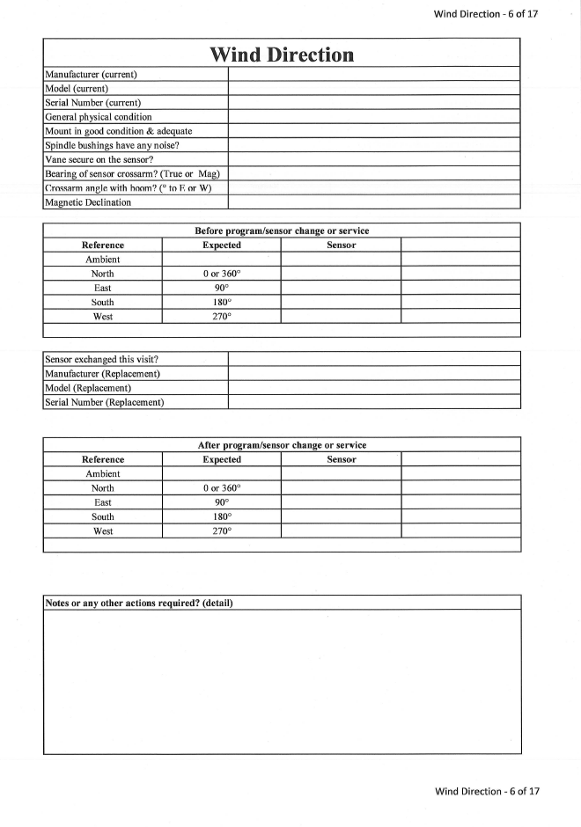
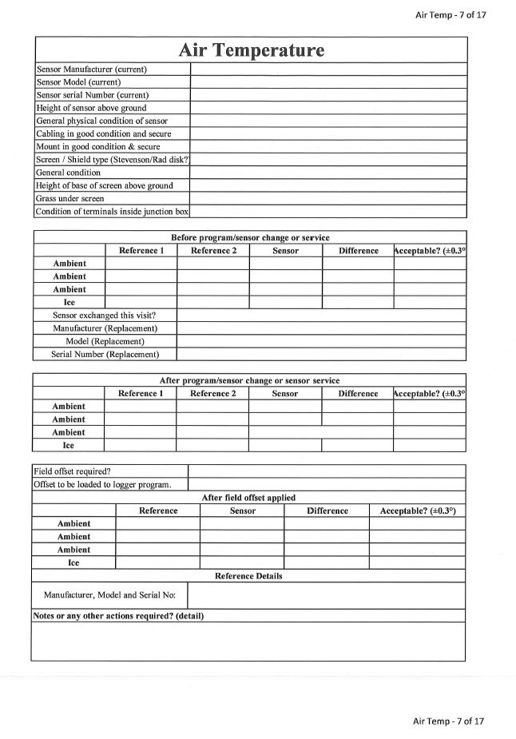
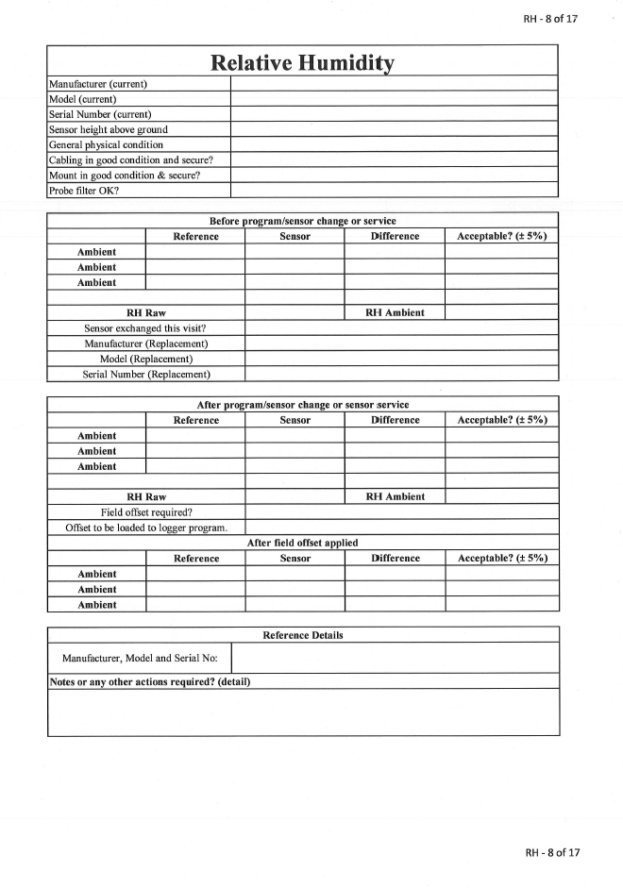

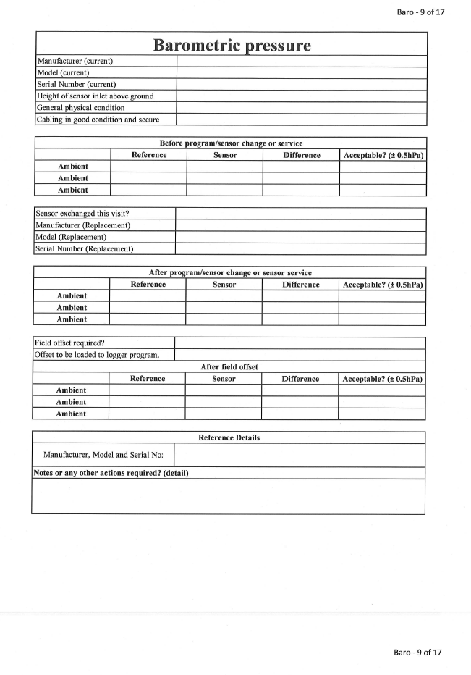

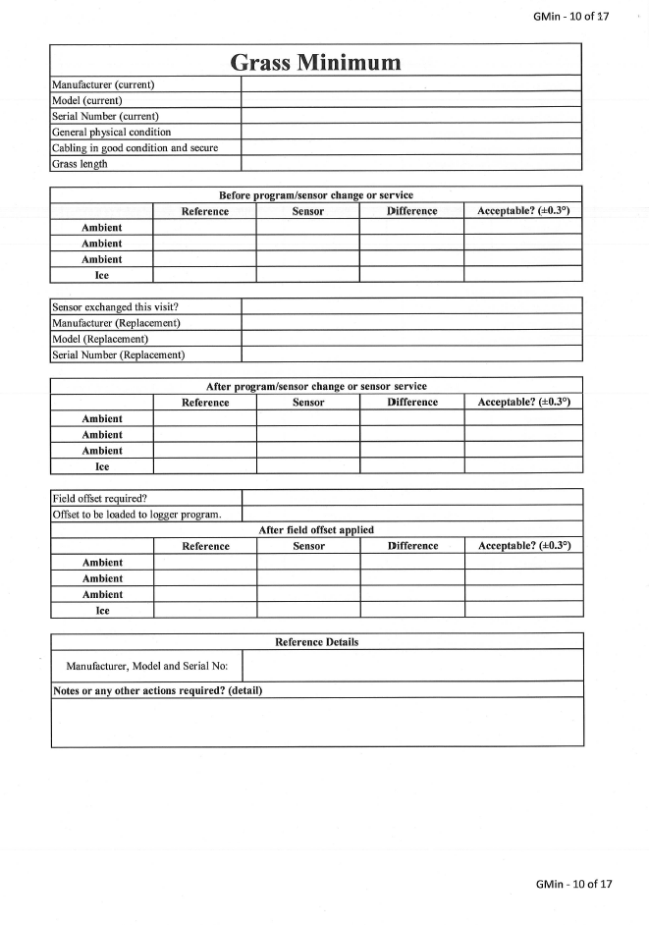
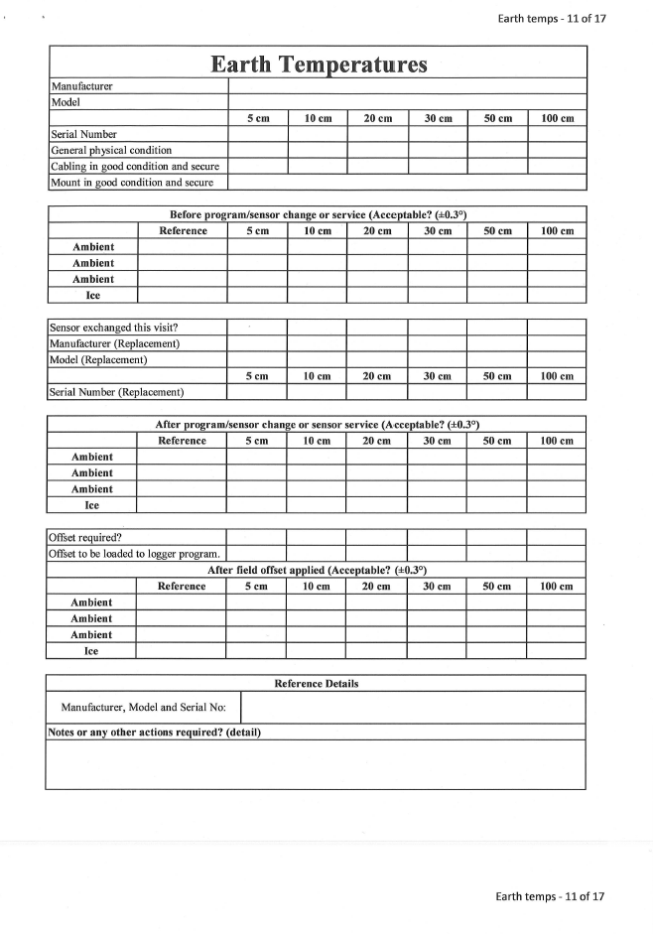
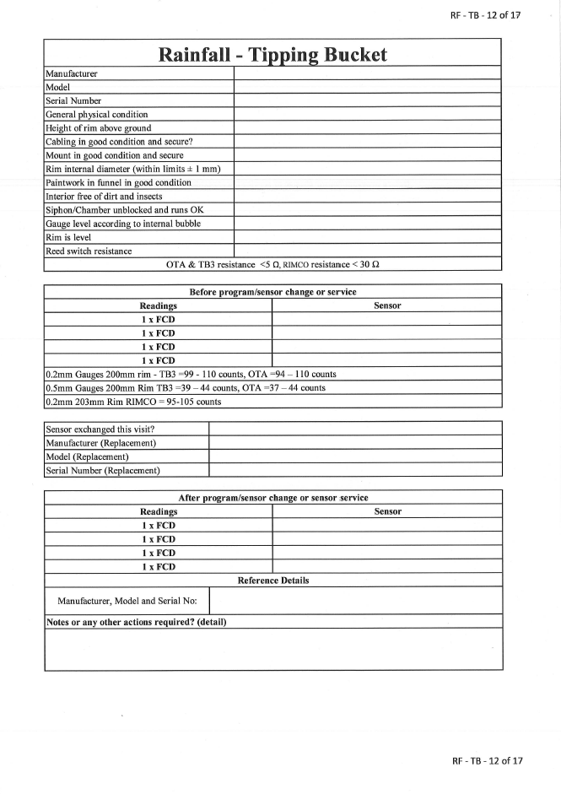
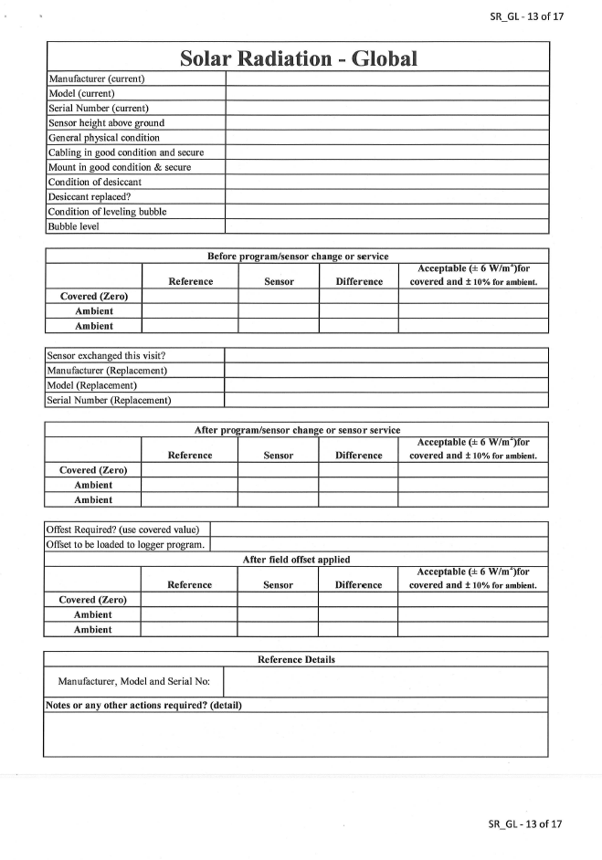
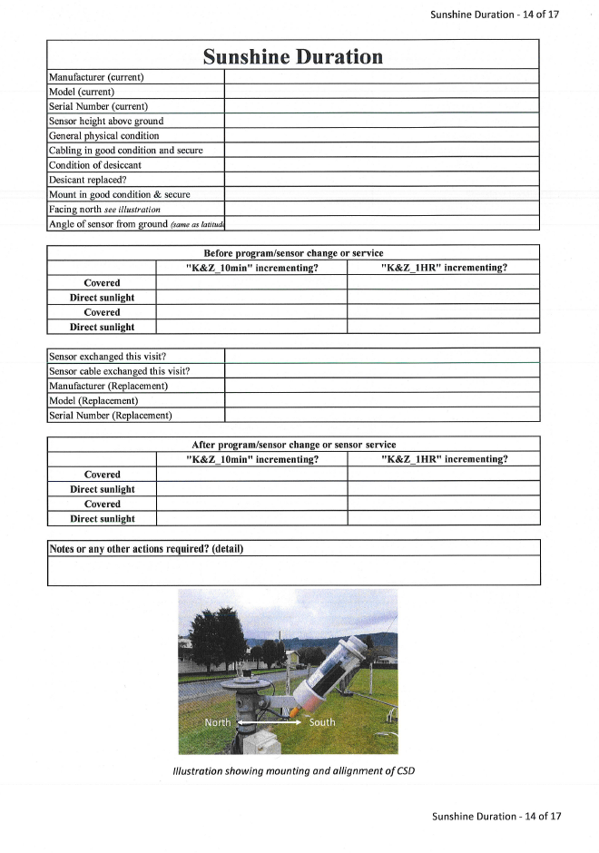

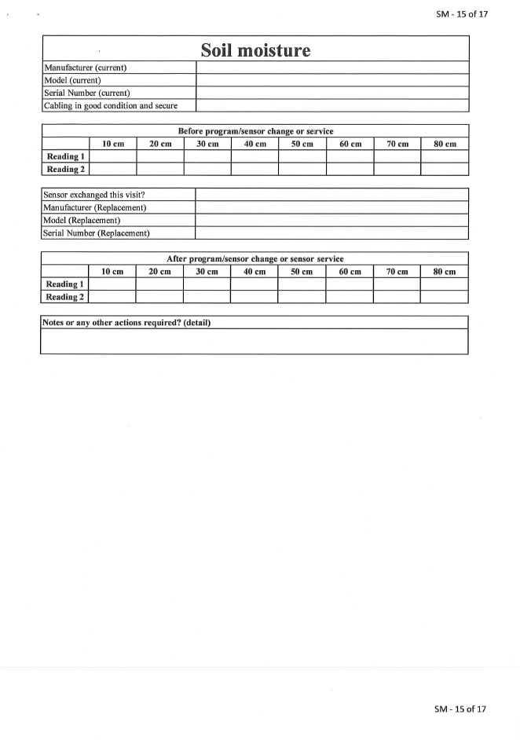
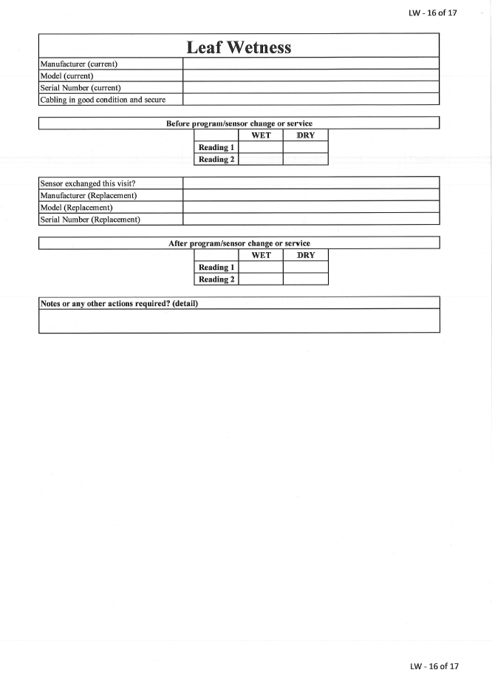
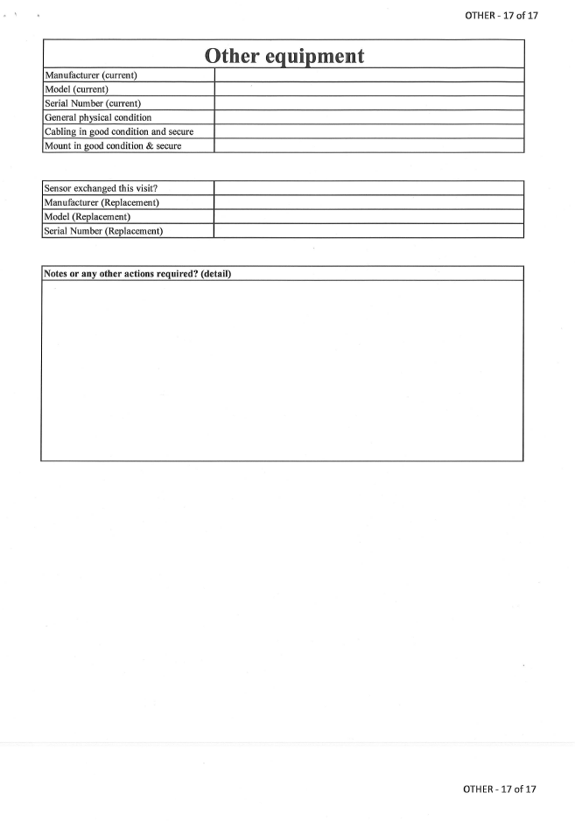

Annex VII(e): Station record sheets / site description form
The following is an example of a form that can be adapted when preparing station metadata.

SITE DESCRIPTION FORM

STATION NAME: |  |  |  |  |  | Variables Observed
Station Type: |  |  |  |  |  | ☐ Wind
CliDE No: |  |  |  |  |  | ☐ Air Temp
TIDEDA No: |  |  |  | ICAO Identifier: |  | ☐ Relative Humidity
WMO No: |  |  |  | WIGOS No: |  | ☐ Grass Temp
 |  |  |  |  |  | ☐ Soil Temperature
Date Station Established: |  |  |  |  |  | ☐ Pressure
Latitude: |  |  |  | Longitude: |  | ☐ Rainfall
 |  |  |  |  |  | ☐ Radiation
Height above MSL:  Horizontal Datum used: |  |  |  | Point used:  Magnetic declination: |  | ☐ Sunshine
 |  |  |  |  |  | ☐ Soil Moisture
Vertical Datum Used: |  |  |  |  |  | ☐ Other
Surface Type:
Land Use: | 0 -100m:
Land Use: | 100m – 1km:
Land Use: | 1km – 10km:
Equipment Owners:
Observer: |  |  |  |  | Phone No:
Postal Address: |  |  |  |  | Physical Address:
Enclosure provided by:
Remarks:

Instructions for locating station by road:

Time of observations:
Transmission of observations:
Returns furnished:
Annual supplies:
Housing/Datalogger/Communications/Power |  | ☐ This Section Not Applicable
Housing:
Datalogger manufacturer and model:
Scan rate:
Log interval/s:
Wiring diagram version:
Modem manufacturer and model:
SIM Card No.:
IP Address:
Power supply:
Charger, Supply or Regulator:
Battery:
Date current battery installed?
Remarks:

Mast |  | ☐ This Section Not Applicable
Type:
Height of head above ground level:
Boom orientation:
Remarks

Surface Wind |  | ☐ This Section Not Applicable
Wind Speed manufacturer and model:
Wind Direction manufacturer and model:
Connector type:
Cable length:
Resistor size and location:
Instrument height above ground level:
Cross arm orientation:
WMO siting classification number:
Remarks:

Temperature Screen |  | ☐ This Section Not Applicable
Type/Model:
Screen base height above ground level:
Date current screen installed?
Remarks:

Air Temperature |  | ☐ This Section Not Applicable
Manufacturer and model:
Manufacturer and model:
Sensing height above ground level:
WMO siting classification number:
Remarks:

Relative Humidity |  | ☐ This Section Not Applicable
Manufacturer and model:
Sensing height above ground level:
WMO siting classification number:
Remarks:

Grass Minimum |  |  | ☐ This Section Not Applicable
Manufacturer and model: | Grass min:
Remarks:

Soil Temperature |  |  | ☐ This Section Not Applicable
Manufacturer and model: | 5cm:
Manufacturer and model: | 10cm:
Manufacturer and model: | 20cm:
Manufacturer and model: | 30cm:
Manufacturer and model: | 50cm:
Manufacturer and model: | 100cm:
Remarks:

Atmospheric Pressure |  | ☐ This Section Not Applicable
Manufacturer and model:
Range:
Inlet height above ground level:
Inlet height above mean sea level:
Remarks:

Rainfall |  | ☐ This Section Not Applicable
Manufacturer and model:
Bucket size:
Rim height above ground level:
WMO siting classification number:
Remarks:

Solar Radiation |  | ☐ This Section Not Applicable
Manufacturer and model (Global):
Sensor height above ground level:
WMO siting classification number:
Remarks:

Bright Sunshine |  | ☒ This Section Not Applicable
Manufacturer and model:
Sensor height above ground level:
WMO siting classification number:
Remarks:

Soil Moisture |  | ☐ This Section Not Applicable
Manufacturer and model #1:
Manufacturer and model #2:
Manufacturer and model #3:
Depth #1:
Depth #2:
Depth #3:
Soil type:
Surface type:
Remarks:

Other Instruments |  | ☐ This Section Not Applicable
Manufacturer and model:
Remarks:

General exposure of station:

Exposure of instrument enclosure:

Local effects/other information:

Site Plan

General sketch

Suneye images

Full fisheye from top of Raingauge –
(North is top of image)

Sun paths from top of Thermometer Screen –

Horizon profile from top of Thermometer Screen –

Sun paths from top of Solar radiation sensor –

Total solar access from top of Solar radiation sensor –

Horizon profile from top of Solar radiation sensor –

Maps

Annex VII(f): Siting classification form
The following is an example of a form that can be adapted when preparing station siting classification.

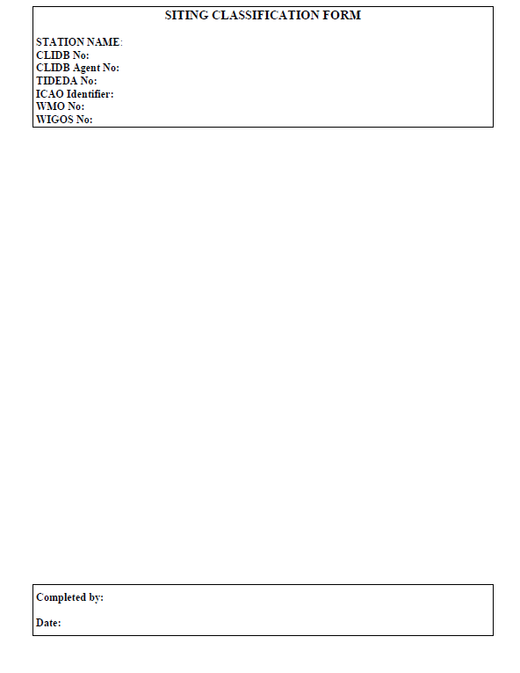
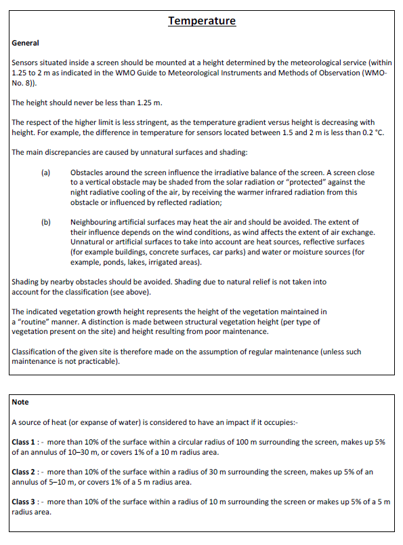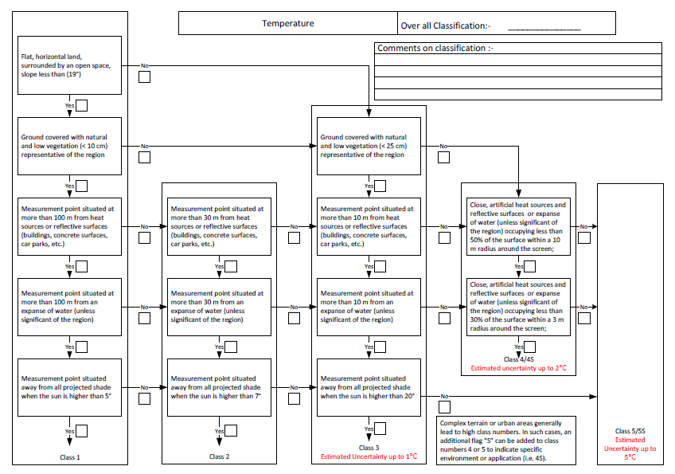
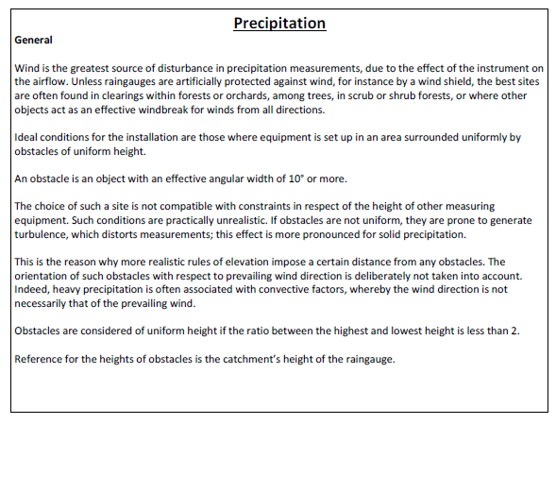

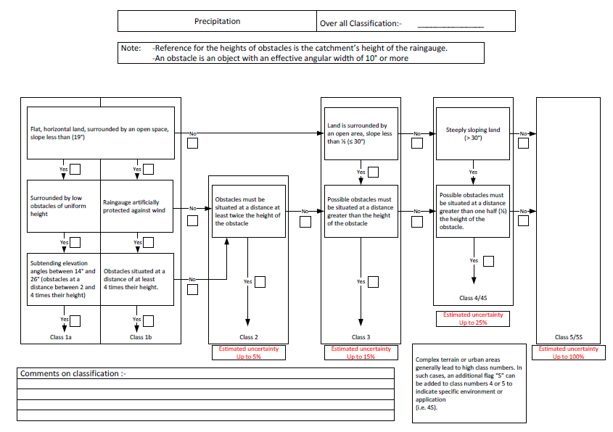

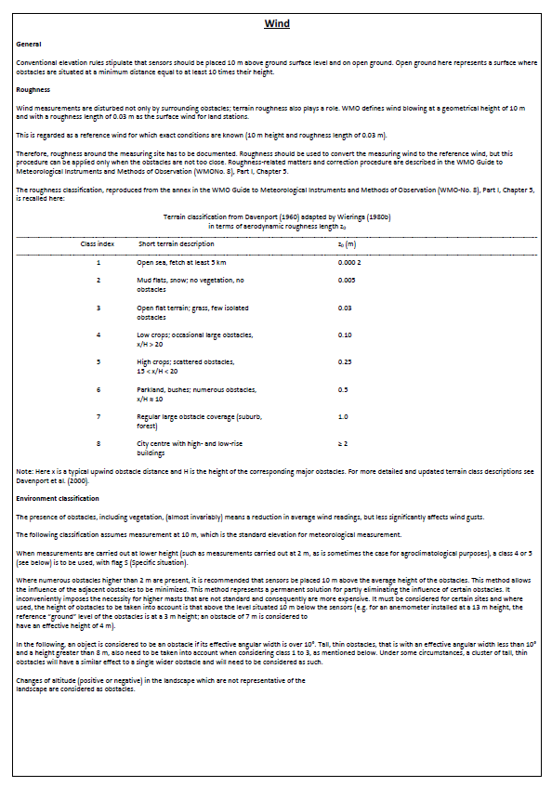

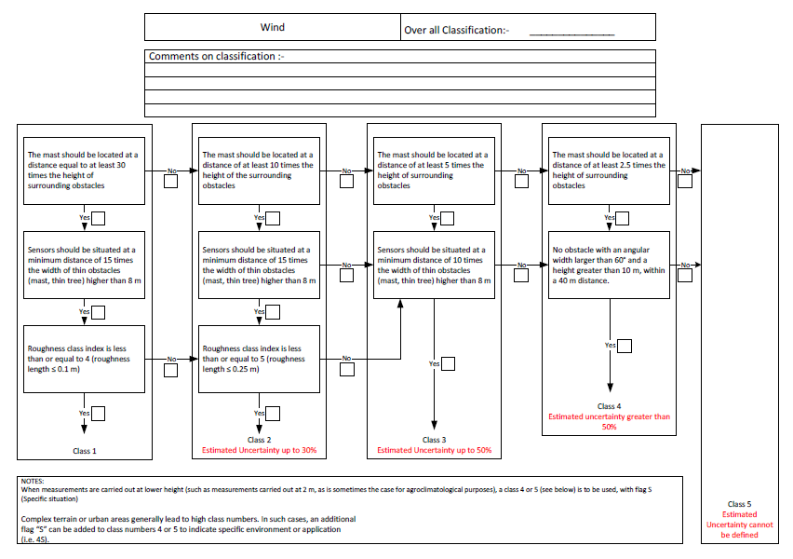
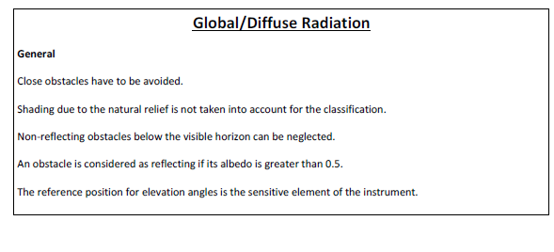

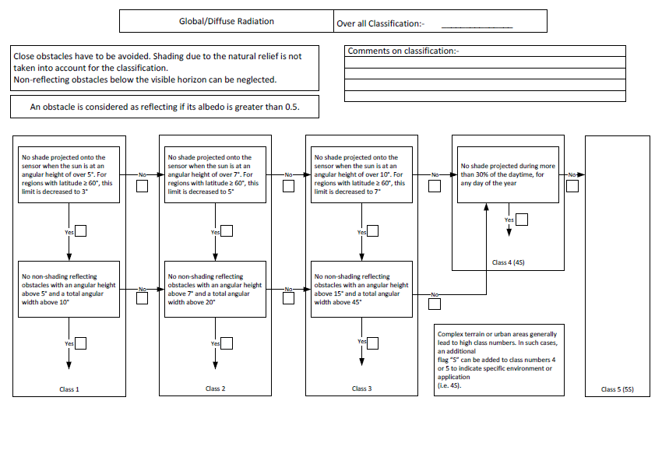
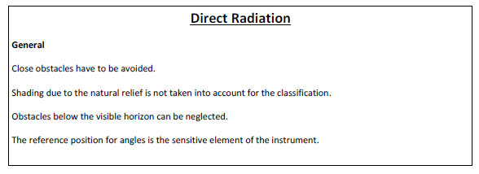

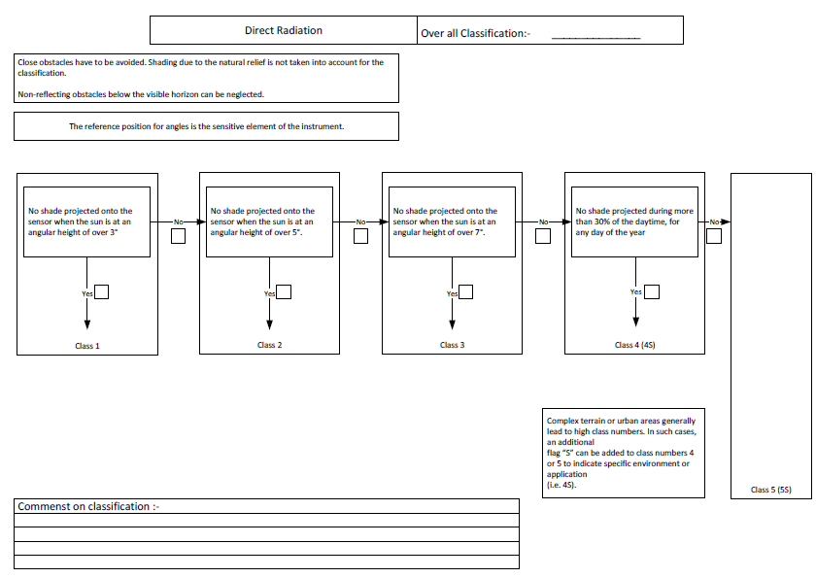

Annex VII(g): Example of installation and maintenance
equipment list
This table lists equipment that may be required for installation, maintenance and verification of observing stations.
The list is not exhaustive and may be adapted to suit the needs of the NHMS.

Field verification essentials
Batteries | Check that you have replacement batteries for the equipment being installed/maintained
Serial adaptor(s) | For communicating with devices using serial using comms protocols
Cables | Inter-connection cables for PC to equipment - often manufacturer specific so make sure you have taken the correct cables to connect to the system you will be working on.
Calibrated field verification kit - RTD precision thermometer | Recommended.  Comes with display and protective carry case. Suitable for immersion into liquid or ice.
Calibrated field verification kit (transfer standard) – pressure, temperature and humidity | Essential.  Comes with display and protective carry case.
Calibrated field verification kit (transfer standard) – solar radiation | Recommended  Comes with display and carry case.
Calibrated field verification kit - precipitation | Must have  Comes with battery, counter and carry case.
Calibrated field verification kit - handheld anemometer | Recommended
Chargers (mains and solar)
Compass
“Fisheye” shade tool | For determining obstructions and horizon profiles
Flask (double walled) | For water/ice for temperature verification
GPS unit
Manuals/SOPs
Multimeter | Minimum standard - Fluke 175
Range/height finder
Remote support assistance | Any WIFI cellular router to allow internet connection
Ruggedised laptop | Loaded with all software supplied by the manufacturer to enable installation, maintenance, fault diagnosis and adjustment.
Spares | This is equipment/manufacturer specific so spend time assembling a spares kit that suits the application.
Station documentation
Winch, mast

Personal protection equipment
Groundsheet/tarpaulin
Insect repellent
Satellite phone
Spot tracker
Sun hat
Sunblock
Umbrella (Sun and rain)
Wet weather gear

Installation and maintenance tool kit
Adjustable wrench/crescent | 100 mm, 200 mm, 250 mm
Allen keys (Hex set) | Metric and Imperial
Angle finder
Band-IT Tool | See also Band-IT consumables
Bolt cutter | 18 " / 450 mm
Cable cutter
Caulking gun | See also consumables
Cordless drill & impact driver | 18 V or similar
Craft knife (c/w blades)
Crimp tool, RS 533-279
Crimp Tool, Weidmuller PZ4
Crowbar/digging bar | 1830 mm
Diagonal cutting pliers | 150 mm, 200 mm
Drills | 19-piece set - 1 mm to 6.5 mm
Drill | 13 mm
Drill screwdriver set | Assorted screw head types
Drill and tap set - complete with tap wrench | M4, M5, M6, M8, M10, M12
Hacksaw
Hammer (claw)
Hole saw driver
Hole saws | 16 mm, 20 mm, 32 mm, 35 mm
Pick
Pipe wrench | 24 "/ 600 mm
Pliers | 6 " long nose
Pliers/grips | 10 " adjusting
Post level
PVC pipe cutter
Screwdriver set | 6-piece miniature
Screwdriver set | 6-piece insulated 75 mm to 125 mm, slotted and Phillips
Sledgehammer
Sockets | Minimum of10 mm, 13 mm, 20 mm.  Recommend a complete socket set
Socket drivers | 167 mm handle (5.5 mm, 11 mm)
Socket extension bar
Socket ratchet handle
Soldering iron | Charged up Battery operated
Spade
Spanner | 13 mm ratchet head
Tape measures | (8 m, 30 m)
Toolbox
Torpedo level | (225 mm)
Trowels, concrete (flat, edger)

Consumables
Band-IT (tape, crimps) | Stainless steel tape and crimps for use with Band-IT tool
Cable ties - assorted | 100 mm, 203 mm, 250 mm, 500 mm
Conduit, Flex 32 mm | 25 m roll
Denso tape
Fasteners (stainless steel c/w washers and nuts) | M4, M6, M8, M10 and M12
Ferrules, 0.5 mm | 100
Fuses M5 x 20, fast blow | 3, 5, 10 and 20 Amp 10 of each
Hacksaw blades
Metal files | Assorted
Multi-purpose lubricant
Paint, red metal shield | 1 litre
Paint, white rust guard | 1 litre
Paint brushes | Assorted sizes for painting and cleaning (e.g., 50 mm, 63 mm)
PVC electrical tape | Assorted colours
Rags/cleaning cloth
Resistors, precision 0.1% | 100 Ohm, 124 Ohm, 147 Ohm, 10K Ohm
Rust prevention – cold galvanising
Sealant cartridges for caulking gun
Silicon grease
Solder
String, builders | Site layout, cable pull through
Wood saw

Workshop essentials
Battery charger (2.3 A float charger)
Soldering iron station

https://library.wmo.int/viewer/68663/?offset=#page=65&viewer=picture&o=bookmark&n=0&q=
https://community.wmo.int/en/activity-areas/imop/Regional_Instrument_Centres

