WRP Procurement ToolKit – Quick Start
  - Part of Weather Ready Pacific Standard, Optimisation & Maintenance Guidelines Document
This Quick Start Guide will get you ready to develop your tender making clear what documents you can consider given your role and responsibilities.

Which Document Do I Need?
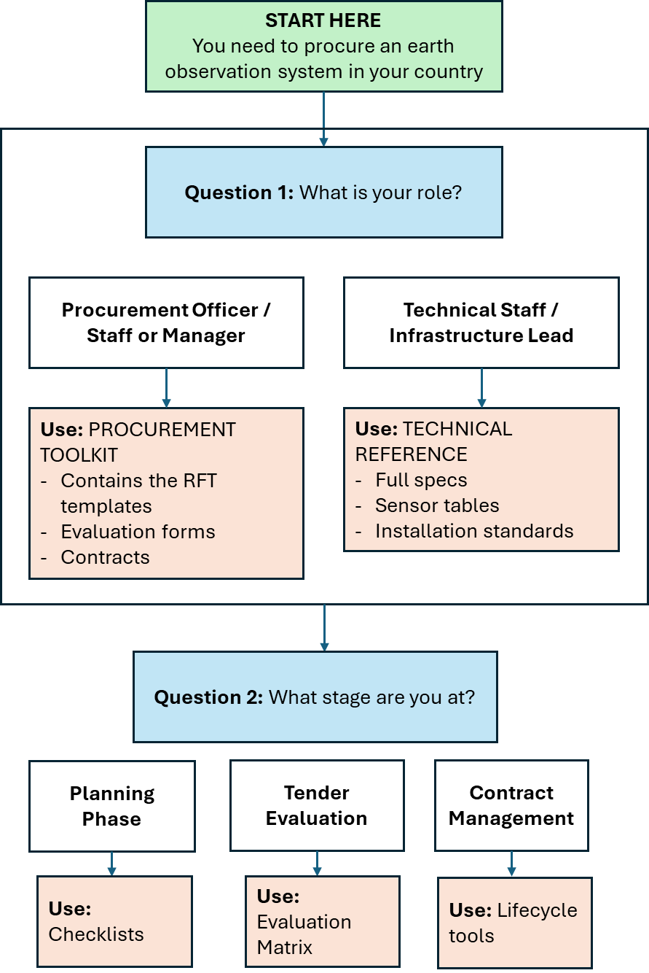

The 10-Step Procurement Process
Step | Activity | Time Needed | Key Document | Who Leads
1 | Define your need | 1-2 weeks | Tier Selection Guide (p.XX) | Technical Manager
1 | ☐What variables must be measured?
1 | ☐ Which tier (1/2/3) do you need?
1 | ☐ How many stations/systems?
1 | ☐ Where will they be located?
2 | Check budget | 1 week | Lifecycle Cost Worksheet | Finance Officer
2 | ☐ Capital available?
2 | ☐ Operations budget confirmed?
2 | ☐ Spare parts funded?
3 | Draft specifications | 1-2 weeks | System Module Templates | Technical + Procurement
3 | ☐ Select your system type
3 | ☐ Copy the tier specifications
3 | ☐ Add site-specific requirements
4 | Prepare tender documents | 1 week | RFT Master Template | Procurement
4 | ☐ Complete all sections
4 | ☐ Attach specs as Annex
4 | ☐ Get legal review
5 | Release and manage queries | 4-6 weeks | Query Log Template | Procurement
5 | ☐ Advertise (min 30 days)
5 | ☐ Respond to all questions
5 | ☐ Issue clarifications
6 | Receive and register bids | 1 day | Bid Register | Procurement
6 | ☐ Check deadlines
6 | ☐ Log all submissions
6 | ☐ Initial compliance check
7 | Evaluate technical bids | 2-3 weeks | Evaluation Scorecard | Technical Panel
7 | ☐ Score each criterion
7 | ☐ Minimum 70% technical score
7 | ☐ Shortlist
8 | Evaluate financial bids | 1 week | TCO Calculator | Finance + Procurement
8 | ☐ Check for unrealistically low bids
8 | ☐ Calculate weighted score
8 | ☐ Prepare recommendation
9 | Award contract | 1-2 weeks | Contract Template | Legal + Procurement
9 | ☐ Negotiate if needed
9 | ☐ Obtain bank guarantee
9 | ☐ Sign contract
10 | Manage delivery | Per contract | Lifecycle Management Tools | Technical Manager
10 | ☐ Oversee installation
10 | ☐ Ensure training delivered
10 | ☐ Track warranty & spares

Quick Help
For help with... | Contact | When
Technical specifications | [Your NMHS technical lead] | During steps 1-3
Procurement process | [Your procurement officer] | Throughout
Regional coordination | SPREP WRP Team | For pooled procurement
Calibration questions | WMO Regional Instrument Centre | Before specifying
Training support | RTC Nadi / RTC Melbourne / SPREP WRP Team | During planning

Quick Tips
Avoid making these mistakes:
Buying equipment without operations budget → Use Lifecycle Cost Worksheet
Specifying Tier 1 when you need Tier 2 → Check the tier guide carefully
Not including training in contract → Training is mandatory (Section 4.5)
Single point of failure in communications → Always require redundant telemetry
Ignoring corrosion protection → Pacific requirements are non-negotiable

Next Steps
Now that you understand the process, proceed to:
For PROCUREMENT STAFF: Go to [Procurement Toolkit - Part A: Master Templates]
For TECHNICAL STAFF: Go to [Procurement Toolkit - Part B: System Modules]
For BOTH: Review [Checklists] before starting any step

