Weather Ready Pacific
Operations Manual

Introduction and Governance
Version 1.0 FOR SC

SCOPE – This chapter applies to WRP and Executing agencies

Contents
Chapter 1. Introduction and Governance 2
1. Purpose and Scope of Manual 3
2. Overview of Weather Ready Pacific Programme 4
3. Beneficiaries of WRP Programme 5
4. Strategic Context 6
4.1 SPREP – Institutional home of WRP 7
4.2 Pacific Meteorological Ecosystem 7
4.3 Key Partners and Donor Landscape 8
5. WRP Principles 10
6. WRP Charter 10
7. WRP Governance 11
7.1 Pacific Ministers and Pacific Meteorological Council 12
7.2 WRP Steering Committee 13
7.3 WRP Liaison Platform and PRP Technical Working Group 13
7.4 WRP Donor Committee 15
7.5 WRP Technical Committee 15
8. Delegations Framework 15
9. SPREP Organisational Context 16
9.1 Climate Science and Information Division 17
9.2 WRP Programme Management Unit 17
9.3 Staffing Structure and Key Roles 18
10. Funding Mechanism 21
11. WRP Reporting Framework 22
Annex 1.1 Terms of Reference - Steering Committee 23
Annex 1.2 Terms of Reference - Technical Committee 23
Annex 1.3 Terms of Reference - Donor Committee 23
Annex 1.4 Terms of Reference - Liaison Platform 23
Annex 1.5 Terms of Reference - PRP Technical Working Group 23
Annex 2. WRP Delegations Authority 23
Annex 3. WRP Charter 23
Annex 4. WRP Reporting Framework 23

Chapter 1. Introduction and Governance

SCOPE – This chapter applies to WRP and Executing agencies.

Accountability
SPREP Sponsor | Director of CSI
SPREP Responsible Officer | WRP Programme Manager

Version History
Date | Version | Description | Author | Reviewer | Approver
250925 | SC | Early Draft provided to September Steering Committee for information | Jessica Yeung | 'Ofa Fa'anunu
160226 | 0.1 | Draft for Technical Committee Review | Jessica Yeung | 'Ofa Fa'anunu
 | 1 | For SC approval | Jessica Yeung | 'Ofa Fa'anunu

SCOPE – This chapter applies to WRP and Executing agencies.
Text in blue indicates changes since last approved version.
- Purpose and Scope of Manual

The Weather Ready Pacific (WRP) Operations Manual provides a comprehensive guide to the programme’s operational framework, governance arrangements, and standard procedures. Its purpose is to ensure consistency, accountability, transparency, and effectiveness in the delivery of the WRP programme across all participating countries and stakeholders.

This manual serves as a reference document for Secretariat of the Pacific Regional Environment Programme (SPREP) staff, Executing Agencies, implementing partners, and donors. It outlines the roles, responsibilities, and procedures that guide programme delivery, including governance structures, financial management, procurement, monitoring and evaluation, risk management, and other cross-cutting issues such as sustainability, Gender Equality, Disability and Social Inclusion (GEDSI), and environmental and social safeguards.

The manual is intended to:
- Ensure clarity and alignment across all WRP partners and stakeholders;
- Promote good governance, compliance, and continuous improvement;
- Provide a single source of truth for operational processes and decision-making;
- Support the delivery of timely, high-quality, and sustainable outcomes in line with WRP’s objectives.

This manual is aligned with SPREP’s internal policies, procedures, and standards.

This document will be periodically reviewed and updated as the programme evolves and lessons are learned, ensuring it remains relevant, practical, and responsive to the needs of Pacific island countries and territories participating in the WRP Programme.

The scope of each chapter applies to WRP and may also extend to Executing agencies. This is outlined in the table below.

Chapters | SPREP Sponsor (Approver) | SPREP Responsible Officer | Scope | Status
Chapter 1. Introduction and Governance | Director of CSI | WRP Programme Manager | WRP and Executing Agencies | For Approval
Chapter 2. Programme Delivery | Director of CSI | WRP Programme Manager | WRP and Executing Agencies | For Approval
Chapter 3. Procurement and Contract Management | Director of Finance | WRP Procurement Officer | WRP | For Approval
Chapter 4. Finance | Director of Finance | WRP Financial Accountant | WRP | For Approval
Chapter 5. WRP Funding Framework | Director of Finance | WRP Financial Accountant | WRP | For Approval
Chapter 6. MERL | Director of SPPRD | WRP MERL Officer | WRP and Executing Agencies | For Approval
Chapter 7. Risk and Issues Management | Director of CSI | WRP Programme Manager | WRP and Executing Agencies | For Approval
Chapter 8. Resource Mobilisation | Director of SPPRD | WRP Programme Manager | WRP | NYC
Chapter 9. Communications & Stakeholder Engagement | DDG SPREP | WRP Communications Officer | WRP | NYC
Chapter 10. Sustainability | Director of CSI | WRP Programme Manager | WRP and Executing Agencies | For Approval
Chapter 11. GEDSI | Director of SPPRD | WRP ESS Officer | WRP and Executing Agencies | For Approval
Chapter 12. Environment and Social | Director of EG | WRP ESS Officer | WRP and Executing Agencies | For Approval
Chapter 13. Knowledge Management | Director of CSI | WRP Knowledge Mgmt Officer | WRP and Executing Agencies | For Approval
Chapter 14. Quality Assurance | Director of CSI | WRP Programme Manager | WRP | For Approval

- Overview of Weather Ready Pacific Programme
In 2021, Pacific Leaders endorsed the Weather Ready Pacific Decadal Programme of Investment (WRP), which seeks to reduce the human and economic costs of severe weather, water and ocean events across Pacific Island communities, by strengthening national meteorological and hydrological organisations and their partnerships with national disaster management organisations. This programme of investment ensures that the Pacific sustainably participates in and benefits from advances in forecast and warning systems that should ultimately enable increased accuracy, geographic specificity and lead time of forecasts.

In 2023, the Pacific Meteorological Ministers endorsed Weather Ready Pacific as the key vehicle for Early Warning for All.

The Weather Ready Pacific (WRP) initiative is formally recognized within the 2050 Strategy for the Blue Pacific Continent as one of the 28 prioritised Regional Collective Actions - a concrete regional commitment to enhance early warning systems and climate resilience across Pacific Island Countries and Territories.

WRP OVERALL OBJECTIVE
Climate and disaster resilient Pacific Island communities have improved safety, security, socio-economic well-being and prosperity.

WRP SPECIFIC OBJECTIVE
Pacific communities, governments and industries have inclusive multi-hazard early warning systems, forecasts, and information to reduce the impacts of extreme weather and other natural hazard events, including those exacerbated by climate change.

- Beneficiaries of WRP Programme
WRP Programme provides support to the following countries. There may be activities through ringfenced funding which is targeted to specific countries.

Countries

Cook Islands | Tokelau
Federated States of Micronesia | Tonga
Fiji | Tuvalu
Kiribati | Vanuatu
Marshall Islands | American Samoa
Nauru | French Polynesia
Niue | Guam
Palau | New Caledonia
Papua New Guinea | Northern Mariana Islands
Samoa | Wallis and Futuna
Solomon Islands

- Strategic Context

4.1 SPREP – Institutional home of WRP

In 2008, Pacific Island Forum Leaders, adopted the Niue Declaration on Climate Change and SPREP, working in cooperation with other regional and international agencies and bilateral climate change programmes, to continue to meet the individual needs of its member countries through its mandated role of:
- strengthening meteorological services,
- consolidating and distributing information on climate change,
- strengthening adaptation and mitigation measures, and
- increasing Pacific Island countries’ capacity to manage their engagement in financial
- and technical resources to do this work.

SPREP (the Secretariat) is the region’s key inter-governmental organisation for environment and sustainable development. The Pacific Meteorological Council (PMC) is a specialised subsidiary body of the SPREP Meeting. The PMC provides relevant policy advice to the SPREP Meeting on the needs and priorities of SPREP member countries and territories in relation to meteorology (weather and climate) and related fields. In 2019, WRP was mandated as a programme of the PMC with SPREP as the implementing agency, with overall responsibility for the delivery of WRP. Under the WRP Decadal Investment Plan, there are multiple executing agencies (including SPREP) responsible for the day to day delivery of WRP activities (section 4.3 refers).

4.2 Pacific Meteorological Ecosystem

The Pacific Meteorological environment has evolved over the past decades and has come a long way in supporting NMHS in the provision of essential services to the safety and well-being of Pacific communities. While we recognise this improvement in the provision of services, more must be done to ensure coherence and coordination of the significant investment in the development and improvement in the capacities and capabilities of NMHSs as recognised in the overarching Pacific Islands Meteorological Strategic (PIMS) 2017-2026 and its associated Roadmaps. The Weather Ready Pacific Decadal Investment Programme, commissioned by SPREP and designed in close partnership with the Australian Bureau of Meteorology (BOM), the World Meteorological Organization (WMO) and Directors of the NMHSs of SPREP members, provides the platform for a facility that will enable greater cohesion and coordination. More importantly, WRP will address the critical gaps and provide a sustainable and harmonised approach.

Within this environment, the region has organised itself under the following arrangements:
The Regional Hub for Meteorological Services in the Pacific called the Pacific Meteorological Desk, in SPREP with the Climate Change and Resilience Directorate, has been operational since 2011, in its current form. Within this Regional Hub, the Pacific Meteorological Council (PMC) and the Pacific Meteorological Desk Partnership (PMDP) work hand in hand, under the guidance of the Director of the Climate Science and Information Programme.

The Pacific Meteorological Council (PMC) is a specialised subsidiary body of SPREP, established at the Fourteenth Regional Meteorological Services Directors meeting in Majuro, Republic of Marshall Island in August 2011 to facilitate and coordinate the scientific and technical programme and activities of the Regional Meteorological Services. The PMC replaces the Regional Meteorological Services Directors body and provides policy relevant advice to the SPREP Meeting on the needs and priorities of its member countries and territories in relation to meteorology (weather and climate) and related fields. The PMC meets on a biennial basis.

The Pacific Meteorological Desk Partnership (PMDP) is a regional coordinated response to meeting weather and climate services development in the Pacific Islands region. Endorsed at the 21st Secretariat of the Pacific Regional Environment Program (SPREP) Meeting, Madang, Papua New Guinea (PNG) in 2011 to renew a Pacific Island regional mechanism urgently needed to develop capacity and advance the sustainability of weather and climate services in Pacific Islands, the establishment of the PMDP serves as the regional weather and climate services coordination mechanism managed by the SPREP and WMO to deliver a regionally coordinated effort to service SPREP Members needs in the area of weather and climate services.

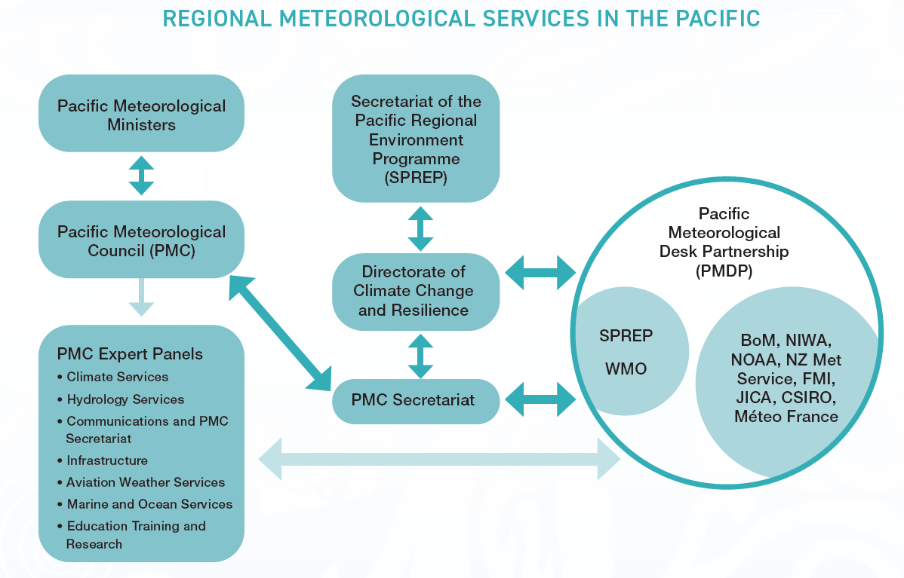

4.3 Key Partners and Donor Landscape

The WRP programme objectives and intended outcomes are enabled by a diverse group of partners and stakeholders, including regional technical agencies, regional delivery partners of complementary projects, UN organisations, civil society, and the private sector, who contribute to strengthening early warning systems and climate resilience across the Pacific.

While not all funding flows through WRP, WRP has a critical role in facilitating information sharing and coordinating these complementary project activities in the region for sustainability, leveraging these activities to achieve the overall WRP programme objectives.

WRP funding contributions are primarily from bilateral donors, multilateral climate finance sources, and philanthropic partners. The donor landscape reflects a shared commitment to the Pacific Island Meteorological Strategy, Pacific roadmap for strengthened climate services, UN Early Warnings For All Initiative (EW4ALL), 2050 Strategy for the Blue Pacific Continent endorsed by the PIF Leaders in 2022, Framework for Resilient Development in the Pacific (FRDP) and global goals such as the Sendai Framework for Disaster Risk Reduction, the Paris Agreement, and the Sustainable Development Goals (SDGs). These partnerships are critical to ensuring locally led, sustainable, and coordinated delivery of the WRP programme across the region.

Key complementary projects and donors may include:
- Systematic Observations Financing Facility (SOFF)
- World Bank
- Green Climate Fund
- ADB
- Government of Australia
- Government of New Zealand
- UK Met Office WISER
- Japan International Cooperation Agency
- EU ClimSA Programme
- COSPPac
- WMO CREWS Pacific
- Intra-ACP
- VanKIRAP (GCF)
- WFP
- UNESCO
- AFD (France)

Technical Agencies and Regional delivery partners include;
- SPC
- UNDP
- UNEP
- WMO
- UNDRR
- Earth Sciences NZ
- NZ Met Services
- Bureau of Meteorology
- NOAA
- JICA
- UK Met Office
- KMA/KMI
- UNESCO
- ICAO
- FAO
- CSIRO
- CMA
- Varysian
- OTT HydroMet

- WRP Principles
The WRP Programme is guided by a set of 4 key principles:

Pacific-led and owned
Driven by Pacific peoples | Responsive to local needs, cultural contexts | Integrates traditional knowledge systems and practices | Harmonised (local, national, regional, global)

Inclusive, equitable and empowering
Rights-based | GEDSI-responsive | Active, Meaningful Participation | Precautionary

Collaborative
Mutually accountable and transparent | Coordinated | Partnership-based

Transformative and sustained
Visionary | Structural and Systemic | Agile | Enduring

- WRP Charter
This operations manual must be read together with the WRP Charter (Annex 3). The Charter establishes the higher-level governance, funding and accountability framework that sits above the Operations Manual, binds donors into a common structure, and anchors key matters such as the WRP Pooled Fund and the unified governance/reporting model. The Charter gives WRP a stable, programme-level “constitution”, while the Operations Manual can be updated more readily as procedures evolve.

In the event of inconsistency between the Charter (Annex 3) and this manual, the Charter takes precedence.

- WRP Governance

This operations manual must be read together with the WRP Charter (Annex 3). In the event of inconsistency between the Charter and this manual, the Charter takes precedence.

7.1 Pacific Ministers and Pacific Meteorological Council

PMC is a designated subsidiary body of the SPREP and operates within the legal and financial frameworks of the SPREP Agreement as part of the Regional Hub for Meteorological Services in the Pacific. The Weather Ready Pacific Programme is established at SPREP and will use the existing structure of the PMC which currently includes the Pacific Met Desk as the secretariat, the current 6 expert Panels, the Ministerial Meeting and the Donor Engagement Meeting setup during PMC-6.

The Weather Ready Pacific Programme Steering Committee will report directly to the PMC, and subsequently to the Pacific Ministers Meeting on Meteorology (PMMM). A WRP Programme Management Unit (WRP PMU) will work closely with the PMC Secretariat to prepare the documentation and all reports to be presented by the Chair of the WRP SC to the PMC. WRP Programme is a standing agenda item for the PMC.

Broadly speaking, the PMC is responsible for strategic policy in relation to WRP. The WRP SC is responsible for management supervision of WRP. This division of functions is reflected in the WRP Delegations Policy.

7.2 WRP Steering Committee

The PMC established a WRP Steering Committee (WRP SC) to ensure that WRP is responding to NMHSs and MHEWS needs. The WRP SC provides strategic direction to WRP. The composition of the WRP SC is determined by the PMC. It currently comprises representatives of the National Meteorological and Hydrological Services, National Disaster Management Offices and development partners (Refer to Annex 1.1 for approved Terms of Reference for WRP SC.

The Steering Committee will approve the unified reporting framework to WRP (Annex 4), which will be provided to all WRP Donors.

The Programme Management Unit (PMU), within SPREP provides secretariat support and technical advice to the WRP SC and the WRP Liaison Platform (refer to section 6.4 for responsibilities of the PMU).

7.3 WRP Liaison Platform and PRP Technical Working Group

The Liaison Platform provides an avenue for WRP Partners to be engaged, with the aim to strengthen existing partnerships, identify new partnerships and facilitate greater collaboration/coordination across partners to jointly achieve WRP objectives. This structure is ideal for multiple partners contributing to the hybrid investment facility. The inclusion of the WRP Liaison Platform ensures implementation of the Pacific Key Outcomes (PKO) 10 – Support to NMHSs is coordinated as outlined in the PIMS 2017–2026. Additionally, the WRP Liaison Platform would also support knowledge sharing and technical coordination between the WRP technical partners and other partners to ensure support provided to NMHSs is technically sound, complementary and coordinated.

The WRP Liaison Platform should be seen as a forum for existing regional and global mechanisms and organsiations to guide and align WRP, and for WRP to communicate with and influence outside the program itself. More specifically, the WRP Liaison Platform is designed to:
- enhance engagement between WRP and Partners beyond the PMC, NDMOs, CROP agencies and current WRP donors;
- to mitigate against redundancy with other regional and global initiatives, and;
- to maximise the benefits to the Pacific meteorology and disaster management sectors through leveraging new and existing initiatives and funds.

The WRP Liaison Platform is designed to be a two-way virtual communication and advocacy platform, facilitated by the PMU, and reporting into the WRP SC. The WRP Liaison Platform shall comprise representatives of:

- The 6 PMC Panels (PIETR, AVIATION, HYDROLOGY, PIMOS, PICI, PICS);
- The Working Groups of the Pacific Resilience Partnership;
- The Working Groups of the Pacific Climate Change Roundtable;
- The Pacific Partnership Coordination Mechanism;
- The UN Agencies responsible for leading the Early Warning Systems for All Initiative (UNDRR, WMO, ITU, IFRC); and
- Development Partners (existing and future).

Recognising that the PMC Expert Panels meet more frequently and are mostly chaired by a NMHSs, it would be essential for the WRP Technical Advisers to provide support to the Chairs of the Panels and interact with the members of these panels. This will allow for greater engagement and technical discussions with a wider group of technical organisations, universities, research institutes who are members of the Panels that will inform the annual work plans of WRP to address the needs of NMHSs on a more timely basis

The regional landscape has a proliferation of partners and technical agencies (such as the Pacific Community’s Ocean services, hydrology and disaster management teams), working in complementary projects/programmes, and it is necessary that WRP work with them and where necessary, draw on this expertise.

Refer to Annex 1.4 for Terms of Reference of the Liaison Platform for coordination of MHEWS activities within the scope of the WRP Implementation Plan. WRP as currently structured does not have the capacity to act as the overarching coordinating agency for MHEWS in the Pacific and across all Pillars of EW4All.

The Pacific Resilience Partnership (PRP) MHEWS & Risk Information TWG may evolve as the primary regional coordination mechanism for MHEWS. Refer to Annex 1.5 for Terms of Reference for TWG.

Established in 2017, the Pacific Resilience Partnership (PRP) is the umbrella implementation mechanism for the Framework for Resilience Development in the Pacific (FRDP). The PRP reports directly to the Pacific Islands Forum Leaders. The PRP has Technical Working Groups for Disaster Risk Finance, Human Mobility, Risk Governance and Resilient Development, Localisation, Information Knowledge Management, Pacific Market Based Mechanisms to address Climate Change, Water Security, Resilient Infrastructure and Resilient Housing, and Gender and Social Inclusion.

The PRP has established a new TWG on MHEWS and Risk Information that provides the potential mechanism for MHEWS coordination in the Pacific. The advantages of coordinating MHEWS through the PRP TWG include (1) political support through direct lines of reporting to Pacific Island Forum Leaders, (2) links to disaster risk financing through FEMM, and (3) institutional capacity to respond rapidly to country requests.

7.4 WRP Donor Committee

The proposed Donor Committee provides a forum for donors and potential donors / investors to the WRP programme to share information. Refer to Anex 1.3 Donor Committee Terms of Reference.

7.5 WRP Technical Committee

The Technical Committee provides (1) a forum for technical advice to the WRP program, and (2) a mechanism for WRP to engage with MHEWS technical experts outside of WRP. Refer to Annex 1.2 Technical Committee Terms of Reference. Notably, the Technical Committee is not established as a decision-making body and does not have coordination responsibilities.

- Delegations Framework

The WRP Steering Committee has approved authorisation and delegations as it relates to:

- Ministers
- PMC
- Steering Committee
- SPREP/WRP

Refer to Annex 2 WRP Delegations Framework. Additionally, the WRP Delegations Framework aligns with, and WRP must adhere to delegations framework of SPREP.

All financial, procurement, and operational decisions within the governing bodies of WRP and the PMU must adhere to these policies. This policy outlines the levels of authority delegated to the specific governing body and roles within the organisation, ensuring accountability, transparency, and appropriate oversight of decision-making processes. It defines who is authorised to approve expenditures, enter into contracts, sign agreements, and commit programme resources, based on the nature and value of the transaction. Compliance with this policy is mandatory for all WRP staff and Executing Agencies, and is critical to maintaining strong internal controls, managing risk, and aligning with donor and audit requirements. The delegations framework is reviewed periodically and updated as necessary to reflect changes in programme structure, funding, and governance arrangements.

- SPREP Organisational Context

9.1 Climate Science and Information Division

The Climate Services and Information (CSI) Division is a newly established division within SPREP, created to enhance the coordination, delivery, and impact of climate, weather, and ocean services across the Pacific region. CSI brings together SPREP’s technical expertise in meteorology, climatology, oceanography, and information systems to support member countries in strengthening resilience to climate variability and change. The division leads the implementation of the WRP programme, Pacific Island Meteorological Strategy (PIMS) (2017-2026) and provides strategic oversight, technical guidance, and operational support to National Meteorological and Hydrological Services (NMHSs) and other partners.

9.2 WRP Programme Management Unit

The WRP Programme Management Unit (PMU) has been established for the coordination and day to day management of activities of the Weather Ready Programme. It will function as the secretariat to the WRP SC. The WRP PMU is based in SPREP to work very closely with the PMC Secretariat. The role of WRP PMU is:

- Develop, coordinate and implement the WRP work plan based on the WRP programme of investment;
- Provide overall financial management of the programme;
- Manage the day-to-day work of the WRP PMU including existing implementation partners;
- Work closely with the other projects in the Pacific Meteorology Desk Partnership to ensure there is no duplication of investments and ensure complementarity of investments;
- Facilitate new development partners involvement;
- Develop and implement WRP PMU communications strategy;
- Coordinate delivery of activities with NMHSs, coordinate, collaborate and draw on technical expertise existing in the region (including entities such as SPC) and manage the deployment of technical staff and experts;
- Ensure programme delivery is in line with the WRP Programme; the Pacific Island Meteorological Strategy and its associated Roadmap 2017-2026; and other ongoing programmes (e.g. COSSPac; PREP; GCF);
- Ensure regular reporting and the provision of updates to the WRP SC on activities and provide secretariat support;
- Ensure regular monitoring and evaluation of WRP PMU effectiveness and suggest adjustment to implementation, as appropriate;
- Provide annual technical and financial reporting to the WRP SC, Liaison Platform and the PMC.
- Ensure regular monitoring and evaluation of PMU effectiveness and suggest adjustment to implementation as appropriate;
- Coordinate the delivery of reports under the WRP Reporting Framework, including consolidating technical, financial, MERL, GEDSI, sustainability, assurance and donor-integrated reporting inputs;
- Manage the timetable for the WRP Reporting Framework; the provision of secretariat support to the WRP governance bodies; and the circulation of draft and final governance products to the WRP governance bodies for approval; and
- Ensure that reports under the WRP Reporting Framework are provided to the Steering Committee, Donor Committee, Liaison Platform, and PMC as required under the WRP Reporting Framework.

9.3 Staffing Structure and Key Roles

WRP PMU structure is depicted below as of September 2025. Future proposed positions (light blue) are also included with timing of recruitment based on the need of the programme and funding availability. The structure is subject to change and refinement as required by WRP. Refer to Implementation Plan and Work Plan for latest target timeframe for roles to be filled.

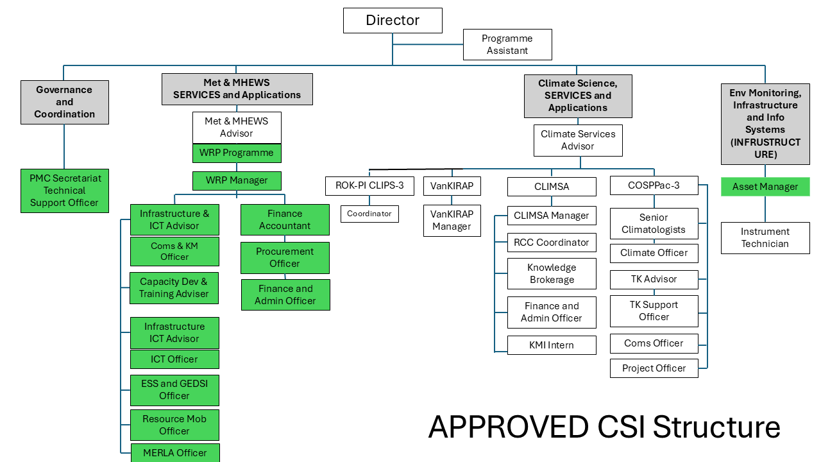

Non-SPREP Staff, Advisors and consultants are engaged at various points in the program.

WRP Manager (Band 14)

As a critically important role to the overall purpose of the WRP and the Pacific Meteorological Desk Partnership, this position seeks to, but is not limited to, the following:

- Provide strategic leadership and management that ensures effective and efficient implementation of the WRP Programme for the benefit of all Members;
- Provide a key coordination function in partnership with the PMDP and the PMC;
- Development of close, strong and collaborative relationships with key stakeholders including Members, donor/development partners, and other implementing agencies;
- Develop a Pacific Meteorological Leadership programme;
- Provide technical support in strengthening the governance and institutional arrangements at the regional and national levels
- Preparation of overall and annual plans, communication plans, risk strategies
- Overall responsibility for monitoring and evaluation of programme implementation, including working with the MERLA Officer and key stakeholders on the design of MERLA framework, implementation of evaluation recommendations, best practices and lessons learned;
- Overall responsibility for the WRP Sustainability Framework
- Ensure programme objectives are realised in accordance with the operational policies and procedures of (SPREP)

Technical Adviser – Forecasts and Warning Communications (Band 12)

This role will be the lead technical adviser to deliver the “Production of forecasts and warnings” and “Infrastructure” components of the WRP.

Technical Advisor – Infrastructure and ICT (Band 12)

This role will be the lead technical adviser to deliver the “Infrastructure and Communications” components of the WRP. They will also lead the coordination and facilitate the activities relating to PICI panel and to the establishment of the WMO Regional Instrument Centre.

Technical Adviser – Capacity Development & Training (Band 12)

This role will be the lead technical adviser to deliver the “Capacity and Training” and “Communications” components of the WRP. They will also lead to coordination and facilitate activities relating to PIETR panel and the establishment of the WMO Pacific Regional Training Centre.

Financial Accountant (Band 11)

This role is a critical role to ensure the programme delivers within the fiduciary standards. Recognising the quantum of WRP and the heavy investment in infrastructure, this role will need to be a highly experienced individual in adopting sound procurement processes (within the framework of SPREP’s procurement policy) and to be responsible for all financial reporting requirements to the PMC and also donors/partners where necessary. Recognising the multiple components to WRP, considerable experience in financial management is essential.

Finance Investment Advisor (Band 13)

The role to support the maintenance fund facility.

Procurement Officer (Band 10)

Leading procurement and contract management activities for WRP.

Communications & Knowledge Management Officer (Band 10)

This role would also develop and implement the WRP Communications Strategy, a critical element to ensure WRP results are recognised by a large audience. This role will also have the responsibility for visibility and knowledge management within and external to WRP.

MERLA Officer (Band 10)

This role focuses on monitoring, evaluation, research and learning to inform purposeful WRP decision-making adaption, strategic communications and ensure accountability to all stakeholders..

During the establishment phase of the PMU, specialist MERL advisor(s) are engaged to develop the MERL framework and may continue to be on contract during the implementation as an advisor to WRP along side the MERLA Officer.

GESDI and Safeguard Officer (Band 10)

This role will support the programme to ensure full inclusivity, equity and equality of all persons and prioritise the needs of the most vulnerable working with various organisations in the Pacific.

During the establishment phase of the PMU, a specialist GESDI advisor is engaged to develop the GESDI strategy and engagement strategy, and may continue to be on contract during the implementation as an advisor to WRP along side the ESS Officer.

Asset Officer (Band 9)

This role will oversee hydrometerological asset management planning for the pacific region and support country level planning. This role will also manage, administer, train and support countries on the asset information system use.

ICT Officer (Band 9)

This role will manage and coordinate ICT systems for the pacific region and support country level systems management.

PMC and SC Secretariat Technical Support Officer (Band 9)

For the Governance structure to operate smoothly, a PMC technical support officer will be recruited to support the overall operations and linking to the PMC, the PPCM and the Ministerial Meeting.

Finance and Administration Officer

This position would provide overall administrative support including financial, logistics and secretarial support to the PMU. The position would also compile data and relevant information required for updating the project information management system, inform the preparation of narrative progress reports, support monitoring and evaluation of project, and other substantive reports.

Resource Mobilisation Officer (Band 10)

The role would assist the WRP Manager to develop a resource mobilsation plan as well as work with potential development partners to invest in the WRP Programme.

During the establishment phase of the PMU, a specialist Resource Mobilisation advisor may be engaged to develop the Resource Mobilisation strategy and engagement with key avenues/contacts.

- Funding Mechanism

The PMC-6 agreed to have the Hybrid of Pooled and individual partner arrangements
to start the implementation while working towards a ‘pooled funding’ approach as
the preferred option for WRP.

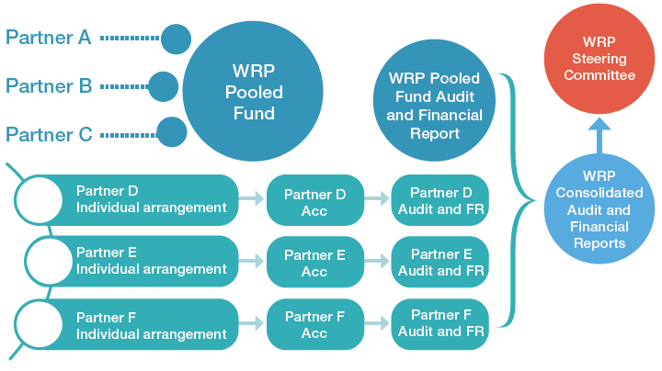

WRP operates through a hybrid but integrated funding architecture. Under this architecture:
- Pooled Funding is the principal funding mechanism for WRP and is managed in the WRP Pooled Fund in accordance with Chapter 5;
- Ringfenced Funding may be accepted on an exceptional basis [during the first phase of the Implementation Plan] where WRP Donor restrictions or partner-system constraints make Pooled Funding impracticable; and
- Other Support may include co-financing, direct technical assistance, in-kind support and other approved support associated with WRP.

All such funding and support must be reflected in the Implementation Plan, Funded Workplan, Programme Tracker and WRP Reporting Framework. Detailed operational rules are set out in Chapter 5 WRP Funding Framework.

- WRP Reporting Framework
WRP reporting approach is detailed in Chapter 2 Programme Delivery and Chapter 6 MERL Framework. The consolidated, multi-donor reporting framework for WRP is set out in summarised view in Annex 4 WRP Reporting Framework.

Annex 1.1 Terms of Reference - Steering Committee

Annex 1.2 Terms of Reference - Technical Committee

Annex 1.3 Terms of Reference - Donor Committee

Annex 1.4 Terms of Reference - Liaison Platform

Annex 1.5 Terms of Reference - PRP Technical Working Group

Annex 2. WRP Delegations Authority

Annex 3. WRP Charter

Annex 4. WRP Reporting Framework

