

Weather Ready Pacific
Operations Manual

Chapter 4
Finance
Version 1.0 FOR SC

SCOPE – This chapter applies to WRP and Executing agencies.

Chapter 4. Finance

SCOPE – This chapter applies to WRP and Executing agencies.

Accountability
SPREP Sponsor | Director of Finance
SPREP Responsible Officer | WRP Financial Accountant

Version History
Date | Version | Description | Author/Reviser | Approver
160226 | 0.1 | Draft for Technical Committee Review | Honsol Chan Tung
 | 1 | For SC

This Chapter sets out the finance-system, accounting, expenditure-classification, foreign-exchange, asset-management and financial-reporting procedures applicable to WRP. The legal and governance architecture for WRP Funding, including the WRP Pooled Fund, Ringfenced Funding, the MHEWS Readiness Fund, Other Support and any other approved funding mechanism, is set out in Chapter 5.
Accordingly:
- whether funding is classified as Pooled Funding, Ringfenced Funding, Other Support or other approved funding mechanism is determined under Chapter 5;
- whether an activity is within the approved Implementation Plan, Funded Workplan or delegated approval pathway is determined under Chapter 2 and Annex 2 to Chapter 1;
- all approved WRP Funded activities must be assigned and tracked through the relevant project, phase and task architecture in accordance with this Chapter;
- all costs recorded in the Programme Tracker exclude SPREP fees, and the treatment of SPREP fees, programme-management fees and cost recovery is governed by applicable SPREP policy; and
- the exception for MHEWS Readiness Fund (Flexi-fund) projects being classified as Phase 90 applies regardless of the output or outcome classification of the relevant activity.

For WRP purposes, where staff costs are budgeted using standard SPREP rates, any resulting variance between budgeted and actual staff expenditure may be reallocated through the approved planning and delegated approval processes. Where grant funding is received or committed in non-USD currencies, estimated USD values may be used until actual receipt values are known, with material changes reflected through the Programme Tracker, Implementation Plan and reporting processes.

- The financial governance and operations of the Weather ready Programme must be undertaken in compliance with SPREP’s policies listed below, as well as any other relevant SPREP policies and procedures that may apply. This includes, but is not limited to:
 | SPREP Policy | Link | Related WRP financial operations
 | Financial Regulations | Financial Regulations | Fagogo Intranet | Financial Governance
 | Financial Procedures Manual | Financial Procedures | Fagogo Intranet | Financial operations including SPREP delegated limits of Authority
 | SPREP Procurement Policy and Procedures Manual | SPREP_PROE-Procurement-Policy-and-Procedure-Manual_January-2025.pdf)  Alfresco » Document Library | WRP Purchases
 | SPREP Travel Policy | Travel Policy | Fagogo Intranet | WRP Travel and mission related processes.
 | Internal Control Framework | Internal Control Framework | Fagogo Intranet | WRP Compliance and governance
 | SPREP Foreign Exchange Policy | Foreign Exchange Policy | Fagogo Intranet | Financial operations
 | Programme Management Fees Policy | Programme management fees policy | Fagogo Intranet | Financial operations and Contract Management.
 | Cost recovery Policy | Cost Recovery Policy | Fagogo Intranet | Financial Operations

- SPREP Chart of Accounts for expenditure reporting classification.

- WRP will utilise the Phase and Task options in the Finance System to capture breakdown of expenditures by activities and by projects in the SPREP finance system.
- Phase and Task numbers associated with any WRP activity is found in the WRP Programme Tracker_280825.xlsx within the Project Register. See Figure 1.
- These Phase and Task numbers can only be assigned or amended by WRP Financial Accountant.
- The project Phase no. is automatically allocated based on the WRP activity no. The mapping of Phase no. to Activity no. in located in the Implementation Plan within the Program Tracker. See Figure 2.
- The exception is MHEWS Readiness Fund related projects which are all classified as Phase 90 in order to track them separately for financial purposes, regardless of what type of WRP activity they fall under from an Output and Outcome perspective.

Figure 1. Allocation of Phase, Task and Project No. In the Project Register within Programme Tracker
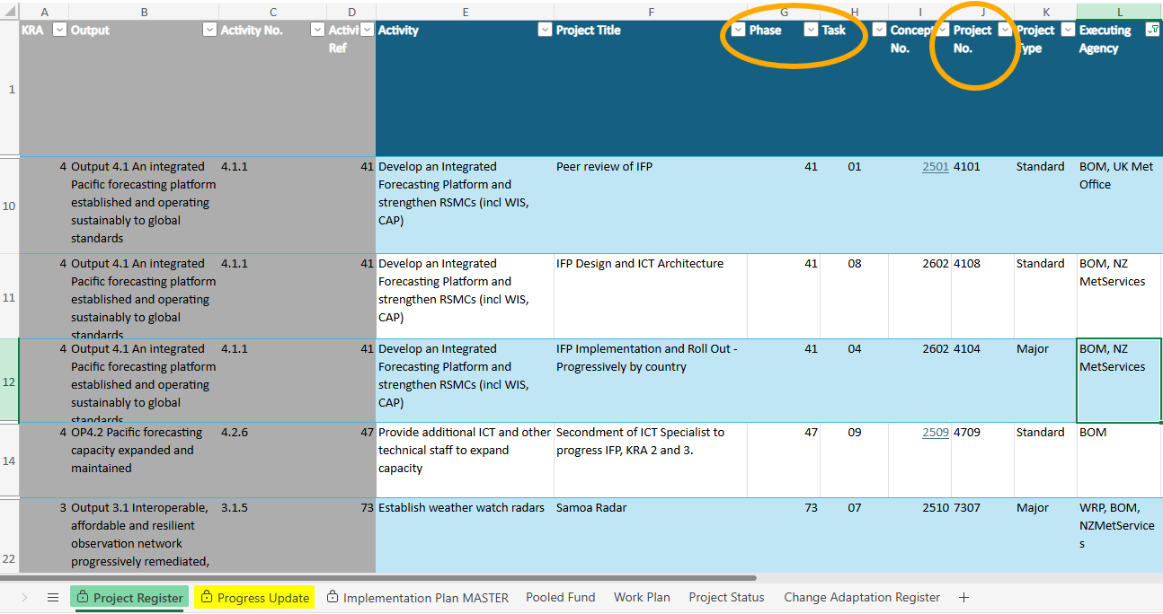

Figure 2. Phase and Activity No. mapping in Implementation Plan, within Programme Tracker
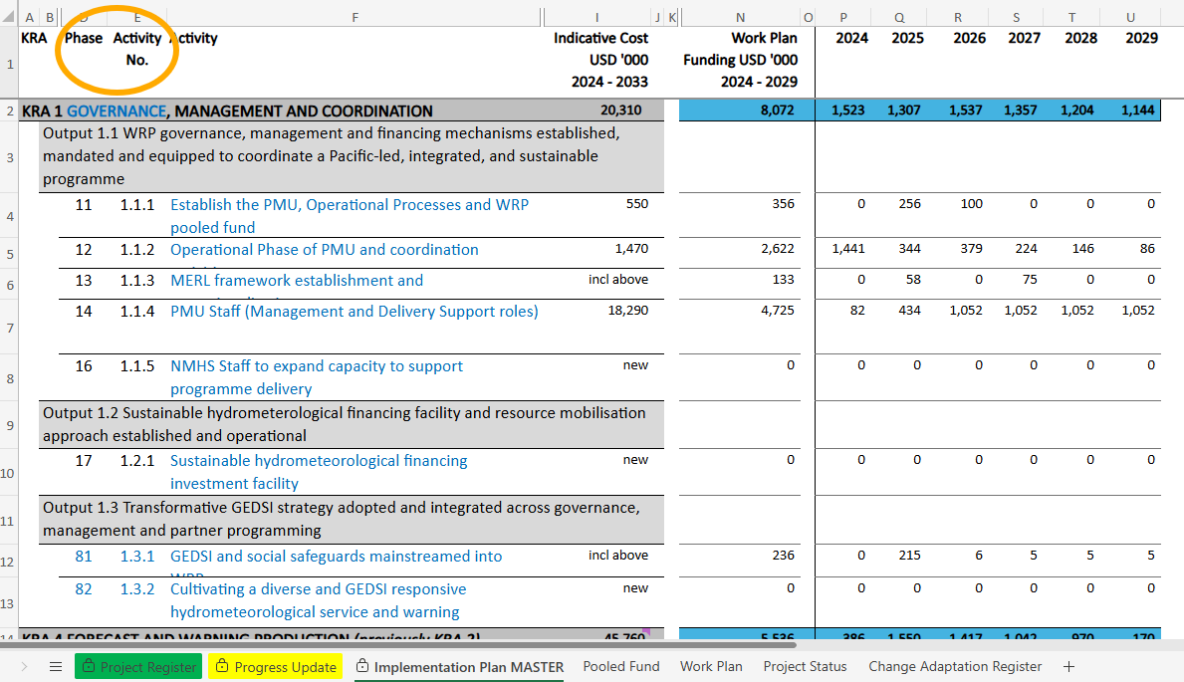

- Asset Management
- Capital expenditures / Assets are defined as “the purchase or construction of all assets (economic resources) in line with the SPREP Procurement Manual including additions to existing assets which will be in use over one year and have a cost over USD$1,000” as per section 11: Capital Expenditures of the SPREP Financial Procedures Policy.
- WRP will maintain a Programme Fixed Asset Register.
- When there is a transfer of ownership of the asset during the execution of the program, the asset transfer form is to be completed and to ensure the asset ownership is registered and recognised within the new owning entity in their organisational/national asset register.
- The Disposal of Assets will be subject to the procedures prescribed under SPREP’s Financial Procedures Manual.

- Financial Reporting.
- The WRP Reporting Framework is set out in Chapter 1 Annex 4.
- SPREP shall maintain a financial reporting architecture that supports the WRP Reporting Framework. At a minimum this must include: financial reports on all WRP Funding (including WRP Pooled Fund accounts); audited annual financial statements for WRP; and an annual audit management letter. Financial reporting outputs must be aligned to the annual reporting calendar and the Steering Committee cycle.
- Where the Weather Ready Programme (WRP) is subject to donor-specific reporting requirements, WRP must ensure full compliance. Examples of such requirements include quarterly reporting to UK and annual financial reporting to Australia and New Zealand and WRP 6-monthly progress reporting.
- All costs in Programme Tracker exclude SPREP Fees.
- Executing Agencies (non-NMHS) is to provide Progress Update report with estimated USD expenditure and note in comments the assumed exchange rate. See Figure 3.

Figure 3. Actual Expenditure Reporting against Forecast in Progress Update, within Programme Tracker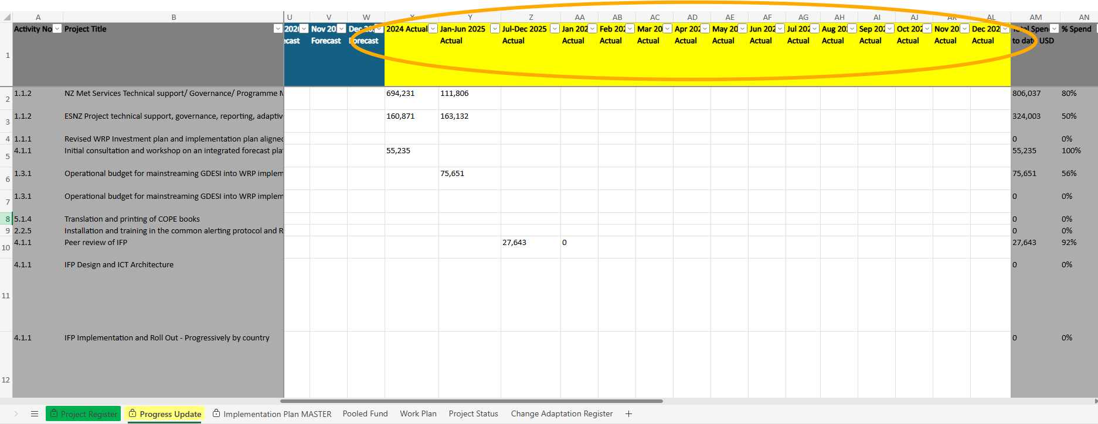
- For grant funding, which has been signed and that is not in USD currency, an estimated USD value is recorded in the Pooled Fund sheet in the Programme Tracker (see Figure 4).

Figure 4. Actual Expenditure Reporting against Forecast in Progress Update, within Programme Tracker
