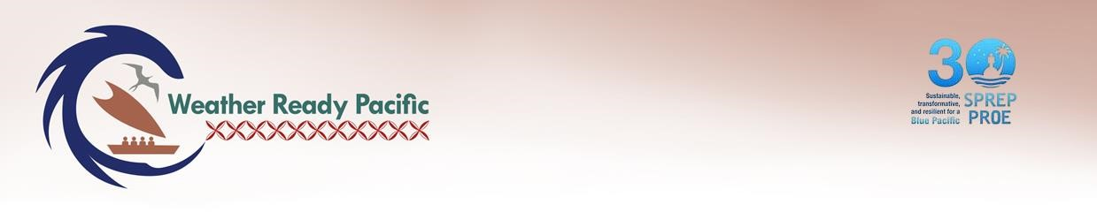

Weather Ready Pacific
Operations Manual

Chapter 6: Monitoring, Evaluation, Research and Learning
Version 1.0 FOR SC

SCOPE – This chapter applies to WRP and Executing agencies.

SCOPE – This chapter applies to WRP and Executing agencies.

Accountability
SPREP Sponsor / Approver | WRP Programme Manager
SPREP Responsible Officer | WRP MERLA Officer

Version History
Date | Version | Description | Author/Reviser | Approver
May 2025 | .1 | Draft Chapter structure | Kat Paton & Nicole Cherry
July 2025 | .2 | Initial draft for PMU consultation | Kat Paton & Nicole Cherry
September 2025 | .3 | Draft for stakeholder consultations | Kat Paton & Nicole Cherry | ‘Ofa Fa’anunu
September 2025 | .4 | Amended draft for Steering Committee endorsement | Kat Paton & Nicole Cherry | WRP Steering Committee
February 2026 | .5 | Updated MERL Chapter in line with WRP Planning Meeting discussions for Technical Committee review. | Kat Paton & Nicole Cherry
May 2026 | 1.0 | For SC | Richard Lal

Table of Contents
Acronyms and Abbreviations 4
1 Introduction 5
1.1 Purpose of Monitoring, Evaluation, Research and Learning 5
2 WRP MERL Framework 6
2.1 Design of MERL Framework 6
2.1.1 Components of the MERL Framework 7
2.1.2 MERL scope 7
2.1.3 Key uses of MERL 12
2.1.4 Ethical considerations 12
2.1.5 Alignment 13
2.2 MERL structure 14
3 Theory of Change - Impact Pathway 15
3.1 Objectives 15
3.2 Key Result Areas 16
3.3 Change Pathways 17
3.4 Integration of WRP principles 20
3.5 Assumptions 20
4 MERL Table 20
4.1 MERL Tables 20
4.2 Baseline data and targets 25
5 MERL Workplan 25
5.1 Overarching approach 25
5.2 Preparation and planning 27
6 Monitoring 27
6.1 Data collection methods/tools 27
6.2 Data analysis and synthesis methods 29
6.3 Data flow, storage and management system 30
7 Evaluation 30
7.1 Approach to evaluation 30
7.2 Staged evaluative reviews 31
8 Research 33
8.1 Identifying research requirements and opportunities 33
8.2 Collaborative research 34
9 Sharing findings and results 34
9.1 Approach to reporting and sharing results 34
9.2 Sharing research findings 35
9.3 Communications and stakeholder engagement strategy alignment 35
10 Learning and Reflection 36
10.1 Progress reviews and reflections 37
10.2 Application, transformation and adaptation 38
11 Operationalising MERL 38
11.1 MERL Governance, roles and responsibilities 38
11.2 MERL Capability Building 40
11.3 MERL Budget 41
Appendix One: MERL Terminology 42
Appendix Two: WRP Impact Pathway 44
Appendix Three: Reporting Requirements 46
Appendix Four: Sources 48

Annexures
Annex One: WRP MERL Tables
Annex Two: Tentative MERL Workplan
Annex Three: Evaluation Terms of Reference

Acronyms and Abbreviations
BoM | - | (Australian) Bureau of Meteorology
CBO | - | Community Based Organisations
CEAP | - | Climate Finance Anchor Investment: Climate Evidence and Advice
ClimSA | - | Climate Services and Related Application (EU Initiative)
COSPPac | - | Climate and Oceans Support Programme in the Pacific
CREWS | - | Climate Risk and Early Warning Systems
DFAT | - | (Australian) Department of Foreign Affairs and Trade
EW4ALL | - | Early Warnings for All
GEDSI | - | Gender Equality, Disability and Social Inclusion
KRA | - | Key Result Areas
MERL | - | Monitoring, Evaluation, Research and Learning
MetOffice | - | (United Kingdom) Met Office
MetService | - | (New Zealand) Meteorological Service
MFAT | - | (New Zealand) Ministry of Foreign Affairs and Trade
MHEWS | - | Multi-Hazard Early Warning System
NGO | - | Non-Government Organisation
NMHS | - | National Meteorological and Hydrological Service
OECD | - | Organisation for Economic Co-operation and Development
PARTneR | - | Partnerships for Advanced Resilience and Transition: Network for Resilience
PDF | - | Pacific Disability Forum
PICTs | - | Pacific Island Countries and Territories
PIMS | - | Pacific Islands Meteorological Strategy
PKO | - | Pacific Key Outcomes within the Pacific Islands Meteorology Strategy
PMC | - | Pacific Meteorological Council
PMU | - | WRP Programme Management Unit
PRP | - | Pacific Resilience Partnership
RBM | - | Results Based Management
SC | - | WRP Steering Committee
SDG | - | Sustainable Development Goals
SOFF | - | The Systematic Observations Financing Facility
SPC | - | The Pacific Community
SPREP | - | Secretariat of the Pacific Regional Environment Programme
SWFP | - | Severe Weather Forecasting Programme
UNDRR | - | United Nations Office for Disaster Risk Reduction
UNESCO | - | United Nations Educational, Scientific and Cultural Organisation
USP | - | University of South Pacific
WISER | - | Weather and Climate Information Services
WMO | - | World Meteorological Organisation
WRP | - | Weather Ready Pacific

SCOPE – This chapter applies to WRP and Executing agencies.

1 Introduction
This Chapter of the Operations Manual sets out the Monitoring, Evaluation, Research and Learning (MERL) Framework for the decadal Weather Ready Pacific (WRP) Programme (2023-2033).

1.1 Purpose of Monitoring, Evaluation, Research and Learning
MERL is a holistic approach to capturing, interpreting, and applying knowledge to improve the effective and efficient delivery of programme outputs, outcomes and impacts. Continuous review and iterative improvement is critical in the pursuit of creating lasting impact. Within the Pacific, “MERL is not just a tool, it is a practice of deep listening, cultural accountability, and transformative change.” When grounded in values and relationships, MERL “is a way of caring for our communities, measuring change with dignity, and ensuring our stories are heard and honoured.”
The SPREP Monitoring and Evaluation Policy (2024) acknowledges the strategic use of monitoring and evaluation to: support strategic planning and policymaking by improving the links between policy interventions, outcomes and impact; enhance accountability and transparency in the use of member and donor funds; promote learning and lessons; and enhance assessment for relevance, effectiveness, efficiency, impact and sustainability of interventions.
The WRP MERL Framework is firmly situated within the regional and global frameworks, strategies and policies of climate and disaster resilience in the Pacific. Informed by and aligned with, WRP indicators directly collect and contribute to the 2050 Strategy for the Blue Pacific Continent, Pacific Island Meteorology Strategy (PIMS), Pacific Resilience Partnership (PRP) and Framework for Resilient Development in the Pacific (FRDP), Sustainable Development Goals, Sendai Framework for Disaster Risk Reduction, Early Warnings for All (EW4ALL) and other complementary initiatives (section 4.1 refers). Nationally, WRP directly supports the national goals and priorities of its member countries National Strategic Development Frameworks, Joint National Action Plans (JNAPs) and disaster and risk reduction policies and strategies.
The WRP MERL Framework outlines a pathway to test our assumptions, track progress, share achievements, research solutions, reflect and apply lessons learned to achieve the programme objectives. It enables intended and unintended outcomes and attributable impacts to be heard and identified, documented, measured and shared. MERL provides evidence-based findings on progress and achievements to support leaders and stakeholders to make timely decisions, utilise resources efficiently and effectively, understand environments that enable change, and identify barriers or impediments to that change. The MERL Framework not only enables a collectively agreed change pathway to be laid out and communicated across all implementing, executing and funding agencies, but also lifts the hood on the programme’s engine to indicate early on what is and is not working along the pathway. The Framework is guided by Pacific approaches/frameworks and WRP Principles through both how it is implemented and what is measured – it seeks to be Pacific-led and owned; inclusive equitable and empowering; collaborative; and transformative and sustained. Gender Equality, Disability and Social Inclusion (GEDSI) is strongly reflected across the MERL Framework not only via a separate Output, but also through twenty specific GEDSI indicators and over fifteen gender, disability and age disaggregated data indicators. The MERL Framework reflects the WRP GEDSI Strategy (Chapter 11 refers) twin-track approach through targeted interventions to address barriers facing marginalised groups, as well as mainstreaming GEDSI across all activities.
Overall, WRP’s MERL Framework is based in logic, but seeks to put the WRP principle of being transformational and sustained into action. Aligned with the Implementation Plan, it too will take time to work towards measuring all the outputs, intermediate outcomes, outcomes and impacts over the lifetime of WRP (currently 2033). The MERL Plan will be implemented through a phased approach, with some processes, activities, indicators able to be immediately delivered, while others will be phased across the decadal programme (See Annex Two: Workplan).
The key uses of MERL for WRP are outlined in section 2.1.3 Key uses of MERL.

2 WRP MERL Framework

2.1 Design of MERL Framework
The WRP MERL Framework builds on the consultations and initial concept representation of how WRP interacts with regional and global observing networks and forecasts, and the logical framing of a pathway to impact, developed within the 2021 WRP Decadal Programme of Investment. It is further informed by other key programmatic, SPREP, investor and partner documentation, and refined through stakeholder consultations with SPREP and the WRP Project Management Unit (PMU) and advisers, the WRP Steering Committee (SC), WRP Technical Committee and targeted interviews and meetings. A comprehensive theory of change and complete MERL Framework was approved at the WRP SC3 held in Honiara, 26 September 2025.
In designing the MERL Framework, the following key considerations were at the forefront:
- To build on (not duplicate) previous WRP efforts and multiple pathways/ frameworks/ models that WRP needs to align to.
- The level of control and influence that WRP will have. Within its sphere of control, WRP will directly report against intermediate outcomes, outputs, activities and project inputs. WRP will look to influence outcomes and aspire to influence impacts.
- The causal linkages and assumptions.
- The ease of use/ how to encourage a culture of collective learning through MERL.
The MERL Framework will continue to be regularly reviewed and amended throughout the WRP, as outlined in section 10.1 Progress reviews and reflections.

2.1.1 Components of the MERL Framework
The following four interconnected components comprise the MERL process:
Monitoring
Evaluation
Research
Learning
Assessing the achievements of the programme, project or activity design, implementation and results.
Identifying evidence-based solutions to inform decision-making and improve the effectiveness of interventions.
Regularly pausing to review and reflect on project, activity and programme progress and achievements to date, capturing and applying any lessons learned or opportunities.
In the collection, recording, reviewing and reporting of data on progress towards defined targets and deliverables.

Figure 1: Components of the MERL Framework

2.1.2 MERL scope

The WRP MERL Framework encapsulates all project inputs, activities, outputs and outcomes delivered under the WRP umbrella - that includes those funded through SPREP and through other executing agencies. As a decadal, Pacific-led, regional programme, WRP requires a wide range of stakeholders as shown in Table 2 WRP Partners and Collaborators to pool their collective resources, knowledge and skills to deliver on its objectives (refer to section 3.1). This MERL Framework aims to monitor, evaluate, research and learn from their collective efforts.
Stakeholders/Beneficiaries: the individuals, communities or organisations who are directly impacted by the programme and the ultimate recipients of the services and activities provided. Beneficiaries are critical stakeholders – their involvement in MERL supports improved accountability, validation, empowerment and learning.

WRP’s impacts will provide direct and indirect benefits to Pacific communities, governments and industry (refer to Table 3 Primary and Secondary audiences and section 3.2). These beneficiaries will guide and inform WRP’s projects, to achieve immediate and tangible impacts to their operations/way of life, whilst also indirectly benefiting from the less tangible effects. All SPREP member countries National Meteorological and Hydrological Services (NMHS), the Pacific Meteorological Council (PMC) and other Pacific Multi-hazard Early Warning System (MHEWS) stakeholders will drive and benefit from WRP, with the World Meteorological Organisation (WMO) indirectly benefiting from its effects.

Beneficiaries | Role | Including, but not limited to:
Direct stakeholders/ beneficiaries | Those who will directly drive and benefit from the programme | All SPREP Member countries and territories NMHS, MHEWS stakeholders and PMC.  Pacific communities, including the last mile, governments and industries that depend on hydrometeorological data, forecasts and warnings.
Indirect stakeholders/ beneficiaries | Those who will indirectly benefit from the programme results | World Meteorological Organisation  Members (and the communities they serve) receiving improved data through global data exchange
Table 1: Direct and indirect beneficiaries

Partners and collaborators | Role | Including, but not limited to:
Implementing Agency | The agency with overall responsibility for the delivery of WRP | SPREP (WRP PMU)
Executing Agencies | Those agencies directly engaged to deliver and provide day-to-day management of WRP activities in line with the Decadal Investment Programme, including via complementary funding arrangements | SPREP (WRP PMU), Pacific NMHS (and other national MHEWS agencies as applicable), SPC, USP, Australian Bureau of Meteorology (BoM), Earth Sciences New Zealand (including subsidiary MetService), NGOs (e.g. Pacific Disability Forum), Industry contractors and consultants
Local partners | Those working with executing agencies to co-deliver within PICTs | Pacific central and local government authorities, traditional governing bodies and groups, CBOs, educational institutions, communities
Industry | Those co-investing (in-kind or financially) in public-private partnerships | In particular Pacific transport and communications industry partners
Development Partners / Investors | Those investing directly into the WRP pooled funding mechanism or through parallel funding mechanisms in line with the WRP Decadal Investment Programme | DFAT, MFAT, UNDRR, UKMO (WISER), ADB, WB
Collaborating Partners and UN agencies | Those partners and agencies providing technical advice and opportunities to collaborate with WRP through complementary programmes and projects | WMO and other UN agencies, JICA, SPC, BoM and other agencies implementing complementary programmes and projects such as COSPPac, ClimSA, PARTneR, EW4ALL, CREWS (Pacific SIDS 2.0 & 3.0), SOFF, SWFP
Table 2: WRP partners and collaborators

The WRP MERL Framework will produce information and reports for:
- primary audiences, to inform of progress and results that support timely decision making; and
- secondary audiences, to raise awareness of WRP progress and results, while building understanding of the Pacific hydrometeorological and MHEWS sector.

Audience | Key information needs
Primary audiences
Pacific NMHS and other MHEWS agencies | - to inform strategic direction and governance decisions (i.e. pilot programme performance, progress, risks, opportunities)  - to inform of project progress and results against National Development Frameworks, NAPAs and disaster and risk reduction strategies
Implementing agency  Executing agencies  Local partners | - to inform of WRP progress and results  - to meet accountability and reporting requirements  - to reflect and learn on progress for continual programme improvement, testing assumptions and informing adaptations  - to inform programme management and coordination decisions (i.e. financial, procurement, recruitment), including on risks and opportunities
Development partners | - to meet accountability and reporting requirements  - to inform investment decisions
Secondary audiences
Direct and indirect stakeholders/ beneficiaries | - to raise awareness of overall WRP progress and results  - to raise awareness and understanding of Pacific hydrometeorological and MHEWS sector
Implementing agency  Executing agencies  Local partners  Development partners/investors | - to inform communication products and stakeholder engagement
Industry | - for information exchange  - to raise awareness of overall progress and results  - to help identify opportunities for investment/ collaboration
Collaborating Partners and UN agencies with complementary programmes and projects | - for information exchange  - to raise awareness of overall progress and results  - to help identify opportunities for collaboration and reduce any duplication
Table 3: Primary and secondary audiences
In addition to the information and results supporting Pacific NMHS to achieve national strategic development frameworks, NAPA, climate/DRR strategy and MERL priorities, it will contribute towards and draw from regional and global frameworks and MERL processes including:
Regional:
- 2050 Strategy for the Blue Pacific Continent (Blue Pacific 2050 Dashboard)
- Pacific Island Meteorology Strategy (PIMS) (Pacific Partner Coordination Mechanism Dashboard)
- Pacific Resilience Partnership (PRP) and Framework for Resilient Development in the Pacific (FRDP)
- Pacific Roadmap for Strengthened Climate Services
Global:
- Sustainable Development Goals (Sustainable Development Report Dashboard)
- Sendai Framework for Disaster Risk Reduction (Sendai Monitor Dashboard)
- Early Warnings for All (EW4ALL) (EW4ALL Dashboard).
The reporting and data flow between the various beneficiaries, partners and collaborators of WRP is outlined in Figure 2 below. Broadly:
- Implementation indicator data will be gathered from executing agencies and the implementing agency, as well as other Pacific in-country partners; and
- High-level data will be obtained through secondary sources with WRP playing a supporting role by strengthening NMHS MERL systems.
This information and results will be fed through to a range of MERL products, including reports, dashboards, learning products, that will inform all audience members. See section 6.1 Data collection methods/tools. For more detailed information on WRP reporting requirements and timeframes, see section 9.1 Approach to reporting and sharing results.

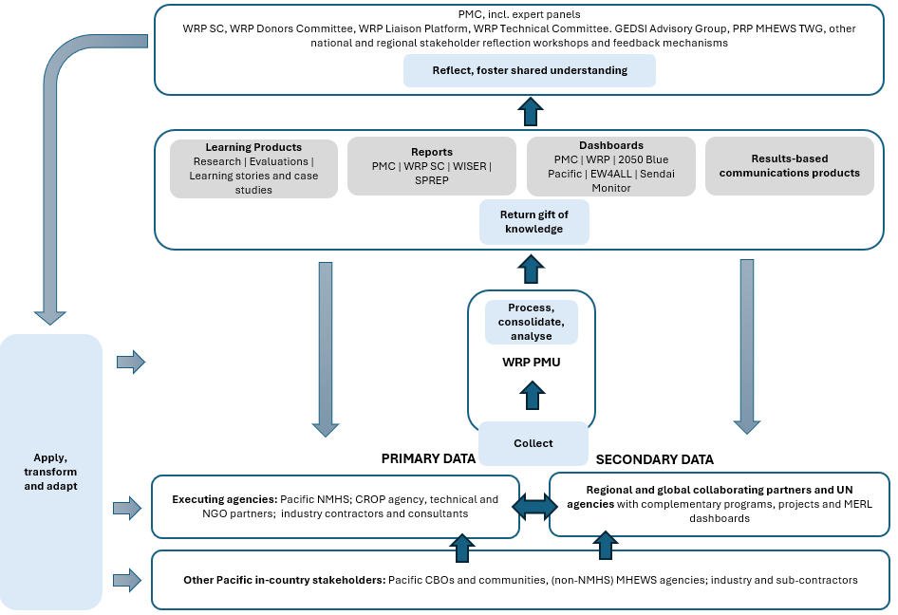
Figure 2: Cascading reporting and data flow structure

2.1.3 Key uses of MERL
The three key uses of MERL are outlined below.
Figure 3: WRP’s key uses of MERL

2.1.4 Ethical considerations
WRP is committed to ensuring that data is collected, stored, analysed, researched and evaluated ethically. Policies and guidelines which frame the WRP approach to MERL ethics include: SPREP’s Information and Knowledge Management Strategy (2022-2027), SPREP Information Security Policy (2021), Records Management Policy (2021), SPREP Publication Guidelines, SPREP Risk Management Policy (2021); SPREP Procurement Policy and Procurement Manual, SPREP Code of Conduct, WRP Environmental and Social Safeguards Policy, and WRP Sustainability Framework.
WRP’s approach to addressing key ethical MERL issues are outlined below.
Honesty and respect, including recognising the Pacific pause (the practice of speaking through silence) as an acceptable form of communicating results; and investing sufficient time to acknowledge the importance of building relationships, understanding local dialogue methods and ensuring MERL is not extractive.
Information and knowledge in its various forms (electronic, physical and verbal) are valuable assets and must be managed and stored responsibly and securely in line with international standards; and be accessible for all audiences (via SPREPs Virtual Library). Explicit information and knowledge are shared legally and safely in compliance with SPREP Information Security Policy, and is the responsibility of everyone.
Privacy and confidentiality all data and information gathered and stored must protect the privacy of the participants and the confidentiality of their data. See WRP Data Policy for more information.
Free, informed and ongoing consent for all participants to ensure they are fully informed about the project, activity, research purpose, procedure and potential risks before agreeing to participate on each occasion (further refer to WRP Environmental and Social Safeguards).
Precautionary approach activities should not result in adverse environmental or social impacts, and seek to protect the rights, health, safety, and livelihoods of people including, children, women, Indigenous Peoples, and other vulnerable or disadvantaged groups, while maintaining the health, diversity and productivity of the environment. Activities must not inadvertently create new risks or exacerbate existing vulnerabilities, especially for women, girls, persons with disabilities, people living with HIV (PLHIV), key populations, and other marginalised groups, as detailed in the GEDSI Strategy.
Inclusivity and Non-Discrimination ensure all individuals, especially vulnerable groups, have equitable access to benefits and are not disproportionately affected. This includes ensuring dignity, self-determination, and active participation consistent with a human rights-based approach. This includes fostering the ownership and transformative leadership of vulnerable, under-served, and under-represented groups, actively embracing the expertise of Pacific women in meteorology and the lived experiences and local knowledge of community Women's Weather Watchers, and proactively addressing the 'Preconditions for Inclusion' for persons with disabilities.
Objectivity and impartiality of results and research findings should be presented without bias and based on sound evidence.
Transparency and accountability of results and findings will be continually shared with all audiences, with specific focus on ensuring the sharing of information/knowledge to those that had given the knowledge (Luva) (further refer to WRP Sustainability Framework Benchmarks).
Continual improvement through learning, reflection and application of lessons in conjunction between the MERL Framework and risk management.
Pacific Context Sensitivity apply safeguard measures and processes in a manner that is sensitive to the unique environmental, social, and cultural contexts of Pacific Island Countries, acknowledging factors such as customary land tenure, traditional governance structures, and deep attachment to natural resources, and explicitly recognising and valuing the traditional and indigenous knowledge, including gender-specific knowledge, held by Pacific women, as identified and disseminated through Women's Weather Watch (WWW) networks.
Integrated, structured and contextualised approaches utilised to ensure MERL, GEDSI, ESS (refer to ESS Policy – Core Principles of Safeguards), Sustainability (refer to Sustainability Framework Benchmarks) risk management is examined across all aspects of WRP.

2.1.5 Alignment
As outlined in the MERL Scope above, WRP’s MERL Framework has been informed by and aligned with goals and indicators of: national plans and strategies; regional MERL frameworks and strategies; complementary programmes and projects, global strategies and programme indicators; and development partners/investors.
WRP’s indicators have been designed to specifically collect, report, contribute to and draw from data within existing national, regional and global indicators. Supporting the sector’s collective approach to community resilience of disaster and climate change events, WRP outlines its indicator alignment within the Compendium of Indicators, found in the MERL tables.

2.2 MERL structure
The WRP MERL Framework comprises the following parts:

Figure 5: WRP MERL Framework
Elements of a MERL Framework
- Theory of Change: comprehensively describes and illustrates how and why a desired change is expected to happen in a particular context, outlining causal linkages between outputs and outcomes that are expected to lead to the objective being achieved. This includes assumptions and external influencing factors.
- Impact Pathway: derived from a Theory of Change, describes how outputs relate to outcomes as well as the longer-term developmental changes (impacts).
- Indicators: variables that help assess or provide an indication of progress or achievement of outputs, outcomes and impacts.
- Data collection tools: methods and instruments used to gather data and information for research, analysis and decision-making.
- Reporting: systematic and timely provision of essential information at periodic intervals to key stakeholders.
- Learning: process of reflection and insights from monitoring, evaluation and research data, evidence; and using these to influence decision-making, education and awareness.
- Adaptation: the application of learning, including re-assessing and adjusting decisions and sharing wisdom, as more information is learnt.

3 Theory of Change - Impact Pathway
The WRP Impact Pathway sets out the WRP objectives, and displays the causal links between KRAs, project inputs, activities and the results of those activities (outputs, intermediary outcomes, outcomes and impacts). The pathway notes significant assumptions and embodies the WRP principles outlined in Chapter 1: Introduction and Governance. Figure 6 below describes each of these MERL terms for the purposes of WRP, the results chain and level of control and influence that WRP will have in achieving each level of result.
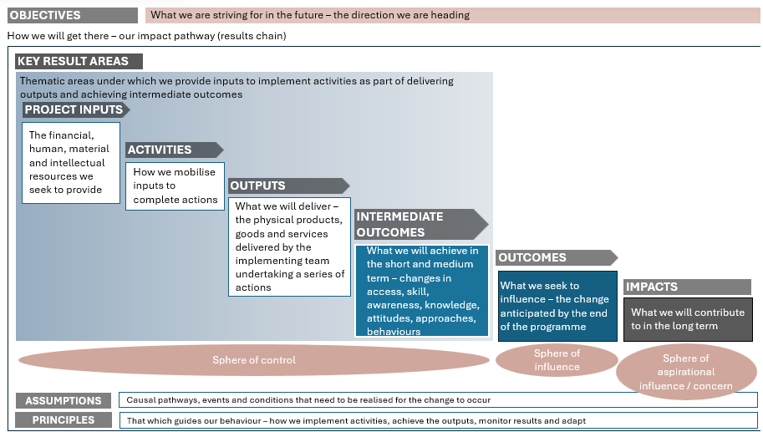
Figure 6: WRP MERL terminology and structure
The full WRP Impact Pathway is represented visually in Appendix Two and is described in the following sub-sections 3.1 to 3.5.

3.1 Objectives
WRP has two key objectives, an overall and specific objective. The overall objective provides a broad, overarching goal that aligns with global and regional weather and climate change strategies, whilst the specific objective creates greater clarity, focus and understanding by detailing in actionable steps how to achieve the overall objective.

WRP’s objectives are:
Overall objective
Climate and disaster resilient Pacific Island communities have improved safety, security, socio-economic well-being and prosperity

Pacific communities, governments and industries have inclusive multi-hazard early warning systems, forecasts, and information to reduce the impacts of extreme weather and other natural hazard events, including those exacerbated by climate change
Specific objective

3.2 Key Result Areas
The initial 2021 WRP Decadal Programme of Investment and original WRP Implementation Plan (2023) identified five Key Result Areas (KRA) for achieving the WRP objectives. A subsequent review of the alignment of WRP with the United Nations Early Warnings for All (EW4ALL) led to an additional KRA being added into WRP to address and align with EW4ALL’s Pillar 1 (disaster risk knowledge) and Pillar 4 (Preparedness and Response Capabilities). In parallel to the EW4ALL review, the draft WRP impact pathway was being further developed and tested for logic flow. As a result, the language and order of the WRP KRAs was revised as follows (refer to Appendix Two for KRA comparison):
KRA 2 - People capability
KRA 3 - Observation network infrastructure
KRA 5 - Communication and delivery of forecasts and warnings to end users
KRA 4 - Forecast and warning production
KRA 1 - Governance, management and coordination
Service value chain expansion
KRA 6 - Risk Information and preparedness
Enablers
Figure 7: Revised WRP KRAs
In essence, the revised KRA language and order recognise and embody the hydrometeorological and multi-hazard service value chain – maximising value and impact at each point in that chain. The revised KRAs clarify the logic, that in order to successfully expand the Pacific hydrometeorological and multi-hazard service value chain, there first needs to be robust foundations on which that value chain is built - this includes strong Pacific-led governance, management and coordination mechanisms, enhanced Pacific capability, and a Pacific regional model underpinning and collectively supporting asset management and maintenance.

3.3 Change Pathways
The change pathways expand the KRAs to map the change pathways (results chains) from outputs through to outcomes and impacts. These pathways are represented visually in Appendix Two and in narrative form below. Notably, as this represents an informational value chain, the outcomes WRP anticipates influencing have a high-level of inter-dependency and are cumulative – to be sustainable, results related to each outcome along the value chain need to rise simultaneously. It is the cumulative effect of achieving these outcomes that will contribute to the impacts being achieved.

WRP Change Pathways:
 If we ensure WRP has robust Pacific-led governance, management, financing and coordination mechanisms, with national and regional transformative and mainstreamed actions and capability to support us to address the needs of underserved and underrepresented groups (KRA 1, supported by KRA 2)
then Pacific hydrometeorological services will be able to collectively secure ongoing, reliable and diverse finance and technical expertise over the next decade, resulting in services that are more integrated, impactful, sustainable and resilient
because investors (including industry partners) will be willing to invest in the value created by those mechanisms knowing that they are genuinely collaborative, inclusive, equitable, mutually accountable, value maximising and driven by Pacific peoples.
If we spend the next decade establishing a lasting hydrometeorological financing investment facility (KRA 1)
then Pacific hydrometeorological services will have an additional ongoing and more sustainable stream of finance that extends beyond the WRP decadal programme
because regular returns on investment will be generated to subsidise ongoing operational and maintenance costs, reducing reliance on external project-based funding.
If we establish a well governed, managed and financed WMO-designated Regional Training Centre in the Pacific, and increasingly offer and deliver accredited and inclusive technical, diploma and postgraduate certifications to Pacific leaders, observers, technicians, forecasters and IT personnel, supported by continuous learning and mentoring (KRA 2, supported by KRA 1)
then Pacific hydrometeorological services will have stronger leadership, increased influence and control of assets/knowledge; there will be less reliance on external expertise across the hydrometeorological and MHEWS information value chain; Pacific users will be assured access to relevant, timely and reliable forecasts/warnings; and decision-makers will have increased confidence to act on the information provided to reduce the adverse impacts of severe weather events
because opportunities to build capability will be more accessible and integrate learning methods to meet the needs of Pacific learners; Pacific NMHS leaders/personnel skills, knowledge and confidence will have increased; and the persistent shortage of trained meteorologists, hydrologists, and technical experts in the Pacific will be reduced.
If we progressively expand interoperable, affordable and resilient observation network infrastructure, whilst also developing regional mechanisms, facilities and capacity to sustainably manage the growing Pacific observation network asset base (KRA 3, supported by KRAs 1, 2)
then Pacific hydrometeorological services will be collectively using and sustaining a growing Pacific-owned and controlled asset and knowledge base; and users will be increasingly assured access to relevant, timely, reliable and accessible forecasts/warnings that they can trust and act on to reduce the adverse impacts of severe weather events
because observation, monitoring and detection systems and real-time data supply will be expanded and enhanced; and GBON-compliant infrastructure will be fit-for-purpose, resilient and well maintained.
If we build a Pacific-owned integrated forecasting platform to receive, analyse and monitor local and global observation data, and adapt the platform/system to each PICT’s needs, whilst also expanding and maintaining local detection, monitoring and forecasting capacity in partnership with local stakeholders (KRA 4, supported by KRAs 1, 2, 3)
then Pacific end users will be increasingly assured access to relevant, timely, reliable, accessible and actionable forecasts/warnings, and decision-makers (of all levels) will have more confidence to apply forecasts, warnings and risk information to their decisions, improving their resilience and reducing the adverse impacts of severe weather events
because data will be continuously exchanged and integrated into the global meteorological system; data will be increasingly analysed, monitored and maintained, and forecasting will be of an increasingly higher quality and accuracy.
If we strengthen and sustain stakeholder capacity and collaboration to deliver locally-relevant and accessible information, forecasts and warnings to end users (in particular, to underserved and underrepresented groups); whilst leveraging networks and technology to build connections and feedback loops with communities and stakeholders (KRA 5, supported by KRAs 1, 2, 3, 4)
then Pacific communities, governments, industries and travellers will increasingly access, trust, understand and apply forecasts, warnings and risk information to their decisions, improving their resilience and reducing the adverse impacts of severe weather events
because, through collaboration, the reach, relevance and effectiveness of the Pacific hydrometeorological and MHEWS sector will be expanded, and forecasts, warnings and risk information will be based around impacts (incorporating traditional knowledge, local insights and modern science) and will be communicated through information systems and languages that are accessible to all.
If we produce, store and share standardised, interoperable, and inclusive multi-hazard data with Pacific agencies under the Pacific Resilience Partnership, and roles and responsibilities to coordinate, update and review hazard inputs (including traditional knowledge) into risk knowledge products, preparedness and response plans and procedures are clear (KRA 6, supported by KRAs 1, 2, 3, 4, 5)
then all Pacific end users (inclusive of all genders, abilities, cultures and socio-economic groups) will be assured access to relevant and actionable risk information that they understand and trust; and this knowledge will assist them to target their disaster preparedness and response actions to: increase resilience of Pacific economies and livelihoods; increase Pacific security and access to safe and reliable transport and communication systems; and reduce the human and economic cost of severe weather events.
because multi-hazard data will be able to be meshed with vulnerability and exposure data into risk models and knowledge products that are relevant and accessible to diverse communities; and will be used to inform preparedness and response planning and procedures.

It is anticipated that these change pathways will aspire to contribute towards achieving the following long-term impacts, consistent with the Blue Pacific 2050 Strategy, Sendai Framework and Sustainable Development Goals. Refer to MERL Tables: Compendium of Indicators for a detailed breakdown of indicator alignment to regional and global indicators.

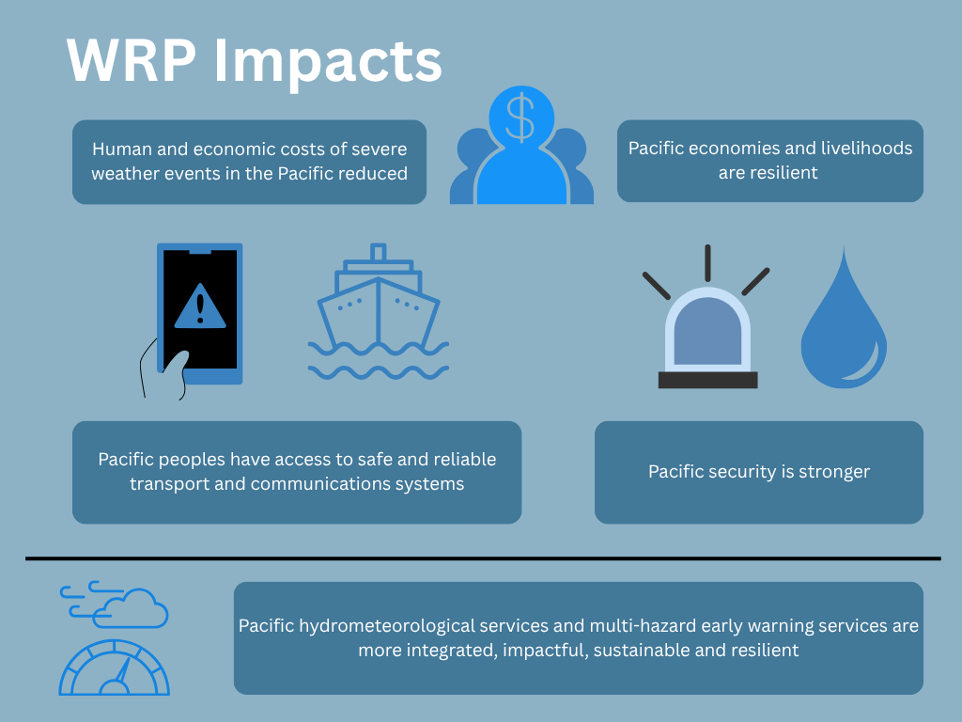
Figure 8: WRP Impacts

3.4 Integration of WRP principles
WRP is guided by a set of principles that outline the agreed way of working (refer to Chapter 1) - these sit at the base of the Impact Pathway. These principles underpin the behaviour and approaches to how WRP implements activities, achieves its outputs, monitors results, and adapts. These principles are integral to MERL approaches proposed in section 5.1, and are in line with SPREP’s seven core monitoring and evaluation (M&E) principles (see SPREP M&E Policy, 2024).

3.5 Assumptions
The change pathways (section 3.3) each embody assumptions of what will result from each action. In addition, there are significant cross-cutting assumptions underpinning the impact pathway:
- WRP implementing and executing agencies can build the momentum through demonstrating sound collective governance/management and impactful results early on, and by doing so will progressively attract sufficient investment to deliver against its targets within the decade of the programme.
- National and regional political will remains solid in the face of any future obstacles or challenges.
- WRP partners’ organisational contexts remain favourable and supportive.
- External shocks can and will be accommodated.
- Services will be more relevant if they include both modern and traditional knowledge.
WRP will reflect on the programme’s assumptions outlined above, as well as those assumptions within the change pathways during each evaluative review to test whether they remain relevant, true and if there are any additional cross-cutting assumptions to be considered.

4 MERL Table

4.1 MERL Tables
Based on the impact pathway, the MERL Tables comprise:

Figure 9: WRP MERL Tables
The Tables for the Headline and high-level indicators and for the Implementation indicators detail:
Indicators | What we will measure against (output, intermediary outcome, outcome and impact level).
Baseline | The position/measurement before the WRP begins.
Targets | Regular and end of programme targets that are specific, measurable, achievable, relevant and time-bound (SMART).
Data source | Tools used to collect the measurable data.
Table 4: MERL Tables detail

A Compendium of Indicators concisely and comprehensively lists all headline, high-level and implementation indicators, providing detailed descriptions and guidance on:
- Type - whether the change is at the output, intermediate outcome, outcome or impact level.
- Description - what it measures.
- Targeted change level - for example, individual, organisation, country/territory, region, globe.
- Disaggregated by - how the data will be split up.
- Tools/data sources type - identifying the tools or data sources to be used to gather the data.
- How to measure and calculate - description of the considerations/sampling when using the tool.
- Data verification by WRP - how WRP will verify/check that the data received is accurate.
- Director of change - Partner(s) responsible for data collection, storage and analysis
- Alignment - how the indicators align with and can be reported through to regional/global targets, and related programmes.
The compendium of indicators also prioritises each indicator into one of three categories for implementation. These categories include:
- Approved indicators for immediate use - available for tools/sources to be developed, data gathered, information analysed and findings recorded.
- Draft indicators, to be finalised and incorporated as part of a specific WRP-related project/activity – as WRP’s projects and activities are designed (especially as KRA 6 activities are defined), these draft indicators will need to be reviewed/discussed and approved.
- Draft indicators, to be introduced as the tools and mechanisms to collect data are developed with other MHEWS stakeholders – further understanding and analysis by the MERLA Officer is required, to fully breakdown how current tools are collecting data, identify any gaps in relation to WRP and confirm whether MHEWS stakeholders will collect any additional data gaps, or if WRP will collect Pacific regional data to inform MHEWS.

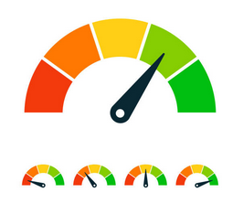
WRP’s Headline Indicators are shown in Figure 10. The quantitative Headline Indicator results aim to become the core drive and focus of direct stakeholders and executing/implementing agencies as they seek to positively shift each dial. These indicators are selected for their alignment to regional and global indicators of significance (in particular, PIMS, Blue Pacific 2050 Strategy, Sendai Monitor, SDGs and EW4ALL Dashboard). They are designed to be concise, relevant, measurable, easily understood and reflections of the combined outcome and impact-level results from action taken under all six KRAs. Together they collectively tell a powerful story of WRP’s influence and contribution to improving safety, security, socio-economic wellbeing and prosperity in the Pacific region. Headline Indicator results will be publicly available via the Pacific Partner Coordination Mechanism Dashboard (linking to relevant regional and global dashboards), and annually upon SC approval of annual reports; and via other communication products.
Data on a number of additional second-tier outcome and impact indicators (High-level indicators) will be collected to support monitoring and evaluation more broadly.
Outcome-level - to measure what we seek to change by the end of the programme, within WRP’s sphere of influence.

Impact-level - to highlight the overall impacts that WRP contributes to in the long term.

Figure 10: WRP Headline Indicators
See Annex One: MERL Tables for further detailed information.
Storytelling reflects Pacific oral traditions. It validates and amplifies Pacific voice. Stories bring the results achieved to life, track and test interdependencies within the impact pathway, and provide us with a deep understanding of achievements and lessons learned. Stories may be oral (captured on video), written or portrayed through other forms such as dance, weaving, photo story or a more locally appropriate format. They are to be used for communication, education and reporting purposes.
Traditional Knowledge and Practice: the knowledge held by communities developed through generations of observation and experience. Encompassing the skills and practices used to adapt to environmental changes, including weather patterns, climate variability, and resource management. This knowledge is often passed down orally, embedded in cultural practices, and is not static, evolving over time.

Five separate data collection methods are outlined, each with its own purpose and use. Space should be given for additional storytelling collection methods to be identified when working with communities.
Data Collection Method | Description | Use
Learning story | Video or 1-2-page written narratives describing the learning experiences and observations in a story format, highlighting strengths and key learnings (intended and unintended). | WRP will be piloting several approaches throughout its life, with key learnings to be documented for future internal SC reference. Learning stories will be presented at SC Meetings, and available for use in community meetings and through related training (in-country / regional).
Performance story | Video or 2-page narrative evidencing how a project contributes to achieving its output. The performance story links action to results, highlighting achievements and areas of improvement. Performance stories provide qualitative assessment of change and place numbers within greater context. | Performance stories will be regularly collected via executing agencies and their local partners. They will be shared via WRP’s reports and as part of WRP communications and engagement with diverse stakeholders.
Impact story | In-depth impact stories will be captured through a range of formats - video, dance, art, craft, photo stories or 2-page narratives. They will outline a challenge/issue that an activity changed; detailing the change process and how the challenge was addressed; describing the results and impact from the change; and identifying the lessons learnt along the way. Impact stories capture organic learning, intentional or unintentional. | Impact stories will be co-created by WRP and its executing agencies along with participating communities and other in-country stakeholders. They will be shared via WRP and SPREP reporting, and as part of WRP communications and stakeholder engagement. Most importantly, impact stories will be shared with community and in-country stakeholders.
Most Significant Change (MSC) story | MSC stories will be captured through a structured talanoa approach with stakeholder representatives collectively gathering, sharing and analysing culturally appropriate stories of significant change. MSC stories will be expressed via various mediums, including video, dance, art, craft, photo stories or a 2-page written narrative.  The space to hold dialogue, that is systematically selected by participating stakeholders will result in identifying, recording and learning from most significant change. | MSC stories will be collected and shared via WRP and SPREP reports under Phase II implementation (2029-2033) to identify the most significant impact/change that WRP has influenced.
Case study | A 4-page written narrative or mini documentary capturing an in-depth, multi-faceted understanding of a complex issue within its real-life context. A variety of data collection tools (semi-structured interviews, photos, quotes, observations, surveys) will be used to collect qualitative data over a sustained period of time, as a way to track progression of change. | Case studies will be shared via WRP and SPREP reports, WRP website and learning platforms to document multi-faceted complex issues. Case studies will also be presented at SC Meetings, and be available for use in community meetings and through related training (in-country / regional).
Table 5: Storytelling collection methods

These five narrative methodologies will require close alignment between the WRP MERLA Officer, WRP Communications and Knowledge Management Officer, WRP executing agencies and stakeholders for showcasing of stories, case studies and lessons learned within communication (including SPREP’s Pacific Environment Data Portal) and knowledge products. See Communications Chapter 8.
See Annex One: MERL Tables for indicative values-based story themes.
Implementation Indicators are outlined in the MERL Tables against each KRA. These quantitative indicators focus on outputs and intermediary outcomes within WRP’s sphere of control. They help track progress at a programmatic level, test assumptions, inform decision-making, learning and adaptations. They also support assessments of value for money, efficiency and effectiveness. Without wanting to overburden the programme with measuring every dimension, the combination of proposed indicators aims to holistically provide an indication that we are moving in the right direction.
The following implementation indicator types have been integrated in the MERL Tables:
Indicator Type | Description
Output indicators | measure the change and results of an activity (ie. people trained, publications produced, services delivered). These results when compared to budget expenditure will also help assess efficiency.
Intermediate Outcome indicators | measure the short and medium-term changes that result from outputs (increased knowledge, changed behaviour or improved skill, behaviour, capacity and motivation among the target population).
Relationship and process indicators | The health of WRP partnerships and relationships and the way WRP is being implemented, including efficiency and effectiveness of its activities.
GEDSI, sustainability & ESS indicators | assess GEDSI/Sustainability/ESS specific activities; mainstreaming of approaches and disaggregation of data.
Table 6: WRP indicator types
See Annex One for all MERL Tables, including implementation indicators and compendium.
The MERL Tables will be reviewed and updated annually and at key evaluative stages, to reflect any changes in direction and scope of WRP. The MERL Tables guided the establishment of the necessary tools in which to measure the indicators see section 6.1 Data collection methods/tools.

4.2 Baseline data and targets
Baseline data were collected through multiple sources, including Pacific NMHS Country Reports to the Pacific Meteorological Council (PMC), executing agency progress reports, the WMO GBON Compliance Tool, the EW4ALL Dashboard, the WMO Integrated Processing and Prediction System (WIPPS), existing regional and global databases (CliDE, WIGOS, AMDAR), biennial sector surveys, and direct consultation with Pacific NMHS and executing agencies. Baseline data collection also drew on programme governance and management records, asset registers, training registers, and partnership logs established during the Inception Phase. Where baseline data gaps exist, these have been noted and measures will be undertaken to address them over time, including through dedicated baseline surveys, strengthened reporting mechanisms, and the progressive rollout of data collection tools and systems as the programme matures.
Targets were revised and confirmed once baseline data were collected. Being a decadal programme, targets reflect the three WRP implementation periods, including:
- Inception Phase implementation (November 2023 to December 2024)
- Phase I implementation (January 2024 to December 2028)
- Phase II implementation (January 2029 to December 2033)
Targets have been designed to be specific, measurable, achievable, relevant and time-bound (SMART); and include activities that funding is still to be secured for. Targets will be monitored and updated annually. Monitoring of targets will inform when GEDSI, sustainability and ESS action plans are to be revised (see Chapter 9: Sustainability; Chapter 10: GEDSI; Chapter 11: ESS for further information).

5 MERL Workplan

5.1 Overarching approach
WRP draws upon interconnected Pacific and western frameworks in designing, implementing, monitoring and evaluating its impact pathway, operations and achievements. Executing agencies delivering WRP projects will have agency-specific MERL frameworks and workplans to guide and measure change for project beneficiaries; which will also feed into WRP’s overarching MERL Framework as part of a cascading reporting structure. See Annex Three: agency-specific MERL template/workplan.
Pacific research and data collection frameworks reflect the cultures and contexts from which they have been born. There are nonetheless common threads that focus on relationships and connections, over time and space, between people, the natural world, non-living and living things.
The Yavu Engagement Tool (‘Yavu’ is ‘foundation’ in Fijian, derived from ‘Yavusa’ referring to one’s ancestral roots). The Yavu provides a framework for how WRP will engage with Pacific communities across all activities, including how it undertakes its MERL. The Yavu provides guidance on how to engage with Pacific communities that is more meaningful and relevant, to understand Pacific values and how they are integral to everything Pacific peoples do. Guided by four principles the tool promotes understanding context (know who Pacific peoples are); environment (make time to connect); responsibility (recognise Pacific people’s contribution); and Teu le va (build, nurture and strengthen relationships).
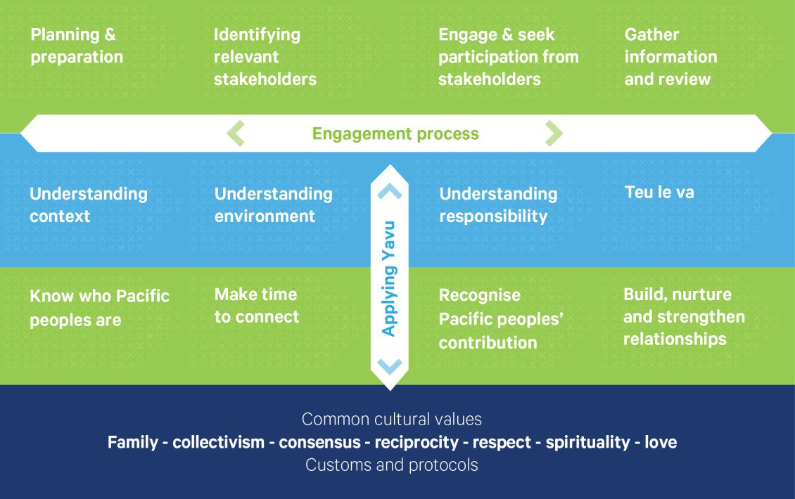
Figure 11: Yavu engagement tool

The Kakala Research Framework, rooted in Tongan world views, protocols and practice, encapsulates common Pacific perspectives, and thinking of the communal process that demonstrates collaboration, sharing of resources and the passing of skills to the next generation. It embodies Pacific philosophies, traditional knowledge and practices, values and customs that underpin WRP’s principles.
The Kakala research framework consists of six key components:

Teu - to prepare: conceptualise, design and plan for the work ahead
Toli - to pick a flower/object: purposely picked depending on the design that has been chosen during the Teu stage (i.e. data collection)
Tui - to string a garland: analysing data to look for patterns, similarities, variations and emerging.
Luva - gift from the heart: returning the gift of knowledge to people who had given knowledge via reporting and disseminating results.

Malie - an expression of understanding: shared understanding between stakeholders and implementers after an activity is delivered (i.e. reflection and lessons learned)

Mafana - warmth: when one goes beyond a receiver of knowledge and skills to be willing to apply and share (i.e. transformation and adaptation)

WRP will adopt the Yavu and Kakala models across its projects and activities, acknowledging that where country-specific MERL Frameworks are developed more culturally appropriate local models may be applied.

5.2 Preparation and planning
The teu of implementing the WRP MERL Framework is outlined in a GANTT chart in Annex Two: MERL Workplan. The workplan outlines key tasks, due dates and responsibilities.

6 Monitoring
The consistent and systematic collection and monitoring of data will inform whether progress and change has occurred. External influencing factors of contextual change (ie. change in government, policies, disasters) will impact upon the data gathered, with contextual change to be monitored alongside WRP’s risk management (refer to Chapter 6: Risks and Issues Management) to inform adaptive management (see section 10.2 Application, transformation and adaptation).
WRP’s approach to data collection, storage, analysis and synthesis is outlined below, including tools and management systems.

6.1 Data collection methods/tools
WRP applies a knowledge management framework using the Data, Information, Knowledge and Wisdom Pyramid (DIKW) model in Figure 8. The Model explains the relationships between data, information, knowledge and wisdom. It suggests a hierarchical structure, on how raw data is transformed into actionable insights and wisdom, with each level building upon the previous.

The MERL tools shall, so far as practicable, distinguish between outputs and results financed through Pooled Funding, Ringfenced Funding, Other Support, and any approved investment facility or other financing mechanism. This is to support accountability, reduce duplication, enable coherent WRP Donor and partner reporting, and preserve a whole-of-programme view of the WRP investment effort.

Through the collection of raw data, we are able to analyse and create meaning of information to identify contextual knowledge. It is through the application of this knowledge that wisdom is achieved.
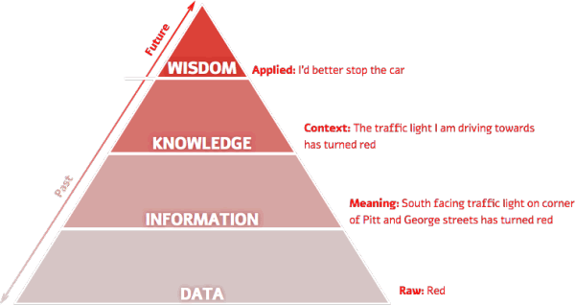
Figure 12: Data, Information, Knowledge and Wisdom Pyramid (DIKW) model
Essentially, monitoring data will be collected via three sources:
- Primary data collection (Stories and Implementation Indicators):
  - Data collection and reporting from executing agencies and in-country partners
  - PMU-coordinated data collection; and
- Secondary data existing assessment processes to inform national, regional and global targets (Implementation Indicators, Headline and High-level Indicators).
WRP will utilise the following primary and secondary data collection methods:
(The methods outlined below should be read in conjunction with the Indicator Compendium, which details the specific data collection approach for each indicator.)
Method | Description | Responsibility
Primary collection methods (direct interaction with the source of information)
Observations |  | WRP PMU and executing agencies (dependent on indicator – see Compendium)
Storytelling | Outlined above in 4.1 | WRP PMU, executing agencies, in-country partners and participating communities
Interviews, Pacific dialogues (talanoa, toktok or similar), focus groups and reflection workshops |  | WRP PMU and executing agencies (dependent on indicator – see Compendium)
Surveys and feedback mechanisms | Structured data collection from direct stakeholders and participants, including community-level surveys and feedback tools. Where relevant, community enumerators support data gathering and dissemination to and from communities, including hard-to-reach populations. | Collected from direct stakeholders/participants
Digital user and system analytics
Documentary records, including reports, plans, policies, agreements, attendance lists, certifications, data sets, forecasts and warnings, etc
Asset Information System(s)
Secondary collection methods (using existing available data)
After-action reports
Country assessments (SOFF / EW4ALL) |  | PMU to retrieve data from assessments, dashboards and databases.  Original monitoring data collected with input from executing agencies, national meteorological and hydrological services, and other relevant programme stakeholders.
Regional and global dashboards (Blue Pacific 2050, Pacific Ocean Portal, WIGOS, EW4ALL, Sendai Monitor…)
Regional and global databases (CliDE, WIS 2.0, AMDAR, EM-DAT…)
Table 7: Data collection methods
Further detail on how each method is used (including sampling), against which indicators, and data collection responsibilities is contained in Annex One: MERL Tables (the Compendium).

6.2 Data analysis and synthesis methods
Under the responsibility of the WRP PMU, specifically MERLA Officer, Communications and Knowledge Management Officer, Asset Management Officer, Capacity Officer and GEDSI Officer, data collection methods outlined above will be processed and analysed through:
- summarising quantitative data, using measures like averages, standard deviation and range (descriptive statistical analysis)
- Pacific dialogues (talanoa, toktok or similar), group reflection sessions and partnership health checks (participatory analysis)
- qualitatively drawing out key themes, emerging lessons and common outcomes across WRP (for example, through storytelling) (deductive and inductive analysis)
- using quantitative sample data to draw conclusions and make predictions about a larger population (inferential statistical analysis)
- qualitatively drawing out key themes, emerging lessons and common outcomes across WRP (example performance and impact stories, most significant change stories) (deductive and inductive analysis)
- analysis by direct stakeholders (i.e. Group reflection sessions and partnership health checks) (participatory analysis).
Analysed data will then be combined and synthesised from multiple sources to identify collective insights. Data synthesis methods that WRP will include:
- Contribution analysis to assess the extent to which WRP’s outputs have influenced Pacific end users trust, understanding and application of forecasts and early warnings.
- Thematic synthesis of qualitative data (impact/performance stories) to identify key themes or concepts.
- Mixed methods synthesis combining both qualitative and quantitative data in analysis to provide a more comprehensive understanding.
Executing agencies will collect, analyse and report against their projects/activities utilising WRP’s report templates and data collection tools/templates. MERL tools are being progressively developed, piloted and annexed to the Operations Manual, including reporting templates (currently being piloted), an indicator compendium, survey and story templates. Once the WRP integrated programme management system is introduced, it will also be used for MERL reporting, data collection, storage and analysis purposes (replacing interim Word and Excel templates). MERL learning products, reports, dashboards and results-based communication products will share the results and return the knowledge to all of WRP’s Partners and Collaborators (refer to Table 2: WRP partners and collaborators). Results findings will be tested and shared with the WRP SC prior to approval of reports and uploading of progress/results to the Pacific Partner Coordination Mechanism Dashboard.
WRP will continue to consider the use of Artificial Intelligence (AI) in the collection and synthesis of data to support automation and optimisation as this MERL Plan is operationalised, reducing the burden on staff, capturing real-time data and identifying trends and insights. Machine learning algorithms can be trained to identify data errors, including duplicate entries, missing values, to enable more reliable and accurate data.

6.3 Data flow, storage and management system
Relevant development in this space is being proposed as a future milestone, to be consulted, workshopped and finalised once the Infrastructure Adviser, under the overall supervision of the WRP Programme Manager, leads the process of securing an appropriate integrated programme management system. MERL considerations have already been fed into the specifications for this system and will inform its design and implementation.

7 Evaluation
WRP will undertake regularly scheduled reviews and assessments of its design, implementation and results across the decadal programme, to determine relevance, coherence, effectiveness, efficiency, impact and sustainability to inform future work.

7.1 Approach to evaluation
For each evaluation, the WRP SC will appoint a time-limited evaluation steering group to oversee and direct the evaluative reviews. Responsibilities of the WRP Evaluation Steering Group members are outlined within the Terms of Reference (TORs) in Annex Four. As outlined in the TORs, evaluations (except for midline evaluation #1) will be assessed by the six OECD DAC lenses to analyse the programme and its results. The six criteria provide complementary perspectives, giving a holistic picture of the programme, its implementation and results. Together they describe the desired WRP principles: they should be relevant to the context, coherent with other interventions, achieve results in an efficient way and have positive, lasting impacts for sustained development.

Supplementary evaluation types (refer to Table 9) will utilise a participatory evaluation approach, drawing on observations and reflections of direct stakeholders. This is consistent with WRP’s principles; enables the integration and application of traditional knowledge; and allows MERL to be a capacity-building opportunity.

7.2 Staged evaluative reviews
Three staged and independent programmatic evaluations will be undertaken during the life of WRP. Each evaluation will be commissioned by SPREP and take approximately six months to complete. Evaluations commissioned should be guided by Pacific research models. Evaluation findings will be presented at the October Steering Committee Meeting for reflection and a formal (published) response to the recommendations. Implementation of the management response to the recommendations will be integrated by December of the year of the review.
Funding for all programmatic evaluations will be drawn from the pooled funding mechanism or separately through the hybrid approach. Evaluations to be shared with all Pacific NMHS and other executing partners, investors/development partners, members of the WRP Liaison Platform and the PRP MHEWS Working Group, and published online for wider stakeholder consideration.
Programmatic Evaluations | Procurement commenced | Start Date | Due Date
Mid-line evaluation 1 - Process evaluation to review and assess whether the WRP management, monitoring and finance systems and mechanisms are operating effectively (fit-for-purpose) to support the service foundations and value chain expansion, and whether the assumptions and principles remain relevant and true. | July 2026 | January 2027 | July 2027
Mid-line evaluation 2 - Formative evaluation to improve implementation. To assess WRP’s interventions for relevance, coherence, effectiveness, efficiency, impact and sustainability; and to test whether the assumptions and principles remain relevant and true. Key findings and recommendations outlined for future programme adaptation. | July 2029 | January 2030 | July 2030
End of Programme evaluation – Summative and Impact evaluation to assess the overall effectiveness, outcomes and long-term effects of WRP. To review relevance, coherence, effectiveness, efficiency, impact, sustainability, assumptions/principles and any areas for improvement recommended during the mid-line evaluation 2. To provide recommendations for the future direction of WRP as the decade comes to an end. | April 2032 | October 2032 | March 2033
Table 8: WRP programme evaluations

To evaluate real-time operations, complementary evaluations will also be conducted:
Complementary Evaluation type | Approach | Frequency/Timing | Responsibility
Pilot project evaluations | For any WRP pilot projects, for example Severe Weather Pilot Programme, identification of baseline, continual monitoring and tracking of findings is required; including an end of project evaluation are essential to reflect and assess what worked well, what didn’t and the operating environment. These evaluations will inform any future rollouts of the project. | Throughout the life of the pilot-project, as scheduled | Executing Agencies
Pre- and Post-capability building evaluations (immediate) | For any WRP capability building, it is mandatory that pre- (where appropriate) and post-training evaluations are undertaken to measure knowledge gained, understanding and quality and satisfaction. | From 2026, any capability building training delivered | Executing Agencies
Six-monthly follow-up capability building evaluations | For any WRP capability building training, it is mandatory that six-monthly follow up training evaluations are performed with the participant to measure application of knowledge/skills received at the training. | Six months after the capability building training | WRP PMU (Capacity Officer and MERLA Officer)
Post event/after-action evaluations | After any disaster a post event/after action review to take place reflecting on processes, systems and responses. Reflections will be noted in writing, shared and inform future responses. | Within one month after a disaster | Executing agencies
Meeting and Workshop Evaluations | Upon completion of each significant/multi-stakeholder meeting and/or workshop the standardised evaluation survey will measure achievement against the Meeting/Workshop objectives, quality and satisfaction, and include opportunity for open-ended feedback/comment and, recommendations. | Upon completion of meetings and workshops | WRP PMU (MERLA Officer)
Partnership Health Checks | Reflective conversations and talanoa supported by a Partnership Health Rubric, to inform the ‘health’ of partnerships within and across WRP (i.e. not yet established, emerging, established/satisfactory, advanced), and identify opportunities and areas for improvement during implementation. Monitoring the health and efficiency of the partnership’s setup-operation and processes, ensuring the building blocks of partnerships are in place, is essential to optimise partnership impact. | Annually at the SC Meeting in May | WRP PMU (MERLA Officer)
Table 9: WRP complementary evaluation types
Note: pilot-project evaluations, pre- and post-training evaluations, six-monthly follow-up evaluations, steering committee evaluations and partnership health check templates can all be found in Annex Three: Data collection and reporting tools, templates.

8 Research
Under WRP, research aims to generate knowledge and understanding about, and for, the Pacific. It seeks to explore deep ideas, challenges and tests new interventions and theories, to generate evidence about what works, for whom, and under what conditions.
Overall, WRP data collected and information management systems established will contribute to key focus areas of the Pacific Climate Change Research Roadmaps 2025-2030 (Research Roadmap 2025). The Research Roadmap 2025 aims to enable multi-disciplinary research to connect the communities responsible for delivering climate change research and for addressing climate change impacts to contribute to the improved safety, security and prosperity of the PICs within the 2050 Strategy for the Blue Pacific Continent. WRP research tasks will focus on improvements across the hydrometeorological sector.
Important research considerations include:
- Drawing on Pacific research methodologies, piloting and trialling locally-led action research.
- Drawing on community-based networks/communities of practice and civil society organisations/non-government organisations for research conduct and feedback on context, challenges and to test approaches.
- Building on and contributing to already available research or information from the sector and region.
- Filling knowledge gaps preventing moving the dial forward against WRP’s headline indicators.
- Streamlining WRP research and any other research in the sector/region, so as not to overwhelm communities and stakeholders.
- Upholding the principles and research ethics of WRP.

8.1 Identifying research requirements and opportunities
Formal research opportunities
All formal research projects will have a clearly defined Terms of Reference outlining the purpose, scope, objectives, roles, responsibilities and timeframes. The Terms of Reference will be developed by the leading researcher (either individual or organisation) and submitted for SC representative group approval. Upon consideration and discussion of the research Terms of Reference, the chosen research projects leading researchers will present an outline of their methodology and approach to the SC representative group for questions and answers. The SC will make the final approval of the research project.
WRP will draw upon the Pacific Islands Education, Training and Research Expert Panel (PIETR) under the PMC, to prepare technical advice and recommendations relating to research. Several research requirements and opportunities have been identified early in the inception and implementation phases, as WRP’s design and implementation plans are consulted and developed. Opportunities for research will be continuously monitored throughout the life of WRP, as new concepts, approaches and ideas are identified to deliver WRP’s outputs. Research opportunities can be identified through a variety of methods, including literature reviews, focus group discussions with stakeholders and executing agencies, and consulting and analysing gaps and needs of direct stakeholders.
A variety of research opportunities have been identified to date, as outlined in Annex One MERL Tables. Review of progress and identification of future research opportunities will be undertaken annually. The WRP MERLA Officer in conjunction with the WRP Programme Manager will oversee the identification, implementation and sharing of research findings.
Participatory action research opportunities
Identified and implemented within a WRP concept note activity, participatory action research is a collaborative, community-driven research process that defines the problem, takes action on testing solutions and reflects and evaluates the outcomes. Participatory action research is owned and driven by the community, using real-world knowledge and experiences to address local contexts for social change and transformation. Key methods include observation, community meetings and talanoa, photo stories, storytelling, testimonials, document analysis. Action research is built on the foundation of participation and collaboration, empowerment, contextualisation and action-oriented knowledge and change. Action research findings and knowledge will be fed back into the community to inform solutions, changes and next steps. Participatory action research will be shared with WRP’s audience members via stories or case studies, incorporated in executing agencies progress reporting.

8.2 Collaborative research
WRP is built on the foundations and principles of collaboration, mutual accountability, coordination and partnership approach to achieve its outcomes. All research will be guided by the Yavu and Kakala models. WRP will utilise various approaches for individuals, communities and institutions to jointly collaborate on research projects/activities. These will include formal research partnerships and informal community action research.

9 Sharing findings and results

9.1 Approach to reporting and sharing results
WRP’s breadth of direct stakeholders, executing/implementing agencies, investors and development partners requires a coordinated and streamlined approach to reporting of WRP results (see Figure 2: Cascading reporting and data flow structure). All stakeholders will require access to timely information, which will be available via WRP’s headline indicators accessible on the WRP dashboard (with data updated annually, once approved at the SC Meeting).
Data gathering, analysis and reporting by NMHS (as WRP executing agencies) requires further discussion and identification of appropriate, streamlined processes. The MERLA Officer, in conjunction with the WRP Programme Manager will consult the PMC to identify if there is scope to meet annually for coordinated data collection (including with other programmes and baseline data needs), or if an alternative option is preferred to regularly collect data from the region.
All other information, progress and results of WRP activities and reflections will be reported on:
- a six-monthly basis via the coordinated reporting arrangements outlined in Appendix Three. The reporting requirements have been streamlined from receiving data from executing agencies’ activities through to WRP’s holistic progress and result updates/reports. The WRP MERLA Officer is responsible for collating and drafting the WRP reports, with oversight and direction by the WRP Programme Manager and support from the WRP Communications and Knowledge Management Officer to ensure clear and concise messages and information.
- regularly via the programmatic evaluations (see section 7.2 staged evaluative reviews),
- regularly as research studies and findings become available (see section 9.2 sharing research findings),
- regularly through results-based communication products (see section 9.3 communications and stakeholder engagement strategy alignment), and
- regularly via scheduled stakeholder progress review and reflections (see section 10.1).

MERL reporting will be incorporated into, and support, the WRP Reporting Framework and provided to all donors via the Steering Committee. The WRP Reporting Framework shall include a sustainability performance section drawing on the Sustainability Framework and associated benchmarks. This section will, at a minimum, address lifecycle sustainability, operations and maintenance, long-term financing, asset ownership and transfer, capability and workforce considerations, and any significant sustainability risks or actions arising during the reporting period.
Separate to formal reporting requirements, Luva will be shared back to knowledge holders, community members and national stakeholders via NMHS, community enumerators/researchers and leaders. It is encouraged where consultations occur that a ‘wrap up’ consultation is included where executing agencies share the findings and enable space for talanoa with the knowledge holders/community members. Other methods to feed back information to the community include the use of media and radio in local vernacular, infographics or other culturally appropriate methods of communication, as defined by each PICT, will be actively undertaken to close the feedback loop.

9.2 Sharing research findings
All research findings and succinct recommendations will be presented by the leading researcher to the SC Meeting for consideration. Once approved, research papers will contribute to the wider sector and Pacific research and knowledge base, as well as being communicated with all WRP stakeholders, partners and communities. All research will be publicly shared by the WRP Communications Team through WRP’s website, newsletters/other knowledge products, the Pacific Data Hub and reputable academic journals (refer Chapter 9 Communications).
In applying the research findings to WRP’s activities, the WRP Technical Committee will participate in discussions to:
1) understand the research findings (i.e. interpret results, identify key takeaways, trends, patterns and implications and assess the strength of evidence/reliability); and
2) translate the findings into usable insights (i.e. convert any academic or technical knowledge into clear and practical messages and understand what this means for WRP’s activities going forward).
It is the responsibility of the executing agencies and WRP PMU to then test the research findings through activity implementation, and ensure timely reflection, via the fortnightly Technical Committee Meetings, and analysis of the research application and results are incorporated into the activity report.

9.3 Communications and stakeholder engagement strategy alignment
Clear communication and engagement across WRP and its stakeholders, nationally, regionally and globally is crucial in sharing WRP’s vision, achievements and impacts. Embracing luva through the gift of sharing and exchanging information and knowledge through stories of individual and collective impact and challenges, will continue to strengthen our Pacific voices and partnerships for more resilient Pacific communities to severe weather events.
The WRP Communications Strategy (see Chapter 8) is essential to ensuring the insights, information and achievements from the MERL Framework are effectively shared, understood and used across all stakeholders. The WRP Communications Strategy will be informed by SPREP’s communication principles. The Communications and Engagement Strategy brings to life the MERL Framework through:
- the use of evidence – enabling findings to be translated into clear and actionable insights; closing the feedback loop and enabling the information to reach decision-makers, investors, development partners and communities in usable formats
- transparency and accountability – to show that decisions are made by evidence and build trust through timely reporting and open reflections of challenges and impact.
- enabling adaptive management – which can only occur when information is communicated clearly, effectively and efficiently to allow for real-time response and correction.
- effective stakeholder engagement – of the relevant information needs for each stakeholder and encouragement of buy-in and collaborative learning
- maximised learning and knowledge sharing – disseminating findings via multiple platforms, dashboards, publications, meetings and networks to share with the wider regional and global communities; and encouraging a culture of learning and continuous improvement
- Influence and policy impact – for research and evaluation findings to be communicated to shape innovations and policy through alignment with government agendas and appropriate formats that resonate with target audiences.
The WRP MERLA Officer and Communications and Knowledge Management Officer will closely collaborate to effectively and efficiently share the data, information and knowledge to all stakeholders (refer Chapter 9: Communications).

10 Learning and Reflection
Drawing on the Kakala Framework of Malie and Mafana, Yavu engagement tool of teu le va (build, nurture and strengthen relationships) it is important to create a place and space for meaningful engagement to sustain partnership relationships, strengthening trust, respect and collaboration. WRP will reflect and learn by looking back to understand how the activity was delivered; was it useful and what were the impacts and results of the process (intended and unintended).
~ look back, learn, look ahead – together ~
WRP will reflect and learn from the data, evidence, experiences and insights of all stakeholders delivering and impacted by its activities to enable collective growth, innovation, decision-making and implementation of responsive approaches. Learning and reflection is everyone’s responsibility, and allows a range of viewpoints and experiences to be heard. This method allows for early risk and opportunity identification.
Identifying lessons learned is about asking ourselves:

WHAT: what worked well that we should CONTINUE, what didn’t work well that we should STOP, and any new ideas that we should START.
WHY: it did or didn’t work well, considering cost, time, scope, quality, processes, motivation, morale. What did it mean to you?
WHEN: were the lessons learned captured
HOW: did we capture the lessons? How were the lessons applied.

See Annex Three for a learning and reflection agenda.

10.1 Progress reviews and reflections
Stakeholders progress review and reflections
Annually, as part of executing agencies and WRP’s annual reporting cycle (see 9.1 Approach to reporting and sharing results), all executing agencies and WRP PMU will undertake coordinated reflection sessions, using the Yavu engagement tool and learning and reflection template to review and reflect on progress, identify future opportunities and risks and create meaningful engagement for partnership relationships (Malie).
To coordinate progress reviews and reflections across the breadth of WRP stakeholders, the following leading agencies will be responsible for performing annual reflection sessions.
Responsible Leading Agencies | Participating Agencies | Reflection session
WRP PMU | Representatives from the Steering Committee, PMC expert panels, SPREP, development partners, investors, executing agencies, research partnerships | Annual reflection workshop, incorporating participation from all representatives, sharing views across the region and all viewpoints of WRP projects and activities; including with breakout meetings for agency groups (i.e. Development partners/investors) to tailor specific reflection questions. Reflections will be recorded and shared in written narrative and visual formats, including video stories/testimonials.
Executing Agencies and local partners | Project representatives from NMHS and other MHEWS agencies, communities and Organisations of People with Disabilities (OPDs)/NGOs/CSOs, | Executing agencies to programme in regular, at least annual, reflection sessions into their workplans. Reflection session methods will be culturally appropriate to share knowledge and experiences with communities.
Table 10: Coordinated reflection sessions
The reflection sessions will identify lessons learned, actions to address lessons and proposed changes to ways of working/adaptations. These will be captured within the WRP Lessons Learned and Adaptations/Change Register (see Annex Three) and SPREP Knowledge Management System to inform learning for country-level or project-specific reflections, PMC, WRP SC and PMU reflections, WRP Technical Committee, WRP Donor Committee, WRP Liaison Platform, GEDSI Advisory Group, and the PRP MHEWS technical working group. For further information see Chapter 1: Introduction and Governance.
MERL Framework reviews
A complete review of the WRP MERL Framework will be undertaken at staged intervals, aligning with the completion of mid-line 1 (July 2027) and 2 (July 2030) evaluations. See 7.2 Staged evaluative reviews.
These two reviews will enable the impact pathway, and subsequently the MERL Tables and MERL Chapter to be amended in line with any new investments, information and findings/recommendations from the evaluative reviews. This will enable the strategic pathway and direction of WRP to be amended in line with progress.
The MERL Tables and MERL Chapter will be reviewed annually, specifically the targets: to ensure they remain SMART (specific, measurable, achievable, relevant and time-bound) against progress achieved to date; and indicators: should any new outputs be identified. Annual review of the MERL Chapter to ensure it remains relevant and effective will be undertaken.

10.2 Application, transformation and adaptation
A key use of MERL is to inform adaptations to the way we work, based on performance, experiences and lessons learnt. Adaptive management is a response to complex and uncertain situations (identified in the risk management matrix) that engage with system dynamics and unpredictable developments (contextual change). It is not only about flexibly adjusting resources and activities in response but deliberately learning and experimenting in circumstances where there is uncertainty and/or a lack of evidence on how best to achieve the intended outcome. Combined with risk management processes, adaptive management enables contextual change to be monitored.

Adaptive approaches are designed to overcome uncertainty by piloting what works and generating evidence and learning to inform decisions. This evidence requires methods, tools and routines to capture and document the changes and decisions made in response to reflections and evaluations. WRP will capture these key decisions and changes via the WRP Adaptations/Change Register (see Implementation Plan).

11 Operationalising MERL
The MERL Framework is an essential tool to communicate WRP’s shared vision, as well as outline and measure the pathway for the journey ahead. The Framework provides the tools, space for talanoa and indications that tell us if we are progressing or successful against our own defined parameters. The WRP MERL is a ‘living’ framework defined and guided by the SC. To continue growing the WRP MERL to allow it to produce data and information required for our ongoing decision making and adaptation, financial and human resourcing inputs and ongoing capability strengthening are required. See Annex Two for the MERL Workplan.

11.1 MERL Governance, roles and responsibilities
The WRP SC will continue to provide high-level strategic guidance, direction and oversight of the MERL Framework. The SC will meet six-monthly to monitor progress and draw on lessons learned and knowledge provided through the WRP MERL Framework. The MERL Framework will inform mid-line and end of programme evaluations.
A summary of key responsibilities of the MERL Framework are outlined below (see job descriptions and Terms of reference for more detail):
Responsibilities | Roles
Conceptualise, design and plan for the work ahead  - Oversight of the WRP MERL Framework  - Finalising baseline data and amending targets, as required  - Monitoring and updating the implementation and work plan  - Design and approve collaborative formal research projects (through formal research partnership agreements (i.e. for large and cross-cutting research projects); and executing agencies activity agreements (i.e. for small to medium research projects to inform current activities – research could be undertaken by PHD students) | Led by WRP Programme Manager  Supported by WRP MERLA Officer, GEDSI Officer, Procurement Officer, executing agencies  Executing agencies delivering WRP projects will have agency-specific MERL Frameworks and workplans to guide and measure their change at an implementation level, feeding into WRP’s overarching MERL Framework, alongside secondary data.
Data collection  - Regular collection of data (quantitative and qualitative)  - Development and storage of data in the integrated programme management system | Led by the WRP MERLA Officer, Asset Management Officer, and implementing/ executing agencies  Supported by the WRP Infrastructure Adviser, communities, and secondary data from regional and global collaborating partners and UN agencies with complementary programmes, projects and MERL Dashboards.
Processing, consolidating and analysing data to look for patterns  - Analysis and interpretation of data to identify patterns | Led by the WRP MERLA Officer, Communications and Knowledge Management Officer, GEDSI Officer, Asset Management Officer, and implementing/ executing agencies  Supported by PICT communities
Returning the gift of knowledge to people who had given knowledge (results sharing)  - Communicating and sharing of progress, information and results to communities, governments, industry and executing agencies  - Production of timely progress/result information products | Led by WRP Programme Manager  Supported by WRP MERLA Officer, GEDSI Officer, Asset Management Officer and Communications and Knowledge Management Officer
Reflecting and fostering a shared understanding between stakeholders and implementers  - Communicating and sharing of progress, information and results to the SC, PMC and at other regional/global meetings;  - Lead reflection and learning sessions;  - Perform evaluations  - Deliver regional and national MERL/GEDSI/ESS training to strengthen capability  - Deliver regional and national training on qualitative data collection (stories, talanoa, focus groups) | Led by WRP Programme Manager and executing agencies  Supported by WRP MERLA Officer, GEDSI Officer, ESS Officer, Communications and Knowledge Management Officer and executing agencies
Transforming, applying and adapting  - Application of pilot programme findings, and project/evaluation results in decision-making  - Share and apply formal and participatory action research (through community driven projects) findings, including sharing knowledge to the wider sector via academia. | Led by SC and WRP Programme Manager  Supported by WRP MERLA Officer, GEDSI Officer, executing agencies, local partners, development partners/investors, and regional and global collaborating partners and UN agencies with complementary programmes and projects and MERL Dashboards
Table 11: MERL Framework responsibilities and roles

11.2 MERL Capability Building
Pacific MEL competencies exist within the region and validate the Pacific voice in monitoring, evaluation and learning. These talanoa (talking), kakala (exploring) and rebbilib (mapping) have been developed to inform the Pacific, by the Pacific and with the Pacific peoples. It is these competencies that guide and underpin the WRP MERL Framework. Existing hydrometeorological technical data and analysis skillsets within Pacific MHEWS agencies are transferable to MERL, and form a sound foundation for enhanced understanding, application and adaptability to MERL capability building within the sector. Nonetheless, during consultations on the WRP MERL Plan, Pacific NMHS have requested support to build service capability and capacity to improve national MERL data collection, analysis and reporting processes.
The request from NMHS to build national and regional MERL capability will be addressed in a coordinated manner. The WRP MERLA Officer will coordinate with and build on current SPREP MERL support through delivery of M&E Fundamentals training; and design and delivery of M&E Advanced training, both utilising examples, case studies and key learnings from WRP’s MERL Framework. The WRP MERLA Officer will coordinate closely with other complementary programmes and projects (such as COSPPac) in the design and delivery of M&E training to strengthen NMHS MERL systems for timely and accurate reporting. It is currently envisaged that COSPPac lead on supporting NMHS to embed MERL fundamentals over 2025/2026 (in consultation with the WRP MERLA Officer) while WRP establishes its central MERL systems as they connect to the broader revised PIMS MERL. WRP will then take a more active leading role in 2027, continuing to support NMHS build their own MERL capability, building on foundations laid.
Strengthening of NMHS MERL capability will first and foremost support national-level data collection, analysis and reporting for Pacific communities and governments. This will indirectly enable greater data, information, analysis and results to be captured, collaborated and shared regionally, which will in turn contribute to the accurate and timely reporting of information towards regional key result areas under the WRP and the Pacific Islands Management Strategy (PIMS).
As data collection processes and information strengthen both nationally and regionally across WRP, consideration will be given to strengthening NMHS, local partners and communities’ capability to analyse and synthesise data in line with section 6.2 data analysis and synthesis methods.
WRP will strengthen formal and participatory action research and modelling capability across the Pacific to ensure that evidence-based decision making reflects national and regional contexts, challenges and priorities. Investing in national and regional institutions, training researchers and fostering collaboration between academia, governments and development partners will enhance regional capability. Strengthening regional research capability supports sustained knowledge, skills and processes to drive forward locally embedded ideas and innovation.

11.3 MERL Budget

The MERL Framework has been costed to include all resourcing and systems costs, MERL activities, research projects and evaluative reviews. An indicative budget for PMU MERL costs is reflected in the Programme Implementation Plan. Executing agencies are encouraged to include their MERL costs as part of concept note preparation.

The budget includes provision for:

- MERL staffing and resourcing needs across the life of the programme
- National MERL capability building
- Community researchers, enumerators and data collection tools
- MERL data management systems
- Dashboard creation and maintenance
- Annual reflection sessions and workshops
- Research projects
- Evaluative reviews
- Other MERL activities and associated travel expenses

Refer to the Implementation Plan for the full MERL budget.

Appendix One: MERL Terminology
The following definitions are provided to clarify terminology relating to the WRP MERL Framework:

Adaptive Management: a structured process that allows action to be taken under uncertain conditions based on the best available information, closely monitoring and evaluating outcomes, re-assessing and adjusting decisions as more information is learned. Adaptive Management is appropriate in circumstances where there is high confidence and agreement on the programme, but the context, conditions, risk and knowledge is dynamic and likely to change over the period of implementation.

Assumptions: the causal pathways, events and conditions that need to be realised for the change to occur

Baseline: the initial data or information that serves as a reference point to measure against the target.

Beneficiaries: the individuals, communities or organisations who are directly impacted by the programme and the ultimate recipients of the services and activities provided. Beneficiaries are critical stakeholders – their involvement in MERL supports improved accountability, validation, empowerment and learning.

Evaluation: the systematic and objective assessment of a planned, ongoing or completed intervention, its design, implementation and results. The aim is to determine relevance, coherence, effectiveness, efficiency, impact and sustainability and use findings to improve ongoing work.

Impacts: what we will contribute to in the long term.

Impact Pathway: derived from a Theory of Change, describes how outputs relate to outcomes as well as the longer-term developmental changes (impacts).

Indicator: a variable that helps assess or provide an indication of progress or achievement of outputs, outcomes and impacts.

Project Inputs: the financial, human, materials and intellectual resources that we seek to provide.

Intermediary outcomes: what we will achieve in the short and medium term, for example changes in access, skill, awareness, knowledge, attitudes, approaches and behaviours.

Key Result Areas: the thematic areas under which we provide project inputs to implement activities as part of delivering outputs and achieving intermediate outcomes.

Learning: involves processes of reflection and deriving insights from monitoring, evaluation and research data, evidence and insights; and using these to influence decision-making, improve implementation, raise awareness and provide education.

Monitoring: the regular and systematic assessment of performance against specific indicators, allowing an understanding of the extent of progress and achievement against planned results and objectives. It helps identify challenges and opportunities requiring decisions to accelerate progress. Monitoring allows real-time learning and feeds into evaluation.

Objectives: what we are striving for in the future – the direction we are heading.

Outcomes: what we seek to influence – the change anticipated by the end of the programme.

Outputs: what we will deliver – the physical products, goods and services delivered by the implementing team undertaking a series of actions

Participatory Action Research: a collaborative, community-driven research process that defines the problem, takes action on testing solutions and reflects and evaluates the outcomes. Participatory action research is owned and driven by the community, using real-world knowledge and experiences to address local contexts for social change and transformation.

Principles: are what guides our behaviour to implement activities, achieve the outcomes, monitor results and adapt.

Activities: how we mobilise project inputs to complete actions.

Reporting: the systematic and timely provision of essential information at periodic intervals to key stakeholders.

Research: plays a critical role in monitoring and evaluation by providing evidence-based solutions, enhancing programme design and implementation, informing policy development, building the evidence base and increasing accountability. Research involves the collection, analysis and interpretation of data to fill knowledge gaps, test critical assumptions, inform decision-making and improve the value, effectiveness and impact of interventions. Research is particularly important in programmes that operate in dynamic contexts with uncertainties, changing risks and opportunities; and where the theory of change or impact pathway represents a best estimation.

Target: expected results to be achieved against each indicator by a specific time.

Theory of Change: building from evidenced-based problem analysis, a theory of change comprehensively describes and illustrates how and why a desired change is expected to happen in a particular context, outlining causal linkages in a programme between outputs and outcomes that are expected to lead to the programme objective being achieved. This includes outlining assumptions and external factors that may influence the programme’s success.

Traditional Knowledge and Practice: the knowledge held by communities developed through generations of observation and experience. It encompasses the skills and practices used to adapt to environmental changes, including weather patterns, climate variability, and resource management. This knowledge is often passed down orally, embedded in cultural practices, and is not static, evolving over time.

Appendix Two: WRP Impact Pathway
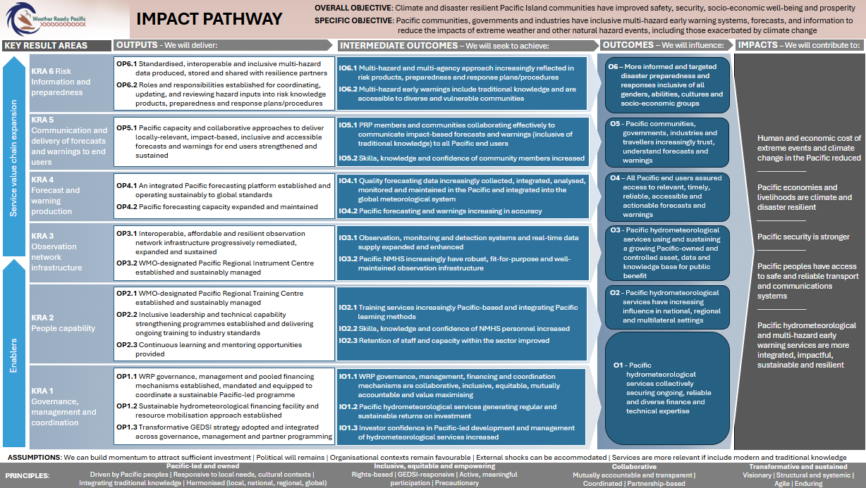

KRA Comparison
Value Chain
Weather Ready Pacific: Original KRA |  | Weather Ready Pacific: Revised KRAs
KRA 1: Management and Coordination |  | KRA 1: Governance, management and coordination
KRA 2: Production of Forecasts and Warnings |  | KRA 2: People capability
KRA 3: Communication and delivery of forecasts and warnings to end-users |  | KRA 3: Observation network infrastructure
KRA 4: Infrastructure |  | KRA 4: Forecast and warning production
KRA 5: Capacity and Training |  | KRA 5: Communication and delivery of forecasts and warnings to end users
 |  | KRA 6: Risk information and preparedness (NEW)

Appendix Three: Reporting Requirements
Reporting period | Format | Executing agency report deadline to WRP PMU | Executing Agency Report Template |  | Feeds into WRP report deadline | WRP Format | WRP PMU Template | Forum(s) for reflection on progress
Fortnightly | Verbal update | Fortnightly WRP Technical Committee | Presentation / verbal briefing by executing agencies to the WRP Technical Committee (free form):  - Progress against deliverables  - Issues/Risks/Opportunities that have arisen / testing solutions  - Opportunities for coordination with other agencies  Documentation: Meeting transcript, Technical Committee rolling action plan, presentations sent through (if relevant) |  | Monthly donor meetings (dates TBC) | WRP Programme Tracker & Verbal update | Presentation / verbal briefing by WRP PMU to donors/ investors  - Progress against deliverables via WRP Programme Tracker  - Issues/Risks/ Opportunities that have arisen / testing solutions | WRP Technical Committee  Monthly donor/investor meetings
Monthly | Written update | Monthly WRP Programme Tracker | Written status update by all executing agencies activity managers directly into the Programme Tracker to record status and comments against each project.
Jan-Jun | Written update | 15 August | Progress report light template (to be shared, likely migrate to online/exportable system report by 2026):  - Significant achievements and progress against deliverables/workstreams (traffic light)  - Progress against applicable implementation indicators (under development)  - Performance story (or similar)  - Financial update against budget  - Significant issues/risks/opportunities that have arisen  - Lessons Learned and Adaptations/Change intended |  | 5 September | Written update | WRP Progress report light template:  WRP Report Card, supported by full consolidated executing agencies reports | WRP Steering Committee - September
Jan-Dec | Written update | 15 February | Annual report template (to be shared, likely migrate to online/exportable report by 2026):  - Most significant achievements  - Key performance story (1 or 2) (or similar)  - Progress against deliverables/workstreams (traffic light)  - Effectiveness - whether deliverables contributing to intended (intermediary) outcomes, plus unintended (positive or negative) consequences  - Progress against Executing Agency GEDSI, ESS and sustainability actions (under development)  - Progress against Executing Agency MERL table, including relevant implementation indicators. (under development)  - Partner and stakeholder relationships/coordination.  - Financial update against budget.  - Lessons learned.  - Significant issues/risks/opportunities.  - Adaptations/Changes intended and upcoming priorities.  - SC decisions required (if applicable). |  | 15 April | Written update | WRP Full annual report template:  WRP Report Card, supported by full consolidated executing agencies reports | WRP Steering Committee - May

Appendix Four: Sources
EvalCommunity: https://www.evalcommunity.com/
OECD DAC: https://www.oecd.org/en/about/committees/development-assistance-committee.html
WMO, Toolkit for Monitoring & Evaluation of Early Warnings for All: https://wmo.int/sites/default/files/2024-09/EW4ALL%20ME%20Toolkit_Final%20Version%201_August2024.pdf
COSPPac Phase 3, Monitoring, Evaluation, Reporting and Learning Plan 2023-2027
Centre for Theory of Change https://www.theoryofchange.org/
Pacific Meteorological Desk & Partnership https://www.pacificmet.net/
2020, Towards more adaptive approaches to managing the New Zealand Aid Programme, MFAT. https://www.mfat.govt.nz/assets/Aid-Prog-docs/Research/Adaptive-Management-Project-Phase-1-Report.pdf
OECD, Results-based approaches, https://www.oecd.org/dac/results-development/results-based-approaches/
Davies R, The Most Significant Change (MSC) Technique: A Guide to Its Use, January 2005: http://www.mande.co.uk/wp-content/uploads/2005/MSCGuide.pdf
Priya, A (2020). Case Study Methodology of Qualitative Research: Key Attributes and Navigating the Conundrums in its application, Vol 70, Issue 1, Sage (https://journals.sagepub.com/doi/full/10.1177/0038022920970318#:~:text=Case%20Studies%20are%20a%20qualitative,a%20sustained%20period%20of%20time.)
Vaughn, L and Jacquez, F, Participatory Research Methods – Choice Points in the Research Process, 2020, vol 1, Issue 1, Journal of Participatory Research Methods (https://jprm.scholasticahq.com/article/13244-participatory-research-methods-choice-points-in-the-research-process)
Pacific Climate Change Research Roadmap 2025-2030, https://www.sprep.org/sites/default/files/32-SPREP-Meeting/Officials/Eng/WP_7_2b_Att_1_Pacific_Climate_Change_Reserch_Roadmap.pdf
Pacific Roadmap for Strengthened Climate Services (2024-2033), https://www.pacificmet.net/sites/default/files/inline-files/documents/PRSCS%202024_33_final.pdf
Kakala Research Framework, a garland in celebration of a decade of rethinking education, Seu’ula Johansson Fua, https://repository.usp.ac.fj/id/eprint/8197/1/Kakala_Research.pdf
Kakala https://www.hqsc.govt.nz/assets/Consumer-hub/Publications-resources/Pacific-models-for-engagement_Kakala_final.pdf
Cousins, J. B., & Earl, L. (1995). The case for participatory evaluation: Theory, research, practice. In J. B. Cousins & L. Earl (Eds.), Participatory evaluation in education: Studies in evaluation use and organizational learning (pp. 3-18). London: Falmer, page 8
Towards more adaptive approaches to managing the New Zealand aid programme, November 2020
WRP Decadal Programme of Investment (2021)
WRP Implementation Plan (2023)
WRP Governance (2023)
WRP Steering Committee Terms of Reference (2023)
WRP Programme Overview (2023)
WRP Concept Note (for DFAT) (March 2025)
WRP GEDSI Report (March 2025)
WRP grant funding agreements (DFAT, MFAT, WISER)
WRP Planning and Steering Committee Meeting papers (2025)
Pacific Islands Meteorological Strategy (PIMS),
PMC Roadmap for Climate Services,
SPREP Monitoring and Evaluation Policy 2024 (draft)
SPREP Strategic Plan Results Framework
SPREP PIP 2023,
SPREP Finance & Resource Sustainability Strategy 2024,
SPREP Procurement Policy and Procedures Manual 2025,
Draft COSPPac Results Framework,
ClimSA Description of Action,
CREWS Theory of Change,
DFAT Design, Monitoring, Evaluation and Learning Standards,
DFAT Promoting Practical Sustainability (2020),
EW4ALL Logic Model (2025),
EW4ALL Monitoring and Evaluation Toolkit (2024),
EW4ALL Outcomes, Outputs and Indicators (February 2024),
MFAT Activity MERL Framework Guidance,
Draft MFAT CEAP MERL planning,
Draft Sustainability Framework (MFAT-funded CEAP),
MFAT Climate Finance MERL Framework,
MFAT Evaluation Operational Policy,
MFAT Integrating Sustainability in International Development (2018),
SOFF Operational Manual, SOFF Theory of Change,
WISER MEL Guidance,
WISER Programme Logframe

Wavu, R. (2025), TokMELPasefika group discussion.
https://www.spc.int/updates/blog/did-you-know/2025/07/a-talanoa-space-for-pacific-voices-in-monitoring-evaluation-and
The original five KRAs were: KRA 1: Strategy and Governance (revised to ‘Management and Coordination’ in the implementation plan 2023); KRA 2: Production of forecasts and warnings; KRA 3: Communication and delivery of forecasts and warnings to end-users; KRA 4: Infrastructure; KRA 5: Capacity and training
Mandated by the: Third Pacific Ministers Meeting of Meteorology (PMMM); PMC-6, PMC-7. Review findings outlined in the WRP SC-2 Paper: Weather Ready Pacific and the Early Warnings for All Initiative: Options and Recommendations for Alignments (May 2025).
As approved at the SC3 Meeting on 26 September 2025.
Ontotext DIKW Pyramid, https://www.ontotext.com/knowledgehub/fundamentals/dikw-pyramid/
The following is a composition example to be confirmed by the WRP Steering Committee. Membership may include 2 WRP SC representatives (1 from each sub-region), 2 executing agency representatives, 1 local partner representative, 1 development partner representative, 1 industry representative, and WRP PMU (Manager and MERLA Officer).
Relevance, Coherence, Effectiveness, Efficiency, Impact and Sustainability
in line with OECD DAC evaluation criteria
The Partnering Initiative, https://thepartneringinitiative.org/wp-content/uploads/2022/08/07-Partnership-health-check.pdf
SPC, Pacific MEL Rebbilib Report, 2020, https://www.spc.int/updates/blog/2020/08/pacific-mel-rebbilib-report-on-mel-capacity-available-for-download; A talanoa space for Pacific voices in Monitoring, Evaluation and Learning, https://www.spc.int/updates/blog/did-you-know/2025/07/a-talanoa-space-for-pacific-voices-in-monitoring-evaluation-and

