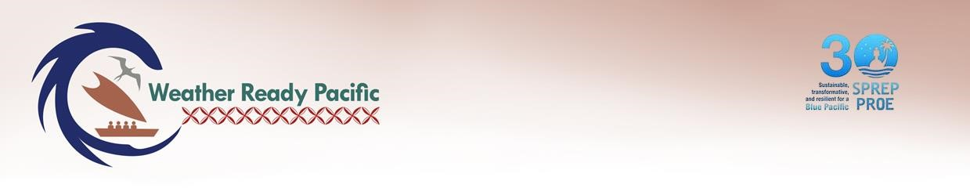

Weather Ready Pacific
Operations Manual

Chapter 9: Sustainability
Version 1 For SC

SCOPE – This chapter applies to WRP and Executing agencies.

Chapter 9. Sustainability

SCOPE – This chapter applies to WRP and Executing agencies.

Accountability
SPREP Sponsor / Approver | Director of CSI
SPREP Responsible Officer | WRP Programme Manager

Version History
Date | Version | Description | Author | Reviewer | Approver
090625 | 0 | Initial draft for PMU consultation | Kat Paton | 'Ofa Fa'anunu
160226 | 0.1 | Draft for Technical Committee Review | Kat Paton | 'Ofa Fa'anunu
 | 1 | For SC

Contents
1Introduction 2
1.1 Purpose of Sustainability Framework 2
1.1.1Process to develop the framework 2
1.2Background 2
1.2.3 Developments not sustained 2
1.2.3 Partnering for sustainability 2
2What is ‘Sustainability’? 2
2.1A WRP definition 2
2.2Sustainability Benchmarks 2
3 Operationalising the Sustainability Framework 2
3.1 Twin track approach to Sustainability 2
3.2 Assessing sustainability 2
3.3 Monitoring, evaluating and reflecting on sustainability 2
3.2 Tools and templates 2
3.4Interaction with other Chapters 2
3.2 Sustainability roles and responsibilities 2
3.3 Building capability 2
3.4 Budget 2
Appendix 1 – Alignment with sustainability goals and ambitions 2
Appendix 2 - Sources 2

SCOPE – This chapter applies to WRP and Executing agencies.

1 Introduction

1.1 Purpose of Sustainability Framework
One of the core multi-faceted challenges facing the hydrometeorological and multi-hazard early warning sector in the Pacific region is the sustainability of the services provided – services which are to be remediated and expanded under WRP. This Framework defines sustainability for the purposes of WRP, and outlines steps required for implementing partners to place sustainability at the centre of decisions for WRP throughout design, implementation, MERL and closure of WRP activities.

1.1.1 Process to develop the framework
This Sustainability Framework drew from an extensive literature and documentary review to understand the sustainability challenges faced by the hydro-meteorological sector in the Pacific region and around the world, and the range of approaches to achieving sustainability. Interviews with a selection of sector stakeholders then assisted with further identifying underlying causes of the challenges faced. A draft framework was shared with WRP Steering Committee members in December 2024. It then went through a considerable refinement process in 2025 with consultations to ensure it is relevant for the Pacific, reflects WRP aspirations and provides clear direction on how WRP implementing and executing partners should seek to achieve sustainability within their activities.

1.2 Background

1.2.3 Developments not sustained
Despite significant investment into the Pacific region over the last forty years, the benefits of the investment have not been sustained as anticipated. Root causes of the decline in assets and services include:
- a lack of ongoing predictable funding and investment to maintain assets and services at the required performance level, particularly given high upfront and downstream costs. This leads to assets falling into disrepair prematurely.
- the sector operating on short-term project funding cycles, leading to a tendency to focus on and deliver results against the immediate priorities. This short-term approach has led to unsustainable service delivery models being adopted.
- insufficient local technical specialist and asset management capability/capacity compounded by high staff turnover in some PICTs, and high reliance on external expertise and training programmes.
- network assets and systems being transferred to Pacific Island Countries and Territories (PICTs) without adequate supports in place, or insufficient time being given for service improvements to be embedded and consolidated before external supports are withdrawn or downscaled.
- Pacific end users not being assured access to relevant, timely, reliable, accessible and actionable forecasts and warnings. This results in reduced trust in the services and less demand for their ongoing provision. Notably, where there is high-level political and institutional support, services are more likely to be financed and sustained.
- wider context and contextual changes and risks (local, regional and international) that significantly contribute to or detract from sustainability. This includes institutional settings and wider government capabilities, political instability, natural disasters, local economic conditions, competing government priorities, external economic shocks, cultural and social shifts, and changes in international standards, recommended practices and technological advances.
WRP has therefore adopted “sustainability” as a WRP Principle to enable transformation within the sector over the investment decade. It aims to drive a step-change in achieving a sustainable and harmonised approach to service provision so that future generations may benefit from an expanded array of services. This focus on ‘sustainability’ is consistent with global, regional, national, sector, and donor goals and ambitions. This alignment is outlined in Appendix 1.
Totō hau tōkiga nei, aua na tupulaga e fāi mai - Plant a seed today for the future generations
(Tokelauan proverb)

1.2.3 Partnering for sustainability
Sustainable Development Goal (SDG) 17 highlights the need to revitalise partnerships for sustained development. The UN guidance notes how strong, trust-based relationships can overcome inevitable partnering challenges and help partners go 'the extra mile' to deliver extraordinary results.
To sustain MHEWS in the Pacific, enduring local, regional and international partnerships are essential. There is a high degree of interdependency amongst national, regional, and international stakeholders and partners within the sector, all with diverse interests, priorities and drivers. There is also a significant history of collaboration, although workstreams have different origins and have not always been driven from the Pacific.
Culture and traditional practices in the Pacific provide a solid foundation for partnership. For example, under the Samoan/Tongan concept of teu le va (build, nurture and strengthen relationships), importance is given to creating a place and space for meaningful engagement. It is important to teu le va to sustain partnership relationships - this strengthens trust, respect and nurtures collaboration with Pacific peoples, including valuing local voice. The members of the Pacific Meteorological Council (PMC) and Partnership already have mechanisms that embody Pacific cultural norms and which enable members to discuss and collaborate on issues, share costs and risks. WRP seeks further amplify the level of collaboration and Pacific regionalism. “Collaboration” (also a WRP Principle) therefore sits at the heart of sustaining Pacific MHEWS.

2 What is ‘Sustainability’?
The word ‘sustainability’ is widely used with different intent. Amongst WRP stakeholders, there is diverse understanding of: what is meant by ‘sustainability’; what it takes to achieve greater sustainability; the level of complexity involved in sustaining Pacific MHEWS, and who is responsible for improving sustainability. This Framework therefore aims to build a common understanding of “sustainability” for this sector in the Pacific; and provides practical guidance on how sustainability can be better achieved.

2.1 A WRP definition
Under this WRP Sustainability Framework, “sustainability” (also referred to as “sustained development”) is defined as:
Enabling both the existing and future Pacific hydrometeorological and multi-hazard early warning services to last, and to be Pacific owned and led in the long term.
This definition:
- includes, but is not limited by, donor definitions guided by the Organisation for Economic Co-operation and Development's Development Assistance Committee (OECD DAC) criteria that focus on the benefit of investment-specific assistance.
- contributes to high-level global policy definitions that focus on three integrated dimensions of sustainable development - economic, social, environmental – but is directed towards hydrometeorological and MHEWS service delivery that contributes to those high-level objectives in the long-term.
- is consistent with the intent of international sector programmes such as the Systematic Observations Financing Facility (SOFF) concerned with sustaining collection and exchange of observation data, including the infrastructure, human and institutional capacity to sustain the operation and maintenance of networks.

2.2 Sustainability Benchmarks
To achieve the level of sustainability envisaged under WRP, ten sustainability benchmarks have been identified to guide best practice by Pacific hydrometeorological and MHEWS services and other WRP implementing and executing partners throughout activity prioritisation, design, implementation, monitoring and evaluation (Figure 1 refers). The Benchmarks are practically detailed in Guiding Questions to Make your Proposal Sustainable (Annex 1 refers). Notably, these Benchmarks:
- overlap with elements of GEDSI and environmental safeguarding (Chapters 11 and 12), demonstrating how these cross-cutting concerns are mutually reinforcing.
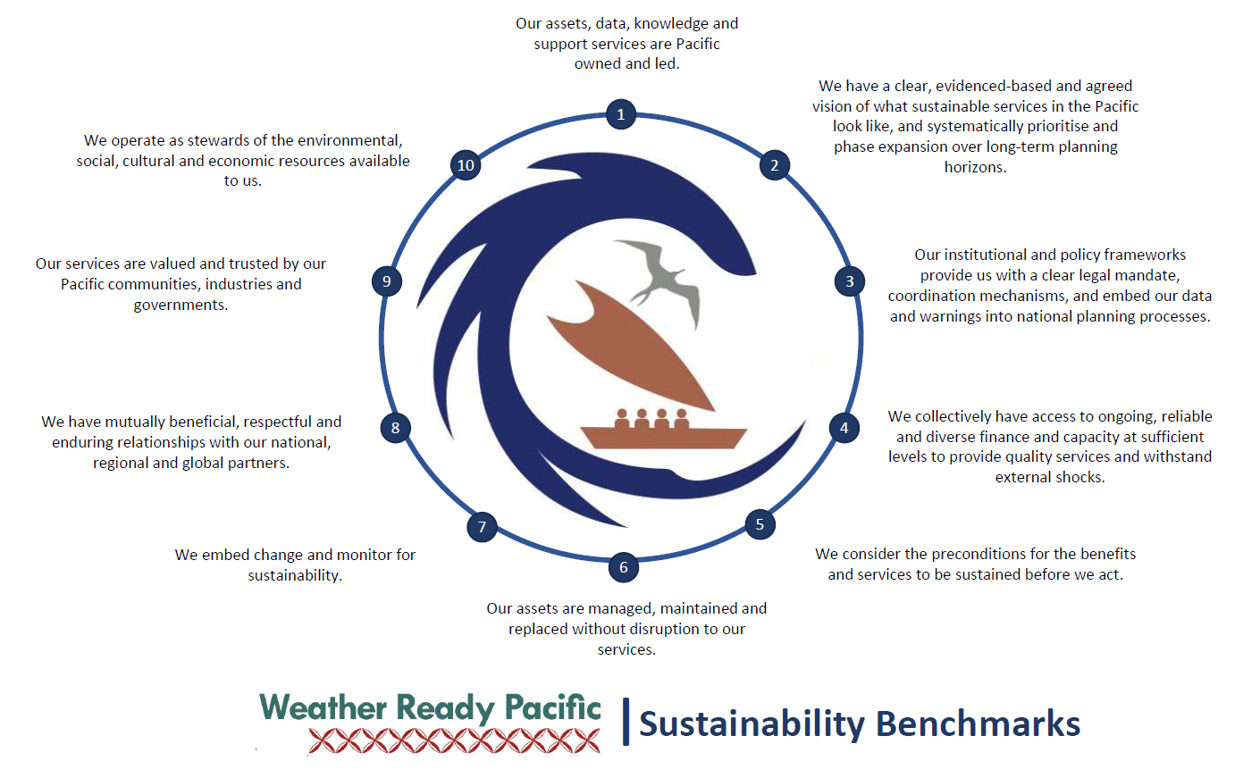
- are aspirational. In some instances, benchmarks may not be achieved within a single project or within the implementation period of WRP. Developing a clear, phased and progressive pathway towards these benchmarks is paramount; ensuring preconditions are in place and the timing is right to progress new phases.
Qalova uaua na moka - Swimming towards the fish trap at high tide
(Fijian proverb)
Do not be overly ambitious, have restraint and be watchful for good timing. Going too early or arriving too late is bad management. Sustainability requires patience, alignment with the environment in which you operate, and good timing.
Figure 1:

Operationalising the Sustainability Framework
The WRP governance, management and coordination mechanisms (Chapter 1 refers) have been designed with sustainability in mind – to facilitate a shift towards greater Pacific leadership and ownership; to support greater adoption of long-term programming approaches that direct resources to where they are most needed; and to foster trust and accountability and strengthen relationships as a foundation for increasing the quantum, diversity, predictability and ultimately the sustainability of financing into the sector.
Sustainability is deeply embedded within the WRP Impact Pathway, and in how progress within implementation and achievement of results will be measured, reported (see Chapter 6) and communicated (see Chapter 9). At an activity level under WRP, sustainability is considered not just when exiting or transitioning away from a funding source (as per the SPREP Project Cycle (2017); but when deciding what activities to do, how to implement them, what to monitor and how to adapt (if necessary).

3.1 Twin track approach to Sustainability
Within this sector, sustainability has often been framed as a challenge that could be addressed through minor adjustments at the point of project completion. History has shown this framing to be inadequate. In reality, the sustainability challenges in the sector range from simple through to complex.

In particular, the following sustainability challenges facing the sector have been identified as complex (WRP Core Sustainability Challenges) and have been prioritised for targeted action under WRP (Track 1):
• A lack of ongoing predictable funding to maintain assets and services.
• Inadequate asset management.
• Insufficient local technical capability and capacity.
Where a sustainability challenge is identified as complex, formulaic approaches and technical expertise are not sufficient to assure success. Instead, appropriate and well consulted system-level actions are needed to ensure the services can be feasibly provided at a level that meets ongoing and growing demand, particularly, in PICTs with significant economic limitations. Such interventions need to be multi-dimensional and will vary across the region. Thus, under this WRP Sustainability Framework a Twin Track approach to integrating sustainability into activity design is proposed:
 | How sustainability considered
Track 1 – Targeted sustainability action | Core Sustainability Challenges are addressed through  Track 1, whereby the root causes of developments not being sustained are identified and fully understood. This involves unravelling what underlying behaviours, ways of thinking, processes, people and structures have hindered sustained developed in the past. Once underlying causes are understood, a long-term roadmap/strategy is developed that:  - addresses the root causes  - is multi-pronged and multi-phased  - progressively works towards achieving the WRP Sustainability Benchmarks  - outlines who will be the long-term owners, doers and funders/investors of the functions and assets, and collectively agrees which specialised functions cannot viably be fully delivered in the foreseeable future without ongoing support of external agencies; and  - is supported by a communications and stakeholder engagement plan.  Track 1 Roadmaps/Strategies are to be considered and approved by the WRP Steering Committee prior to Track 1 projects for the first phases of the roadmaps being developed, assessed and implemented. When developing Concept Notes/Project Management Documents for Roadmap activities, sustainability actions and risks should be considered as per Track 2.  The first activities under the Track 1 Roadmaps/Strategies should begin within the first three years of WRP implementation (i.e. by 2027) allowing change to be embedded prior to moving onto subsequent phases. 2033 should be dedicated to bedding in change.
Track 2 – Mainstreaming | All WRP project Concept Notes/Project Management Documents that are not related to the Core Sustainability Challenges will proceed under Track 2 (Mainstreaming).  Project developers should use the Guiding questions to Make your Proposal Sustainable to identify opportunities to improve sustainability, formulate actions, and identify sustainability risks (with mitigations). Roles and responsibilities for actions should be clearly documented in the concept/project document.  It is important that sufficient time is factored into the project timeline for changes to be embedded prior to external support mechanisms/funding being downscaled or retired. It is proposed that no new activities are introduced in 2033, but that the year is dedicated to bedding in change. When assets are being transferred to a final beneficiary, it is important that the recipient undertakes to use, maintain and dispose of the asset in a manner consistent with this Sustainability Framework (refer WRP Asset Transfer form).  If additional Core Sustainability Challenges are identified as Track 2 project are developed, the WRP PMU will decide whether to develop and present additional Roadmaps to the WRP Steering Committee. If not, any concept note relating to a newly identified Core Sustainability Challenges should be presented to the Steering Committee in absence of the Roadmap, clearly setting out the sustainability risks of proceeding without a longer-term vision.

3.2 Assessing sustainability
When the PMU assesses and prioritises activities/projects outlined in both Track 1 and Track 2,
- sustainability is a key assessment criteria (Chapter 2 Annex 2 refers). Its significant weighting within the criteria reflects the importance of sustaining development within WRP.
- careful evidenced-based analysis and thought is to be given to the timing and sequencing of activities, with sufficient priority given early on to slow burn activities that will be the building blocks of longer-term systemic change even where shorter-term funding cycles are in play.
When approving a project, the Steering Committee and/or PMU may choose to add additional sustainability-related conditions and/or identify indicators of sustainability to be monitored in relation to the proposed activity.

3.3 Monitoring, evaluating and reflecting on sustainability
Achieving more sustained development means regularly monitoring and reflecting on sustainability and adapting implementation accordingly. For this reason, the WRP MERL (Chapter 6) has been designed to systematically track sustainability, including:
- Implementation indicators: At an Output level primarily tracking the degree to which sustainability has been considered in project design; and implementation progress for activities specifically targeted to address complex sustainability challenges. At an Intermediate Outcome level, tracking changes required to embed change and increase the probability change will endure.
- Headline and high-level indicators: At an Outcome-level, tracking annual funding diversity and reliability; income generated; levels of Pacific ownership and management of assets (including integration into national systems and budgets); asset life spans and uptime/availability; and stakeholder trust (through feedback loops). use of nature-based solutions. At an Impact-level, overarching Pacific MHEWS capacity and capability is tracked (maturity) as is use of renewable energy.
Targets are realistic as achieving greater sustainability takes considerable time and results are likely to be incremental. Reporting against sustainability targets is to be regular to ensure sustainability is always front of mind and informing activity adaptations. Sustainability actions should be revised where monitoring shows a need.
Sustainability performance/impact stories and lessons learned will be collected as part of MERL, shared and showcased within communication and knowledge products.
Evaluations (second midline and endline evaluation) will not only evaluate output and outcome level indicators of sustainability, but also assess human, economic and security impacts as they relate to sustainable development, and the level of sustainability and resilience of Pacific hydrometeorological services. This Sustainable Framework and related tools and templates will be updated to include sustainability learnings from MERL.

3.2 Tools and templates
The following tools, templates and guidance will support implementing and executing agencies to embed sustainability within WRP.
WRP Sustainability-specific tools and guidance
Chapter 10, Annex 1: Guiding questions to Make Your Proposal Sustainable (for developing projects)
Chapter 10, Annex 2: Sustainability and transition tool
Chapter 10, Annex 3: Asset transfer form
WRP Tools integrating sustainability
Annex X: Concept Note/Project Document template
Annex X: Assessment Criteria
Annex X: Risk Register
Annex X: MERL Results table
Annex X: Progress Report templates
Annex X: WRP Evaluation Terms of References
Additional sustainability-related policies or guides
Annex X: WRP Roadmap for Sustainable Financing and Asset Management
Annex X: WRP Roadmap for sustained Pacific hydrometeorological capacity and capability (future)
Annex X: Regional meteorological infrastructure asset management policy (future)
Annex X: Guidance to Standardise and Maintain Pacific Meteorological Equipment (future)
Annex X: Pacific Hydrometeorological Total Cost of Ownership framework and template (future)
Annex X: Regional meteorological infrastructure asset management SOPs (future)

3.4 Interaction with other Chapters
Considerations outlined in Environment and GEDSI chapters of this Operations Manual (Chapters 12 and X respectively) are critical to improve sustainability within the sector. As with all development action, Pacific environmental, economic, cultural and social resources may positively or adversely impact through WRP. To operate sustainably, the sector needs to be: responsive to local needs and cultural contexts; mindful of data sovereignty; inclusive, equitable and empowering of marginalised communities; and embrace low carbon intensity / energy efficient models of service delivery.
Sustainability risks are to be identified and monitored as part of Risk Management (Chapter 7), and progress towards sustainability across each KRA monitored within the WRP MERL (Chapter 6) to enable timely adaptions to design and implementation, thus better sustaining services in the long-term. Successful implementation of Communications and Stakeholder Engagement guidance (Chapter 9) is also critical for improved sustainability of services as it will:
- improve understanding of the benefit of Pacific MHEWS; and increase visibility amongst government decision-makers and core agencies.
- ensure sufficient resources and time is available to teu le va to sustain relationships, and that stakeholder engagement is purposeful and timely under all WRP activities (paving the way for a whole-of-society approach to sustaining hydrometeorological and multi-hazard early warning services).
- inform stakeholder engagement and communication with analysis (commensurate to the nature and size of activities) of what shifts in power and resources are required to achieve a sustainable future state across activity, and what underlying interests, incentives, and institutions might enable or frustrate that shift.
- foster conditions conducive for supportive and enduring partnerships.

3.2 Sustainability roles and responsibilities
Within WRP, all implementing and executing partners have a role in planning for, implementing and/or monitoring the sustainability of activities and service functions, although their levels of control and influence will vary depending on their power and mandate. Within the PMU, the WRP Programme Manager is responsible for guidance on and implementation of this Framework.

3.3 Building capability
The PMU will support activities to build a shared understanding of sustainability amongst WRP partners and will provide coaching in the application of this Framework and tools.

3.4 Budget
Activities that address Core Sustainability Challenges under Track 1 have dedicated budget within the WRP Implementation Plan. Budget for sustainability actions under Track 2 projects is mainstreamed within each project budget.

Appendix 1 – Alignment with sustainability goals and ambitions
Global, regional, national, sector, and donor goals and ambitions all aim to better sustain development efforts. The Sendai Framework notes how effective disaster risk reduction contributes to sustainable development. It identifies Small Island Developing States (SIDS) as needing special support to ensure capacity building, assistance, and technological transfer is not only adequate and timely, but is also sustainable. By operationalising this Framework within WRP, PICTs will make more enduring progress towards achieving priorities in the Sendai Framework and the SDGs. Within the Pacific,
- elements of sustainability are threaded throughout the 2050 Strategy for the Blue Pacific Continent (2050 Strategy) with ambitions to achieve: sustainable economic prosperity and development; greater accountability and transparency for sustainable resource management and development; genuine and durable partnerships; and to consider innovative financing instruments and mechanisms that address fiscal sustainability risks. Under the 2050 Strategy, Pacific Leaders committed to nurturing collective political will, deepening regionalism and solidarity, and resolving challenges in a uniquely Pacific Way involving consensus-based decision making.
- the fourth Pacific Resilience Standard (PRS) under the Pacific Resilience Partnership (PRP) is “sustaining resilience building” – WRP will contribute to sustaining climate and disaster resilience through contributions to strengthening local capacities, leadership and ownership for preparedness and response, as well as supporting Pacific communities to be more resilient through forecasts, warnings and risk information.
- the Pacific Islands Meteorology Strategy (PIMS) seeks to sustain long-term National Hydrological and Meteorological Services (NHMS) observation and warning services.
- the SPREP Secretariat is mandated to promote cooperation, provide assistance and ensure sustainable development for present and future generations. It aims to have a reliable and sustainable funding base to achieve outcomes for the Pacific; and
- sustainability is a key evaluation criteria for Pacific development partners and the Organisation for Economic Cooperation and Development (OECD) Development Assistance Committee (DAC).

Appendix 2 - Sources
2021 WRP Decadal Investment Plan
2023 WRP Governance Framework
2030 Agenda for Sustainable Development
2050 Strategy for the Blue Pacific Continent
Adam Smith International (2018) Integrating Sustainability in International Development Cooperation, MFAT Sustainability Integration Project
COSSPaC3 draft Transition Agenda (2024)
DFAT (2000) Promoting Practical Sustainability
Grimes, D., Rogers, D., Schumann, A. & Day, B (2022) Charting a course for Sustainable Hydrological and Meteorological Observation Networks in Developing Countries. World Bank
ICHCAP (2014) Traditional Knowledge and Wisdom - Themes from the Pacific Islands. Retrieved from SPREP library
INTRAC/UKAID (2022) Exiting / transitioning from International Partnerships.
Mafile’o, T. (2024). Pacific-led approaches: Guidelines for practice, policy and research [policy brief]. Mana Pacific Consultants Ltd
MFAT (2022) Quality Domain Guideline
Pacific Island Meteorology Strategy (2017-2026)
Pacific Region Infrastructure Facility (2021) A Shared Approach for Management of Environmental and Social Risks and Impacts
Pacific Region Infrastructure Facility (nd) A guide for undertaking an economic analysis
PRP Taskforce (2021) Pacific Resilience Standards - A Practitioner’s Guide
Sendai Framework for Disaster Risk Reduction 2015-2030
SPREP (2017) Project Cycle
SPREP Strategic Plan (2021-2026)
Tamarack Institute (2017) Tool: Single, Double and Triple Loop Learning.
The Partnering Initiative and UN DESA (2019). Maximising the Impact of Partnerships for the SDGs. Retrieved from: 2030 Agenda Partnership Accelerator
WMO SOFF Operational Handbook and sample of Pacific SOFF assessments and plans. Multiple – retrieved from SOFF Document Library
WMO (2016) Project Management Guidelines and Handbook
WMO (2017) Guidelines on the Role, Operation and Management of National Meteorological and Hydrological Services
WRP PMU (2025) Roadmap for Sustainable Financing and Asset Management

Notably, as this trend is common within Pacific infrastructure intensive sectors, sustainable infrastructure management is also a core concern of the Pacific Regional Infrastructure Facility.
Grimes et al (for World Bank) outline this global trend. They identify 10 elements to successfully plan sustainable observation networks: defining the network/system purpose; identifying necessary meteorological observations; defining requirement specifications; a network plan; a network data management plan; defining operational requirements; identifying personnel requirements; determining the most effective business model; and performing total cost of ownership analysis.
Where changes in practice and behavior are needed, there is strong evidence that consolidating changes and avoiding slipping back into old patterns of behavior takes an extended period of time.
https://partnershipaccelerator.org/library/ Key elements of partnership relationships are identified as: trust and transparency, power balance and equity, mutual benefit, and accountability and commitment.
Teu – beautify, cherish, nurture; Le va – the space between, which allows for the nurturing of the relationship between the physical, spiritual, cultural dimensions of Pacific peoples. New Zealand Ministry for Pacific Peoples (2022) Yavu – Foundations of Pacific Engagement.
Zimmerman, B in Tamarack Institute (2017) Tool: Single, Double and Triple Loop Learning.
Exception – activities that commenced during the WRP inception phase.
For example: sustainability roadmaps; and asset/network plans, management and remediation; RTC/RIC establishment; financing facilities, MHEWS and industry partnerships) as well as stakeholder inclusion.

