Guiding Questions to Make Your Proposal Sustainable
Purpose | This guide is to support you to identify opportunities to improve the sustainability of your WRP concept or project.
What do we mean by "sustainability"? | WRP defines sustainability as "Enabling both the existing and future Pacific hydrometeorological and multi-hazard early warning services to last, and to be Pacific owned and led in the long term". To achieve the level of sustainability envisaged under WRP, ten aspirational Sustainability Benchmarks have been identified (see below) to guide best practice by WRP partners throughout activity prioritisation, design, implementation, monitoring and evaluation. This guide aims to help you to mainstream these Sustainability Benchmarks throughout WRP activities. For further information on Sustainability see the WRP Operations Manual.
How to use the guide | The guide should be used during the design (or revision) of a WRP concept or project to prompt reflection on how sustainability could be strengthened under the proposal.  For small initiatives, it may be sufficient to simply consider whether elements of your proposal contributes towards or detract from achieving the Sustainability Benchmarks when developing sustainability actions. For larger initiatives, the Guiding Questions overleaf encourage you to consider each of the Sustainability Benchmarks in more depth as they relate to the design. Any significant sustainability risks and risk mitigations should also be reflected in your risk register.  This guide should be used in conjunction with the complementary and inter-related WRP Gender Equality, Disability and Social Inclusion Guide, and alongside the Environmental and Social Safeguard process.
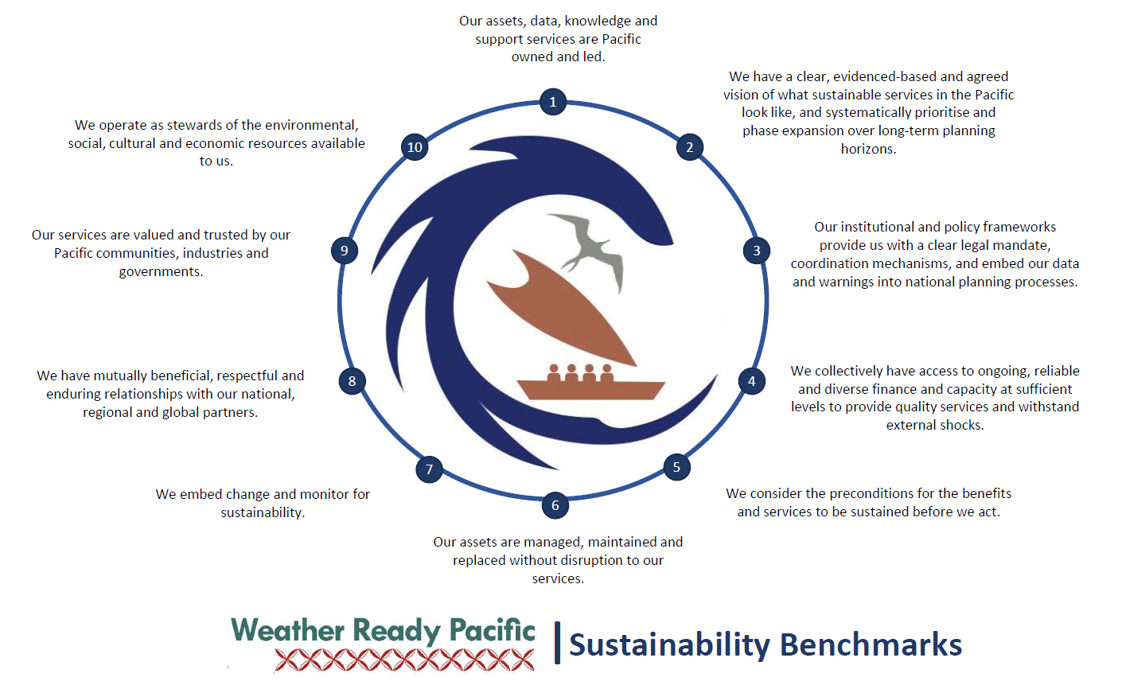

Sustainability Benchmark 1: Our assets, data, knowledge and support services are Pacific owned and led

- Ownership/leadership
- Does the initiative foster transformative leadership amongst stakeholders (from Pacific agencies through to vulnerable groups), ensuring their perspectives directly shape outcomes?
- Is the proposed initiative owned or driven by, led from, and responsive to Pacific leadership, priorities, cultural contexts and diverse decision-maker/user demands? Or is there a clear pathway toward Pacific ownership?
- Empowering delivery model
- Have alternative business models been explored for long-term sustainability, considering factors such as: Pacific ownership, control and operations; economies of scale; capacity and capability; compatibility with existing and future standards; public-private partnerships and regulatory frameworks?
- Is local engagement and delivery led by Pacific MHEWS agencies and their local partners, or is there a realistic plan to transition delivery to Pacific institutions over time? Are Pacific procurement systems (national or regional) being used wherever possible?
- Where external technical support is required, does the approach prioritise teamwork, capacity building, and knowledge transfer to avoid creating long-term dependencies?
- Does the model reduce long-term reliance on external capability, and are shifts in power, resources (and barriers to this transition) clearly understood and addressed?
- Data sovereignty
- Is data hosted and controlled locally or regionally, with Pacific communities making decisions on how it is collected, stored, and shared?
- Are risks to data exchange, misuse, or loss of control identified and mitigated? Do systems respect and protect indigenous knowledge, especially where artificial intelligence (AI) may be involved?

Sustainability Benchmark 2: We have a clear, evidenced-based and agreed vision of what sustainable services in the Pacific look like, and systematically prioritise and phase expansion over long-term planning horizons

- Shared long-term vision
- Is this initiative built on a clear and shared understanding of current needs at national or regional levels? For example, are career pathways supported for both current and future learners, accounting for automation and evolving roles?
- Do Pacific stakeholders have a shared long-term vision for which services/competencies should exist nationally, regionally (as shared resources), or be contracted externally? Does the initiative support this vision?
- Will the initiative contribute to a harmonised and interoperable network?
- Evidenced-based prioritisation
- Does the initiative identify and actively address the root causes of unsustainable practices, including behaviours, mindsets, and systemic barriers (not just symptoms)? Are long-term change drivers (systemic / structural) being tackled through the intervention? Are critical system blockages or gaps being addressed?
- Are investments prioritised based on clear evidenced-based identification of hazard or service gaps aligned with sector requirements, national risk profiles, end user needs, and technological advances? Is there evidence that this delivery model has previously produced sustainable and relevant outcomes?
- Strategic and phased implementation
- Are system-level changes planned in realistic, incremental phases? Are phases clearly structured to build progressively on prior success and learning?
- Are new or innovative approaches being piloted to demonstrate end-to-end value before full-scale rollout?
- Does the project design allow for agility and adaptation based on learning and evolving needs, considering for instance the learnings to improve and enhance the resilience of communities?
- Context awareness and risk scanning
- Are there systems to regularly assess local, regional, and global contextual factors that may impact sustainability? (e.g. via PESTLE analysis).
- Have contextual risks and location-specific changes been considered? (e.g. future land use or development around proposed infrastructure sites).

Sustainability Benchmark 3: Our institutional and policy frameworks provide us with a clear legal mandate, coordination mechanisms, and embed our data/warnings into national planning processes

- Mandate
  - Within relevant institutional and policy frameworks, is it clear who will be the long-term owners, users, doers, and funders/investors of this service? Does this vary by context due to size, structure, national or local authority, community, etc?
  - Are interagency data-sharing agreements in place and supported by compatible systems? Are government expectations and public/private sector boundaries clearly defined?
- Integration
  - Does the proposed delivery approach align with national government systems and priorities to build sustainable public service capacity?
  - Is asset management integrated into national asset management frameworks, practices and finances?
  - Does increased access to accredited training have implications for staffing or banding within the government, and are additional costs (if relevant) accounted for?
  - Are communication and information sharing approaches integrated into existing community, industry, and MHEWS systems?
  - Are systems compatible with relevant global forecasting systems?

Sustainability Benchmark 4: We collectively have access to ongoing, reliable and diverse finance and capacity at sufficient levels to provide quality services and withstand external shocks
- Affordability
  - Have costs and benefits over the full life of infrastructure or systems been analysed using a Total Cost of Ownership (TCO) model and fully discussed (including with Departments of Finance/Planning)?
  - Is the model of delivery affordable and realistic for the Pacific (agencies through to local users) in both the short and long term ('fit for local budgets')? Does it account for real-world operational capacity, delivery costs, and trade-offs with other priorities?
  - Is the system cost effective and non-duplicative, and does/can it leverage economies of scale?
- Sustained Funding Source
- Is there a clear plan or exit strategy for how critical systems or services will be financially sustained? Have diverse funding sources (e.g. government budgets, climate or sector-specific finance, cost-recovery, donor support) been identified and pursued to ensure consistent service delivery and support key staff/systems into the future?
- Human Resourcing
- Are human resource plans aligned with career development, recruitment, and retention strategies tailored for Pacific Island contexts?
- Do governments have the ability (and plan) to resource and retain the personnel required for sustained operation of services? Is there support for shared, mobile, or regional human resourcing models where national staffing may not be viable long-term?

Sustainability Benchmark 5: We consider the preconditions for the services to be sustained before we act
- Prerequisite skills, capacity and understanding
  - Do service providers and end users have a shared understanding of the services and user demands/needs? Are we using common language and concepts?
  - Do selected learners have the prerequisite skills to undertake and benefit from the training? Are learners participating in other capability building and/or are they ready for further learning?
  - Has infrastructure siting considered accessibility, safety and vulnerability to natural, climatic or manmade hazards, including hydro-meteorological elements?
- Connectivity and supply
  - Are contingencies in place to ensure consistent access to power, internet, and data systems that the service depends on?
  - Is there a reliable supply chain for spare parts or consumables the system depends on?
  - Can repairs be carried out locally or regionally, and are those arrangements confirmed?

Sustainability Benchmark 6: Our assets are managed, maintained and replaced without disruption to our services
- Procurement specifications
- Do procurement specifications include expectations for long-term usability, durability, interoperability/compatibility and fitness for purpose in Pacific contexts? Are they in line with Pacific standards (being developed) and are they scaleable? Is the asset or system aligned with standards (e.g. QMS, ICAO, SOLAS, Pacific training standards) and user needs?
  - Have requirements for installation, maintenance, operation, and replacement been fully considered and clearly specified during procurement? Are suppliers required to meet defined standards for quality, support, and ongoing service provision (repair, replacement, upgrades)?
  - Have the selected systems or products been tested, reviewed, or proven in similar contexts before selection?
- Management and maintenance plans, procedures and systems
  - Will formal asset or infrastructure management plans be in place and integrated with national systems? Are procedures for asset tracking and documentation clearly defined and resourced?
  - Do management systems include clear protocols for regular maintenance, performance monitoring, and timely replacement (including assigning roles and responsibilities)?
  - Is there a schedule and resourcing for regular preventive maintenance and servicing of equipment or systems? Are maintenance tasks assigned to trained personnel or teams with the appropriate tools and support?
  - Are users/technicians equipped to carry out routine troubleshooting and minor repairs locally?
  - Are there mechanisms for identifying, reporting, and responding to faults or breakdowns promptly to avoid service disruptions?
  - Are there underlying incentives to maintain or not maintain the infrastructure? (e.g. is it easier to get finance for a replacement asset than maintenance)?

Sustainability Benchmark 7: We embed change and monitor for sustainability
- Embedding change
  - How will the initiative ensure an enduring impact and build sustained resilience? Are partners or end users supported after the initiative ends to reinforce skills, systems, and ownership?
- Are there regular follow-ups planned to ensure changes are sustained over time? Is follow-up embedded in national or organisational practices rather than reliant solely on external support?
- Institutional support
  - Is there access to capability strengthening? Is there leadership/management buy in to, and involvement in capability strengthening being provided? Do the selected learners work in a role and environment where they can apply new skills? Will learners be supported to apply their learnings in their workplace?
  - Will increasing access to transportable qualifications lead to higher staff turnover? If so, is there a plan to institutionalise knowledge and responsibilities (e.g. documented procedures, succession plans, standard operating processes) rather than have it held only by individuals?
- Exit/Transition Plans
- Is there a clear transition or exit strategy in place to support handover of responsibilities to local partners? (if applicable) Does it leave sufficient time for change to be embedded prior to external support mechanisms being downscaled or retired? Are local partners prepared, resourced, and willing to take full ownership once external support ends?
- Monitoring, Evaluation, Research and Learning (MERL)
  - Have robust mechanisms to monitor, evaluate and reflect on Sustainability Benchmarks been identified to track progress, identify gaps, and hold all stakeholders accountable both during implementation and after completion?

Sustainability Benchmark 8: We have mutually beneficial, respectful and enduring relationships with our national, regional and global partners
- Relationships
- Does the initiative foster direct, partnership-based, and coordinated approaches between communities, industry and government services? Are these relationships equitable, respectful, mutually accountable and value maximising?
- Does the initiative leverage existing/traditional communication networks for collaboration?
- Are spaces to teu le va (build, nurture and strengthen relationships) built into coordination arrangement and agreements?

Sustainability Benchmark 9: Our services are valued and trusted by our Pacific communities, industries and governments
- Legitimacy through mutual accountability and transparency
  - Does this initiative support the free, open and ready access to reliable and culturally appropriate information where that data is essential to the protection of life and property?
  - Does the initiative facilitate high levels of meaningful and active local participation of all relevant stakeholders (key industries, communities, government, academia) to ensure their needs are met resulting in increased trust and use of the services?
  - Are there mechanisms for transparent reporting and feedback to stakeholders to foster trust and shared responsibility? Are feedback loops and complaints mechanisms in place and known/trusted by communities and other end users / stakeholders?

Sustainability Benchmark 10: We operate as stewards of the environmental, social, cultural and economic resources available to us
- Stewardship
  - Have environmental, social, and cultural risks and impacts been assessed? (refer Environmental and Social Safeguarding processes).
  - Have low-carbon and energy-efficient approaches been prioritised in service delivery and infrastructure design?
  - Have nature-based solutions been considered where feasible?

