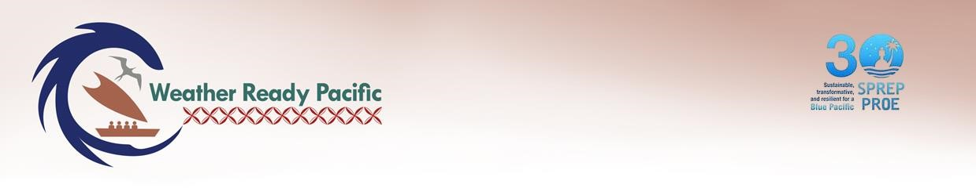

Guide:
- This tool should be used by Executing Agencies and the WRP PMU when your WRP project is coming to an end or transitioning to a new project. Transition or exit planning should suit the particular context of the project, so details will vary. The recommended process to complete this tasks is as follows:
  - Reflect on the quality of sustainability, transition or exit planning during design and implementation, including whether actions have been completed, the results from those actions, and the degree to which they will aid sustainability of outcomes.
  - Outline key steps to support sustainability of outcomes and services beyond completion of the existing project, including ensuring sufficient local capacity/capability monitoring for services to endure, evaluation and reflection tasks, communication and engagement with stakeholders, return of unspent funds, finalised asset registers, ensure sensitive and financial data and records are being managed, etc. Identify inputs, timeframes, responsibilities and any capacity development required for carrying out each step. Consider expectations / roles of national governments or other investors.
  - Provide for meaningful and equitable participation of under-represented and under-served groups in transition or exit planning (where relevant).
  - If transitioning to a new project, briefly describe what is intended for the new, follow-up initiative; anticipated approach or modality; and implementing partner(s)
  - Ensure all assets have been transferred to the final beneficiary using the WRP Transfer form and process. Ensure all assets to be disposed of are done so in a manner that minimises negative environmental impacts.
- All guidance in brown italics should be removed prior to finalising.
SUSTAINABILITY AND TRANSITION PLAN
Task to be continued after project completion | Necessary inputs | Timeframe | Responsible organisation | Capacity development required to support responsible organisation

