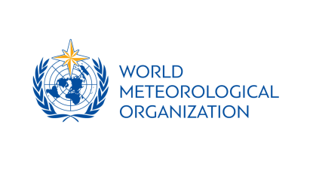
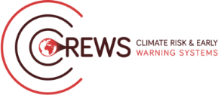
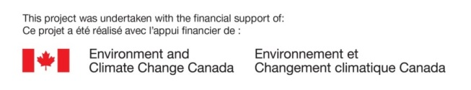
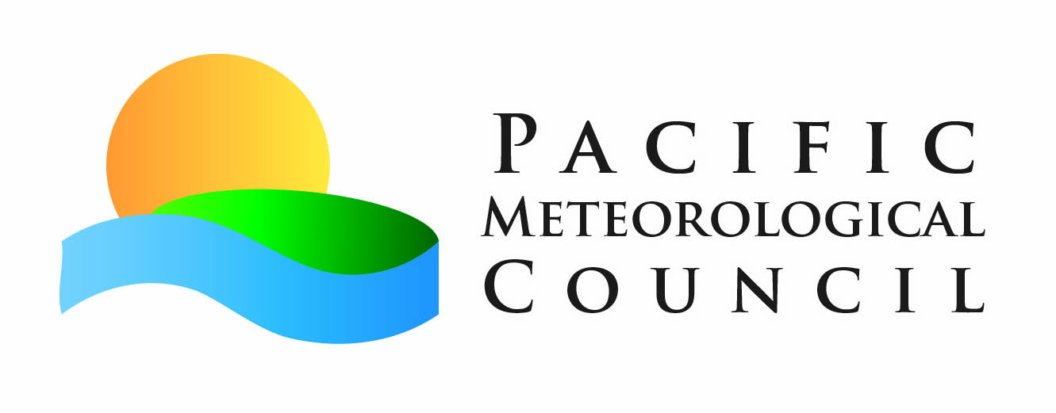

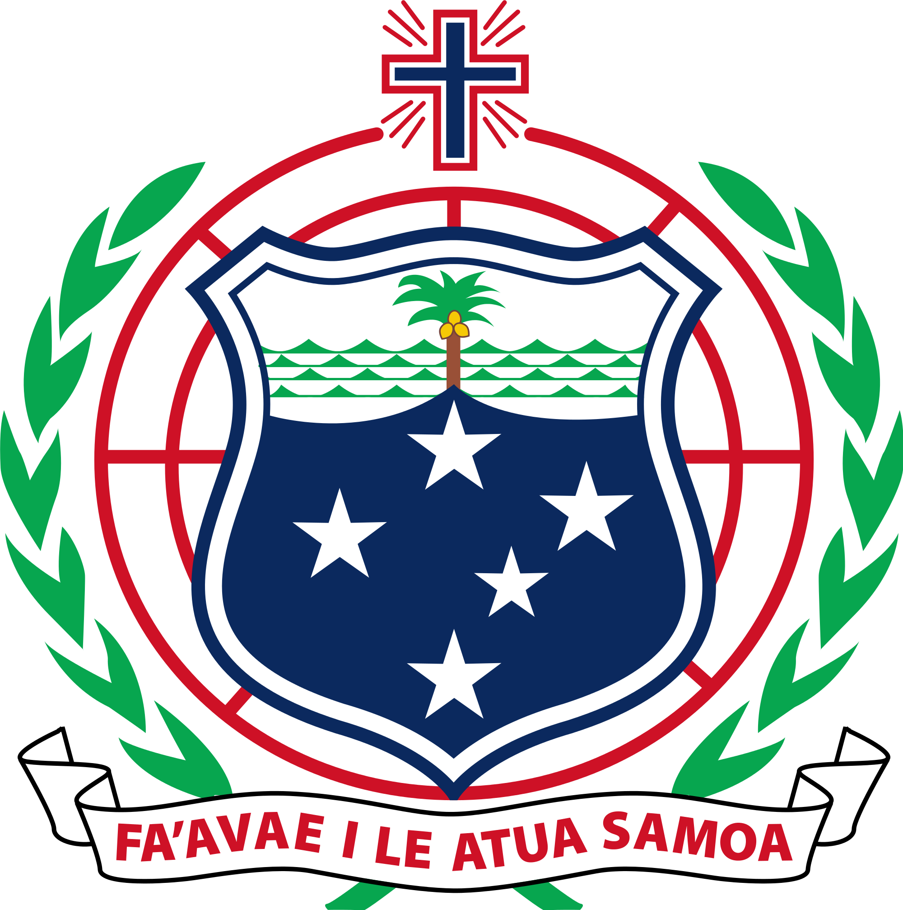
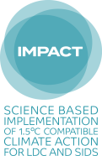
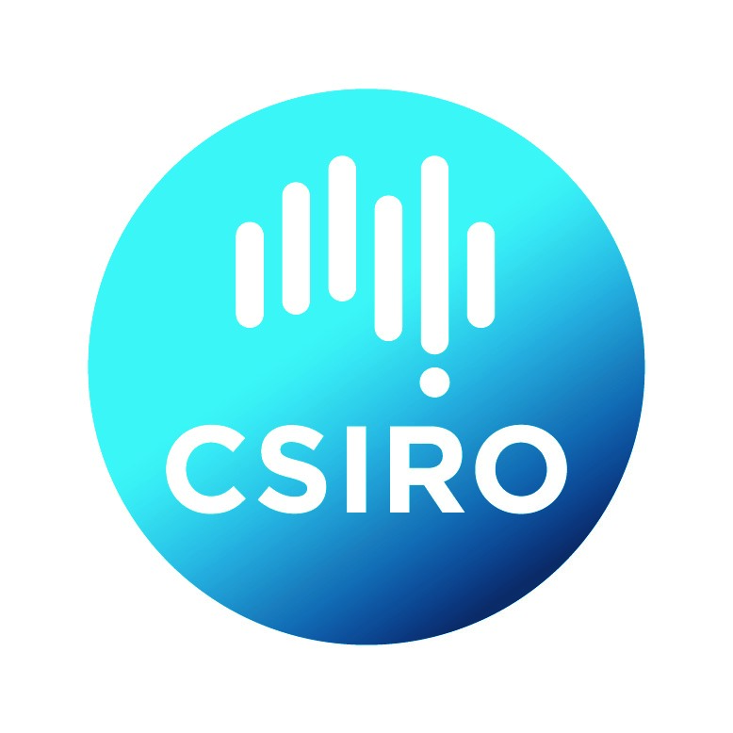



Mana Class: Hearing you loud and clear on radio
Mana Class with SPREP with financial support from WMO, CREWS Initiative, Environment and Climate Change Canada and the Government of Samoa. Training support provided by Pacific Environment Journalists Network, Pacific Media Network and Radio New Zealand Pacific. 1.00pm – 4.00pm • 2 August 2019 • Sheraton Hotel
About this training: | Communicating information clearly and effectively to a wide audience helps enable effective preparedness for weather and climate impacts to come. Hence the role of communications for Meteorological Services across the world is crucial to the well-being and survival of many Pacific island communities and people.
Format: | 4 hour Mana Class
Target group: | Pacific Island Met Directors and Staff
Course goal: | This Mana class aims to support Directors and other senior personnel of Meteorological Hydrological Services in their endeavour for effective communication skills through master classes in social media and radio to be held prior to the fifth Pacific Meteorological Council.
Course outcomes: | As a result of this Mana Class, Pacific Island Met Directors and Staff will have  - Increased confidence when sharing information through radio;  - Understanding of the behind the scenes and technical aspects of radio;  - Strengthened relationships between Radio New Zealand Pacific  - Increased visibility and sharing of information through live and pre-recorded radio.
Prerequisites: | To be eligible to do this course, participants will need to be:  - A Pacific Island Met Director or staff member  - Fully funded under the Pacific Meteorological Council 2019 event
Tagline: | The [Insert name here] Mana Class was held on [Insert date here] August, 2019 before the Fifth Pacific Meteorological Council to take place from 7 – 9 August, 2019 in Samoa. It is a partnership between the World Meteorological Organisation, the Climate Risk and Early Warning Systems Project, Environment and Climate Change of the Government of Canada, the Government of Samoa and the Secretariat of the Pacific Regional Environment Programme, United Nations Development Programme, IMPACT, Commonwealth Scientific and Industrial Research Organisation, and the Climate and Ocean Support Program for the Pacific. Facilitated by SPREP, this is one of three communication Mana classes conducted with training support from the Pacific Environment Journalists Network, Pacific Media Network and Radio New Zealand Pacific.
Contacts
Name | Organisation | Email | Role
Nanette Woonton | Secretariat of the Pacific Regional Environment Programme | nanettew@sprep.org | Trainer
Moera Tuilaepa | Radio New Zealand Pacific |  | Trainer
Angelica Salele | Secretariat of the Pacific Regional Environment Programme | angelicas@sprep.org | Support
Leanne Moananu | Secretariat of the Pacific Regional Environment Programme | leannem@sprep.org | Support

Agenda
No. | Topic | Dur | Time | Facilitator | Timekeeper
1 | Registration for Mana Class  [Coffee will be available] | 15 mins | 8.15 – 8.30 | Leanne
2 | Prayer - Welcome/Housekeeping  Introductions by all | 15 mins | 8.30 – 8.45 | Nanette
3 | National radio and our relationship  [Interactive with Notes taken] | 30 mins | 8.45 – 9.15 | Iliesa  Angelica to take notes
4 | Radio 101: Getting to know radio better  [Interactive session] | 30 mins | 9.15 – 9.45 | Moera
5 | Practical tips for good radio  [Presentation] | 30 mins | 9.45 – 10.15 | Iliesa
6 | Radio New Zealand Pacific Cyclone Service Watch  [Presentation] | 30 mins | 10.15 – 10.45 | Moera
7 | What we can do together  [Open discussion forum] | 1 hr | 10.45 – 11.45 | Moera and Nanette
8 | End with wrap | 30 mins | 11.45 – 12.15

