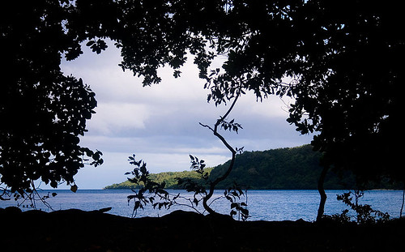
Developing an Effective Fisheries-Based Marine Heat Wave Risk Assessment Methodology for Use in Vanuatu
Correspondence to: Isabella Aitkenhead (Isabella.Aitkenhead@bom.gov.au), Yuriy Kuleshov (Yuriy.Kuleshov@bom.gov.au)
Technical report
Written by Isabella Aitkenhead and Yuriy Kuleshov
Contents
Executive Summary 3
Background 4
Marine Heat Waves in Vanuatu Fisheries 4
Introduction: 4
Fisheries Risk Management in Vanuatu through Marine Heat Wave Risk Assessment 4
6
Risk assessment validation 6
Aims and Objectives 11
Methods 11
Overview 11
Study Area 12
Methodology Part 1: Development of a tailored fisheries-based risk assessment methodology for Vanuatu, and completion of a retrospective risk assessment utilising this methodology 16
Methodology Part 2: Validation of retrospective risk assessment results using surveys and a literature review as ground truth sources. 21
Results 24
2015-2017 Case study results 24
Vulnerability and Exposure 24
Combined Risk 25
2020-2022 Case study results 35
Vulnerability and Exposure 35
Combined Risk 36
Participant details 48
Key comparisons of survey results: 2015-2017 vs 2020-2022 results 53
Discussion 68
What do the retrospective risk assessment results mean? 68
Time periods of concern, as indicated by the risk assessment 68
Areas of concern, as indicated by the risk assessment 70
Is the risk assessment developed here likely valid? 72
Are there any limitations to this work? 75
What are the uses of such an assessment methodology in the future? 75
References 76
Appendix 81

Executive Summary
This study was completed as part of the Van-KIRAP project in collaboration with SPREP and VMGD. In this study we develop an efficient Marine Heat Wave (MHW) risk assessment methodology for fisheries in Vanuatu specifically. This is motivated by the adverse impacts MHWs can have on Vanuatu communities and the fisheries sector specifically. As the fisheries sector is critical to Vanuatu, we employ a fisheries specific approach to risk assessment to aid in fisheries management of MHW impacts.
A retrospective risk assessment is conducted to gauge the ability of the MHW risk assessment methodology to produce useful results. Hazard, vulnerability, and exposure levels are calculated and mapped through integrated GIS systems. Risk levels were then calculated and mapped through the combination of hazard, vulnerability, and exposure indices. These results are validated through two ground-truth investigations: a literature search and survey of local fishery stakeholders.
Overall, the risk assessment was deemed valid, with results commonly corroborated by the literature and locals. The risk assessment results give a lead time of at least one month, signalling severe risk levels, prior to locals in Vanuatu experiencing MHW impacts. This has implication for MHW risk management, particularly for fisheries management. If employed in the future, this risk assessment could potentially prepare local fisheries stakeholders for MHW impacts with enough time to reduce the more long-term impacts of a MHW event.

Background

Marine Heat Waves in Vanuatu Fisheries

A Marine Heat Wave (MHW) can be described as a spatial area with prolonged and extremely warm sea surface temperature (SST), which can persist for days or months (Frölicher and Laufkötter 2018). Such events affect vulnerable coastal communities throughout the world, particularly Small Island Developing States (SIDS) in the Pacific, like Vanuatu (Shultz et al. 2016). MHW events occurring around Vanuatu are generally driven by the following climatic phenomena: El Niño - Southern Oscillation (ENSO) (Frölicher and Laufkötter 2018; Sen Gupta et al. 2020), Interdecadal Pacific Oscillation (IPO), and North Pacific Gyre Oscillation (NPGO) and Pacific Decadal Oscillation (PDO) (Holbrook et al. 2022). ENSO is seen as the dominant driver of MHWs across Vanuatu. During the El Niño phase of ENSO, SSTs are generally increased throughout the tropical central and eastern Pacific, northern Pacific, and the central South Pacific. Accordingly, these regions commonly experience more severe MHW events during El Niño. Other regions of the Pacific generally see rising SSTs and associated severe MHW events during the La Niña phase of ENSO, including the central and western subtropical pacific. Although ENSO phases are linked to SST changes across the Pacific, it is important to note that MHW events can also be driven by other factors, and not all ENSO events are similar in their impacts (Weir et al. 2021).
MHW events are known to have dramatic impact, specifically the ecological impacts of MHWs can be devastating and result in negative flow-effects to all other sectors of a community. Coral bleaching, fish kills, and species range shifts are some of the more significant ecological impacts known to occur because of MHWs (Holbrook et al. 2022). Such MHW impacts commonly detriment all aspects of Vanuatu communities, but can especially affect the fisheries sector. Fisheries is a critical sector to Vanuatu communities, providing key food and livelihood sources (Eriksson et al. 2017). Particularly in rural Vanuatu communities, most people rely on subsistence fishing as their main source of income and protein. For the country overall, inshore, and offshore fisheries comprise the biggest export (Rosegrant et al. 2016). Hence, it is vital that fisheries supply is sustained in Vanuatu (Eriksson et al. 2017). MHWs that have previously occurred across the Pacific have been recorded to cause variation in the distribution and thus the regional catch of key fisheries resources (e.g., tuna) and decreased local fish abundances (Dunstan et al., 2018). In extreme cases, fishery exports have been halted, severely threatening local livelihoods (Andréfouët et al., 2018).
Due to geographical limitations, lower levels of economic development, and limited resources, Vanuatu communities commonly have low adaptive capacity to endure the impacts of MHWs (Spickett et al. 2013; Jackson et al. 2017). Additionally, the fisheries industry has been under studied when it comes to MHW impacts in Vanuatu. Therefore, it is vital that future MHW impacts, specific to fisheries in Vanuatu, are sufficiently investigated, prepared for, and managed (Holbrook et al. 2022).

Introduction

Fisheries Risk Management in Vanuatu through Marine Heat Wave Risk Assessment

In the context of disaster events, risk management refers to a combined approach of risk assessment, implementation of management actions to control, reduce and transfer risks, and handling uncertainty to reduce the potential for loss and harm. Efficient MHW risk assessment is therefore a critical method contributing to efficient MHW risk management (Aitkenhead et al. 2023; Frölicher and Laufkötter 2018). Such an assessment would examine three main components of disaster risk: hazard, vulnerability, and exposure (Frölicher and Laufkötter 2018). Hazard is described as the climatic disturbances’ characteristic of a MHW event which may cause damage to the livelihoods, resources, and environment in a certain area (Aubrecht et al. 2013). Vulnerability is seen as how much the livelihoods, resources and environment of a certain area are susceptible to being affected when MHW impacts occur (Kouwenhoven 2013. Exposure refers to the actual livelihoods, resources, and environment of a population in a specific area where a MHW event may occur (Kouwenhoven 2013).
Literature recognises that for efficiency, a MHW risk assessment is required to:
- Dynamically assess the spatial and temporal components of MHWs (Aubrecht et al. 2013).
- Be tailored to specifically estimate MHW risk in a particular area and output user-specific risk information (Asare-Kyei et al. 2015; Twomlow et al. 2022).
- Incorporate both ecological and human indicators (Barbeaux et al. 2020; Frölicher and Laufkötter 2018).
- Calculate risk indices and produce risk maps using integrated GIS-based techniques (Chen et al., 2003).

Although these are commonly recognised as key for efficiency, such methods are lacking in past MHW risk assessments not only in Vanuatu, but across most studies on Pacific SIDS (Major et al. 2021; Pedersen Zari et al. 2019; Kaly and Pratt 2000; Bell et al. 2013; Jackson et al. 2017; SPREP and CSIRO (2021)). Aitkenhead et al. 2024 (unpublished) aimed at making strides to address these knowledge gaps, focusing on exploring the first two steps of an efficient MHW risk assessment methodology for Vanuatu: tailored indicator selection and weighting. The study implemented a user-centred approach to select tailored hazard, vulnerability, and exposure indicators that would be appropriate in assessing MHW risk to Vanuatu fisheries (Table 1).
Table 1. List of indicators selected by Aitkenhead et al. (2024) for use in a fishery based MHW risk assessment in Vanuatu.
Index | Indicator
Hazard | Sea Surface Temperature (SST)
Hazard | Coral bleaching
Hazard | Chlorophyll-a concentration
Vulnerability | Terrestrial-based food and income generation
Vulnerability | Fishing skills and technology
Vulnerability | Fishery fish diversity/fishery flexibility
Vulnerability | Primary production of commercial fisheries
Exposure | Seagrass population/C content
Exposure | Coral Habitat Health/Crown of Thorns Prevalence
Exposure | Crab stock health
Exposure | Fish mortality/fish stock health

As per Wang et al. (2011), the critical next steps in developing an efficient MHW risk assessment methodology to analyse fisheries-based risk in Vanuatu would include data collection, index calculation, index mapping and validation (Figure 1).

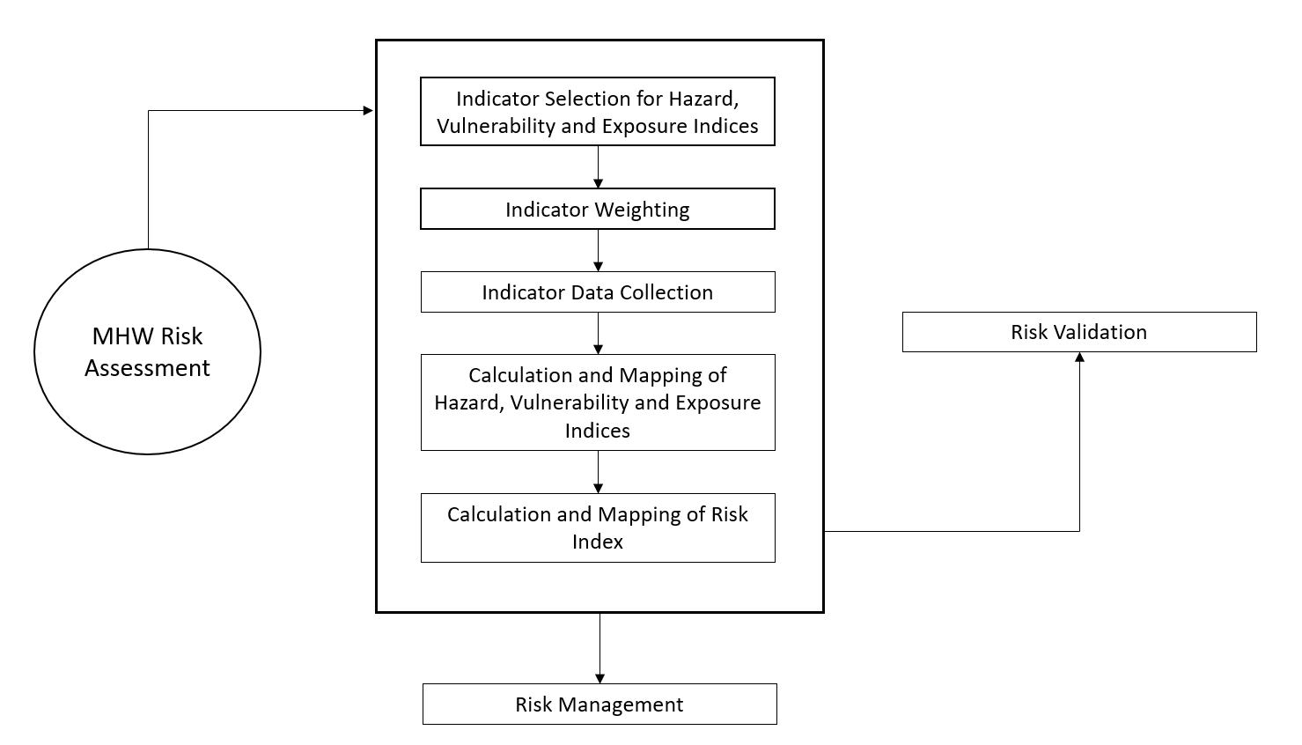

Figure 1. The key steps involved in MHW risk assessment methodology. The steps addressed in this paper are highlighted in yellow. This figure is adapted from Wang et al. (2011).

Risk assessment validation

Disaster risk assessment are being increasingly utilised to inform proactive and suitability risk management decisions across the globe for natural hazards like tropical cyclones, floods, and drought. However, MHW risk assessments remain underexplored, especially in the context of Pacific SIDS like Vanuatu. The minimal number of studies that have utilised risk assessment methodology to investigate MHWs in the Pacific commonly lack adequate validation, thus limiting the insights that can be gained from results. Table 2 displays the various MHW risk studies focusing on study areas in the Pacific, determines knowledge gaps in the risk assessment methodologies used, and analyses if comprehensive validation was conducted. Overall, most previous studies have not focused on Pacific SIDS specifically, have looked at only one (mainly hazard) component of MHW risk rather than all three (hazard, vulnerability, and exposure), have not mapped risk levels, and have omitted a fisheries-based approach in preference for a generalised approach. In addition to this, most studies that have included validation have only used one method of validation. Hagenlocher et al. (2019) recommends the use of multiple validation techniques to complete a comprehensive validation of disaster risk assessment results.
Table 2. Knowledge gap table:
Source | Study Area | Study Information | Addressing common knowledge gaps | Was validation used? | If yes, what technique/s were utilised? | Is it likely this validation is adequate?
Samhouri et al. 2021 | Northeast Pacific- U.S West Coast | This study examined how the 2014–2016 Northeast Pacific marine heatwave influenced trade-offs in managing conflict between conservation goals and human activities for large whale entanglements in the U.S. west coast's fishery.  It was shown that the MHW diminished the power of multiple management strategies to resolve trade-offs between entanglement risk and fishery revenue.  The study provided insight into how MHWs can exacerbate human–wildlife conflict. | -Not focused on SIDS  -Had a fishery focus  -Looked at Ecological and Social aspects of MHW events  -No risk mapping was conducted  -Recommendations were made based off study results | Yes | Whale models were validated against several independent datasets, including localized aerial surveys, shipboard marine mammal surveys and standardized whale-watching data. Validation was made for not only the spatial scale, but temporally as well. | No- only one method of validation was used. Literature recommends the use of multiple validation methods (ref).
Asner et al. 2022 | Hawaiian Islands- Central Pacific | In this study a large-scale, high-resolution coral mortality monitoring capability was developed based on airborne imaging spectroscopy for a MHW event in the Hawaiian Islands.  Mapping analyses indicated that potential reef refugia underwent up to 40% lower coral mortality compared with neighbouring reefs, despite similar thermal stress. Overall, the findings of the study provided insight into the role that coral mortality mapping, rather than bleaching monitoring, can play for targeted conservation that protects more surviving corals in a changing climate. | -Not focused on SIDS  -Focused on corals purely from an ecological perspective  -Mapped risk data  -Recommendation were made from study findings | Yes | Remote sensing SST data was used to validate study results. | No- only one method of validation was used. Literature recommends the use of multiple validation methods (ref).
Xue et al. 2023 | Northwest Pacific Ocean | To assess the abilities of global climate models (GCMs) on simulating the spatiotemporal distribution of MHWs, GCMs from the Coupled Model Intercomparison Program in Phase 6 (CMIP6) were evaluated from a historical period between 1985 and 2014 in the Northwest Pacific Ocean using remote sensing data. MHW simulation capabilities were assessed using Rank Score (RS) and Comprehensive Rating (MR) metrics that include both spatial and temporal scoring metrics. In all scenarios, all MHWs metrics except frequency will have an increasing trend for the fixed baseline method. | -Not focused on SIDS or fisheries  -Focused generally on MHW hazard, no vulnerability or exposure indicators considered  -Data was not mapped  -Recommendations were made from the study findings | Yes | SST data from the Optimal Interpolation Sea Surface Temperature (OISST) Dataset of the National Oceanic and Atmospheric Administration (NOAA) was used to validate results | No- only one method of validation was used. Literature recommends the use of multiple validation methods (ref).
Giamalaki, Beaulieu and Prochaska 2022 | Northeast Pacific | Random forests were applied to assess skill in forecasting MHWs onset and severity at multiple prediction lead times. The best performing random forest model accurately captures MHW presence/absence in the northeast Pacific and is capable of forecasting realistic extreme SST patterns at weekly lead times. | -Not focused on SIDS or fisheries specifically  -Focused generally on MHW hazard  -Data was not mapped  -Recommendations were made from study findings | Yes | Utilized publicly available observational and reanalysis datasets to train, test and validate the random forest model. The years 1981–2016 were used for the training and validation process. | Yes- multiple data sources were used to validate study results.
Kajtar et al. 2022 | Tropical Western and Central Pacific Ocean (Fiji, Samoa, and Palau) | Processed MHW metrics were computed from daily SST data, from both observations and models over the period 1982–2019. MHW timeseries metrics were produced for three case study regions: Fiji, Samoa, and Palau. | -Not focused on fisheries  -Focused generally on MHW hazard rather than vulnerability and exposure as well  -Data was mapped  -Recommendations were made from study findings | No | No clear validation method employed | N/A
Wyatt, Resplandy, and Marchetti 2022 | Northeast Pacific | This study aimed to explain the contrast between two regions (Alaska Gyre (AG) and the North Pacific Transition Zone (NPTZ)) using a global ocean biogeochemical model (MOM6-COBALT) with Argo float and ship-based observations to investigate how MHWs influence marine productivity. It was found that phytoplankton and zooplankton production respond relatively modestly to MHWs in both regions. | -Not focused on fisheries  -Looked at MHW risk from a marine ecology perspective  -Data was not mapped  -Recommendations were made from findings | No | No clear validation of the overall study method was employed | N/A
Muir, Done and Aguirre 2021 | Central Great Barrier Reef and Maldives Archipelago | This study identified regional variation in MHWs in terms of the bleaching-susceptibility of individual coral species on some Indian Ocean and Pacific Ocean reefs. This was investigated for 2002 in the Great Barrier Reef study area, and for 2016 in the Maldives. Following marine heat-wave conditions, timed in-situ surveys were used to record bleaching responses of individual coral colonies. The high regional variation in coral bleaching-susceptibility suggested in this study means that there may be important differences in the extent to which Indian and Pacific Ocean coral populations are exhibiting responses to MHW-induced heat stress. | -Investigated MHW impacts in an area other than Pacific SIDS  -Not focused on fisheries  -Focused on purely ecological impacts of MHWs  -Hazard indicators were of focus, with no investigation of vulnerability and exposure indicators  -Data was not mapped  -Recommendations were made from findings | No | No validation technique described for the study | N/A
Holbrook et al. 2022 | Tropical Western and Central Pacific Islands- Fiji, Samoa and Palau. | MHWs were investigated in the tropical western and central Pacific Ocean region, focusing on observed MHWs, their associated impacts, and future projections using Coupled Model Intercomparison Project phase 6 simulations under a low and a high emissions scenario. Documented impacts from “Moderate” mean intensity MHW events in Fiji, Samoa, and Palau, that were categorised as “Strong” at their peak, included fish and invertebrate mortality and coral bleaching. “Extreme” MHWs were projected to increase by 2050 under the low emissions scenario, highlighting the importance for Pacific Island nations that global emissions more closely follow the low emissions scenario trajectory. | -Investigated MHW impacts in Pacific SIDS, and risk to future impacts  -Not focused on fisheries  -Considered impacts in terms of hazard, exposure, and vulnerability factors  -Data was not mapped  -Recommendations were made from findings | Yes | Comparisons between local in-situ observations and OISST data for all three country locations confirmed that the patterns and magnitudes of warming were represented very well by the data. The validity of using the gridded data to investigate MHWs and their variability was confirmed, as well as their characteristics and potential impacts more locally on Pacific Island Countries. | No- only one method of validation was used. Literature recommends the use of multiple validation methods (ref).
Le Grix et al. 2021 | Pacific Ocean | Satellite-based SST and chlorophyll concentration estimates were used to provide a first assessment of MHW events. Hotspots of MHW and low chlorophyll compound events in the equatorial Pacific were identified. It was found that the frequency of compound MHW and low chlorophyll events is strongly modulated by the El Niño–Southern Oscillation, whose positive phase is associated with increased compound event occurrence in the eastern equatorial Pacific. | -Investigated MHW risk for the overall Pacific region, with no specific focus on Pacific SIDS  -Not focused on fisheries  -Considered impacts in terms of hazard only  -Data was mapped  -Recommendations were made from findings | Results were not validated, but products used had been mentioned as validated products | Used previously validated satellite-based SST and Chlorophyll products | No- the study used validated products but did not include validation of final study results
Phillips et al. 2022 | Mesoamerican reef | This study produced future DHW projections for the Mesoamerican reef using a multi-model climate change ensemble. Current MHW conditions were found to be linked to coral bleaching and will be far exceeded in an average year by mid-century, creating an environment where corals in the study region have no opportunity for normal year recovery between extreme years. Strong adaptation interventions need to be developed and implemented as soon as possible to support coral systems. | -Did not look at MHW risk in Pacific SIDS  -Not focused on fisheries  -Looked at MHW risk purely from an ecological perspective with hazard indicators only considering corals  -Data was mapped  -Recommendations were made from findings | No | No noted validation technique | N/A
Singh 2022 | Pacific Ocean | In this study, the effects of temperatures between 10- 16°C and two pCO2 levels (ambient and high pCO2) on hatching and survival of Pacific herring was investigated. Overall, this study reinforced that Pacific herring are resilient to moderate pCO2 and temperature stress but are vulnerable to acute temperature increases that may accompany MHW events. | -Did not look at MHW risk in Pacific SIDS, but at risk to a specific type of fish that is important in the Pacific Ocean  -Looked at MHW risk purely from an ecological perspective with hazard indicators only considering Pacific Herring  -Data was not mapped  -Recommendations for the future were not explicitly made from findings | No | No noted validation technique used | N/A
Hunsicker et al. 2022 | Californian Current Ecosystem | The environmental and biological variability was summarised in the southern and central regions of the Californian Current Ecosystem during the 2014-2016 Pacific MHW. These patterns were then compared to past variability. A clear community response to the MHW was detected. This research demonstrated skill in creating forecasts of species responses and community state based on estimates of nitrate flux. These forecasts displayed promise as tools for informing ecosystem-based and climate-ready fisheries management in the Californian Current Ecosystem. | -Did not look at MHW risk in Pacific SIDS, but at a different ecosystem and its responses to a MHW in the Pacific Ocean  -Looked at MHW risk purely from an ecological perspective using hazard indicators  -Data was not mapped  -Recommendations for the future were made from findings | Yes | The models used in this study provided spatial and temporal coverage of conditions. The models were validated against independent in situ observations. As the objectives of the study involved evaluating the models used for future prediction, the researchers used a Leave-Future-Out Cross Validation Information Criterion method to further validate results. The Bayesian Leave-One-Out Cross Validation was used to determine accuracy of the different models used compared to each other. | Yes- multiple validation methods were used. This is recommended in the literature describing effective risk assessment validation techniques (ref).
Spencer et al. 2019 | Eastern Bering Sea | A trait‐based  vulnerability assessment focused on vulnerability to climate change conditions (including increased SSTs) was applied to 36 fish and invertebrate stocks in the eastern Bering Sea. The vulnerability assessment used projections (to 2039)  from three downscaled climate models, and graphically characterized the variation  in climate projections between climate models and between seasons. The vulnerability of fish stocks to climate change ranged between “low” and “moderate” due to limited exposure. | -Vulnerability and exposure were assessed  -The study displayed a focus on fisheries  -Did not investigate Pacific SIDS.  -Data was not mapped  -Recommendations were made from findings | Yes | Results were compared to more  detailed studies as a validation  exercise. To further examine the validity of vulnerability and exposure levels produced in this study, the following techniques were employed:  -evaluating a range of climate projections  -allowing analysts  to convey confidence in their rankings conducting bootstrap analyses on the rankings  -conducting sensitivity  analyses on specific attributes | Yes- multiple validation methods were used. This is recommended in the literature describing effective risk assessment validation techniques (ref).

Of those studies that have conducted some form of validation, the most common technique used is comparison with historical in-situ or satellite data (Holbrook et al. 2022; Giamalaki, Beaulieu and Prochaska 2022; Xue et al. 2023; Samhouri et al. 2021; Asner et al. 2022). The preciseness of this technique is criticised in the literature (Fekete, 2019; Molinari et al. 2019) due to restrictions of data quality, and the importance of end-user input. A validation technique increasingly recognised as effective in addressing such obstacles is participatory research.
Participatory research integrates the views of end-users as a ‘ground-truth’ source, providing real information from real-world observation and measurement. This technique relies on stakeholder collaboration and the participation of local people and experts in an area of focus for risk assessment (Mckenna and Yakam, 2021; Fragaszy et al., 2020). This method is often used in combination with an additional ‘ground-truth’ validation source to further increase the reliability of validation results (González Tánago et al. 2016).
A statistical validation method called sensitivity analysis is also recommended as an accurate method for risk assessment validation. This method particularly deals with determining the validity of the different risk indicators used in a risk assessment (Hangelocher et al., 2019). Sensitivity analysis examines how different values of an indicator influence the final risk result under a specific set of assumptions (Tate 2012). Indicators are then ranked based on the sensitivity of the output to changes in the indicator values. Sensitivity analysis are helpful in validating the selection of risk indicators and the weighting scheme applied to indicators. Results of such an analysis can provide recommendations on increasing transparency, robustness and reliability of the indicators used to inform the final risk index in a risk assessment (Tate 2012).
Overall, to address past knowledge gaps, and apply best practice processes for validating disaster risk assessments, a comprehensive validation of MHW risk assessment results would likely include a combination of multiple reliable techniques (e.g., comparison with user perspectives as a ‘ground-truth’ source and use of a sensitivity analysis) (Aitkenhead et al. 2023). Ensuring MHW risk assessment validation is accurate is vital to confirming the level of trust in risk assessment results to accurately inform relevant communities and stakeholders on critical risk information and priority management areas (Matsuura & Azahari Razak 2019).

Aims and Objectives

Accordingly, this study aims to build upon the work of Aitkenhead et al. (2023) to conduct the next critical steps in developing an efficient, fisheries based, MHW risk assessment in Vanuatu. It is intended that this study completes a fisheries focused MHW risk assessment for retrospective years (a period from 2015-2017 and a period from 2020-2022) on the most localised level as data will allow. This assessment is intended to reveal any previous occurrences of MHW events throughout Vanuatu, which impacted on fisheries. Additionally, we seek to validate this assessment through multiple ground-truth sources to gauge the accuracy of risk assessment results.
Specifically, it is intended that this study:
- completes data collection for the indicators proposed by Aitkenhead et al. (2023)
- calculates hazard, vulnerability, exposure, and risk indices for retrospective time periods
- produces GIS-based MHW hazard, vulnerability, exposure and risk maps displaying retrospective risk assessment results.
- Conducts a survey with local Vanuatu participants to validate risk assessment results, along with a literature search.

The development of a valid MHW risk assessment is intended to aid VMGD in informing local Vanuatu stakeholders on which area councils are of highest concern and guide resilient MHW risk management practices within priority communities.

Methods

Overview

The methodology of this study followed a two-part process:
- Development of a tailored fisheries-based risk assessment methodology for Vanuatu, and completion of a retrospective risk assessment utilising this methodology.
- Validation of retrospective risk assessment results using surveys and a literature review as ground truth sources.
In this study, we regard a MHW event as the experience of hazardous MHW conditions with corresponding impacts. The MHW risk assessment methodology proposed here addresses the gaps identified in previous studies to achieve a tailored and accurate risk assessment focused on the fisheries sector of Vanuatu. We consider local, subsistence and commercial fisheries in this assessment. Hazard, vulnerability, and exposure components are equally considered, and the spatial and temporal aspects of MHW risk are investigated, using retrospective and periodically updated data. The assessment is deemed as semi-dynamic as it has a dynamic hazard component, that can be updated daily, weekly or monthly, but also includes more semi-dynamic and static components of vulnerability and exposure, which are updated annually. The MHW risk assessment developed here is conducted on the area council level for two retrospective time periods: 2015-2017 and 2020-2022. The two case study time periods were chosen as they would likely display Vanuatu before, during and after MHW events, thus would demonstrate the risk assessment’s ability to signal MHW risk when transitioning in/out of the disaster event. It is widely known that a MHW event occurred across Pacific SIDS throughout 2016 (Holbrook et al. 2022). Several more recent events have also been suspected to have occurred throughout the South-West Pacific around 2020 and 2022 (WMO 2023).

Study Area

Vanuatu is a country in the South-West Pacific Ocean consisting of approximately 80 islands, totalling to a land area of 12,335km². It consists of six provinces Torba, Sanma, Penama, Malampa, Shefa and Tafea (Figure 2) which are made up of many local area councils (Figure 3-8). Vanuatu is considered a Small Island Developing State (SIDS), meaning it is a developing small island country facing sustainable development challenges (Spickett et al. 2013). Vanuatu is mainly made up of coastal communities (Spickett et al. 2013). The climate is tropical and cycles through two distinct seasons - a warm, wet season and a cool, dry season. Climatic variability is mainly driven by ENSO (Frölicher and Laufkötter 2018; Sen Gupta et al. 2020). Under increasing climate change, it is expected that air and sea surface temperatures will arise in Vanuatu, as well as the occurrence of altered rainfall patterns, sea level rises and ocean acidification (Spickett et al. 2013)). The Vanuatu economy is supported by three key sectors: tourism, agriculture, and fisheries. Fisheries in particular play a vital role in maintaining food security in Vanuatu communities (Eriksson et al. 2017). Vanuatu has a history of malnutrition; thus, food security is essential to the resilience of Vanuatu communities (Spickett et al. 2013).
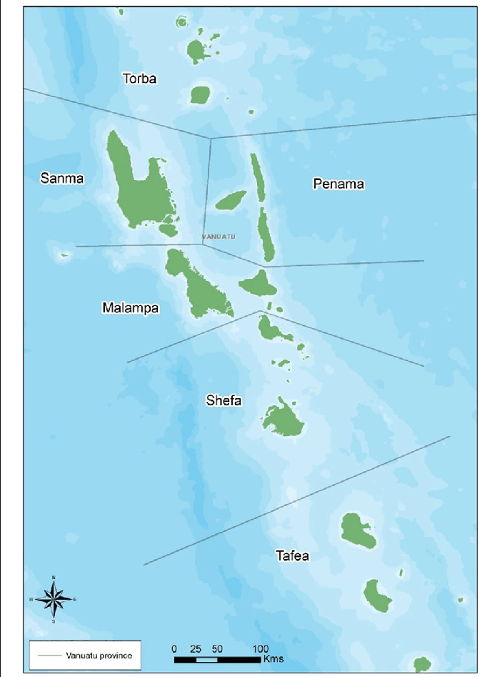
Figure 2. A Vanuatu administrative map, displaying province boundaries. The six provinces are displayed: Malampa, Penama, Sanma, Shefa, Tafea, and Torba. Figure is from Allen et al. (2017).
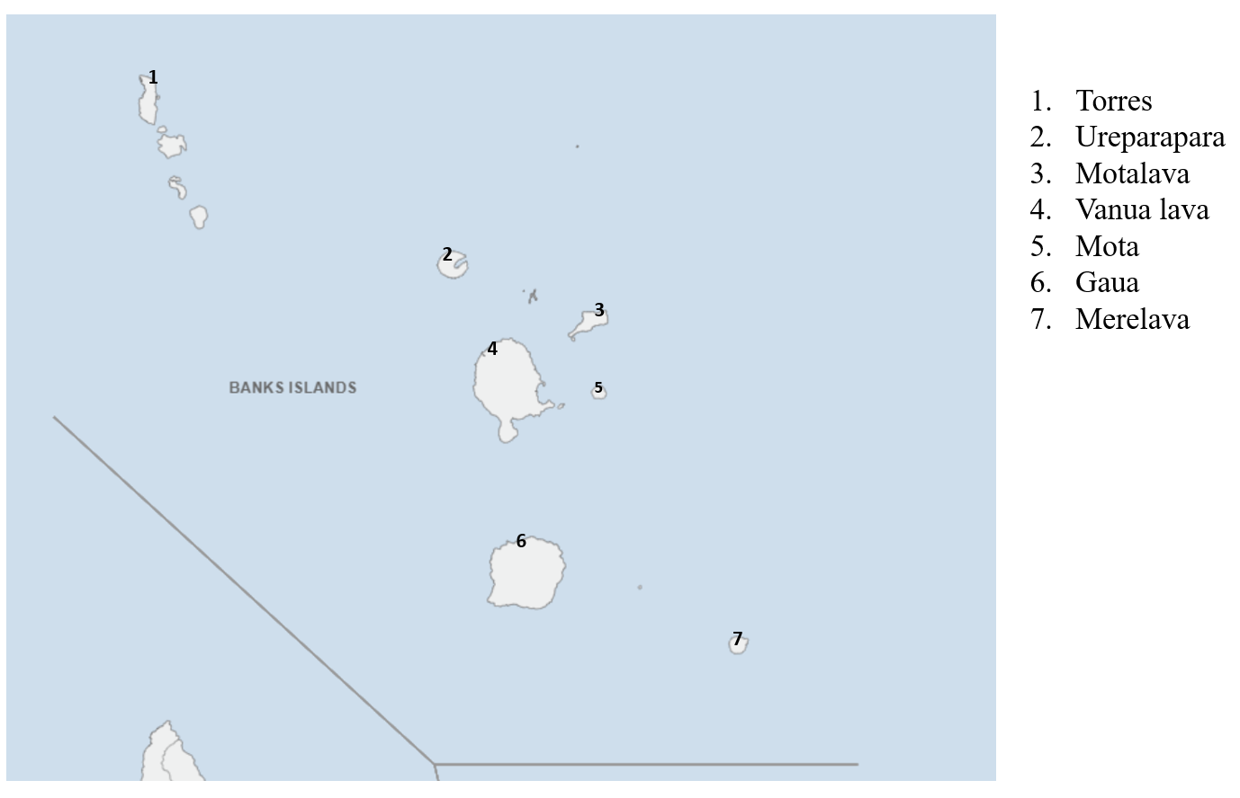
Figure 3. Map of Torba province area councils.
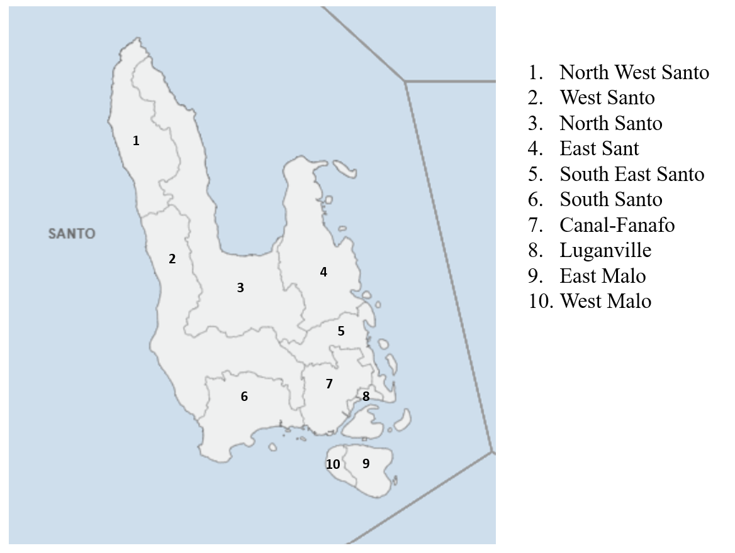
Figure 4. Map of Sanma province area councils.
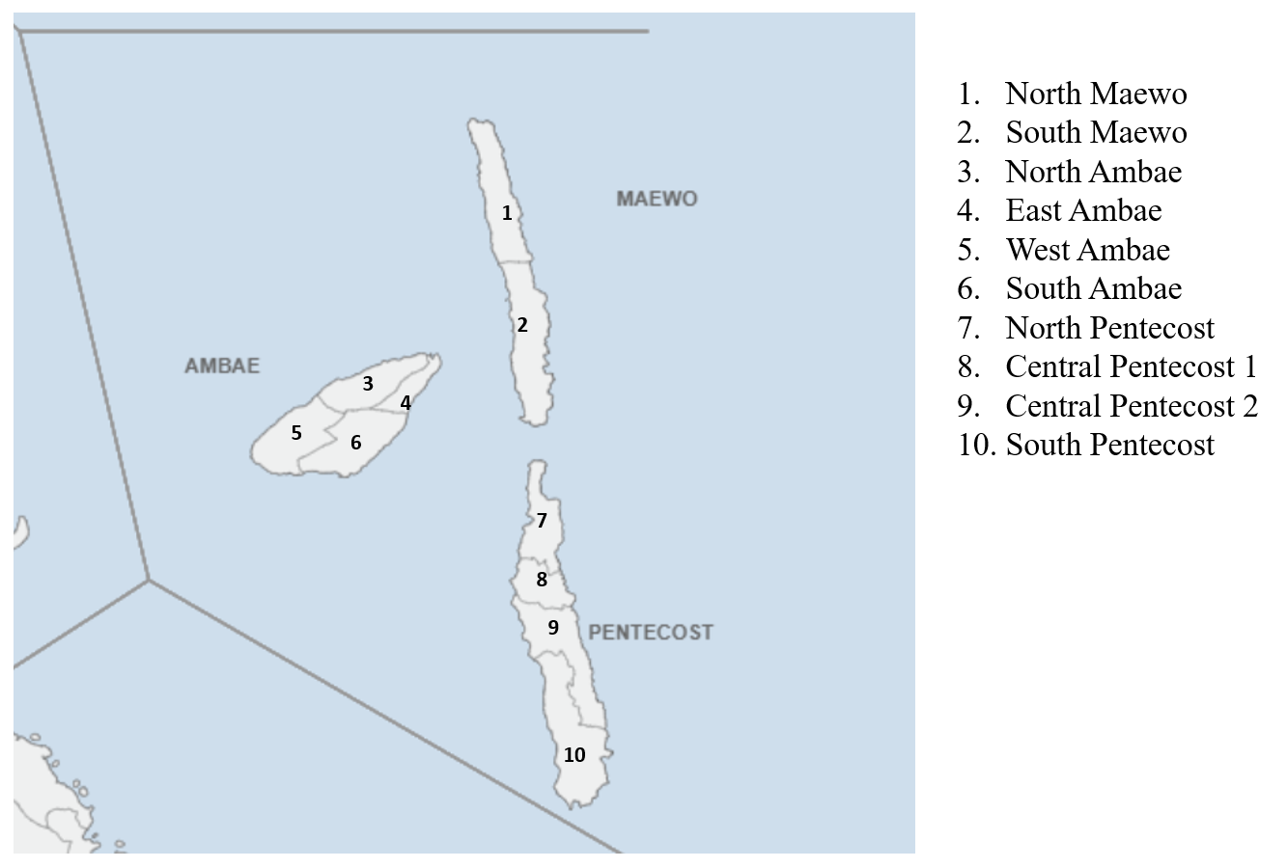
Figure 5. Map of Penama province area councils.

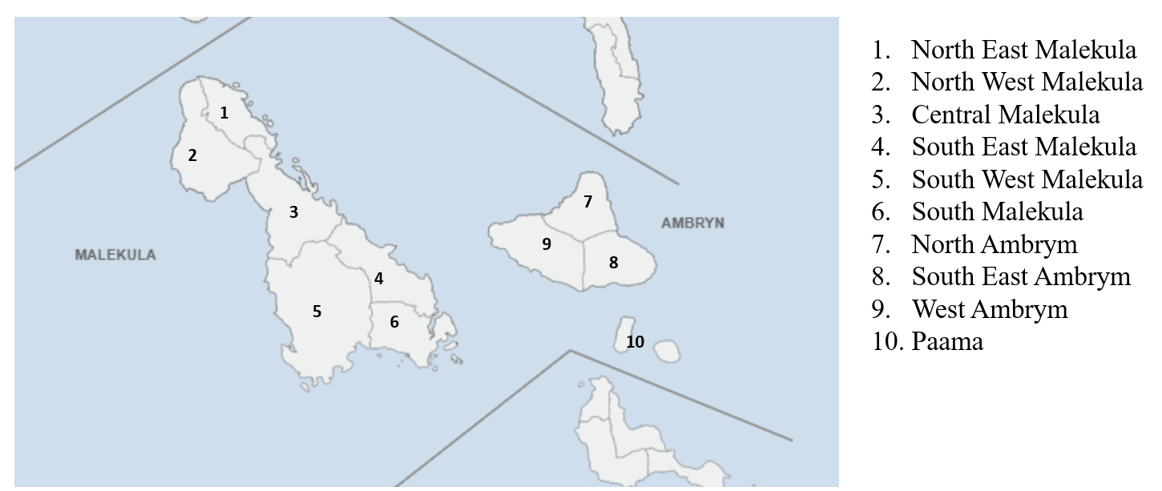
Figure 6. Map of Malampa province area councils.

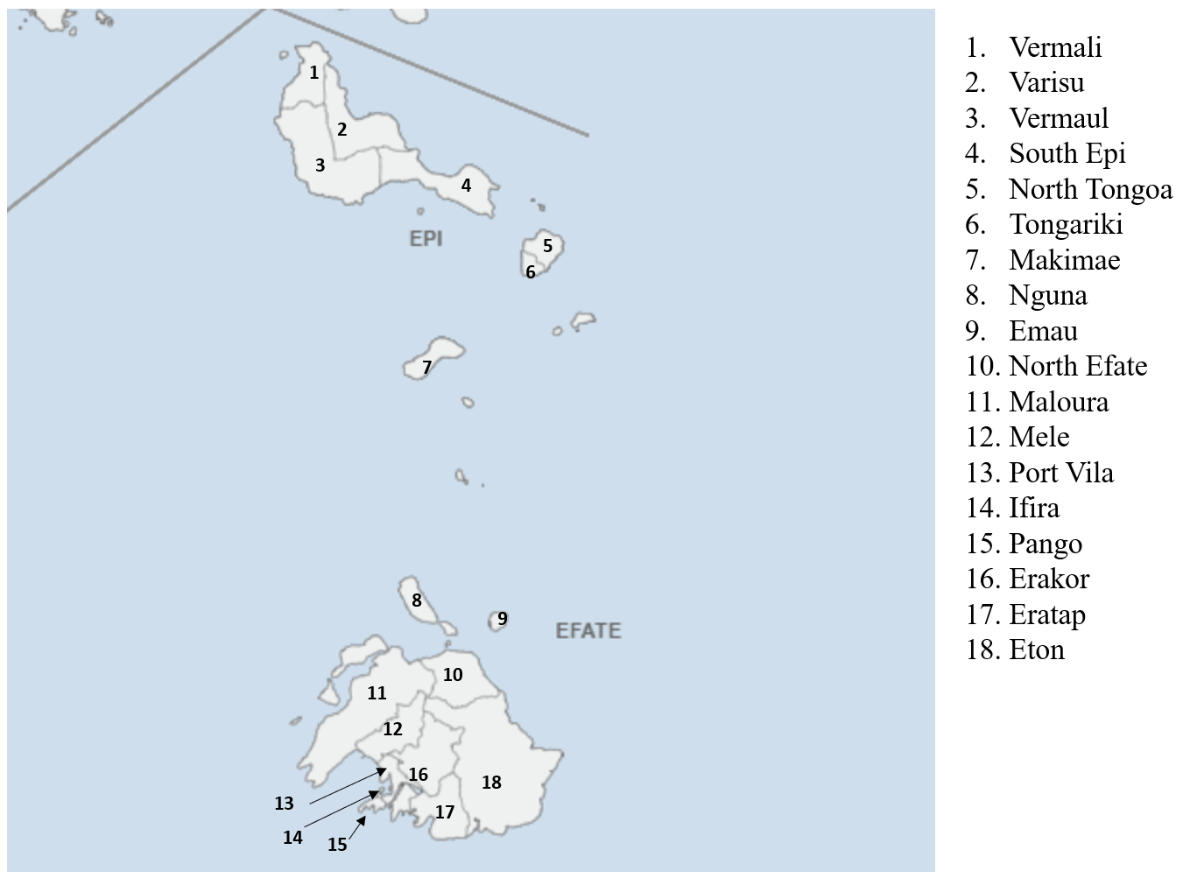
Figure 7. Map of Shefa province area councils.

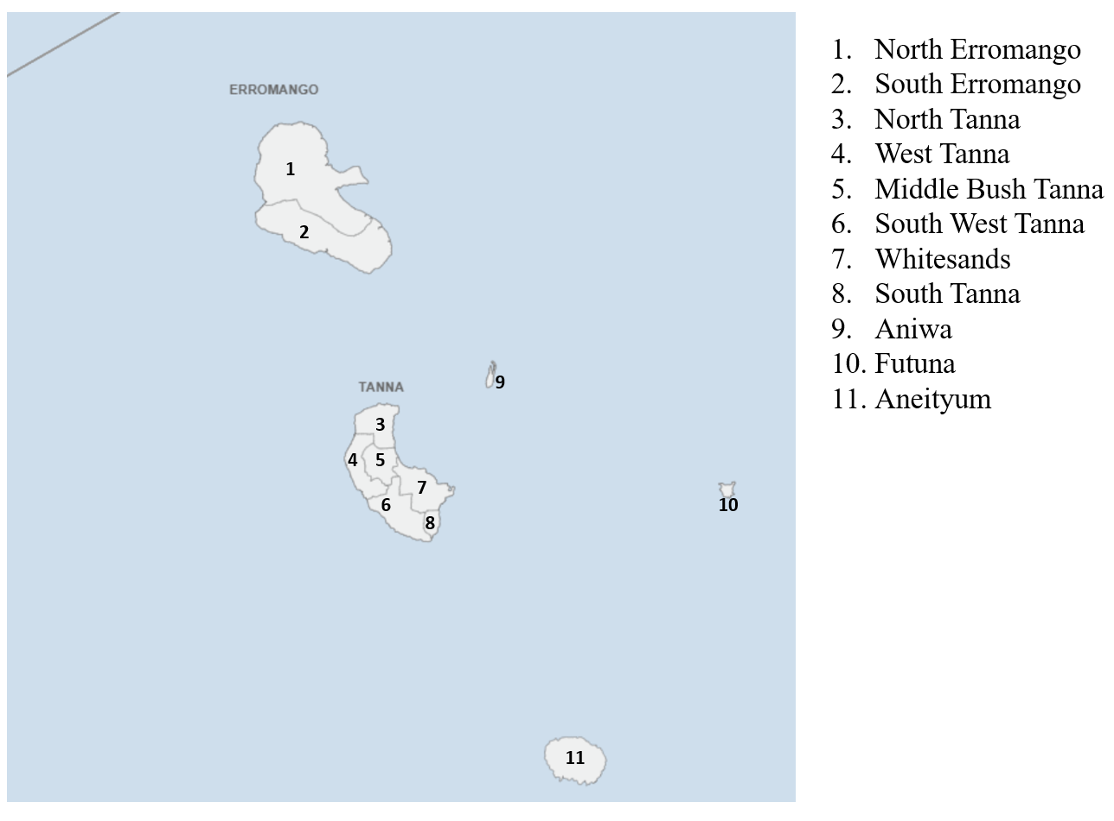
Figure 8. Map of Tafea province area councils.

Methodology Part 1: Development of a tailored fisheries-based risk assessment methodology for Vanuatu, and completion of a retrospective risk assessment utilising this methodology

The risk indicators selected for incorporation in the hazard, vulnerability and exposure index calculations were based off the findings from Aitkenhead et al. (2023). The MHW hazard indicators were selected to cover the possible occurrence of future MHW events (Aubrecht et al. 2013). The MHW vulnerability indicators were chosen to consider the tendency of exposed factors to suffer adverse impacts when a MHW event does occur (Kouwenhoven 2013). MHW exposure indicators were selected to reflect the total population, its livelihoods, and assets in a specific area in which MHW events occur (Kouwenhoven 2013). These definitions are kept consistent throughout the overall MHW risk assessment process.
Minor adjustments were made to the selected indicators, to ensure that appropriate data could be found and used in this study. Table 3 displays the slightly adjusted list of indicators chosen for use in this study compared to those recommended in Aitkenhead et al. (2023), along with the data source for each indicator, and the spatial/temporal extent of the available indicator data. The smallest possible spatial and temporal scale were used for each indicator. As data availability is commonly scarce in Pacific SIDS like Vanuatu, some indicators displayed only static or yearly data, as well as the provincial scale being the smallest spatial scale for some indicators.
Table 3. Tailored indicator selection and data collection information for indicators used in the risk assessment.

Index | Proposed Indicator from Aitkenhead et al. (2023) | Actual Indicator used in this study | Data Source | Spatial Scale | Temporal Scale
Hazard | SST | Mean Sea Surface Temperature Anomaly | NOAA THREDDS Server | Averaged satellite-based ocean data to the area council level | Monthly
Hazard | Coral Bleaching | Coral Bleaching Alert Area | NOAA THREDDS Server | Averaged satellite-based ocean data to the area council level | Monthly
Hazard | Chlorophyll-a Concentration | Chlorophyll-a Concentration | Pacific Ocean Portal | Averaged satellite-based ocean data to the area council level | Monthly
Vulnerability | Terrestrial (land)-based food and income generation | Percentage of households growing crops/owning livestock for food and income generation | Vanuatu National Statistics Office | Area council | Yearly
Vulnerability | Fishing skills and technology | No. of People required to sufficiently increase fishery skills and technology in each area | Australian Aid Province Skills Plan | Provincial | Yearly
Vulnerability | Fishery fish diversity/fishery flexibility | No. of Fishery resources fished | Vanuatu National Biodiversity Strategy and Action Plan | Provincial | Yearly
Vulnerability | Primary production of commercial fisheries | Commercial fisheries annual added value (USD) | National Marine Ecosystem Service Valuation | Provincial | Yearly
Exposure | Seagrass population/C content | Seagrass species richness (# of observed seagrass species) | McKenzie et al. (2021) | Area council | Static
Exposure | Coral Habitat Health/Crown of Thorns Prevalence | Crown of Thorns Prevalence Score (none-0, low-1, medium-2, high-3) | Dumas et al. (2020) | Area council | Yearly
Exposure | Crab stock health | Stock status score for Coconut Crab (0-no noted population, 1-overfished, 2-unstable, 3-stable, 4-underfished) | Vanuatu National Coconut Crab Fishery Management Plan | Area council | Yearly
Exposure | Fish mortality/fish stock health | Fish catch score (based on the fishing of tuna & billfishes by the fleets of Vanuatu) (1-7 low to high catch) | Food and Agriculture Organization of the United Nations (FAO) FishStat database | Area council | Yearly

It is important to note that:
- the selected indicators were specifically chosen to reflect MHW risk to the fisheries sector
- publicly accessible data was only available for certain indicators as data availability is relatively poor across Vanuatu (all indicators ultimately selected for use in the risk assessment had publicly accessible data available), thus indicators which may have been more appropriate for use were omitted.
- indicator data was only available at certain spatial resolutions, so in some cases where provincial data was only available, the same value was repeated for all area councils in each province.
- space-based monitoring products were used when collecting data for the MHW hazard indicators to make sure accuracy was achieved. It is widely known that space-based monitoring products are highly accurate and use of such products should be increased when monitoring climate extremes in future disaster risk investigations (Kuleshov et al., 2020; Blauhut, 2020).
All the selected hazard, vulnerability, and exposure indicators to be used in the MHW risk assessment have differing standard thresholds for signalling the different strengths of MHW events. Table 3 shows the standard thresholds for each indicator used in this study. These thresholds were established according to use in past studies (Hobday et al, 2018; Aitkenhead et al, 2023), the advice of Vanuatu Meteorological and Geohazards Department (VMGD), and past data trends. The different thresholds are sorted according to the likely signal of ‘no to mild MHW risk’, ‘moderate MHW risk’, or ‘severe to extreme MHW risk’. The thresholds displayed in Table 4 were not utilised in any of the index calculations in our study, they are displayed here only for insight into the standard signals likely given by each range of values in the indicator data.
Table 4. Indicator thresholds that signal different stages of MHW risk. These thresholds were developed through literature investigation (Hobday et al, 2018; Aitkenhead et al, 2023), the advice of the Vanuatu Meteorological and Geohazards Department (VMGD), as well as past data trends in Vanuatu.
Index | Indicator | No to Mild MHW Risk | Moderate MHW Risk | Severe to Extreme MHW Risk
Hazard | Mean Sea Surface Temperature Anomaly | 0°C and under | 1°C-2°C | Above 2°C
Hazard | Coral Bleaching Alert Area | 0 | 1-2 | 3-4
Hazard | Chlorophyll-a Concentration | Above 0.15 | 0.06 to 0.15 | 0 to 0.05
Vulnerability | Percentage of households growing crops/owning livestock for food and income generation | 90% to 100% | 75% to 90% | Below 75%
Vulnerability | No. of people required to sufficiently increase fishery skills and technology in each area | 250 and under | 250-450 | 450 and above
Vulnerability | No. of fishery resources fished | 20 and above | 15 to 19 | 0 to 14
Vulnerability | Commercial fisheries annual added value | $1,500,001 and above | $1,000,001 to $1,500,000 | 0 to $1,000,000
Exposure | Seagrass species richness | 7 and above | 4 to 6 | 0 to 3
Exposure | Crown of Thorns Prevalence Score | 0 | 1 | 2 to 3
Exposure | Stock status score for Coconut Crab | 3 to 4 | 2 | 0 to 1
Exposure | Fish catch score | 6 to 7 | 4 to 5 | 1 to 3

Data was mapped on the area council scale for each month in the 2015-2017 and 2020-2022 periods for the hazard index, and for each year in the 2015-2017 and 2020-2022 periods for vulnerability and exposure indices (as exposure and vulnerability indicator data is only static or updated yearly). For the 2015-2017 case study period, index maps were produced for the 66 area councils across Vanuatu. Area council boundaries were amended by the Vanuatu Government recently (VNSO), however the boundary data is not yet available, so the 2020-2022 maps were produced using the 66 area councils as in the 2015-2017 case study period. All maps produced in this study used the same base map from the open-sourced platform GISMap.
Integrated-GIS methodology for calculation and mapping was used to produce and display monthly index levels for 2015-2017 and yearly index levels for 2020-2022, on the area council scale across Vanuatu. Indicator data was firstly reclassified on a 1-10 scale by a linear function through the rescale by function tool in ArcGIS pro (Environmental Systems Research Institute (Esri) Inc., 2019). Data for each indicator was then standardised with fuzzy logic (using the fuzzy membership tool in ArcGIS Pro). Fuzzy logic applies a fuzzy membership class to data, describing the relationship between it and MHW risk (Rahmati et al. 2020; Aitkenhead et al. 2021). Fuzzy values are produced on a 0-1 scale based on the likelihood that the indicator data contributes to MHW risk. A value of 0 is assigned to indicator data unlikely to be associated with MHW risk. A value of 1 is assigned to indicator data most likely to be associated with MHW risk. Equation 1 below displays the mathematical process behind fuzzy logic in GIS (Aitkenhead et al. 2021).
𝜇𝐴(𝑥): 𝑋 ⟶ [0,1] (1)
where μA(x) refers to the grade of membership for element x in a fuzzy set A, and the X is the universal set.
In this study, two classes of fuzzy membership were applied: fuzzy small and fuzzy large. Fuzzy small was used when smaller data values have a higher likelihood in influencing MHW risk. Fuzzy large was used when larger data values have a higher likelihood in influencing MHW risk. Accordingly, with fuzzy large, greater data values are assigned membership values closer to 1 and with fuzzy small, smaller data values are assigned membership values closer to 1. Both transformation functions are defined by a midpoint value that can be left as a default in ArcGIS Pro, or can be changed manually to ensure it is most appropriate for the specific dataset being standardised. In this study, we altered the midpoint manually when running the fuzzy membership function. The midpoint used when standardising each indicator was based on the average data value expressed in historical data records. This allowed for data to be standardised both spatially and temporally.
The mathematical process for the fuzzy large membership function is displayed in Equation 2, and the mathematical process for the fuzzy small membership function is displayed in Equation 3 (Aitkenhead et al. 2021).
𝜇(𝑥) =11+(𝑥𝑓2)−𝑓1290 (2)
where f1 is the spread and f2 is the assigned midpoint.
𝜇(𝑥) =11+(𝑥𝑓2)𝑓1 (3)
where f1 is the spread and f2 is the assigned midpoint.
The fuzzy membership class assigned to each indicator is displayed in Table 5 below.
Table 5. Fuzzy membership classes assigned to each indicator in the hazard, vulnerability, and exposure indices.
Index | Indicator | Fuzzy membership class
Hazard | Mean Sea Surface Temperature Anomaly | Large
Hazard | Coral Bleaching Alert Area | Large
Hazard | Chlorophyll-a Concentration | Small
Vulnerability | Percentage of households growing crops/owning livestock for food and income generation | Small
Vulnerability | No. of people required to sufficiently increase fishery skills and technology in each area | Large
Vulnerability | No. of fishery resources fished | Small
Vulnerability | Commercial fisheries annual added value | Small
Exposure | Seagrass species richness | Small
Exposure | Crown of Thorns Prevalence Score | Large
Exposure | Stock status score for Coconut Crab | Small
Exposure | Fish catch score | Small

The fuzzy values for each indicator in the hazard, vulnerability and exposure index were mapped on the area council scale as monthly and yearly raster layers in ArcGIS Pro. Following indicator data standardisation, numerical weights were applied to each indicator based on those recommended by Aitkenhead et al. (2024) (unpublished). The weights assigned to each hazard, vulnerability and exposure indicator in this study are shown in Table 6. These weights reflect the respective significance and influence of each indicator to the relative index that it contributes to. Weights were produced on a 0-1 scale where 0 indicates no likely influence of the indicator on the overall hazard, vulnerability, or exposure index which it informs, and 1 indicates total likely influence of the indicator on the overall hazard, vulnerability, or exposure index which it informs (Frischen et al., 2020).
Table 6. Indicator weights as per Aitkenhead et al. (2024) (unpublished).
Index | Indicator | Proposed Weight
Hazard | Mean Sea Surface Temperature Anomaly | 0.50
Hazard | Coral Bleaching Alert Area | 0.30
Hazard | Chlorophyll-a Concentration | 0.20
Vulnerability | Percentage of households growing crops/owning livestock for food and income generation | 0.35
Vulnerability | No. of people required to sufficiently increase fishery skills and technology in each area | 0.10
Vulnerability | No. of fishery resources fished | 0.30
Vulnerability | Commercial fisheries annual added value | 0.25
Exposure | Seagrass species richness | 0.35
Exposure | Crown of Thorns Prevalence Score | 0.30
Exposure | Stock status score for Coconut Crab | 0.10
Exposure | Fish catch score | 0.25

The standardised indicator raster layers were used to calculate the vulnerability, hazard and exposure indices. The raster calculator function in ArcGIS Pro was used to calculate the indices, following Equations 4, 5 and 6 (Dayal et al., 2018). Vulnerability and exposure indices were calculated and mapped for each year being investigated. A hazard index was calculated and mapped for each month being investigated.
𝐻𝐼 = ∑ ( 𝑤𝑖 ∗ 𝑥𝑖′ )𝑛𝑖=1 (4),
𝑉𝐼 = ∑ ( 𝑤𝑖 ∗ 𝑥𝑖′ )𝑛𝑖=1 (5),
𝐸𝐼 = ∑ ( 𝑤𝑖 ∗ 𝑥𝑖′ 𝑛𝑖=1 325 (6),
where HI is the Hazard Index, VI is the Vulnerability Index, EI is the Exposure Index, n is the number of indicators, xi′ refers to the standardised indicators and wi refers to indicator weight.
To calculate and map the final MHW risk index value for each area council across the study period, the MHW hazard, vulnerability and exposure index maps were integrated. This was done through the Fuzzy Gamma Overlay function in ArcGIS Pro (with a gamma of 0.75). The mathematical expression for the Fuzzy Gamma overlay function is displayed below (Equation 7) (Dayal et al., 2018).
𝜇𝑔𝑎𝑚𝑚𝑎 = (𝜇𝑠𝑢𝑚)𝛾 × (𝜇𝑝𝑟𝑜𝑑𝑢𝑐𝑡)1−𝛾 (7)
where μgamma is the calculated fuzzy membership function, γ is a parameter chosen between 0 and 1; μsum is the fuzzy algebraic SUM and μproduct is the fuzzy algebraic PRODUCT. The mathematical process of Fuzzy SUM and fuzzy PRODUCT are additionally given below in Equations 8 and 9 respectively (Dayal et al., 2018).
𝜇𝑠𝑢𝑚 = 1 − ∏ (1 −𝜇𝑖)𝑛𝑖=1 (8),
𝜇𝑝𝑟𝑜𝑑𝑢𝑐𝑡 = 1− ∏ (𝜇𝑖)𝑛𝑖=1 (9)
where μi is the fuzzy membership, and i equals the number of maps to be overlayed. In the fuzzy gamma process, γ=0 is equivalent to the fuzzy PRODUCT and γ=1 is equivalent to fuzzy SUM.
The MHW risk levels displayed in the final MHW risk maps were categorised into five severity classes commonly used in disaster risk assessment studies (Dayal et al., 2018; Frischen et al., 2020):
- Very mild (includes all index values from 0.01-0.20)
- Mild (includes all index values from 0.21-0.40)
- Moderate (includes all index values from 0.41-0.60)
- Severe (includes all index values from 0.61-0.80)
- Extreme (includes all index values from 0.81-1.00)

Methodology Part 2: Validation of retrospective risk assessment results using surveys and a literature review as ground truth sources.

The results of these retrospective analyses, specifically the peak periods that were identified were validated through participatory research data (surveys) and literature review results. Peak periods in the risk assessment results were identified as periods consisting of one month or more in which at least one area council was experiencing severe risk levels, with most other experiencing moderate risk levels and very few experiencing very mild risk levels. MHW impact severity levels expressed by participants and by the literature for the two-case study period were compared to the severity levels signalled in the risk assessment results. The different levels of MHW impacts investigated in this validation investigation are Very Mild, Mild, Moderate, Severe and Extreme. Table 7 explains the different impacts expected when each of these levels are signalled.
Table 7. Information on the types of impacts associated with the five severity classes used to classify MHW severity in this study.
Severity Class | Types of impacts associated
Very Mild | slight fish die-off occurred, nothing significant
Mild | slight fish die-off occurred, with slight die-off of additional marine species
Moderate | significant fish die off occurred, with significant deaths of other marine animals
Severe | significant fish die off occurred, with significant deaths of other marine animals; coral bleaching occurred; increased crown of thorns prevalence and occurrence of algal blooms; catch amounts reduced and productivity of commercial fisheries reduced
Extreme | significant fish die off occurred, with significant deaths of other marine animals; coral bleaching occurred; increased crown of thorns prevalence and occurrence of algal blooms; catch amounts reduced and productivity of commercial fisheries reduced; food supply of locals reduced; economic losses occurred at the household and industrial level

Risk level accuracy was validated through comparison of peak periods identified in the risk assessment with documented records of observed impacts during the study period as a ground-truth source. Literature sources on this topic were analysed for the two retrospective periods to determine when MHW impacts were recorded. The impact severity levels recorded in the literature were compared to those identified by the risk assessment.
A literature search was undertaken to gather appropriate sources for analysis. Criteria for the inclusion and exclusion of sources was developed, guided by the requirements of this study. Table 8 displays the criteria used to select sources for this study. Note: although newspaper articles are not robust scientific sources, we had limited sources to work with, so we deem them appropriate enough for the purpose of this study. The search parameters used to gather the sources are listed in Table 9. Overall a total of 24 sources were included in the literature investigation. Each of the 24 sources were analysed and the following information was recorded: the year that the source was produced, if MHW impacts were mentioned in the source, if impacts occurred then when and where did they occur specifically and how severe were these impacts?
Table 8. criteria for the inclusion of sources in MHW risk validation investigation (adapted from Aitkenhead et al. 2022).
Criteria for inclusion | Criteria for exclusion
Literature in English | Literature in other languages
Mention of a specific point in time in Vanuatu when a MHW was present and/or MHW impacts were observed/experienced. | Vague mention of MHW events overall in the history of Vanuatu or the general Pacific Ocean area, with the omission of noting specific years/Vanuatu regions, and/or mention of MHWs in years outside of the study periods (outside of 2015-2017 and 2020-2022).
MHW impacts are mentioned in detail, with the specific type of impacts described. Particular provinces and/or area councils are noted as experiencing specific impacts. | MHW conditions are briefly mentioned, with no reference to specific MHW impacts experienced in Vanuatu, or in specific provinces/area councils.
MHW impacts that are noted are not only general meteorological/hazard impacts, socio-economic/ecological vulnerability/exposure impacts are also described. | Only general meteorological/hazard impacts are described (e.g., elevated SSTs).
Publicly available government/relevant organisation documents, Open access Journal articles, review articles and book chapters, and relevant grey literature other than relevant organisation documents (e.g newspaper articles). | Restricted access books/book chapters, journal/ review articles.

Table 9. Search parameters used to find literature sources to be used in the MHW risk assessment validation investigation.
Database | Search Parameters | Result
Google Scholar | 1st search:  “Vanuatu” AND “Marine heatwaves”  Filtered date from 2015 onwards  2nd search:  "Vanuatu" AND "coral bleaching event"  Filtered date from 2015 onwards | 1st search:  120 items found, 2 included, 118 excluded  2nd search:  70 items found, 2 included, 52 excluded, 16 repeated
ScienceDirect | 1st search:  Marine heatwave AND Vanuatu  Filtered date from 2015 onwards  2nd search:  marine heat wave impacts AND Vanuatu  Filtered date from 2015 onwards | 1st search:  21 items found, 0 included, 19 excluded, 2 repeated  2nd search:  76 items found, 0 included, 70 excluded, 6 repeated
Advanced Google Search | 1st search:  'marine heat wave' impacts in 'Vanuatu'  Filtered date from 2015 onwards  2nd search:  marine heat wave events AND coral bleaching AND fish kills in Vanuatu  Filtered date from 2015 onwards | 1st search:  89 items found, 14 included, 65 excluded, 10 repeated  2nd search:  138 items found, 6 included, 110 excluded, 22 repeated

Included Sources:
- Holbrook et al. (2022)
- Castillo et al. (2022)
- Goreau (2022)
- ESCAP, UNDP and RIMES (2016)
- CSIRO and SPREP (2023)
- The Pacific Community (2016)
- Asia Pacific Report (2016)
- Blair 2022
- Eriksson et al. (2017)
- Howes et al. (2018)
- Jackson (2016)
- Radio New Zealand (2016)
- Roberts (2021)
- UN Environment, UDP and University of the South Pacific (2020)
- Blaschke et al. (2017)
- Ministry of Climate Change (2020)
- Blunden and Boyer (2020)
- NOAA (2022)
- VMGD (2022a)
- COSPPac (2020)
- Bertrand et al. (2023)
- VMGD (2022b)
- Pacific Meteorological Desk (2022)
- Hoey et al. (2022)
A survey was deployed in the last half of 2023 and the beginning of 2024 to collect qualitative data to validate the peak periods identified in the risk assessment results. To aid in understanding the survey content prior to the deployment of the survey, a presentation was given to fisheries staff and VMGD staff in Vanuatu at the VMGD offices in the first half of 2023. This presentation ran through the likely survey content and structure and covered the scientific complexities that were to be covered by the survey. The survey was designed with the intention of participants identifying when and where MHW impacts were experienced throughout 2015-2017 and 2020-2022. The survey was structured in three parts:
- Marine Heat Wave Risk Assessment Validation questions: Part 1- 2015 to 2017 case study period
- Marine Heat Wave Risk Assessment Validation questions: Part 2- 2020 to 2022 case study period
- Marine Heat Wave Risk Management questions
The survey was designed to take a maximum of 30 minutes, to lessen survey fatigue. Most questions were centred around impacts noticed throughout the two different time periods. As this is a scientifically complex topic, and survey participants were not required to have a science background, sufficient information on the topic and intention of the research was provided at the beginning of the survey. Vanuatu locals with a connection to the fisheries industry were asked to participate. All participants were sourced through networks of the Vanuatu Fisheries Department. A total of 17 people completed the survey, falling into three main stakeholder groups: local community members, fisheries staff, and fisher person. Although the sample size is relativitley small, this research is novel with no similar data collected for this study’s focus, so results are still seen as meaningful (Asadzadeh et al. 2015).

Results

Part 1: Risk Assessment Results

2015-2017 Case study results

Vulnerability and Exposure

In 2015, 2016 and 2017 the following local area councils were the most concerning in terms of vulnerability, with severe levels: Ureparapara, Torres, Merelava, South East Malekula, North Tongoa, Tongariki, and Nguna (Figure 9). These local area councils are spread between Torba, Malampa and Shefa provinces. Vulnerabilty levels did not change across the years, except for in the case of North Tanna. In 2015, North Tanna displayed mild vulnerability, which changed to very mild in 2016 and 2017.
There were more severely exposed than vulnerable area councils through 2015-2017, with East Santo, Canal-Fanafo, South Santo, East Malo, South East Malekula, Makimae, Mele, Ifira, Pango and Port Vila at severe exposure levels in all three years (Figure 10). Exposure levels changed for some provinces throughout 2015-2017. West Ambae and South Tanna both changed from very mild exposure in 2015, to mild in 2016, and then back to very mild in 2017. North Maewo displayed moderate exposure in 2015, which escalated to severe in 2016, and then dropped back to moderate in 2017. In Nguna, exposure was shown as mild in 2015, which seemed to less in 2016 and 2017 with very mild levels displayed. Overall, area councils were more exposed in 2016 than in 2015 or 2017.
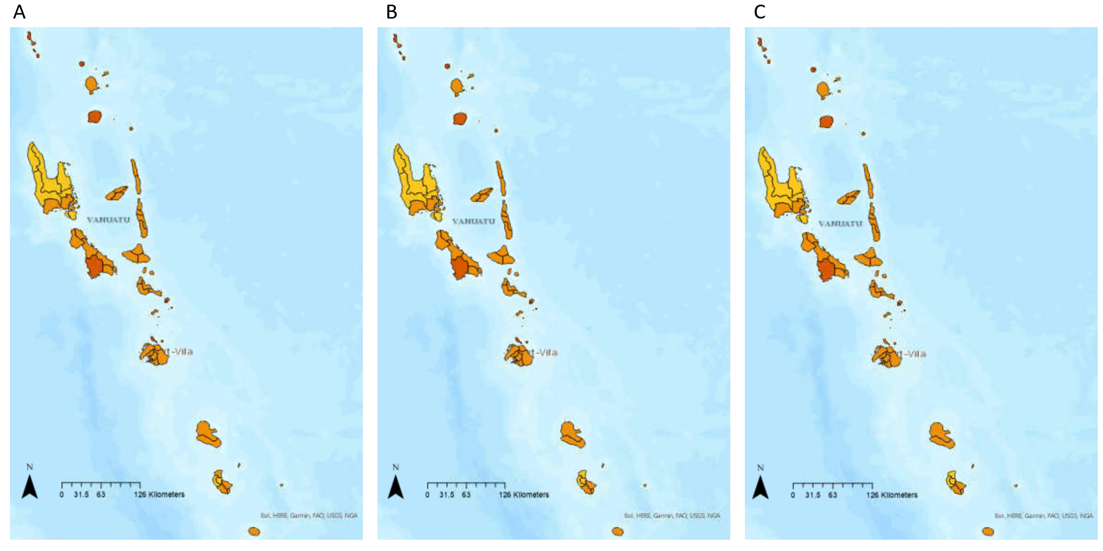
Figure 9. Comparison of yearly vulnerability index map for Vanuatu area councils in 2015 (A), 2016 (B), and 2017 (C).
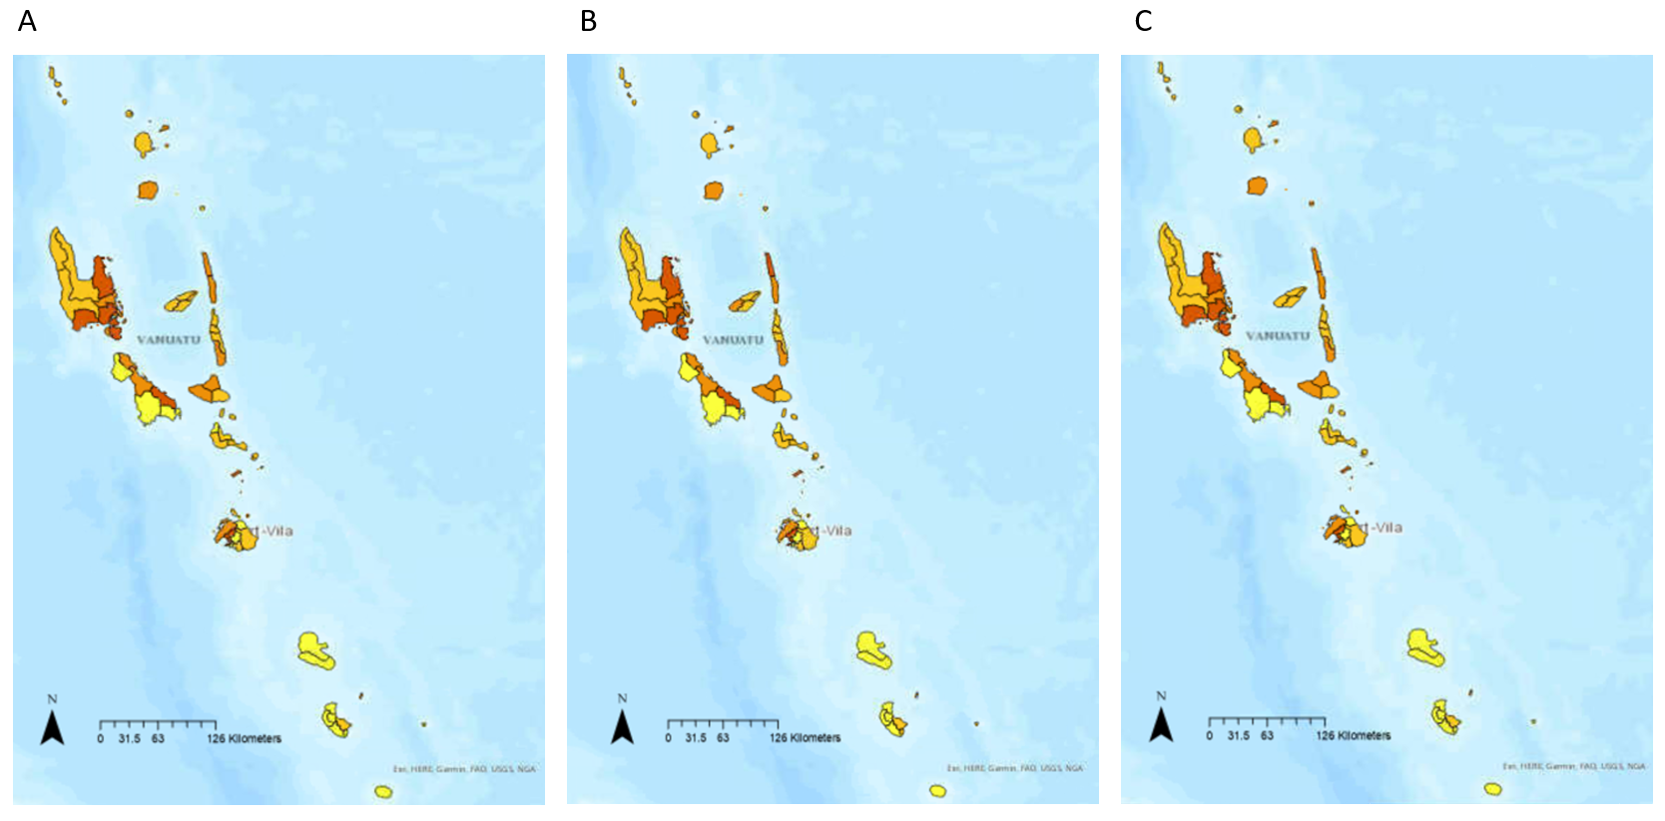
Figure 10. Comparison of yearly exposure index map for Vanuatu area councils in 2015 (A), 2016 (B), and 2017 (C).

Combined Risk

The risk assessment highlighted several peak periods of MHW risk throughout 2015-2017: January to March 2015, May 2015, July 2015, October to November 2015, January to May 2016, December 2016 to February 2017, April to May 2017, and November 2017 (Tables 10 – 12 ). In these periods, MHW risk levels were seen to spike across the area councils throughout Vanuatu.
In the first peak period (Jan-Mar 2015) two area councils, Gaua and South Pentecost, were the most-at risk (Table 10). Both area Gaua and South Pentecost were at risk to severe impacts throughout January and February and then moderate impacts in March. Other area councils of concern in this peak period were Canal-Fanafo, Central Malekula, North East Malekula and South East Malekula which had moderate risk levels in Jan-Feb which then elevated to risk of severe impacts in March. Merelava, North Ambrym, North Maewo and South Maewo were also of concern with severe levels at the beginning of the peak period (Jan) and then moderate levels for the rest of the period. Motalava also had severe levels at the beginning of this peak period, these levels then declined rapidly changing to moderate in February and then mild in March. In May 2015, most area councils were at moderate risk levels, with Makimae displayed as having risk to severe MHW impacts. In July 2015, majority of area councils were at risk to moderate MHW impacts. Gaua was the most concerning in this period with severe risk. Throughout the Oct-Nov 2015 peak period, South Maewo was the most concerning area council with consistent severe risk levels. Canal-Fanafo, Gaua, and Makimae, were also highlighted in the risk assessment as area councils of concern in this period with moderate levels in October which elevated to severe in November.
Overall, throughout the 2015 year there were three neutral periods in which most area councils had mild or verry mild levels in April and June, August to September, and in December (Table 9). Out of the 26 area councils that were at high risk (moderate or severe) at the beginning of the peak period from October to November 2015, in the neutral period of August to September:
- 11 area councils expressed steadily increasing risk levels
- 1 area council (North Maewo) expressed steadily decreasing levels prior to the peak period in October-November (decreasing from moderate in August to mild in September), and then experienced a sudden spike back up to moderate risk at the beginning of the October-November peak period.
- 14 area councils expressed consistent risk levels, with no change throughout the two months of the neutral period. 11 of these expressed moderate risk throughout the neutral period, which continued throughout the peak period. 2 area councils (North Pentecost and Torres) consistently had mild risk levels in the neutral period of August-September, but then spiked to moderate levels at the beginning of the October-November peak period. 1 province (South Maewo) had consistently moderate levels in the neutral period of August-September, but levels jumped to severe risk at the beginning of the peak period.
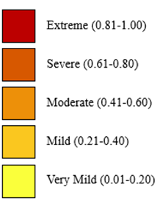
Table 10. Monthly risk index levels for Vanuatu area councils throughout the year of 2015.
Area Council | Monthly Risk Index Level 2015
Area Council | Jan | Feb | Mar | Apr | May | Jun | Jul | Aug | Sep | Oct | Nov | Dec
Aneityum
Aniwa
Canal - Fanafo
Central Malekula
Central Pentecost 1
Central Pentecost 2
East Ambae
East Malo
East Santo
Emau
Erakor
Eratap
Eton
Futuna
Gaua
Ifira
Luganville
Makimae
Malorua
Mele
Merelava
Middle Bush Tanna
Mota
Motalava
Nguna
North Ambae
North Ambrym
North East Malekula
North Efate
North Erromango
North Maewo
North Pentecost
North Santo
North Tanna
North Tongoa
North West Malekula
North West Santo
Paama
Pango
Port Vila
South Ambae
South East Ambrym
South East Malekula
South East Santo
South Epi
South Erromango
South Maewo
South Malekula
South Pentecost
South Santo
South Tanna
South West Malekula
South West Tanna
Tongariki
Torres
Ureparapara
Vanua Lava
Varisu
Vermali
Vermaul
West Ambae
West Ambrym
West Malo
West Santo
West Tanna
Whitesands

The first 2016 peak period (Jan-May 2016) arose with most provinces expressing moderate or severe risk level, with January 2016 being the most intense month out of the five months of this peak period (Table 11). Central Malekula, Makimae and South East Malekula were the most at risk area councils during the peak period of Jan-May 2016, with consistent risk of severe impacts. North Tongoa, Pango and Tongariki are also of concern, with three out of the four months in the peak period being severe risk for these area councils. Other provinces of concern, with at least one or two months in the peak period being at severe risk levels, included Canal-Fanafo, Emau, North Ambryn, North East Malekula, North Maewo, South Pentecot, South Santo, West Ambrym, Ifira, Mele, and Port Vila. In December 2016 (which was the beginning of a signalled peak period that endured until February 2017), the most common risk level throughout Vanuatu area councils was moderate. Gaua and Merelava were of high concern in this period, with severe risk levels.
Overall, throughout the 2016 year there was one neutral period from June to November in which most area councils throughout Vanuatu had very mild or mild risk levels (Table 11). Several area councils demonstrated a consistent transition from high MHW risk to impacts in the first peak period, that ended in May 2016, until the second peak period, that began in December 2016. Central Malekula, Central Pentecost 2, East Malo, Gaua, North Ambrym, North East Malekula, Paama, South Ambae, South East Ambrym, South Santo, Torres, Ureparapara, West Ambae, West Ambrym, West Malo, all demonstrated a decrease from higher risk levels (moderate or severe) in May 2016 to lower risk levels (mild or very mild), with most reaching their lowest risk value in August 2016, and then experienced a steady rise back up towards the higher risk levels (moderate or severe) demonstrated again in December 2016.
Table 11 . Monthly risk index levels for Vanuatu area councils throughout the year of 2016.
Area Council | Monthly Risk Index Level 2016
Area Council | Jan | Feb | Mar | Apr | May | Jun | Jul | Aug | Sep | Oct | Nov | Dec
Aneityum
Aniwa
Canal - Fanafo
Central Malekula
Central Pentecost 1
Central Pentecost 2
East Ambae
East Malo
East Santo
Emau
Erakor
Eratap
Eton
Futuna
Gaua
Ifira
Luganville
Makimae
Malorua
Mele
Merelava
Middle Bush Tanna
Mota
Motalava
Nguna
North Ambae
North Ambrym
North East Malekula
North Efate
North Erromango
North Maewo
North Pentecost
North Santo
North Tanna
North Tongoa
North West Malekula
North West Santo
Paama
Pango
Port Vila
South Ambae
South East Ambrym
South East Malekula
South East Santo
South Epi
South Erromango
South Maewo
South Malekula
South Pentecost
South Santo
South Tanna
South West Malekula
South West Tanna
Tongariki
Torres
Ureparapara
Vanua Lava
Varisu
Vermali
Vermaul
West Ambae
West Ambrym
West Malo
West Santo
West Tanna
Whitesands

In the first peak period of 2017 which continued from 2016 (December 2016-February 2017), Makimae, North Ambryn, and Tongariki displayed the highest risk levels (moderate/severe) (Table 12). Motalava, North Maewo, South Maewo, Gaua and Merelava were also of concern, reaching severe risk in one month throughout this first peak period, but changing rapidly to mild or very mild in the other months within the period. Gaua, Merelava and South Maewo were also of high concern for the second peak period (April-May 2017), with severe risk levels displayed for both months. A number of months also displayed severe risk in this period, but only in one month (Central Malekula, Makimae, Motalava, North Ambrym, North East Malekula, North Maewo, South East Malekula, Tongariki, West Ambrym). Gaua and Motalava were also of high concern in the peak period that occurred at the end of 2017 in November, with risk to severe impacts being displayed in the risk assessment.
Overall, throughout the 2017 year there were three neutral periods in which most area councils had mild or verry mild levels (in March, in Jun-Oct, and in Dec) (Table 12 . Following the first peak period of the year, most previously high-risk area councils declined to moderate or mild risk levels in March. A consistent transition out of and into MHW impacts was demonstrated throughout the second neutral period, which saw many provinces decline in risk following the peak period of April-May, and then rise again into the peak period of November. 14 area councils (Canal-Fanafo, Central Malekuls, East Malo, East Santo, Gaua, Makimae, Merelava, Mota, North Ambrym, South East Malekula, South East Santo, Tongariki, Torres, and West Ambrym) reflected a transition transition from high risk levels in May to mild and very mild levels throughout June-October, with levels slowly rising to high risk again in November.
Table 12. Monthly risk index levels for Vanuatu area councils throughout the year of 2017.
Area Council | Monthly Risk Index Level 2017
Area Council | Jan | Feb | Mar | Apr | May | Jun | Jul | Aug | Sep | Oct | Nov | Dec
Aneityum
Aniwa
Canal - Fanafo
Central Malekula
Central Pentecost 1
Central Pentecost 2
East Ambae
East Malo
East Santo
Emau
Erakor
Eratap
Eton
Futuna
Gaua
Ifira
Luganville
Makimae
Malorua
Mele
Merelava
Middle Bush Tanna
Mota
Motalava
Nguna
North Ambae
North Ambrym
North East Malekula
North Efate
North Erromango
North Maewo
North Pentecost
North Santo
North Tanna
North Tongoa
North West Malekula
North West Santo
Paama
Pango
Port Vila
South Ambae
South East Ambrym
South East Malekula
South East Santo
South Epi
South Erromango
South Maewo
South Malekula
South Pentecost
South Santo
South Tanna
South West Malekula
South West Tanna
Tongariki
Torres
Ureparapara
Vanua Lava
Varisu
Vermali
Vermaul
West Ambae
West Ambrym
West Malo
West Santo
West Tanna
Whitesands

2020-2022 Case study results

Vulnerability and Exposure

The most vulnerable area councils throughout Vanuatu included Nguna, Port Vila, Vanuatu Lava and Motalava. These are spread across two provinces, Torba in the North (Vanua Lava and Motalava) and Shefa in Central Vanuatu (Nguna and Port Vila) (Figure 11). More area councils were at severe levels of exposure compared to vulnerability. East Santo, East Malo, Canal-Fanafo, South Santo, South East Malekula, Makimae, Port Vila, Pango, and Ifira. Like vulnerability, the highest exposure levels were seen in Shefa province. However, area councils in Sanma, and Malampa province were also seen with severe exposure (Figure 12). All area councils had at least mild levels of vulnerability and exposure, and no area councils had extreme levels. The vulnerability and exposure levels across all local area councils remained unchanged throughout the three-year period of 2020-2022.
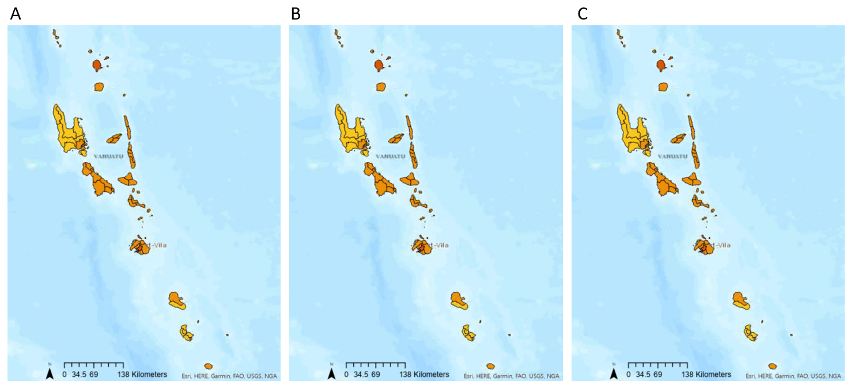
Figure 11. Comparison of yearly vulnerability index map for Vanuatu area councils in 2020 (A), 2021 (B), and 2022 (C).
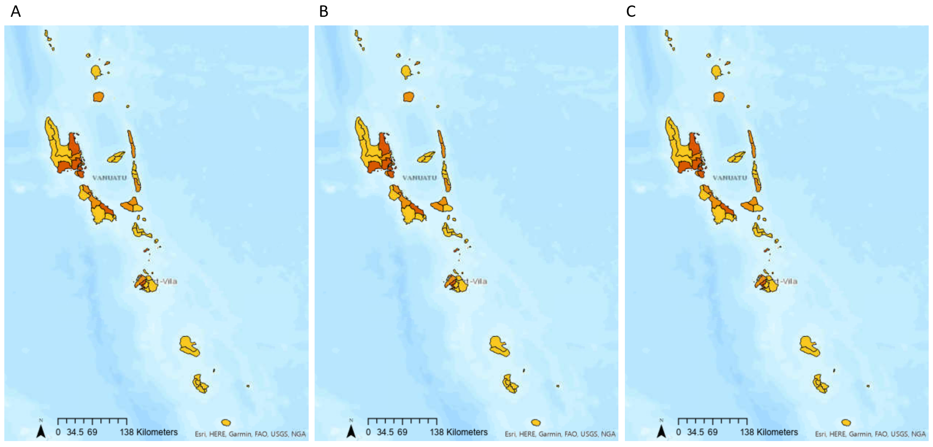
Figure 12. Comparison of yearly exposure index map for Vanuatu area councils in 2020 (A), 2021 (B), and 2022 (C).

Combined Risk

The risk assessment highlighted several peak periods throughout 2020-2022: January to July 2020, September 2020, December 2020 to February 2021, November 2021 to August 2022, and November to December 2022. Most peak periods in the 2020-2022 lasted for a span of at least 3 months, with some extending to 10 months (Tables 13 – 15). These are much longer than the peak periods observed throughout 2015-2017.
In the first peak period of January to July 2020, the most at-risk area councils were Canal-Fanafo, Makimae, Motalava and Port Vila (Table 13). Canal-Fanafo, Makimae and Motalava were consistently at moderate and severe risk throughout this peak period. Whereas Port Vila expressed severe risk in April, then dropped throughout May, and became low risk in June with a Very mild level. In September 2020 most area councils were of risk to moderate MHW impacts. Canal-Fanfo, Makimae and Port Vila were the only area councils to display a higher risk level of severe in this month. Only two neutral periods were observed in the 2020 risk assessment results: August 2020 and October to November 2020 (Table 13). In August, most area councils displayed a Very mild risk level. In October all area councils were of very mild or mild risk except for Mota and Motalava, which were at moderate risk. Levels then jumped in November, with 14 area councils displaying moderate risk.
Table 13 . Monthly risk index levels for Vanuatu area councils throughout the year of 2020.
Area Council | Monthly Hazard Index Level 2020
Area Council | Jan | Feb | Mar | Apr | May | Jun | Jul | Aug | Sep | Oct | Nov | Dec
Aneityum
Aniwa
Canal - Fanafo
Central Malekula
Central Pentecost 1
Central Pentecost 2
East Ambae
East Malo
East Santo
Emau
Erakor
Eratap
Eton
Futuna
Gaua
Ifira
Luganville
Makimae
Malorua
Mele
Merelava
Middle Bush Tanna
Mota
Motalava
Nguna
North Ambae
North Ambrym
North East Malekula
North Efate
North Erromango
North Maewo
North Pentecost
North Santo
North Tanna
North Tongoa
North West Malekula
North West Santo
Paama
Pango
Port Vila
South Ambae
South East Ambrym
South East Malekula
South East Santo
South Epi
South Erromango
South Maewo
South Malekula
South Pentecost
South Santo
South Tanna
South West Malekula
South West Tanna
Tongariki
Torres
Ureparapara
Vanua Lava
Varisu
Vermali
Vermaul
West Ambae
West Ambrym
West Malo
West Santo
West Tanna
Whitesands

Throughout December 2020 to February 2021, Makimae was the most consistently at-risk area council, displaying a severe risk level in each of the three months of this peak period (Table 13). South East Malekula was of risk to severe impacts in December 2020 but dropped down to a moderate level of risk in January and February 2021. Canal-Fanafo rose from a moderate risk level in December 2020 to a severe level in January 2021 and then dropped back down to moderate in February 2021.
A long neutral period was seen in 2021, from March to October (Table 14), in which several transitioning patterns arose:
- Some area councils (Ifira, Makimae, Paama, Pango, Port Vila, South East Ambrym, South East Malekula, South Epi, South Pentecost, South West Malekula, Vermail, Varisu, Vermaul, West Ambrym and West Malo) displayed a steadily decreasing pattern from the end of the peak period in January/February 2021, to a specific low point in the neutral period, and then displayed a steady rise from that point to the start of the next peak period in November 2021.
- Some area councils (Erakor, Eton and South Erromango) displayed steadily decreasing levels from end of the January/February 2021 peak period that reached a low point in October 2021, with a sudden spike occurring to higher levels in November/December 2021 in which the next peak period commenced.
- All other area councils displayed a more random patter throughout the neutral period, with rising and falling levels observed at many stages throughout March to October 2021.
Table 14 . Monthly risk index levels for Vanuatu area councils throughout the year of 2021.
Area Council | Monthly Hazard Index Level 2021
Area Council | Jan | Feb | Mar | Apr | May | Jun | Jul | Aug | Sep | Oct | Nov | Dec
Aneityum
Aniwa
Canal - Fanafo
Central Malekula
Central Pentecost 1
Central Pentecost 2
East Ambae
East Malo
East Santo
Emau
Erakor
Eratap
Eton
Futuna
Gaua
Ifira
Luganville
Makimae
Malorua
Mele
Merelava
Middle Bush Tanna
Mota
Motalava
Nguna
North Ambae
North Ambrym
North East Malekula
North Efate
North Erromango
North Maewo
North Pentecost
North Santo
North Tanna
North Tongoa
North West Malekula
North West Santo
Paama
Pango
Port Vila
South Ambae
South East Ambrym
South East Malekula
South East Santo
South Epi
South Erromango
South Maewo
South Malekula
South Pentecost
South Santo
South Tanna
South West Malekula
South West Tanna
Tongariki
Torres
Ureparapara
Vanua Lava
Varisu
Vermali
Vermaul
West Ambae
West Ambrym
West Malo
West Santo
West Tanna
Whitesands

Throughout the long peak period of November 2021 to August 2022, the area council of Makimae was consistently at severe risk (Table 14). South East Malekula was of severe risk in the first few months of this peak period but dropped to moderate levels from March 2022 onwards. Mele, Pango and Port Vila displayed moderate/mils risk levels throughout the first half of this peak period, but levels escalated to severe and remained so throughout the last part of this peak period.
Only one, short neutral period was observed for 2022 in September to October (Table 15). In this neutral time, many of the moderately/severely at-risk area councils from the previous peak period rapidly dropped to very mild/mild risk levels. This was particularly evident in area councils in or around Efate (Emau, Eratap, Eton, Ifira, Maloura, Mele, Pango, and Port Vila). Most area councils escalated rapidly from very mild or mild risk levels in the two months of this neutral period, to return to high risk levels in the November-December 2022 peak period. Particularly:
- Emau jumped from mild risk in October to Moderate in November, and then spiked rapidly again to reach severe risk in December.
- Ifira rapidly escalated from mild risk in October to severe risk in November.
- Mele rapidly escalated from very mild risk in October to severe risk in November.
- Nguna jumped from very mild risk in October to moderate risk in November.
- Pango jumped from mild risk in October to severe in November.
- Port vila rapidly escalated from very mild risk in October to severe in November.
Overall, the last peak period in November to December 2022 was seemingly sudden, with no clear signal by the risk assessment of a transition into a period of high risk to MHW impacts.
Table 15. Monthly risk index levels for Vanuatu area councils throughout the year of 2022.
Area Council | Monthly Hazard Index Level 2022
Area Council | Jan | Feb | Mar | Apr | May | Jun | Jul | Aug | Sep | Oct | Nov | Dec
Aneityum
Aniwa
Canal - Fanafo
Central Malekula
Central Pentecost 1
Central Pentecost 2
East Ambae
East Malo
East Santo
Emau
Erakor
Eratap
Eton
Futuna
Gaua
Ifira
Luganville
Makimae
Malorua
Mele
Merelava
Middle Bush Tanna
Mota
Motalava
Nguna
North Ambae
North Ambrym
North East Malekula
North Efate
North Erromango
North Maewo
North Pentecost
North Santo
North Tanna
North Tongoa
North West Malekula
North West Santo
Paama
Pango
Port Vila
South Ambae
South East Ambrym
South East Malekula
South East Santo
South Epi
South Erromango
South Maewo
South Malekula
South Pentecost
South Santo
South Tanna
South West Malekula
South West Tanna
Tongariki
Torres
Ureparapara
Vanua Lava
Varisu
Vermali
Vermaul
West Ambae
West Ambrym
West Malo
West Santo
West Tanna
Whitesands

Part 2: Literature Review Validation Results
17 out of the 24 sources analysed recorded MHW impacts as having occurred throughout 2015-2017. Each year in the 2015-2017 case study period was recorded as having experienced MHW impacts (Table 16). Particularly, the beginning of 2016 (January-March) was mentioned by many sources (6) as having experienced moderate/severe impacts. Most sources mentioning impacts in 2015-2016 identified area councils in Efate island as specifically affected. 2017 was only identified by two sources as a year in which MHW impacts were experienced. These impacts were described as moderate and severe, with significant fish kills due to high SSTs and coral bleaching listed specifically (Table 16).
Table 16. Literature search results for MHW conditions and impacts throughout 2015-2017.
Source # | Were MHW impacts mentioned in Vanuatu for the 2015-2017 period? | Was a specific time during the 2015-2017 period mentioned for when MHW impacts occurred? | Was a specific place (region, province, and/or area council) mentioned as having experienced MHW impact? | What types of impacts were mentioned? | What was the severity level of MHW impacts described in this source?
1 | Yes | February/March 2016 | -Pango Village  -Emten Lagoon  -Port Vila  -Aneityum | The MHW had serious impacts causing the deaths of hundreds of marine fin fish and invertebrates including sea snakes, octopus, and crabs, which were found washed ashore on beach shorelines and floating on shallow reefs and waters. | Moderate
2 | Yes | 2016 | No | The MHW caused mass fish  mortality due to increased water temperatures. | Moderate
3 | Yes | 2016 | No | High SSTs caused significant coral bleaching. | Severe
4 | Yes | 2015-2016 | No | Significant coral bleaching occurred due to high SSTs. | Severe
5 | Yes | February 2016 | -Pango area  -Efate island | The strong MHW, with an SST anomaly  of 1.75–2.0 °C, resulted in a major fish kill event in the Pango  area, and seagrass loss around the island of Efate. | Severe
6 | Yes | January/February 2016. | -Pango Village on Efate  -Emten Lagoon in Port Vila  -Aneityum Island | Hundreds of dead fish and invertebrates were observed. Along with the significant fish kills, several coral bleaching events were also reported. | Severe
7 | Yes | January/February 2016 | -Pango village  -Port Villa  -Emten Lagoon | Hundreds of fish kills and deaths of other marine species (octopuses) reportedly occurred from a significant increase in SSTs. | Moderate
8 | Yes | 2015/2016 | -Efate island | Major coral bleaching. | Severe
9 | Yes | 2015/2016 | -Communities in Malampa and Shefa provinces | Crown-of-thorns outbreak and coral bleaching/mortality. | Severe
10 | Yes | 2015-2016 | No | High SSTs caused mass fish mortality.  Simultaneously, there was mass  bleaching of giant clams and coral, resulting in a loss of  habitat for demersal fish. | Severe
11 | Yes | January/February 2016 | No | High SSTs resulted in fish kills by the thousands as well as the deaths of octopuses and crabs which were found floating in the water and washed up on the shore. | Moderate
12 | Yes | February 2016 | -Efate island | High SSTs resulted in thousands of fish kills, which impacted fish stocks. This caused locals to worry about their livelihoods. Coral bleaching also occurred, damaging coral reefs. | Extreme
13 | No | n/a | n/a | n/a | n/a
14 | Yes | 2015-2016 | -Torres island  -Pentecost island  -Epi island  -Aneityum island  -Erromango island | High SSTs resulted in mass fish mortality and coral bleaching events, with associated reductions in local fish stocks. | Severe
15 | Yes | 2016/2017 | -Erakor | Significant fish kills due to high SSTs. | Moderate
16 | Yes | 2015-2016 | -Torres island  Pentecost island  -Epi island  -Aneityum island  -Erromango island | High SSTs caused mass fish mortality, coral bleaching events and reductions in local fish stocks. | Severe
17 | No | n/a | n/a | n/a | n/a
18 | No | n/a | n/a | n/a | n/a
19 | No | n/a | n/a | n/a | n/a
20 | No | n/a | n/a | n/a | n/a
21 | Yes | 2015/2016 | No | Severe coral bleaching was seen throughout Vanuatu. | Severe
22 | No | n/a | n/a | n/a | n/a
23 | No | n/a | n/a | n/a | n/a
24 | Yes | 2016/2017 | No | Major coral bleaching events have been recorded in 2016 and again in 2017. Susceptible coral taxa were significantly reduced. | Severe

Only 9 of the 24 sources analysed mentioned MHW conditions as having occurred throughout 2020-2022. Several periods of interest were identified for this period (Table 17). The first half of 2020 was said to have been a period in which mild MHW impacts occurred by one source. February-March of 2021 was recorded as a period in which moderate/severe MHW impacts occurred. Most months in 2022 were recorded as having experienced MHW impacts (January, April-July, and November-December). These impacts were commonly described as severe, with only one source noting them as mild (Table 17).
Table 17. Literature search results for MHW conditions and impacts throughout 2020-2022.
Source # | Were MHW impacts mentioned in Vanuatu for the 2020-2022 period? | Was a specific time during the 2020-2022 period mentioned for when MHW impacts occurred? | Was a specific place (region, province, and/or area council) mentioned as having experienced MHW impact? | What types of impacts were mentioned? | What was the severity level of MHW impacts described in this source?
1 | No | n/a | n/a | n/a | n/a
2 | Yes | 2019/2020 | No | Intense MHW events occurred in 2019 and again in 2020. | Moderate
3 | No | n/a | n/a | n/a | n/a
4 | No | n/a | n/a | n/a | n/a
5 | No | n/a | n/a | n/a | n/a
6 | No | n/a | n/a | n/a | n/a
7 | No | n/a | n/a | n/a | n/a
8 | No | n/a | n/a | n/a | n/a
9 | No | n/a | n/a | n/a | n/a
10 | No | n/a | n/a | n/a | n/a
11 | No | n/a | n/a | n/a | n/a
12 | No | n/a | n/a | n/a | n/a
13 | Yes | February 2021 | -Erakor Bridge community  -Efate island  -Emten Lagoon. | Dead fish were found in shallow waters and washed up on the shore. | Moderate
14 | No | n/a | n/a | n/a | n/a
15 | No | n/a | n/a | n/a | n/a
16 | No | n/a | n/a | n/a | n/a
17 | Yes | First half of 2020 | No | High SSTs persisted across Vanuatu through the first half of 2020. | Mild
18 | Yes | November/December 2022 | No | High SSTs (>2°C above normal) developed across Vanuatu. | Mild
19 | Yes | November 2022 | -Torba province  -North of Sanma and Penama provinces  -Central and southern region island groups | High SSTs induced coral bleaching across Torba and in some parts of Sanma and Penama, as well as decreased Chlorophyll concentrations  in the central and southern region island groups. | Severe
20 | Yes | September 2020 | -North and central Vanuatu | High SSTs were observed across north and central Vanuatu. | Mild
21 | No | n/a | n/a | n/a | n/a
22 | Yes | January 2022 | No | High SSTs caused coral bleaching across all provinces in Vanuatu, as well as decreased Chlorophyll concentration throughout all Vanuatu regions. | Severe
23 | Yes | April-July 2022 | -Erromango island  -Torres island group | In April to June 2022, significantly high SSTs were recorded, and coral bleaching was observed. | Severe
24 | Yes | 2020 and February-March 2021 | No | A severe and widespread coral bleaching event was recorded in 2020, causing significant decline in coral cover. High SSTs were particularly observed in February 2020. Heat stress among coral taxa was observed after this month, and mortality was seen throughout the rest of the 2020 year.  In February-March 2021, high SSTs caused bleaching-induced coral mortality. Coral cover declines in 2022 are likely due to this event.  Both events also occurred in association with declines in reef fish species richness and abundance. | Severe

Part 3: Validation survey results

Participant details
A diverse array of Vanuatu locals participated in this survey. The age range of participants was from 26 to 47, with participants distributed quite evenly throughout this range. There was also a relatively even gender distribution with 7 females and 10 males participating. A range of stakeholder groups were represented, with 6 local community members, 4 fisheries staff, 1 fisher person, and 6 who selected ‘other’ when asked what stakeholder group they pertained to (those who selected ‘other’ consisted mostly of Vanuatu locals employed at the VMGD). A wide geographical range was represented in participants, with participants located across four of the six provinces in Vanuatu (Malampa, Tafea, Shefa and Sanma were represented) (Figure 13 ). Only Torba and Penama provinces were unrepresented. Additionally, a wide range of local are councils were represented by participants, with area councils on the island of Efate being most represented.

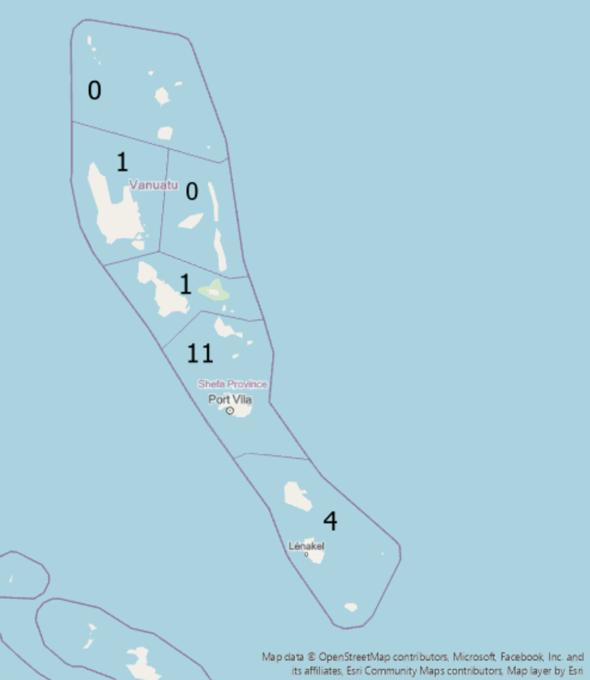
Figure 13. Survey participant distribution per province in Vanuatu. Most participants were located in Shefa Province.

Question 1
The majority of participants (76%) stated that they recalled MHW impacts in Vanuatu sometime within 2015-2017.
Question 2
Of those that could recall the specific year in which these impacts occurred, 5 noted 2016, 3 noted 2015, and 2 noted 2017. Specific months highlighted by participants included May-July 2015, February-July 2016, and April in 2017.
Question 3
When asked if specific regions or areas were affected by MHW impacts during 2015-2017, most participants (9) highlighted Shefa province as being particularly affected. Tafea province was also mentioned by several participants (5) as having been affected by MHW impacts during this time period. Torba, Penama and Malampa provinces were only mentioned once as having been affected in this time.When Malampa and Penama were noted, the eastern areas were particularly identified as having been impacted. There was no mention of impacts in Sanma province.
Participants also highlighted that localised impacts were also experienced throughout specific local areas including:
- Aneityum area council
- Erakor area council (Emten Lagoon was specifically noted)
- Eratap area council
- Eton area council
- Ifira area council
- Maloura area council
- Mele area council
- North Efate area council
- Pango area council
- Port Vila area council (Loukatai village and Second Lagoon were specifically noted)
- South Tanna area council
- West Tanna area council (Lenakel was specifically noted)
- Whitesands area council (Port Resolution was specifically noted)
Pango was especially highlighted by many (5) participants.
Question 4
In terms of MHW impacts experienced during the 2015-2017 period, fish kills was mentioned the most. All of the 13 participants who noted MHW impacts to have occurred in this time period identified fish kills as an experienced impact. Coral bleaching was also noted among most (10) participants as a MHW impact experienced throughout 2015-2017. Die-off of additional marine animals (e.g., crabs) and Increased number of crown of thorns starfish were noted as experienced impacts by 6 participants. Reduced catch amounts was noted by 4 participants. Only two participants mentioned Reduced food supply and Reduced production of commercial fisheries as experienced impacts, and only one mentioned Significant economic losses on household and industrial scale as an experienced impact.
Question 5
The MHW impacts experienced across Vanuatu in 2015-2017 were most likely Severe. Four participants described impacts as Severe, with three participants noting moderate and mild impact levels. Only two participants described impacts as extreme, and one participant stated impacts were very mild.
Question 6
As with the 2015-2017 period, the majority of participants (76%) stated that they recalled MHW impacts in Vanuatu some time within the 2020-2022 time period.
Question 7
Of the 13 participants who noted the occurrence of MHW impacts during 2020-2022, 7 stated that these MHW impacts occurred during 2021. Three participants stated that impacts had occurred in 2022, and two participants noted impacts for the 2020 year. Specific months that were of concern for MHW impacts included February and June 2020, January-February 2021, as well as May and November-December 2022.
Question 8
Shefa was the most noted province among participants when asked where MHW impacts occurred throughout 2020-2022. Sanma and Tafea were also highlighted as provinces in which MHW impacts were experienced. There was no mention of Torba, Penama, or Malampa. Participants also noted several specific area councils that were affected by MHWs during 2020-2022. These included:
- Aniwa area council
- Canal-Fanafo area council
- East Santo area council
- Erakor area council (Erakor Lagoon was specifically noted)
- Eratap area council
- Eton area council
- Futuna area council
- Gaua area council
- Ifira area council
- Luganville area council
- Maloura area council
- Mele area council
- Mere Lava area council
- Middle Bush Tanna area council
- Mota area council
- Mota lava area council
- North Efate area council (Paunangisu was specifically noted)
- North Santo area council
- North Tanna area council
- North West Santo area council
- Pango area council (Vale vale bay was specifically noted)
- South East Santo area council
- South Santo area council
- South Tanna area council
- South West Tanna area council
- Ureparapara area council
- Vanuau lava area council
- West Santo area council
- West Tanna area council
- Whitesands area council
Question 9
The most noted impact for the 2020-2022 period was fish kills. Die-off of additional marine animals (e.g., crabs) was the second most noted impact, with 9 participants mentioning it for the 2020-2022 period. Coral bleaching was stated by 6 participants as having occurred during 2020-2022. Three participants noted reduced catch amount and reduced production of commercial fisheries as experienced MHW impacts. Two participants stated reduced food supply was an experienced impact for 2020-2022. Algal blooms, Increased number of crown of thorns starfish, Significant economic losses on household and industrial scale were only noted as experienced impacts by one participant.
Question 10
MHW impacts experienced in Vanuatu throughout 2020-2022 were mostly likely Moderate to Very mild. Only one person stated the impacts in this period to be extreme, and only two participants noted them as severe. Whereas four participants described the impacts to have been very mild, and three participants mentioned the impacts to have been moderate/mild.
Question 11 and 12 Merged
When asked about the MHW management strategies implemented by the fishing industry/governing bodies in Vanuatu, most participants referred to strategies implemented by the Vanuatu Fisheries Department (Table 18). Most strategies discussed by participants implemented by both the fishing industry/government body and by individual participants focused on raising awareness and the sharing of information (Table 18). The only strategies said to be implemented by the fishing industry/governing bodies that did not revolve around information/awareness included the completion of pre and post disaster risk assessments/surveys, the banning of unsafe marine products, the controlled breeding of fish in aquaculture tanks to relieve pressure on reef ecosystems, and the collection and translocation of at-risk marine species (e.g., sea cucumbers) from impacted areas to low-risk areas. The few management responses of individuals to MHW conditions, that did not entail information sharing or raising awareness, included the cleaning of coastal areas, the avoidance of fishing in affected areas, and the mindful consumption of marine products.
Table 18. Responses from survey question 11 and 12, detailing the MHW management strategies implemented by the Vanuatu fishing industry/governing bodies in comparison to the strategies implemented by individual participants.
Participant Identifier | Management strategy implemented in response to MHWs by Vanuatu fishing industry/government body as noted by participants | Management strategy implemented in response to MHWs by individual participants
P1 | Fisheries Department delivered community awareness and removed the whale stranded on the beach and used an excavator to move the fish back to sea. | Do nothing but to learn from authorities on what to do, take action when required.
P2 | The Provincial Fisheries Officers put a temporary ban in some areas for people not to fish e.g., South Tanna around Kwamera village near the sea allowing only few selected locations for people to fish. Fisheries Department also undertaken community consultations with selected communities for awareness and to encourage people to protect marine resources e.g., small fish and work with chiefs and communities to establish bylaws to conserve limited fish resources. | Help the local communities to make a general clean at the coastal area to give a clean and healthy environment for the marine species to reproduce their species in order to keep the environment in a safe place.
P3 | Information provided by VMGD and Fisheries regarding oxygen level in Ocean and also Coral bleaching and ENSO status. VMGD set up a Fisheries Early Warning System that looks into COTS outbreak, Coral Bleaching, and other variables influencing Pelagic fisheries. VMGD needs to look into this and use this effectively and finalise the fisheries ENSO handbook | I manage to organise a workshop between VMGD with NOAA/BOM to set up Vanuatu Fisheries Early Warning System and develop the fisheries ENSO handbook
P4 | Awareness from the Fisheries and Health department. | I share awareness messages using my facebook account. Additionally, as part of work at the National Met Service, we provide information on projected SSTs, sea level height and coral bleaching alerts for citizens to know the type of oceanic conditions their area will experience so that can prepare themselves
P5 | There's usually media release being released with fisheries sector specific applications on how to better manage coastal resources | I sent the information out to families and add in a brief explanation on the effects of marine heat waves on particularly coastal resources if we are not being careful. Advice was not to consume any dead sea creatures found along the beach or coast and not to overfish but to seek information at the Fisheries department for guidance on fish consumption.
P6 | Only awareness on coral bleaching and others | Don't burn plastics, replant more coastal plant species
P7 | Department of Fisheries normally dispatches officers to conduct an assessment around the affected areas. Then the department will advise the community on how they should respond to event to minimize/ manage the impacts. | I personally share any information I have on MHW to my families and friends and help them by recommending some actions that I think will help them to minimize the impacts of MHW.
P8 | Conduct survey and then take actions according to the result from the survey. | Not to go fish in that particular area
P9 | In 2016 when marine head wave occurs, particularly in Pango Village south of Efate, Fisheries research team were deployed to the site to asses the impact and advise village community not to fish or eat any dead animal that wash ashore | Just advise communities there were impacted that this is a natural event were sea surface temperature rise above normal causing stress to marine animal that may end up dead and wash ashore. So in any future event that marine heatwave may occur there will be no fishing occur in the area until a survey is conducted by fisheries and other relevant stakeholders
P10 | Awareness to people in the community/local areas for no consuming dead fish/marine organisms that are washed ashore by the marine heat wave. Also, refer to fresh water fish and not touched fish in the sea especially reef fishes. | We just do a marine coastal area observation to spot out the damages the marine heat waves has done.
P11 | We conduct a risk assessment then put a ban on marine products to not be eaten just as a precaution | Do awareness to others about marine heat waves
P12 | Public awareness on radio and social media, I do not think the government implemented any management strategies except for undertaking an assessment of the area affected with fish kills at the time. | Share information with family members, and work colleagues. Share marine heat wave information from VMGD and reduce the consumption of fish to avoid putting pressure on fish and the marine environment.
P13 | The Fisheries Dept did the tanks for aquaculture to breed more fish and put less pressure of the reef | I bought less fish not to endanger my health
P14 | n/a | n/a
P15 | n/a | Initiate in the product the need to provide information from VMGD through the VanKIRAP project to provide information on marine heatwaves in the monthly outlooks
P16 | From what I recall that year, fisheries department did something like collecting the Sea cucumbers and transporting them to a location that is not affected. | Pass on information given by fisheries department and inform others
P17 | n/a | Seek information from Fisheries department.

Question 13
When asked about the efficiency of MHW management strategies implemented by the Vanuatu fisheries industry/governing bodies, the greatest number of participants (8) indicated that management strategies had only been moderately effective. A total of six participants indicated that the strategies were not effective at all. Only three participants stated that the strategies were very effective.

Key comparisons of survey results: 2015-2017 vs 2020-2022 results

- 10 out of 17 participants noted MHW events in both study periods.
- The same number of participants noted the presence of MHW impacts during both study periods (2015-2017 and 2020-2022). However, the times of year during these periods in which MHW impacts were said to be experienced differed in some cases. February, May, June and July were months highlighted to have been of concern for MHW impacts for multiple years in each study period. July was highlighted for 2015 and 2016. June was noted of concern for 2015, 2016 and 2020. May was noted for 2015, 2016 and 2022. And February was highlighted for experiencing MHW impacts in 2016, 2020, and 2021. March was only highlighted for 2016, April only for 2017, January only for 2021, and November and December were only highlighted for 2022.
- Shefa was identified as the most impacted province during both the 2015-2017 and 2020-2022 period. Tafea was also mentioned by participants for the 2015-2017 and the 2020-2022 period. Malampa, Penama and Torba were only mentioned by 1 participant for the 2015-2017 period only. Whereas Sanma was identified by 1 participant, only for the 2020-2022 period (Figure 14).

Figure 14. The number of participants that highlighted each Vanuatu province as experiencing MHW impacts during the 2015-2017 (black bars) and the 2020-2022 (grey bars) periods.
- Fish kills was the most mentioned impact by participants for both the 2015-2017 and 2020-2022 period (Figure 15). Coral bleaching was mentioned the second most for the 2015-2017 period, with 10 participants noting it as an impact, but for the 2020-2022 period it was mentioned the third most with 6 participants noting it. Die-off of additional marine animals (e.g., crabs) was the opposite, being mentioned the third most for the 2015-2017, but then being mentioned the second most for 2020-2022. Increased number of crown of thorns starfish was mentioned by many (6) participants for the 2015-2017 period impacts but was not likely a great impact for the 2020-2022 period with only 1 participant noting it. All other potential impacts were mentioned by similarly low numbers of participants for both the 2015-2017 and 2020-2022 study periods (Figure 15).

Figure 15. MHW impacts noted by participants for each study period: 2015-2017 (black bars) and 2020-2022 (grey bars).
- MHW conditions indicated by participants for the 2015-2017 were described mostly as severe. Comparatively, conditions in 2020-2022 were mostly described as very mild (Figure 16).

Figure 16. The differing severity levels (very mild, mild, moderate, severe, and extreme) noted by participants for MHW impacts which occurred in each study period: 2015-2017 (black bars) and 2020-2022 (grey bars).
- Impacts like fish kills and die-off of additional marine animals were impacts noticed by all types of stakeholders. For both study periods, reduced catch amounts were noticed by fisher persons and local community members but not by fisheries staff (Table 19 and 20). Additionally, significant economic losses on household and industrial scale were only noticed by fisher persons; no other stakeholder group noticed this impact (Table 18 and 19).
Table 19. Stakeholder group compared to impacts noted for the 2015-2017 study period.
 | Fish kills | Die-off of additional marine animals (e.g., crabs) | Coral bleaching | Increased number of crown of thorns starfish | Algal blooms | Reduced catch amounts | Reduced production of commercial fisheries | Reduced food supply | Significant economic losses on household and industrial scale
Fisher person | Y | Y | Y | Y | Y | Y | Y | Y | Y
Local community member | Y | Y | Y | Y | Y | Y | Y | N | N
Fisheries staff | Y | Y | Y | Y | N | N | N | N | N
Other (VMGD staff mostly) | Y | Y | Y | Y | N | Y | N | N | N

Table 20. Stakeholder group compared to impacts noted for the 2020-2022 study period.
 | Fish kills | Die-off of additional marine animals (e.g., crabs) | Coral bleaching | Increased number of crown of thorns starfish | Algal blooms | Reduced catch amounts | Reduced production of commercial fisheries | Reduced food supply | Significant economic losses on household and industrial scale
Fisher person | Y | Y | Y | N | N | Y | Y | N | Y
Local community member | Y | Y | Y | N | N | Y | Y | Y | N
Fisheries staff | Y | Y | N | N | N | N | N | N | N
Other (VMGD staff mostly) | Y | Y | Y | Y | N | Y | N | N | N

- Raising awareness was noted as an implemented management strategy by all stakeholder groups (Figure 17). Sharing information was only noted as an implemented strategy by local community members. Cleaning of coastal areas were only noted as an implemented strategy by fisher persons. Mindful consumption of marine animals was noted by many fisheries staff as an implemented management strategy, as well as a participant from the local community member stakeholder group (Figure 17).

Figure 17. Management strategies implemented by government bodies/fishing industry in Vanuatu, as noted by the different stakeholder groups represented in the survey participants for MHWs in the past. The different stakeholder groups represented include fisher person (black), local community member (grey), fisheries staff (light blue), and other (dark blue).
- Many participants in the group of ‘other’ (mostly VMGD staff) noted that they had personally shared information in times of MHW events. A participant from the local community member group also noted that they had shared information as a strategy to manage impacts from MHW events in the past. Fisheries staff was the only stakeholder group to mention completing assessments and adjusted fishing practices as personally implemented management strategies. Providing advice was noted by all but fisher persons as a personally implemented management strategy (Figure 18).

Figure 18 . Management strategies implemented by individual participants, by stakeholder group which the individual is apart of, for MHWs in the past. The different stakeholder groups represented include fisher person (black), local community member (grey), fisheries staff (light blue), and other (dark blue).
- Females were more likely to share information and provide advice in response to a MHW as well as raise awareness, clean coastal areas and adjust fishing practices. Whereas males were more likely to seek advice (Figure 19).

Figure 19. Management strategies implemented by individual participants, by gender, for MHWs in the past. Females are represented by black bars and males are represented by grey bars.
- Survey results indicate that it was likely a MHW event occurred with corresponding impacts in all study years (Table 21). A Severe MHW event likely occurred throughout May-July in 2015, a Moderate event in February-July in 2016, a moderate to severe event in April 2017, a mild event in February and then very mild event in June in 2020, a moderate event in January-February 2021, and a moderate event in May then severe to extreme event again in November-December in 2022. The impacts of each MHW event seemed to be spread throughout the country of Vanuatu, with Shefa province being a key affected province for all events except for that in April 2017 which was said to affect areas in Tafea province only. The widest range of impacts were noted to have occurred in 2015, with all potential impacts listed in the survey indicated by participants as having occurred. The event in June 2020 was noted to only have one impact, which was algal blooms (Table 21).
Table 21. Comparative table of likely MHW events identified by survey participants, detailing when, where, and what impacts occurred, along with the severity level of impacts.
Study Year | Was it indicated to have MHW impacts? | When did these impacts occur? | Where were these impacts experienced? | What types of impacts occurred? | How severe were these impacts?
2015 | Yes- 3 people noted this as a MHW impacted year | May-July | -Shefa province  - The eastern side of Penama and Malampa provinces  -Pango area  -Port Vila  -Efate island | Fish kills, Die-off of additional marine animals (e.g crabs), Coral bleaching, Increased number of crown of thorns starfish, Algal blooms, Reduced catch amounts, Reduced production of commercial fisheries, Reduced food supply, Significant economic losses on household and industrial scale | Severe
2016 | Yes- 5 people noted this as a MHW impacted year | February-July | -Shefa and Tafea provinces  -Efate island  -Pango  -Emten lagoon  -Aneityum | Fish kills, Die-off of additional marine animals (e.g crabs), Coral bleaching, Increased number of crown of thorns starfish, Reduced catch amounts, Reduced food supply | Moderate
2017 | Yes- 2 people noted this as a MHW impacted year | April | - Lenakel  -Southeast Tanna  -Port Resolution  -Tafea province | Fish kills, Coral bleaching, Reduced catch amounts, Reduced production of commercial fisheries | Moderate to Severe
2020 | Yes- 2 people noted this as a MHW impacted year | February and then again in June | -Shefa Province (February and June)  -Santo (February)  -Efate island (February)  -North Efate (June) | Fish kills (Feb), Die-off of additional marine animals (e.g crabs) (Feb), Coral bleaching (Feb), Algal blooms (June) | Mild (Feb)  Very mild (June)
2021 | Yes- 7 people noted this as a MHW impacted year | January-February | -Shefa province -Pango area council  -Pango village  -Erakor lagoon  -Erakor village  -Efate Island (particularly eastern parts)  -Paunangisu  village  - Vale vale bay  -Mota lava island  -Banks Islands | Fish kills, Die-off of additional marine animals (e.g crabs), Coral bleaching, Increased number of crown of thorns starfish, Reduced catch amounts | Moderate
2022 | Yes- 3 people noted this as a MHW impacted year | May and then again in November-December | -Shefa province (May and November-December)  -Efate island (May)  -Tafea Province (Nov-Dec)  -Tanna island (Nov-Dec)  -Aniwa (Nov-Dec)  -Futuna (Nov-Dec) | Fish kills (May and Nov-Dec), Die-off of additional marine animals (e.g crabs) (May and Nov-Dec), Coral bleaching (May and Nov-Dec), Reduced catch amounts (May and Nov-Dec), Reduced production of commercial fisheries (May and Nov-Dec), Reduced food supply (Nov-Dec), Significant economic losses on household and industrial scale (May) | Moderate (May)  Severe to Extreme (Nov-Dec)

Part 4: Collation of risk assessment, literature review and survey results
In 2015, all three sources (risk assessment, literature review and survey) noted MHW impacts in July. The risk assessment was corroborated by the literature review in noting MHW impacts in January, February, March, October, and November 2015 (Table 22). The risk assessment did not signal MHW impacts in May or June 2015, whereas the literature and survey both noted impacts in these months. There were the only two months out of 2015 in which the risk assessment results were uncorroborated. In 2016, there was much more corroboration through the sources as to which months experienced MHW impacts. All sources noted February and March as having MHW impacts. All sources noted August, September, October, and November as having no impacts (Table 22). The risk assessment results for January 2016 were collaborated only by the literature, and the results of April and May 2016 were collaborated only by the survey results. The survey results indicated MHW impacts throughout June and July of 2016, but neither the assessment nor the literature recorded impacts for these months. The risk assessment results were uncorroborated by either ground-truth source for only one month in 2016 (December). For all months throughout 2017, the risk assessment results were corroborated by at least one ground-truth source (either the literature review or surveys). All sources noted MHW impacts for April 2017. The risk assessment results showing MHW impacts in Jan, Feb, May, and Nov 2017 were corroborated by the literature. In all other months of 2017, only the literature noted impacts (Table 22).
In May 2015, all three sources noted a likely MHW impact occurring, with risk assessment results showing high risk levels, and MHW impacts recorded in the literature and survey results (Table 22). The severity of MHW impacts were classified as moderate by the risk assessment, but as severe by the literature and survey results. Makimae, which was described as the most at-risk province by the risk assessment by this month, lies in Shefa province. Shefa was identified by the literature and survey results as a province of high concern in this period. Other provinces (Malampa, Penama, and Tafea) were also mentioned as places of high impact in May 2015 by literature sources and survey participants, but the risk assessment displayed most area councils in these areas as having moderate rather than severe risk levels.
In July 2015, which all three sources noted as having MHW impacts, the severity level of impacts were described by each source as severe (Table 22). However, the area councils of most concern during this month, differed according to each source. The risk assessment highlighted Gaua as being of most concern, whilst neither the literature review nor survey results mentioned Gaua as being particularly affected in this time. Both the literature review and survey results highlighted the area councils in Penama and Malampa provinces as being particularly of concern in July 2015. Area councils in and around Efate island (in Shefa province) were also noted by both the literature records and survey participants as having experienced particularly adverse MHW impacts in July 2015.

For February 2016, in which all three sources noted MHW impacts, the severity level of impacts differed between each source (Table 22). The risk assessment displayed risk to impacts of a severe MHW event, whilst the survey results noted the occurrence of moderate impacts only. The literature records were less specific, providing evidence for impacts ranging from a moderate to extreme level. Area councils of Efate island, particularly Pango, were noted as being of high concern in this month by all three sources. The risk assessment also noted area councils in Malampa province as being of high concern in this month, with the literature records corroborating this. The risk assessment did not mention area councils in tafea province as having been at risk to particularly high impacts at this time, whereas the literature review and survey results noted this province as being of high concern for February 2016.

Similar severity levels were mentioned by each source for impacts experienced in March 2016 (Table 22). However, the particular area councils of most concern differed for each source. The risk assessment highlighted area councils throughout Shefa (Makimae), Sanma (South Santo) and Malampa (Central Malekula and South East Malekula) as most concerning at the time. Area councils in Shefa province were similarly mentioned in the literature and survey results as being significantly affected in March 2016. Malampa province was also mentioned in the literature results as having area councils in which particularly adverse MHW impacts occurred at this time. Unlike the risk assessment results, both the literature review and survey results noted area councils in Tafea province (North and South Erromango, and Aneityum) as also having experienced highly concerning impacts in March 2016.

For April 2017, there was no discrepancy in the severity levels recorded in the risk assessment, literature review and survey results, with all three sources describing moderate to severe MHW impacts in this month (Table 22). There was however discrepancy in which area councils were highlighted by each source as being of most concern at the time. The risk assessment gave Canal-Fanafo, South Maewo, Gauau and Merelava as the most concerning provinces at risk to severe impacts. The literature search only highlighted Erakor as a highly concerning province. Alternatively, the survey results highlighted the area councils of Tanna island, Aniwa, Aneityum and Futuna as the most affected.

In 2020, all sources noted MHW impacts in Feb and June (Table 22). All sources also noted that no impacts occurred throughout August, October, and November 2020. Assessment results showing MHW impacts in Jan, Mar, Apr, May, and Sep were corroborated by literature review results. The assessment results signalling MHW impacts in July and December 2020 were not corroborated by either of the two ground-truth sources. 2021 was the year in which the least MHW impacts were recorded by the three sources, with all sources nothing no impacts from April 2021 to October 2021. All sources noted impacts in February 2021, and the survey corroborated risk assessment results showing impacts in January 2021. The risk assessment results also showed impacts in November and December 2021; however, the literature and survey did not note these months as having experienced MHW impacts. In 2022, all sources noted MHW impacts in May, November, and December. All sources agreed that no impacts occurred in September and October of 2022. Assessment results noting impacts in January, April, June, and July, were corroborated by literature review results. The risk assessment results showing impacts in February, March, and August 2022 were uncorroborated by the literature review and survey results.

In February 2020, all three sources similarly described MHW impacts as Mild (Table 22). However, there was discrepancies in the area councils highlighted as most concerning in this month. The risk assessment noted Canal-Fanafo as most concerning, corroborated by the mention of Santo island area councils being of most concern by the survey results. However, the survey results also highlighted area councils on Efate island as particularly concerning. The literature results were generalised, mentioning no specific area councils for this high impact month.

For June 2020, the risk assessment and literature search noted MHW impacts as mild. Whereas the survey results recorded impacts in this month as very mild. The risk assessment noted Motalava as the most concerning area council in this time, whilst the survey results noted all area councils in Shefa province as the most concerning. The literature results mentioned no specific area council as concerning for this time (Table 22).

The MHW impacts experienced in February 2021 were similarly described as moderate in the risk assessment and survey results, with the literature search providing that impacts were moderate to severe. All three sources noted area councils in Shefa province as most concerning (particularly Makimae, Pango and Erakor). The survey results also described Torba province area councils (Gaua, Mota lava, Mota, Mere lava, Vanua lava and Torres) as being of high concern in this period (Table 22).

The risk assessment and survey noted the impacts that occurred in May 2022 as being Moderate, whereas the literature review noted impacts as severe (Table 22). The risk assessment and survey both described the most concerning area councils as those in Shefa province (particularly Makimae, Mele, Pango and Port Vila). Whereas the literature review noted as North Erromango, South Erromango and Torres as the most concerning area councils at this time.

There was discrepancy in the severity level recorded for the impacts noted in November 2022 (Table 22). The risk assessment noted risk of moderate impacts, the literature review recorded impacts to have been severe, and the survey results noted impacts to have been severe to extreme. There was additional discrepancy in the most concerning area councils noted for the month. The risk assessment results showed area councils in Shefa province (Ifira, Makimae, Mele, Pango and Port Vila) were of most concern to high risk. The survey results similarly noted area councils in Shefa province of most concern, along with area councils in Tafea province (Tanna island, Aniwa and Futuna). Literature results differed from this, listing area councils in Torba, Sanma and Penama provinces as most concerning.

The severity level of the MHW impacts in December 2022 was described differently by each of the three sources. The risk assessment displayed impacts associated with a severe MHW event, whereas the literature described the MHW impacts as mild, and the survey results noted impacts to be severe to extreme. Similarly, area councils in Shefa provinces were mentioned to be most concerning at this time by the risk assessment and survey results. The survey results also noted, Tafea province area councils (Tanna island, Aniwa and Futuna) as being of high concern. The literature review results did not specify specific area councils that were of most concern for December 2022. In terms of the no-impact signals produced by the risk assessment, 90% of the months indicated as no-risk months were corroborated by at least one ground-truth source. Approximately 50% of the no-risk months signalled by the risk assessment were corroborated by both ground-truth sources (Table 22).

Table 22. Comparison of MHW impact levels throughout the two case studies (2015-2017 and 2020-2022) as signalled by the risk assessment results, recorded in the literature, and noted by local Vanuatu stakeholders.
Year | Month | Risk Assessment Result- MHW impacts indicated? Severity level? Key area councils? | Literature Result- MHW impacts indicated? Severity level? Key area councils? | Survey Result- MHW impacts indicated? Severity level? Key area councils?
2015 | January | Yes  Moderate to Severe  Gaua, Merelava, Motalava, North Ambrym, North Maeo, South Maewo and South Pentecost | Yes  Severe  Efate Island, Malampa province, Shefa probince, Torres island, Pentecost island, Epi island, Aneityum island, and Erromango island | No
 | February | Yes  Moderate to severe  Gaua and South Pentecost | Yes  Severe  Efate Island, Malampa province, Shefa probince, Torres island, Pentecost island, Epi island, Aneityum island, and Erromango island | No
 | March | Yes  Moderate to severe  Canal-Fanafo, Central Malekula, North East Malekula and South East Malekula | Yes  Severe  Efate Island, Malampa province, Shefa probince, Torres island, Pentecost island, Epi island, Aneityum island, and Erromango island | No
 | April | No | Yes  Severe  Efate Island, Malampa province, Shefa probince, Torres island, Pentecost island, Epi island, Aneityum island, and Erromango island | No
 | May | Yes  Moderate  Makimae | Yes  Severe  Efate Island, Malampa province, Shefa probince, Torres island, Pentecost island, Epi island, Aneityum island, and Erromango island | Yes  Severe  -Shefa province  - The eastern side of Penama and Malampa provinces  -Pango area  -Port Vila  -Efate island
 | June | No | Yes  Severe  Efate Island, Malampa province, Shefa probince, Torres island, Pentecost island, Epi island, Aneityum island, and Erromango island | Yes  Severe  -Shefa province  - The eastern side of Penama and Malampa provinces  -Pango area  -Port Vila  -Efate island
 | July | Yes  Moderate to severe  Gaua | Yes  Severe  Efate Island, Malampa province, Shefa probince, Torres island, Pentecost island, Epi island, Aneityum island, and Erromango island | Yes  Severe  -Shefa province  - The eastern side of Penama and Malampa provinces  -Pango area  -Port Vila  -Efate island
 | August | No | Yes  Severe  Efate Island, Malampa province, Shefa probince, Torres island, Pentecost island, Epi island, Aneityum island, and Erromango island | No
 | September | No | Yes  Severe  Efate Island, Malampa province, Shefa probince, Torres island, Pentecost island, Epi island, Aneityum island, and Erromango island | No
 | October | Yes  Moderate to severe  South Maewo | Yes  Severe  Efate Island, Malampa province, Shefa probince, Torres island, Pentecost island, Epi island, Aneityum island, and Erromango island | No
 | November | Yes  Moderate to severe  Canal-Fanafo, Gaua, Makimae and South Maewo | Yes  Severe  Efate Island, Malampa province, Shefa probince, Torres island, Pentecost island, Epi island, Aneityum island, and Erromango island | No
 | December | No | Yes  Severe  Efate Island, Malampa province, Shefa probince, Torres island, Pentecost island, Epi island, Aneityum island, and Erromango island | No
2016 | January | Yes  Severe  Central Malekula, Gaua, Makimae, Merelava, Mota, Motalava, North Ambrym, North East Malekula, North Maewo, North Tongoa, Pango, South East Malekula, South Pentecost, Tongariki and Ureparapara | Yes  Moderate to Extreme  Pango, Emten lagoon, Port Vila, Aneityum, Efate island, Malampa province, Shefa province, Torres island, Pentecost island, Epi island, Aneituym and Eroomango island | No
 | February | Yes  Severe  Canal-Fanafo, Central Malekula, Ifira, Makimae, Mele, North Tongoa, Pango, Port Vila, South East Malekula and Tongariki | Yes  Moderate to Extreme  Pango, Emten lagoon, Port Vila, Aneityum, Efate island, Malampa province, Shefa province, Torres island, Pentecost island, Epi island, Aneituym and Eroomango island | Yes  Moderate  -Shefa and Tafea provinces  -Efate island  -Pango  -Emten lagoon  -Aneityum
 | March | Yes  Moderate to severe  Central Malekula, Makimae, South East Malekula and South Santo | Yes  Moderate to Extreme  Pango, Emten lagoon, Port Vila, Aneityum, Efate island, Malampa province, Shefa province, Torres island, Pentecost island, Epi island, Aneituym and Eroomango island | Yes  Moderate  -Shefa and Tafea provinces  -Efate island  -Pango  -Emten lagoon  -Aneityum
 | April | Yes  Severe  Central Malekula, Emau, Ifira, Makimae, Mele, North Tongoa, Pango, Port Vila, South East Malekula, Tongariki and West Ambrym | No | Yes  Moderate  -Shefa and Tafea provinces  -Efate island  -Pango  -Emten lagoon  -Aneityum
 | May | Yes  Moderate  Aniwa and South East Malekula | No | Yes  Moderate  -Shefa and Tafea provinces  -Efate island  -Pango  -Emten lagoon  -Aneityum
 | June | No | No | Yes  Moderate  -Shefa and Tafea provinces  -Efate island  -Pango  -Emten lagoon  -Aneityum
 | July | No | No | Yes  Moderate  -Shefa and Tafea provinces  -Efate island  -Pango  -Emten lagoon  -Aneityum
 | August | No | No | No
 | September | No | No | No
 | October | No | No | No
 | November | No | No | No
 | December | Yes  Moderate to Severe  Gaua and Merelava | No | No
2017 | January | Yes  Severe  Makimae, Motalava, North Ambrym, North Maewo, South Maewo and South Pentecost | Yes  Moderate to Severe  Erakor | No
 | February | Yes  Moderate to severe  Tongariki | Yes  Moderate to Severe  Erakor | No
 | March | No | Yes  Moderate to Severe  Erakor | No
 | April | Yes  Moderate to severe  Canal-Fanafo, South Maewo, Gaua and Merelava | Yes  Moderate to Severe  Erakor | Yes  Moderate to Severe  - Lenakel  -Southeast Tanna  -Port Resolution  -Tafea province
 | May | Yes  Severe  Makimae, North East Malekula, Canal-Fanafo, North Maewo, Central Malekula, South East Malekula Gaua, South Maewo, Merelava, South Pentecost, Motalava, Tongariki, North Ambyrm and West Ambrym | Yes  Moderate to Severe  Erakor | No
 | June | No | Yes  Moderate to Severe  Erakor | No
 | July | No | Yes  Moderate to Severe  Erakor | No
 | August | No | Yes  Moderate to Severe  Erakor | No
 | September | No | Yes  Moderate to Severe  Erakor | No
 | October | No | Yes  Moderate to Severe  Erakor | No
 | November | Yes  Moderate  Gaua and Motalava | Yes  Moderate to Severe  Erakor | No
 | December | No | Yes  Moderate to Severe  Erakor | No
2020 | January | Yes  Moderate  Motalava | Yes  Mild  All area councils | No
 | February | Yes  Mild  Canal-Fanafo | Yes  Mild  All area councils | Yes  Mild  Shefa province area councils  Santo island area councils  Efate island area councils
 | March | Yes  Moderate  Canal-Fanafo, Makimae, Motalava | Yes  Mild  All area councils | No
 | April | Yes  Mild  Port Vila, Makimae | Yes  Mild  All area councils | No
 | May | Yes  Mild  Motalava | Yes  Mild  All area councils | No
 | June | Yes  Mild  Motalava | Yes  Mild  All area councils | Yes  Very Mild  Shefa province area councils  North Efate
 | July | Yes  Mild  Canal-Fanafo | No | No
 | August | No | No | No
 | September | Yes  Moderate  Canal-Fanafo, Makimae, Port Vila | Yes  Mild  North and Central Vanuatu | No
 | October | No | No | No
 | November | No | No | No
 | December | Yes  Moderate  Makimae, South East Malekula | No | No
2021 | January | Yes,  Moderate  Canal-Fanfo, Makimae | No | Yes  Moderate  Shefa province area councils, Pango, Erakor, Efate island area councils, Mota lava, Mota, Mere lava, Gaua, Vanua Lava, Gaua, Torres
 | February | Yes,  Moderate  Makimae | Yes  Moderate to Severe  Erakor, Efate island area councils | Yes  Moderate  Shefa province area councils, Pango, Erakor, Efate island area councils, Mota lava, Mota, Mere lava, Gaua, Vanua Lava, Gaua, Torres
 | March | No | Yes  Severe  All area councils | No
 | April | No | No | No
 | May | No | No | No
 | June | No | No | No
 | July | No | No | No
 | August | No | No | No
 | September | No | No | No
 | October | No | No | No
 | November | Yes,  Moderate  Canal-Fanafo, Makimae | No | No
 | December | Yes,  Moderate  South East Malekula, Makimae | No | No
2022 | January | Yes  Moderate  Makimae, South East Malekula | Yes  Severe  All area councils | No
 | February | Yes,  Moderate  Makimae, South East Malekula | No | No
 | March | Yes  Mild  Makimae | No | No
 | April | Yes  Mild  Makimae | Yes  Severe  North Erromango, South Erromango, Torres | No
 | May | Yes  Moderate  Makimae, Mele, Pango, Port Vila | Yes  Severe  North Erromango, South Erromango, Torres | Yes  Moderate  Shefa province area councils, Efate island area councils
 | June | Yes  Mild  Port Vila | Yes  Severe  North Erromango, South Erromango, Torres | No
 | July | Yes  Moderate  Makimae, Mele, Pango, Port Vila | Yes  Severe  North Erromango, South Erromango, Torres | No
 | August | Yes  Very Mild  Port Vila | No | No
 | September | No | No | No
 | October | No | No | No
 | November | Yes  Moderate  Ifira, Makimae, Mele, Pango, Port Vila | Yes  Severe  Torba province area coucnils, North Sanma and Penama province area councils, Central and Southern region island groups area councils | Yes  Severe to extreme  Shefa province area councils, Tafea province area councils, Tanna island area councils, Aniwa, Futuna
 | December | Yes  Severe  Ifira, Makimae, Mele, Pango, Port Vila, Emau | Yes  Mild  All area councils | Yes  Severe to extreme  Shefa province area councils, Tafea province area councils, Tanna island area councils, Aniwa, Futuna

Discussion

What do the retrospective risk assessment results mean?

Time periods of concern, as indicated by the risk assessment

The years and months of concern that are highlighted by the risk assessment reflect the various climate drivers and influences of marine heat wave events, known to influence conditions across the Pacific, as well as the various factors of vulnerability and exposure evident across Vanuatu. The risk assessment highlighted several peak periods of MHW risk throughout 2015-2017: January to March 2015, May 2015, July 2015, October to November 2015, January to May 2016, December 2016 to February 2017, April to May 2017, and November 2017. The risk assessment also highlighted several peak periods throughout 2020-2022: January to July 2020, September 2020, December 2020 to February 2021, November 2021 to August 2022, and November to December 2022. The regular occurrence of short peak periods throughout the risk assessment years is not unexpected. In the Southwest Pacific, MHW events are known to occur at a high frequency, adding to cumulative stress exerted on local communities each year (Marin et al. 2021). Overall, these peak periods signifying heightened risk to significant MHW impacts align with the years and months we expect impactful MHW events to have occurred in the past, due to the climatic factors which drive MHW conditions.
The timing of MHW events and impacts in South Pacific SIDS can be somewhat linked to the different phases of ENSO, and the occurrence of TCs. Historically, throughout Vanuatu MHW conditions have been noted to associate with the La Niña ENSO phase (Gouriou and Delcroix 2002). MHWS in Vanuatu are described by Sen Gupta et al. (2020) as typically associated with warming during La Niña events (being a part of the south-western subtropical Pacific), often experiencing its most severe MHW during La Niña periods. However, recent evidence displays that strong MHWs can also occur in the absence of these climatic periods, rather resulting from long-term climate change and local drivers (Huang et al. 2024). Additionally, climatic factors only relating to SST increase inform on just one area of hazardous MHW conditions. There are many other systems and factors with feedbacks that facilitate MHW intensification (e.g., wind-evaporation-SST feedback) (Sen Gupta et al. 2020).
The South Pacific convergence zone (SPCZ) is a climate system progressively noted as an influencer of MHW conditions across countries like Vanuatu, which may itself be varied in response to ENSO and the IPO (Figure 20) (Chand et al. 2023). The SPCZ stretches across the southwest Pacific Ocean, covering Pacific SIDS like the Cook Islands, Fiji, Nauru, Niue, Samoa, Solomon Islands, Tonga, Tuvalu, Vanuatu, and Kiribati (Figure 20). Gouriou and Delcriox (2002) define the SPCZ as a “diagonal band of intense rainfall and deep atmospheric convection extending from the equator to the subtropical South Pacific”. When the SPCZ is displaced, variation is seen in rainfall, marine heat wave conditions, tropical cyclone activity, etc. This subsequently impacts the ecosystems and communities in countries like Vanuatu (Gouriou and Delcroix 2002). From November to April the SPCZ is more active, coinciding with the wet season of Vanuatu (November to March).
MHWs have also occurred commonly at the wet season which coincides with tropical cyclone season, with evidence of the strengthening of TCs due to the presence of MHWs (Choi et al. 2024). This is due to the influence of SSTs on the development of TCs, which draw energy from warming ocean waters to develop and intensify (Gray 1979; Lavender et al. 2018). Lavender et al. (2018) demonstrated that in the Pacific, an increase in SSTs can result in heightened intensity, precipitation, and integrated kinetic energy from storms resultant of TCs. However, there is no influence on TC tracks prior to landfall. Overall, it is expected that the occurrence of a MHW and an intense TC at the same time in a country like Vanuatu would have interlinking, damaging impacts on the environment and communities.
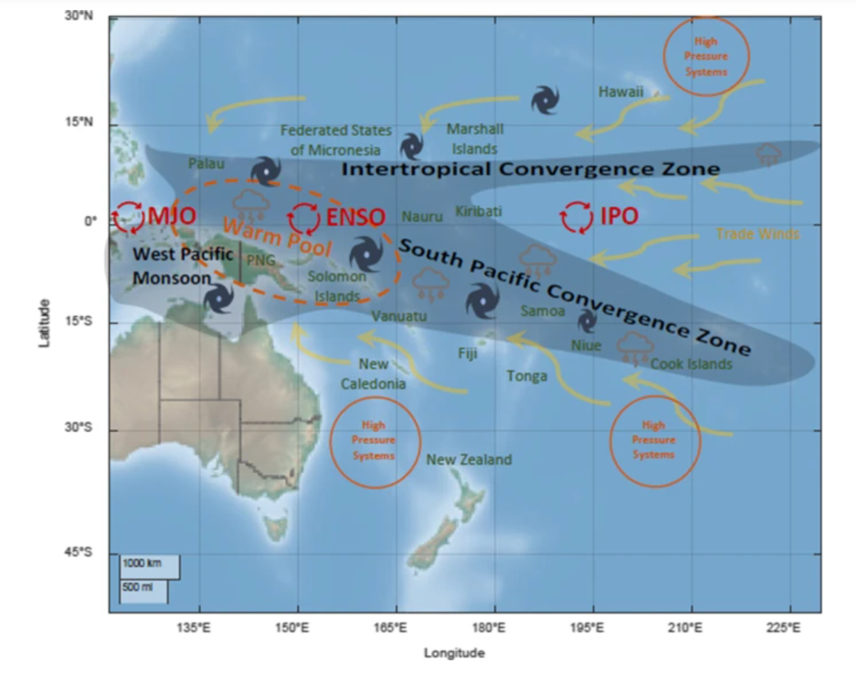
Figure 20. Areas and climate factors associated with the SPCZ (Chand et al. 2023).
The many peak periods displayed for 2015 and 2016 by the risk assessment are expected, with a 2015-2016 El-Niño noted as causing MHW conditions in Pacific islands like Vanuatu, with its warming signature concentrating in Fiji and surrounding countries (Marin et al. 2021). Notably, the March 2015 severe MHW risk levels are congruent with impacts caused by Tropical Cyclone (TC) Pam, which occurred across Vanuatu in mid-March 2015 as an intense Category 5 event. At this time, several adverse impacts on Vanuatu fisheries occurred due to the TC, which likely increased vulnerability to other disaster events, including MHWs in local Vanuatu communities (Le Dé et al. 2018). Terrestrial-based food and income generation was significantly reduced following TC Pam, with shortages in drinking water, crops, and infrastructural damages occurring. This caused increased reliance on marine resources to support communities. However, fishing skills and technology were low, and this reduced the ability of marine resources to support recovery in local communities (Eriksson et al. 2017). The peak periods displayed by the risk assessment for the beginning of 2017 (Feb, Apr and May) are likely concurrent with impacts induced by Category 4 TC Donna. TC Donna occurred at the beginning of May 2017, disrupting Vanuatu marine ecosystems via algal blooms (Russell and Horvat 2023).
The high-risk levels indicated by the risk assessment in the peak periods throughout 2020, 2021 and 2022 could be signalling impacts associated with the extended La Niña period. In this three year La Niña period, an increase in the strength and intensity of trade winds was seen, which enhanced the warm pool in the Western Pacific (CSIRO and SPREP 2021). As a result, countries like Vanuatu experienced warming ocean temperature and heightened coral bleaching. Notably, February 2021 saw the occurrence of four TC events (TC Lucas from Jan 29-Feb 4, TC Bina from Jan 29 to Feb 1, TC Ana from Jan 28 to Feb 3, and TC Niran from Feb 27 to Mar 7) (van Vloten et al. 2023).
The longest MHW-impact peak periods, indicated by the risk assessment, were seen in 2016 (with a 5-month peak from Jan-May), 2020 (with a 7-month peak from Jan-Jul), and in 2022 (with 8 months in 2022 extending the peak which was noted to begin in Nov-Dec in 2021). 2022 also displayed the most months in which significant MHW impacts were likely occurring, with the risk assessment recording 10 peak months spread throughout this year. It is not unusual that the risk assessment identified increasingly long periods of high-risk to MHW impacts. MHW events are progressively extending, with recent MHWs known to endure for over 250 days (Sen Gupta et al. 2020). The long peak in 2016, most likely signalled the impact period for the 2015/2016 El Niño-induced MHW event in the Pacific (Sen Gupta et al. 2020). The extended peak period of 2020 could have been signalling risk of impacts to fisheries from MHW conditions concurrent with the intensification of severe TC Harold, which was widely destructive across Vanuatu throughout April 2020 (Maclellan 2021). Additionally, throughout 2020, Vanuatu was recorded to have been undergoing an extended mass coral bleaching event (Huang et al. 20240). 2022 is expected as a year in which Vanuatu fisheries experienced many MHW-induced impacts. The occurrence of Category 4 TC Dovi in February 2022, as well as a mass coral bleaching event that persisted throughout the year, means it was expected to see some high-risk signals throughout 2022 in the risk assessment results (Bartow-Gillies et al. 2023; Huang et al. 20240).

Areas of concern, as indicated by the risk assessment

Throughout the peak periods highlighted by the risk assessment, MHW risk levels were seen to spike across the area councils throughout Vanuatu, but there were area councils signalled as distinctly more at-risk than other during each peak period. The local area councils of concern that are highlighted by the risk assessment reflect the proximity to MHW hotspots (Pacific Warm Pool and the South Pacific Convergence Zone) which elevate hazardous conditions, as well as the various factors of vulnerability and exposure evident across Vanuatu.
At the beginning of the first peak period (Jan-Mar 2015), higher risk levels were seen across area councils in the Northern and Central regions of Vanuatu (in Torba, Penama and Malampa provinces). Most of these severely at-risk provinces dropped to moderate levels in February 2015, with only Gaua and South Pentecost area councils persisting at severe risk levels. Gaua is expected to have such high-risk levels in times of increased hazard, as it is severely vulnerable and moderately exposed to MHW fisheries impacts. The South Pentecost risk levels were most likely a result of high hazard levels in combination with moderate severe and exposure levels for 2015. At the end of this period, in March 2015 higher risk levels were seen more in Sanma and Malampa provinces. Impacts which would have likely occurred in the high-risk area councils during this period include significant fish die off, significant deaths of other marine animals, coral bleaching, increased crown of thorns prevalence, algal blooms reduced catch amounts and reduced productivity of commercial fisheries. Eriksson et al. (2017) explains that communities throughout Malampa and Shefa provinces noted a crow-of-thorns outbreak in March 2015, which caused coral mortality. Shefa and Sanma provinces were noted as having reduce fisheries resilience at this time, due to impacts of TC pam, thus risk of experiencing severe MHW impacts in these provinces would be increased (Partners in Research for Development 2015)
In the longer peak period from January to May 2016, severe impacts were seemingly widespread, affecting area councils throughout all provinces of Vanuatu at some point. Overall, South East Malekula was the most concerning area council for this peak period, with persisting severe risk levels for each of the five months. This is not unexpected as South East Malekula is severely exposed to MHW impacts, with moderate vulnerability. Particularly low biodiversity in South East Malekula’s seagrass habitats and poor crab stock levels result in high exposure levels, making it more at risk to not only the environmental impacts of MHWs, but impact to fisheries production and income generation aswell (as these socio-economic factors heavily rely on the health of marine ecosystems in Vanuatu) (Eriksson et al. 2017). Central Malekula, Makimae, and North Tongoa were also of high concern, with severe risk levels displayed in these area councils for four out of the five months in this period. Unexpectedly, Aniwa displayed severe risk levels in the last month of this period. Throughout all peak periods, area councils in Tafea province were not commonly displayed to have high risk levels. This may be because of the southern location of Aniwa and the other area councils in Tafea province. The southern areas of Vanuatu are less likely to experience warming waters associated with the Indo-Pacific Warm Pool (Muir et al. 2021).
During peaking MHW risk in December 2016 to February 2017, high risk levels were seen in the Northern province of Torba and the Central provinces of Penama, Malampa and Shefa. Impacts were seen across several area councils in both December 2016 and January 2017 but were focused only in Tongariki throughout February 2017. Tongariki is expected to have high risk to MHW impacts when hazard conditions elevate, as it is a highly exposed area council. Throughout the peak period in April-May 2017, we saw severe risk levels persisting for Canal-Fanafo, South Maewo and Merelava. These span across three different provinces (Sanma, Penama and Torba respectively). This is interesting, as it gives evidence to widespread impact across the entire country of Vanuatu, rather than localised impacts in one specific province.
In the seven-month peak period from Jan-July 2020, severe impacts were likely widespread across Vanuatu, with high risk levels displayed for Torba, Sanma and Shefa provinces. The two most concerning area councils in this period included Canal-Fanafo of Sanma province, which had severe risk levels persisting across three months in this period, and Motalava of Torba province, which had severe risk levels persisting for four months in this period. Throughout the peak period of December 2020 to February 2021, Makimae area council displayed severe risk for each month. Makimae is expected to have high risk levels, even in periods of lower hazard levels. This is because it has moderate vulnerable and sever exposure levels. When hazard levels rose across Vanuatu in this period, it makes sense that Makimae would be highly sensitive to this, spiking overall risk levels to concerning values.
For the long, ten-month peak period of November 2021 to August 2022, many area councils exhibited severe risk levels: Canal-Fanafo, Makimae, South East Malekula, Mele, Pango and Port Vila. Most of these high-risk area councils are located in Shefa province (all but Canal-Fanafo and South East Malekula). Particularly, Canal-Fanafo and South East Malekula are expected to have high risk levels in times of increased hazard, due to their severe exposure levels. Makimae was particularly concerning for this period, with severe levels shown for eight out of the ten months in this peak period (it dropped to a moderate risk level in both June and August).
In the last peak period indicated in this study by the risk assessment (Nov-Dec 2022), severe risk levels were localised to area councils in or around Efate island. Efate island area councils are moderately vulnerable to MHW fisheries-based impacts, but area councils like Mele, Pango, ifira and Port Vila are severely exposed.

Is the risk assessment developed here likely valid?

The retrospective risk assessment results were commonly corroborated by the literature search and survey results. There were eleven months throughout the entire research period that were noted by all three sources as likely to or having experienced significant MHW impacts. These months included May 2015, July 2015, February 2016, March 2016, April 2017, February 2020, June 2020, February 2021, May 2022, November 2022, and December 2022. All these months fell within the peak periods identified by the risk assessment. However, not all months within the peak periods identified by the risk assessment were corroborated with both ground-truth sources.
The peak period of Jan-Mar 2015 was only corroborated by the literature review. The survey participants may not have identified MHW impacts for this period, as they may have attributed impacts to the disaster event of TC Pam. TCs are known to have similar impacts to the fisheries sector in Pacific SIDS as MHWs (e.g., disruption to fish supply, reduced catch amounts and reduced coral habitat health) (Le Dé et al. 2018). Similarly, the October to November 2015 peak period identified in the risk assessment was only corroborated with the literature records. This may be attributed to the distribution of survey participants. The most at-risk area councils identified by the risk assessment for Oct-Nov 2015 included Canal-Fanafo, Guau, Makimae and South Maewo. Two of these area councils are in provinces unrepresented by survey participants (Gaua in Torba and South Maewo in Penama). Thus, impacts in these areas likely went unnoticed by survey participants as they were experienced in areas far from where they live.
Although February-March 2016 was identified as a period of MHW impact by all three sources, the risk assessment also noted January 2016 as well as April and May 2016 as high-risk months apart of this peak period. January 2016 was recorded as a month in which significant MHW impacts occurred by the literature, but the survey results did not reflect this. Alternatively, April-May 2016 was identified by survey participants as months in which MHW impacts were experienced, but impacts were not noted in the literature as well. For April-May 2016 it is likely that most literature sources, recorded disaster impacts in Pacific SIDS would have focused on TC Zena, which occurred across several Pacific SIDS, including Vanuatu, in April 2016 (Le Dé et al. 2018). Impacts of TC Zena did not overlap with common MHW impacts, but the impacts of the TC were intense for this month, so it is reasonable to assume that the literature sources focused on recording on the TC impacts and omitted the recording of MHW impacts occurring at the same time (Le Dé et al. 2018).
The peak period of December 2016 to February 2017 identified in the risk assessment. January 2017 and February 2017 were corroborated as MHW impact month in the literature, but December 2016 was omitted as a high-risk month in both the literature review and survey results. This may be due to the risk level warning of potential MHW impacts, without the actual occurrence of such impacts in this month rather impacts were experienced in the following two months. This does not invalidate the risk assessment results; it gives light to the potential of the risk assessment to signal rising risk levels prior to the occurrence of MHW impacts ‘on-the-ground’.
May 2017 was displayed as a high-risk month in an April-May 2017 peak period by the risk assessment but was only corroborated by literature sources as a month of high impact. Survey results did recall impact in April 2017; as we were asking participants to recall the timing of impact from events 6 years prior, it is understandable that they may not recall every month in which impacts occurred, but it is encouraging that impacts were listed around May 2017, if not in that month specifically. Another potential explanation for the omission of May 2017 as a high impact month in the survey results, is the occurrence of TC Donna. TC Donna occurred in May 2017, affecting areas in Vanuatu (particularly in Torba province, but also having impact on areas of Sanma, Malampa and Shefa provinces). It may be that at this time MHW impacts were attributed to the impacts of TC Donna, and/or locals were occupied from coping with the harsh impacts of TC Donna (including infrastructural damage, damage to crops and disrupted water supply) (Le Dé et al. 2018).
November 2017 was also identified by the risk assessment as a peak period in which MHW impacts occurred, but this result was only corroborated by the literature. This is likely because the most severely affected provinces at this time were Gaua and Motalava, which are both apart of Torba province, which was not represented in the survey. No participants were from Torba, thus it is less likely that they would be able to pinpoint specific months in which this province experienced impacts.
Out of the long peak period of January to July 2020 displayed by the risk assessment, only two months in this period were corroborated as high impact months by the two ground-truth sources (February 2020 and June 2020). The literature results did corroborate January, March, April, and May 2020 as additional months in this peak period. However, July 2020 was not noted as a high impact month in either the risk assessment or literature. Canal-Fanafo was the area council in July that was indicated to have severe MHW risk, thus elevating the month to ‘peak period status’. Hazard conditions were only at a moderate level for this area council, giving reason as to why the ground-truth sources may not have noticed prominent MHW impacts in this month. However, the severe exposure level of Canal-Fanafo, combined with moderate vulnerability and hazard levels, meant that the risk assessment signalled high risk. Even if MHW impacts ended in June (as per the literature and survey results), the fact that this area council remained in a high-risk state due to severe exposure, could have highlighted to stakeholders that Canal-Fanafo is priority for improved MHW risk management. For example, Canal-Fanafo was signalled at risk to severe impacts again in September, this result being corroborated by impacts recorded in the literature. If increased management efforts were made in July, encouraged by the sustained high-risk signal despite the drop off in hazard conditions, stakeholders could have been better prepared for dealing with MHW impacts two months later in September.
The peak period of September 2020, as identified by the risk assessment, was only corroborated by literature results. This is unexpected as two of the three area councils identified by the risk assessment at risk to severe impacts, Port Vila and Makimae, were located within the most represented province in the survey, Shefa. If MHW impacts did occur ‘on-the-ground’ in these areas during this period, it would be expected that they would be noted by locals. Further investigation should be implemented to determine why locals may not have noticed MHW impacts to fisheries in this month. Only one month out of the three-month peak period of December 2020 to February 2021 that was identified in the risk assessment was also corroborated by both ground-truth sources (February 2021). Whilst January 2021 was noted by the survey results as well, December 2020 was not mentioned by either the literature sources or the survey participants as a high impact month. This is very similar to the case of the peak period from December 2016 to February 2017, in which Jan and Feb were corroborated by one or both ground-truth sources, with December being omitted from high-risk periods described by the literature review and survey. As previously discussed, the omission of December 2020 from being described as a high impact period by the ground-truth sources might be because the risk assessment signals risk of impact rather than actual impacts. Thus, giving warning to the occurrence of the actual impacts experienced in the following two months. Another potential reason for December 2020 being omitted from the literature and survey results as a month of high MHW impact, is the occurrence of TC Yasa which occurred in December 2020. This TC affected an approximated 93,000 people across Fiji and Vanuatu (Choi et al. 2024). Like the case of March 2015, the occurrence of a TC during December 2020 may have reduced the ability of locals to pick up on MHW impacts. Not only were locals experiencing another disaster event, which would have pulled focus from more nuanced events like MHWs, impacts caused by a MHW event at the time could have been attributed to the TC instead (Choi et al. 2024).
The signal of MHW risk to impacts in November and December 2021, could have been due to the risk assessment picking up on seasonal changes in SST, as Vanuatu moved into the summer season associated with warming ocean temperatures. The risk assessment identified the longest peak period for likely severe MHW impacts as November 2021 to August 2022. However, only May 2022 was confirmed by both ground-truth-sources as a high impact month. Unexpectedly, five out of the ten months of this peak period were uncorroborated by the ground-truth sources.
The area councils of concern expressed by the risk assessment, literature and survey results were consistent in most cases. Additionally, there were minimal false negatives, with no-risk periods as indicated by the risk assessment corroborated with at least one ground-truth source in majority of cases. Overall, Shefa province was identified as the most impacted province with most severely at-risk area councils, for both the 2015-2017 and 2020-2022 periods, by all three sources. The risk assessment commonly expressed Makimae area council and area councils within Efate island (located in Shefa province), throughout the two time periods, as being the most concerning area councils. Erakor and Pango area councils, both located on Efate island were the most commonly highlighted area councils of concern in the literature and survey results. It is expected that Efate island be more at-risk than other area in Vanuatu, especially in terms of socio-economic impacts as it is the most populated island in Vanuatu (with Port Vila being the largest city of Vanuatu). Additionally, Shefa province has a high proportion of income from the sale of fish and seafood, thus it is expected to have area councils highly at risk to adverse impacts on MHW fisheries (Eriksson et al. 2017).
There were some cases in which the risk assessment signalled high risk levels at least one month prior to locals noticing on-the-ground MHW impacts. In January of 2016, signals of moderate and severe MHW risk across Vanuatu were present in the risk assessment results. These levels persisted until May 2016. There was a delay seen in when MHW impacts were recorded by survey participants for this time. Moderate MHW impacts were noticed in February 2016 and were noticed until July 2016. This suggests the realistic impacts experienced at this time, by locals, persisted lasted beyond the signals of the risk assessment results. Another case in which the risk assessment would have given warning to locals and fisheries stakeholders before noticeable MHW impacts occurred was at the beginning of 2020. The risk assessment picked up significant MHW impact signals in January 2020, which lasted until February. The survey results identified that Vanuatu people only noticed MHW impacts in February. Similarly, in December 2020, severe risk levels were signalled by the risk assessment, persisting until February 2021. MHW impacts were only noticed on the ground from January to February 2021. This early signalling suggests that the MHW risk assessment developed here could have warned locals of concerning MHW risk levels, at least one month before significant impacts were experienced.

Are there any limitations to this work?

- The hazard indicator of chlorophyll-a expressed some anomalous results throughout the study. When coral bleaching and SSTs were indicating higher MHW hazard, chlorophyll-a concentrations would directly contradict this time periods. A sensitivity analysis should be conducted to confirm the validity of this indicator for this assessment.
- In the literature search, most sources only mention the year in which MHW impacts have occurred across Vanuatu, with little specification as to what months such impacts were experienced. This limits the usefulness of the literature search as a ground-truth source in which to validate our results against. However, the inclusion of an additional ground-truth source (the local surveys) allows for stronger confidence in validation results despite this limitation.
- For the survey undertaken, the sample size was relatively small with 17 participants. This limits the number of insights able to be gained by results. Since this study is unprecedented, it is deemed that any insights gained from the survey results are useful, regardless of sample size. Additionally, the use of a second ground-truth source (literature records), the small number of surveys used for validation does not diminish our ability to gauge the overall validity of risk assessment results.
- There were no extreme risk levels expressed in the retrospective risk assessment results, which may be a result of methodological limitations. However, it could be due to the fact that no extreme MHW events have occurred in the past. Although the impacts of such periods like 2016 saw intense MHW impacts in Vanuatu, the specific impacts that occurred only amounted to the category of severe (as described in the literature). Thus, the risk assessment is likely still valid, and suggests that it isn’t too sensitive to overestimate high risk signals. The methodology should be tested in future MHW events, in which impacts reach the extreme category.
- Although this assessment covered a large enough time period to demonstrate the validity of the risk assessment in picking up the signals of transitioning into and out of MHW events, it would be useful in the future to ‘fill in the gaps’ for the years of 2018 and 2019. There have been no recorded MHW events in these years, but it would be useful to determine if the risk assessment would pick up ‘false positives’ during these years and signal a MHW event when one did not actually occur.

What are the uses of such an assessment methodology in the future?

The risk assessment gives at least one month of warning prior to the noticing of MHW impacts on the ground. This means in the future, it could be implemented to inform on the division of resources to areas of concern, to increase resilience when a MHW event occurs. Specifically, it could aid in preparedness. Current MHW management in Vanuatu is reactive, focusing on managing the impacts of an event after they have already occurred and caused significant damage. If warned one month prior, communities and stakeholders may not have sufficient time to lessen the environmental impacts of a MHW event (which require long-term planning measures to reduce harm) but could be useful in reducing the socio-economic impacts of MHW events (guiding fisheries resource management, warning local fisherman of areas in which not to fish, and allowing communities to gather enough terrestrial based food and income to offset disruption to fisheries food and income generation).
Overall, the risk assessment methodology is deemed valid, with retrospective risk assessment results confirming the ability for the risk assessment to signal when a MHW event is likely to have impact, and where impacts would be experienced most harshly. In the few cases in which the retrospective risk assessment results went uncorroborated, reasonable explanations for this have been found. Further investigation to improve upon this work but we believe this risk assessment methodology is accurate enough to aid in fisheries stakeholder decision making if employed in the future. It is encouraged that this risk assessment be applied in future scenarios, or where capacity is low, the more static vulnerability and exposure maps are used in the future to contextualise hazard data monitored by the VMGD in terms of what areas are most at risk and will need increased management efforts to reduce the severity of impacts when a MHW occurs. The data gathered for the socioeconomic and environmental indicator data is gathered from various data sources and has been filed into a holistic risk database which can be transferred to staff at VMGD to be used in future work. This increases data availability, which is known to commonly obstruct disaster risk assessment work in Pacific SIDS.

References

Aerts, J. C. J. H., Botzen, W. J., Clarke, K. C., Cutter, S. L., Hall, J. W., Merz, B., Michel-Kerjan, E., Mysiak, J., Surminski, S., and Kunreuther, H.: Integrating human behaviour dynamics into flood disaster risk assessment, Nat. Clim. Change, 8, 193–199, doi:10.1038/s41558-018-0085-1, 2018.
Agliata, R., Bortone, A., and Mollo, L.: Indicator-based approach for the assessment of intrinsic physical vulnerability of the built environment to hydro-meteorological hazards: Review of indicators and example of parameters selection for a sample area’, Int. J. Disaster Risk Red., 58, 102-199, doi: 10.1016/j.ijdrr.2021.102199, 2021.
Ainsworth, T.D., Hurd, C.L., Gates, R.D., and Boyd P.W.: How do we overcome abrupt degradation of marine ecosystems and meet the challenge of heat waves and climate extremes?, Glob. Change Biol., 26, 2, 343-354, doi:10.1111/gcb.14901, 2020.
Aitkenhead, I., Kuleshov, Y., Watkins, A. B., Bhardwaj, J., and Asghari, A.: Assessing agricultural drought management strategies in the Northern Murray–Darling Basin, Natural Hazards, doi:10.1007/s11069-021-04884-6, 2021.
Aitkenhead, I., Kuleshov, Y., Bhardwaj, J., Chua, Z-W., Sun, C., and Choy, S. :Validating a tailored drought risk assessment methodology: drought risk assessment in local Papua New Guinea regions, Nat. Hazards Earth Syst. Sci., 23, 553–586, doi: 10.5194/nhess-23-553-2023, 2023.
Amos, J.: Vanuatu fishery resource profiles, SPREP, Apia, Samoa, ISBN: 978-982-04-0372-7, accessed 17 December 2022. http://archive.iwlearn.net/sprep.org/att/publication/000557_IWP_PTR49.pdf, 2007.
Asadzadeh, A., Kötter, T., and Zebardast, E.: An augmented approach for measurement of disaster resilience using connective factor analysis and analytic network process (F’ANP) model, Int. J. Disaster Risk Red., 14, 4, 504-518, doi: 10.1016/j.ijdrr.2015.10.002, 2015.
Asare-Kyei, D., Renaud, F. G., Kloos, J., Walz, Y., and Rhyner, J.: Development and validation of risk profiles of West African rural communities facing multiple natural hazards, PLOS ONE, 12, e0171921, doi: 10.1371/journal.pone.0171921, 2017.
Asner, G., Vaughn, N.R., Martin, R.E., and Gove, J.: Mapped coral mortality and refugia in an archipelago-scale marine heat wave, PNAS, 119, 19, 212-333, doi: 10.1073/pnas.2123331119, 2022.
Aubrecht, C., Fuchs, S. and Neuhold, C.: Spatio-temporal aspects and dimensions in integrated disaster risk management, Nat Hazards, 68, 1205-1216, doi: 10.1007/s11069-013-0619-9, 2013.
Bang, S. and Crimp, S.: Accessible weather forecasts, advisories key to PNG farm resilience, 3, Australian Centre for International Agricultural Research, 14–17 pp., doi:10.3316/informit.950510834174223, 2019.
Bang, S., Sitango, K. and UN.ESCAP: Indigenous Drought Coping Strategies and Risk Management against El Nino in Papua New Guinea, CGPRT Centre Working Paper, Papua New Guinea, 2003.
Barbeaux, S.J., Holsman, K. and Zador, S.: Marine Heatwave Stress Test of Ecosystem-Based Fisheries Management in the Gulf of Alaska Pacific Cod Fishery, Front. Mar. Sci., 7, 703, doi: 10.3389/fmars.2020.00703, 2020.
Bell, J.D., Reid, C., Batty, M.J., Lehodey, P., Rodwell, L., Hobday, A., Johnson, J.E. and Demmke, A.: Effects of climate change on oceanic fisheries in the tropical Pacific: implications for economic development and food security, Clim. Change, 119, 199-212, doi: 0.1007/s10584-012-0606-2, 2013.
Bhardwaj, J., Kuleshov, Y., Chua, Z.-W., Watkins, A. B., Choy, S., and Sun, Q.: Building Capacity for a User-Centred Integrated Early Warning System for Drought in Papua New Guinea, Remote Sensing, 13, doi: 10.3390/rs13163307, 2021.
Blauhut, V.: The triple complexity of drought risk analysis and its visualisation via mapping: a review across scales and sectors, Earth-Science Reviews, 210, doi: 10.1016/j.earscirev.2020.103345, 2020.
Chen, K., Blong, R., and Jacobson, C.: Towards an integrated approach to natural hazards risk assessment using GIS: with reference to bushfires, Environ Manage, 31, 546-560, doi: 10.1007/s00267-002-2747-y, 2003.
Cheung, W.W.L. and Frölicher, T.L.: Marine heatwaves exacerbate climate change impacts for fisheries in the northeast Pacific, Sci Rep, 10, 6678, doi:10.1038/s41598-020-63650-z, 2020.
Commonwealth Scientific and Industrial Research Organisation (CSIRO) and Secretariat of the Pacific Regional Environment Programme (SPREP): NextGen’ Projections for the Western Tropical Pacific: Current and Future Climate for Vanuatu. Final report to the Australia-Pacific Climate Partnership for the Next Generation Climate Projections for the Western Tropical Pacific project. CSIRO and SPREP, CSIRO Technical Report, Melbourne, Australia, accessed 18 December 2022, doi: 10.25919/hexz-1r10, 2021.
Dunstan, K., Moore, B.R., Bell, J.D., Holbrook, N.J., Oliver, E.C.J., Risbey, J., Foster, S.D., Hanich, Q., Hobday, A. and Benner, N.J.: How can climate predictions improve sustainability of coastal fisheries in Pacific Small-Island Developing States?, Mar. Policy, 88, 295-302, doi: 10.1016/j.marpol.2017.09.033, 2018.
Environmental Systems Research Institute (ESRI) Inc.: ArcGIS Pro (10.7.1), Environmental Systems Research Institute (ESRI) Inc. [code], 2019.
Eriksson, H., Albert, J., Albert, S., Warren, R., Pakoa, K. and Andrew, N.: The role of fish and fisheries in recovering from natural hazards: Lessons learned from Vanuatu, Environmental Science & Policy, 76, 50-58, doi:10.1016/j.envsci.2017.06.012, 2017.
Fekete, A.: Social Vulnerability (Re-)Assessment in Context to Natural Hazards: Review of the Usefulness of the Spatial Indicator Approach and Investigations of Validation Demands, International Journal of Disaster Risk Science, 10, 220-232, doi: 10.1007/s13753-019-0213-1, 2019.
Food and Agriculture Organisation of the United Nations: FAO 2020–2021 La Niña advisory, Food and Agriculture Organisation of the United Nations, Rome, 1-14, 2021.
Food Security Cluster, Secretariat of the Pacific Regional Environment Programme, and World Food Programme: Anticipatory Action Advisory for Pacific Food Security - La Niña 2021, Italy, 2021.
Frölicher, T.L. and Laufkötter, C.: Emerging risks from marine heat waves, Nat Commun, 9, 650, doi:10.1038/s41467- 018-03163-6, 2018.
Giamalaki, K., Prochaska, J.X., and Beaulieu, C.: The rapid rise of severe marine heat wave systems’, Environmental Research: Climate, 2, 2, 2-21, doi:10.1088/2752-5295/accd0e, 2023.
Giardino, A., Nederhoff, K., and Vousdoukas, M.: Coastal hazard risk assessment for small islands: assessing the impact of climate change and disaster reduction measures on Ebeye (Marshall Islands), Reg Environ Change, 18, 2237–2248, doi:10.1007/s10113-018-1353-3, 2018.
González Tánago, I., Urquijo, J., Blauhut, V., Villarroya, F., and De Stefano, L.: Learning from experience: a systematic review of assessments of vulnerability to drought, Natural Hazards, 80, 951-973, doi: 10.1007/s11069-015-2006-1, 2016.
Gray, W. M., 1979: Hurricanes: their formation, structure and likely role in the tropical circulation. Meteorology Over the Tropical Oceans, D. B. Shaw, Ed., Royal Meteorological Society, 155–218.
Hagenlocher, M., Meza, I., Anderson, C. C., Min, A., Renaud, F. G., Walz, Y., Siebert, S., and Sebesvari, Z.: Drought vulnerability and risk assessments: state of the art, persistent gaps, and research agenda, Environmental Research Letters, 14, 083002, doi: 10.1088/1748-9326/ab225d, 2019.
Hagenlocher, M., Thieken, A., Schneiderbauer, S., Aguirre Ayerbe, I., Dobes, P., Donovan, A., Morsut, C., Paris, N., Pedoth, L., and Tonmoy, F.: Risk Assessment, in: Science for Disaster Risk Management 2020: acting today, protecting tomorrow, edited by: Casajus Valles, A., Marin Ferrer, M., Poljanšek, K., and Clark, I., Publications Office of the European Union, Luxembourg, 54-65, doi: 10.2760/571085, 2020.
Hobday, A., Alexander, L.V., Perkins, S.E., Smale, D.A., Straub, S.C., Oliver, E.C.J., Benthuysen, J.A., Burrows, M.T., Donat, M.G., Feng, M., Holbrook, N.J., Moore, P.J., Scannell, H.A., Sen Gupta, A., and Wernberg, T.: A hierarchical approach to defining marine heatwaves, Progress in Oceanography, 141, 227-238, doi:10.1016/j.pocean.2015.12.014, 2016.
Holbrook, J., Hernaman, V., Koshiba, S., Lako, J., Kajtar, J.B., Amosa, P., and Singh, A.: Impacts of marine heatwaves on tropical western and central Pacific Island nations and their communities, Global and Planetary Change, 208, 103-680, doi:10.1016/j.gloplacha.2021.103680, 2022.
Horton, J. B., Lefale, P., and Keith, D.: Parametric Insurance for Solar Geoengineering: Insights from the Pacific Catastrophe Risk Assessment and Financing Initiative, Global Policy, 12, 97-107, doi: 10.1111/1758-5899.12864, 2021.
Hunsicker, M.E., Ward, E.J., Litzow, M.A., Anderson, S.C., Harvey, C.J., and Field, J.C.: Tracking and forecasting community responses to climate perturbations in the California Current Ecosystem, PLOS Clim, 1, 3, 14, doi: 10.1371/journal.pclm.0000014, 2022.
Jackson, G., McNamara, K., and Witt, B.A.: Framework for Disaster Vulnerability in a Small Island in the Southwest Pacific: A Case Study of Emae Island, Vanuatu, Int J Disaster Risk Sci, 8, 358–373, doi:10.1007/s13753-017-0145-6, 2017.
Kajtar, J.B., Bachman, S.D., Holbrook, N.J., and Pilo, G.S.: Drivers, dynamics, and persistence of the 2017/2018 Tasman Sea marine heatwave, Journal of Geophysical Research: Oceans, 127, doi: 10.1029/2022JC018931, 2022.
Kouwenhoven, P.: Profile of risks from climate change and geohazards in Vanuatu: Draft Report, CLIMsystems, accessed 20 October 2022. https://www.nab.vu/sites/default/files/nab/documents/03/04/2014%20-%2012:45/risk_profile_report_draft_1.pdf, 2013.
Kuleshov, Y., Inape, K., Watkins, A., Bear-Crozier, A., Chua, Z.-W., Xie, P., Kubota, T., Tashima, T., Stefanski, R., and Kurino, T.: Climate Risk and Early Warning Systems (CREWS) for Papua New Guinea, in, Drought - Detection and Solutions, edited by: Ondrasek, G., IntechOpen, doi: 10.5772/intechopen.85962, 2020.
Kuleshov, Y., Kurino, T., Kubota, T., Tashima, T. and Xie, P.: WMO Space-based Weather and Climate Extremes Monitoring Demonstration Project (SEMDP): First Outcomes of Regional Cooperation on Drought and Heavy Precipitation Monitoring for Australia and Southeast Asia, in: Rainfall - Extremes, Distribution and Properties, edited by Abbot, J. and Hammond, A., IntechOpen, doi: 10.5772/intechopen.85824, 2019.
Kuleshov, Y., McGree, S., Jones, D., Charles, A., Cottrill, A., Prakash, B., Atalifo, T., Nihmei, S., and Seuseu, F. L. S. K.: Extreme weather and climate events and their impacts on island countries in the Western Pacific: cyclones, floods and droughts, Atmospheric and Climate Sciences, 4, 803-818, doi: 10.4236/acs.2014.45071, 2014.
Le, T., Sun, C., Choy, S., and Kuleshov, Y.: Regional drought risk assessment in the Central Highlands and the South of Vietnam, Geomatics, Natural Hazards and Risk, 12, 1, 3140-3159, doi: 10.1080/19475705.2021.1998232, 2021.
Le Grix, N., Zscheischler, J., Laufkötter, C., Rousseaux, C.S., and Frölicher, T.L.: Compound high-temperature and low chlorophyll extremes in the ocean over the satellite period, Biogeosciences, 18, 6, 2119-2137, doi: 10.5194/bg-18-2119, 2021.
Major, D.C., Blaschke, P., Gornitz, V., Hosek, E., Lehmann, M., Lewis, J., Loehr, H., Major-Ex, G.A., Pedersen Zari, M., Vásquez Vargas, M.J., Watterson, E., and Wejs, A.: Adaptation to climate change in small island settlements, Ocean and Coastal Management, 212, 105-789, doi: 10.1016/j.ocecoaman.2021.105789, 2021.
Matsuura, S., and Razak, K.A.: Exploring transdisciplinary approaches to facilitate disaster risk reduction, Disaster Prevention and Management, 28, 6, 817-830, doi: 10.1108/DPM-09-2019-0289, 2019.
Mcnamara, K.E., Westoby, R., and Chandra, A.: Exploring climate-driven non-economic loss and damage in the Pacific Islands, Curr Opin Environ Sustain, 50, 1-11, doi: 10.1016/j.cosust.2020.07.004, 2021.
Mercer, J.: Disaster risk reduction or climate change adaptation: Are we reinventing the wheel?, Journal of International Development, 22, 247-264, 2010.
Molinari, D., De Bruijn, K. M., Castillo-Rodríguez, J. T., Aronica, G. T., and Bouwer, L. M.: Validation of flood risk models: Current practice and possible improvements, International Journal of Disaster Risk Reduction, 33, 441-448, doi: 10.1016/j.ijdrr.2018.10.022, 2019.
Mosquera-Machado, S., and Dilley, M.: A comparison of selected global disaster risk assessment results, Nat Hazards, 48, 439–456, doi: 10.1007/s11069-008-9272-0, 2009.
Muir, P.R., Done, T., and Aguirre, J.D.: High regional and intrageneric variation in susceptibility to mass bleaching in Indo-Pacific coral species, Global Ecology and Biogeography, 30, 1889–1898, doi: 10.1111/geb.13353, 2021.
Nations Online Project: Administrative Map of Vanuatu [digitised map], One World-Nations Online, accessed 8 December 2022, https://www.nationsonline.org/oneworld/map/vanuatu-map.htm, 2015.
Nicholls, N.: Atmospheric and Climatic Hazards: Improved Monitoring and Prediction for Disaster Mitigation, Natural Hazards, 23, 137-155, doi: 10.1023/A:1011130223164, 2001.
Pacific Islands Forum Secretariat: 2015 Pacific Regional MDG Tracking Report, Fiji, 1-166, 2015.
Pascal, N.: Cost-Benefit analysis of community-based MARINE PROTECTED AREAS: 5 case studies in Vanuatu, South Pacific. Research report, CRISP-CRIOBE (EPHE/CNRS), Moorea, French Polynesia, accessed 19 December 2022. https://spccfpstore1.blob.core.windows.net/digitallibrary-docs/files/77/774a013676c7114870831e1ef4886e8d.pdf?sv=2015- 12-11&sr=b&sig=g4JcxithRy%2B%2BDge%2FuElMdrz13sJERsXl9cIGH7HsGjs%3D&se=2023-05- 02T02%3A21%3A11Z&sp=r&rscc=public%2C%20max-age%3D864000%2C%20maxstale%3D86400&rsct=application%2Fpdf&rscd=inline%3B%20filename%3D%22ENG_2011_Cost Benefit_analysis_Vanuatu.pdf%22, 2011.
Pedersen Zari, M., Blaschke, P., Jackson, B., Komugabe-Dixson, A., Livesey, C., Loubser, D.I., Martinez-Almoyna Gual, C., Maxwell, D., Rastandeh, A., Renwick, J., Weaver, S., and Archie, K.M.: Devising urban ecosystem-based adaptation (EbA) projects with developing nations: A case study of Port Vila, Vanuatu, Ocean Coast Manag, 184, 105037, doi: 10.1016/j.ocecoaman.2019.105037, 2020.
Phillips, M.M., De Mel, M., and Romanou, A.: Catastrophic bleaching risks to Mesoamerican coral reefs in recent climate change projections, ESS Open Archive, 2022.
Pulwarty, R. S. and Sivakumar, M. V. K.: Information systems in a changing climate: Early warnings and drought risk management, Weather and Climate Extremes, 3, 14-21, doi: 10.1016/j.wace.2014.03.005, 2014.
Regional Bureau for Asia & the Pacfic and Food Security Markets and Vulnerability Analysis unit: PAPUA NEW GUINEA El Nino 2015-16, World Food Programme, Bangkok, 1-6, 2015.
RIMES and Papua New Guinea National Weather Service: ENSO Impact Outlook: Papua New Guinea 2017/2018 (La Niña), Papua New Guinea, 2017.
Rufat, S., Tate, E., Burton, C.G., and Sayeed Maroof, A.: Social vulnerability to floods: Review of case studies and implications for measurement, Int. J. Disaster Risk Red., 14, 4, 470-486, doi: 10.1016/j.ijdrr.2015.09.013, 2015.
Samhouri, J.F., Feist, B.E., Fisher, M.C., Liu, O., Woodman, S.M., Abrahams, B., Forney, K.A., Hazen, E.L., Lawson, D., Redfern, J., and Saez, L.E.: Marine heatwave challenges solutions to human–wildlife conflict, Proc. Royal Soc. B, 288, 1964, doi: 10.1098/rspb.2021.1607, 2021.
Savage, A., Bambrick, H., and Gallegos, D.: Climate extremes constrain agency and long-term health: A qualitative case study in a Pacific Small Island Developing State, Weather and Climate Extremes, 31, 100-293, doi: 10.1016/j.wace.2020.100293, 2021.
Shultz, J.M., Cohen, M.A., Hermosilla, S., Espinel, Z., and McLean, A.: Disaster risk reduction and sustainable development for small island developing states, Disaster Health, 3, 1, 32-44, doi:10.1080/21665044.2016.1173443, 2016.
Singh, N.R., Love, B., Murray, C.S., Sobocinski, K.L., and Cooper, W.J.: The combined effects of acidification and acute warming on the embryos of pacific herring (clupea pallasii), Frontiers in Marine Science, doi:https://doi.org/10.3389/fmars.2023.1307617, 2023.
Smith, I., Moise, A., Inape, K., Murphy, B., Colman, R., Power, S., and Chung, C.: ENSO-Related Rainfall Changes over the New Guinea Region. Journal of Geophysical Research - Atmosphere, 118, 10,665–10,675, doi: 10.1002/jgrd.50818, 2013.
Spencer, P.D., Hollowed, A.B., Sigler, M.F., Hermann, A.J., Nelson, M.W.: Trait-based climate vulnerability assessments in data-rich systems: An application to eastern Bering Sea fish and invertebrate stocks, Glob Change Biol, 25, 3954–3971, doi: 10.1111/gcb.14763, 2019.
Spickett, J.T., Katscherian, D., and McIver, L.: Health Impacts of Climate Change in Vanuatu: An Assessment and Adaptation Action Plan, Glob J Health Sci, 5, 3, 42-53, doi:10.5539/gjhs.v5n3p42, 2013.
Sutherland, J., Broad, S., Butchart, S.H.M., Clarke, S.J., Collins, A.M., Dicks, L.V., Doran, H., Esmail, N., Fleishman, E., Frost, N., Gaston, K.J., Gibbons, D.W., Hughes, A.C., Jiang, Z., Kelman, R., LeAnstey, B., le Roux, X., Lickorish, F.A., Monk, K.A., Mortimer, D., Pearce Higgins, J.W., Peck, L.S., Pettorelli, N., Pretty, J., Seymour, C.L., Spalding, M.D., Wentworth, J., and Ockendon, N.: A Horizon Scan of Emerging Issues for Global Conservation in 2019, Trends Ecol. Evol., 34, 1, 83-94, doi: 10.1016/j.tree.2018.11.001, 2019.
United Nations International Strategy for Disaster Reduction (UNISDR): Global Survey of Early Warning Systems, Bonn, Germany, 2006.
Tate, E.: Social vulnerability indices: a comparative assessment using uncertainty and sensitivity analysis, Nat Hazards, 63, 325–347, doi: 10.1007/s11069-012-0152-2, 2012.
Twomlow, A., Grainger, S., Cieslik, K., Paul, J.D., and Buytaert, W.: A user-centred design framework for disaster risk visualisation’, Int. J. Disaster Risk Red., 77, 103067, doi: 10.1016/j.ijdrr.2022.103067, 2020.
van Riet, G., and van Niekerk, D.: Capacity development for participatory disaster risk assessment, Environ. Hazards, 11, 3, 213-225, doi:10.1080/17477891.2012.688793, 2012.
Wang, Y., Li, Z., Tang, Z., and Zeng, G.: A GIS-Based Spatial Multi-Criteria Approach for Flood Risk Assessment in the Dongting Lake Region, Hunan, Central China, Water Resour. Manag., 25, 3465-3484, doi: doi.org/10.1007/s11269-011- 9866-2, 2011.
Wyatt, A., Resplandy, L., and Marchetti, A.: Ecosystem impacts of marine heat waves in the Northeast Pacific, EGUsphere, doi: 10.5194/egusphere-2022-17, 2022.
Xue, T., Frenger, .I, Terhaar, J., Prowe, A.E.F., Frölicher, T.L., and Oschlies, A.: Southern Ocean phytoplankton under climate change: shifting balance of bottom-up and top-down control, Biogeosciences Discuss, doi: 10.5194/bg-2023-171, 2023.

Appendix

Appendix A- Participatory Survey Content

Conducting a tailored and localised Marine Heat Wave risk assessment for Vanuatu fisheries

Required Participant Information
Participant Details
Please provide the following details
Local area council:
Age:
Gender:
Stakeholder group (fisher person, fisheries staff, and/or local community member):

Administrative Details
Would you be willing to participate in further related studies? (If yes, you are consenting to being contacted in the future)

Would you like a copy of the report sent to you via email? (If yes, please include the email address you would like to receive this at)

Survey Questions
Marine Heat Wave Risk Assessment Validation questions: Part 1- 2015 to 2017 case study period
Question 1- Do you recall marine heat wave impacts occurring across Vanuatu between 2015 and 2017? (please circle one)
Yes
No
If yes, please answer Questions 2-5. If no, please move onto the next section.
Question 2- When did you notice marine heat wave impacts occurring across Vanuatu (please provide the year and month if possible)?

Question 3- Were these impacts widespread across several provinces or do you recall a particular province/local area that was most affected?

Question 4- What types of impacts occurred? (please provide a Y for yes or N for no)
Type of Impact | Y/N
Fish kills
Die-off of additional marine animals (e.g crabs)
Coral bleaching
Increased number of crown of thorns starfish
Algal blooms
Reduced catch amounts
Reduced production of commercial fisheries
Reduced food supply
Significant economic losses on household and industrial scale

Question 5- How severe would you say these impacts were? (Please circle one)
Very Mild (minimal fish die-off occurred, nothing significant)
Mild (slight fish die-off occurred, with slight die-off of additional marine species)
Moderate (significant fish die off occurred, with significant deaths of other marine animals)
Severe (significant fish die off occurred, with significant deaths of other marine animals; coral bleaching occurred; increased crown of thorns prevalence and occurrence of algal blooms; catch amounts reduced and productivity of commercial fisheries reduced)
Extreme (significant fish die off occurred, with significant deaths of other marine animals; coral bleaching occurred; increased crown of thorns prevalence and occurrence of algal blooms; catch amounts reduced and productivity of commercial fisheries reduced; food supply of locals reduced; economic losses occurred at the household and industrial level)
Marine Heat Wave Risk Assessment Validation questions: Part 2- 2020 to 2022 case study period
Question 6- Do you recall marine heat wave impacts occurring across Vanuatu between 2020 and 2022? (please circle one)
Yes
No
If yes, please answer Questions 7-10. If no, please move onto the next section.
Question 7- When did you notice marine heat wave impacts occurring across Vanuatu (please provide the year and month if possible)?

Question 8- Were these impacts widespread across several provinces or do you recall a particular province/local area that was most affected?

Question 9- What types of impacts occurred? (please provide a Y for yes or N for no)
Type of Impact | Y/N
Fish kills
Die-off of additional marine animals (e.g crabs)
Coral bleaching
Increased number of crown of thorns starfish
Algal blooms
Reduced catch amounts
Reduced production of commercial fisheries
Reduced food supply
Significant economic losses on household and industrial scale

Question 10- How severe would you say these impacts were? (Please circle one)
Very Mild (slight fish die-off occurred, nothing significant)
Mild (slight fish die-off occurred, with slight die-off of additional marine species)
Moderate (significant fish die off occurred, with significant deaths of other marine animals)
Severe (significant fish die off occurred, with significant deaths of other marine animals; coral bleaching occurred; increased crown of thorns prevalence and occurrence of algal blooms; catch amounts reduced and productivity of commercial fisheries reduced)
Extreme (significant fish die off occurred, with significant deaths of other marine animals; coral bleaching occurred; increased crown of thorns prevalence and occurrence of algal blooms; catch amounts reduced and productivity of commercial fisheries reduced; food supply of locals reduced; economic losses occurred at the household and industrial level)
Marine Heat Wave Risk Management questions:
Question 11- When Marine Heat Wave events have occurred across Vanuatu in the past, what management strategies were implemented by the fishing industry or government bodies?

Question 12- How would you rate the response of the fishing industry/government bodies to marine heat wave impacts? (Please circle one)
Not effective
Moderately effective
Very effective
Question 13- When Marine Heat Wave events have occurred in the past, what actions did you take personally, to manage impacts?

